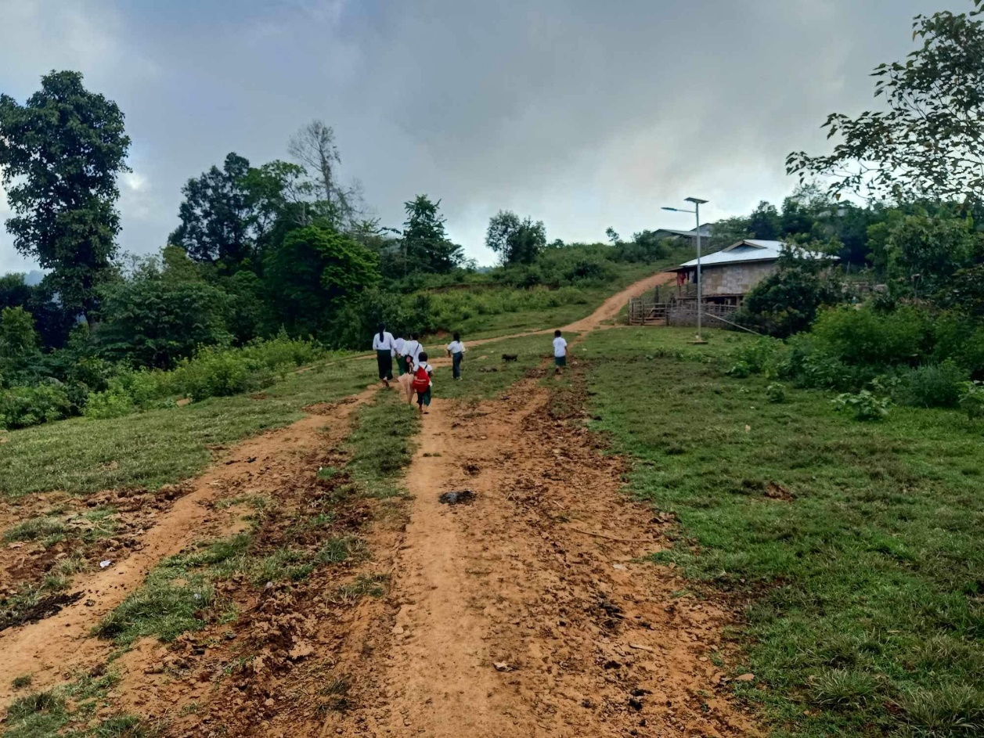

Transition & Monitoring Officer

(This position is open to Myanmar Nationals)

Based in: Eastern Shan State (Kyaning Tong)
Contract period: Full-time position (One-year fixed contract with possible extension.
Reporting to: Country Director

United World Schools (UWS) is a growing INGO working in Cambodia, Myanmar, Nepal, and Madagascar. We believe every child deserves a quality education and we commit to fulfil these rights by working in areas where no meaningful education alternative currently exists for them. We invite you to please visit our website www.unitedworldschools.org to learn more about us.

This role will work closely with Country Director, and will provide strong management and oversight for all matters relating to monitory, evaluation and smooth transition of the schools. Also, due to the small size of our team and close working culture of UWS, the Transition & Monitory Officer also works in a very hands-on and flexible manner, often attending to a variety of tasks at all levels as needed.

***** UWS is committed to the safeguarding of children and ensuring safe recruitment is central to the commitment of UWS. All staff will be required a proof of clearance from child criminal records.

In General:
Roles and Responsibilities: (Transition)
Teacher Training and Capacity Building:
- Develop and implement training programs for teachers to align them with the government
curriculum and teaching methodologies.
- Provide ongoing support to teachers during the transition period.
- Assess and address specific needs and challenges faced by teachers in adapting to the
government system.
School Support Committee Capacity Building:
- Conduct workshops and training sessions for school support committees on government policies, procedures, and administrative requirements.
- Support the development of leadership and governance skills among committee members. Collaboration and Stakeholder Engagement:
- Liaise with relevant government authorities, school administrators, and community
stakeholders to ensure a collaborative and transparent transition process.
- Foster positive relationships and effective communication channels with all stakeholders
involved in the transition.
Roles and Responsibilities: (M & E)
Responsibilities (including, but not limited to):
- With technical guidance from Global MEAL Manager, lead responsibility for designing, developing and maintaining a fit-for-purpose, high quality central database (Programme Management System) for all UWS Myanmar operations.
- Consult, develop, and introduce effective systems and procedures for collecting and using information and data in-country.
- Responsible for the quantitative and qualitative monitoring, analysis and reporting on UWS Myanmar’s activities, primary impact and secondary impact.
- Lead on developing ‘Learning’ culture within UWS Myanmar by ensuring data analysis and evaluation reports are easily accessible and user-friendly.
- In collaboration with Global MEAL Manager, develop MEAL tools to evaluate UWS Myanmar’s primary and secondary impact.
- In collaboration with UWS Myanmar Communication Manager, improve internal MEAL and impact reporting in-country and globally.
- Responsible for timely and accurate external reporting of UWS Myanmar programmes and institutional-funded projects as per varied and growing stakeholder requirements.
- Identify needs and lead the training of UWS Myanmar staff in data management and analysis where necessary.
- Ensure that UWS Myanmar’s strategic planning is evidence-driven and that relevant information is accessible for the Global Executive, Myanmar SMT, Myanmar staff and Global MEAL Working Group.
- Keep up to data with MEAL models of best practice and current research, to ensure that UWS’ data management and analysis is as efficient and effective as possible. Complete external MEAL training as per needs identified.
- Support all areas of work of the Global MEAL Working Group as per the Global MEAL Working Group TOR.
- Work with external consultants as required.

Knowledge and core competencies
We are looking for an ambitious candidate to grow and develop with the organization. This means that above all, we are looking for someone who is open to learning new skills and can take a proactive approach to new tasks and responsibilities.
● Educated to degree level, ideally with previous experience in a similar position
● Excellent verbal and written communication skills (in Myanmar and English)
● Strong relationship building skills with proven ability to liaise with a diverse range of stakeholders, including communicating remotely with teams in the field
● Ability to think and work strategically - identifying the right opportunities for impact and leading their delivery with confidence
● Strong project management skills and the ability to work in a fast-paced environment and priorities work and juggle multiple things at once
● A high level of numeracy and confident managing and analyzi information and data.
● Ability to research, set up and train others in new systems and procedures for MEAL.
● A broad understanding of the issues around impact evaluation in development education
● Ability to produce high quality reports, proposals, presentations and other communications to a range of current and potential stakeholders
● Ability to lead independent projects involving the wider team, interns and volunteers as needed
● Determined, persuasive, ambitious, flexible and a proactive team player … which means you commit and deliver for the cause.

How to Apply:
Please send a CV (resume) and covering letter, contact of the reference person and explaining why you wish to be considered for this role, and why you meet the criteria above. Please, state the position in email subject line and send to cmoo@uwsglobal.net

Please note:
**UWS reserve the right to keep this vacancy open, or re-advertise until a suitable candidate is identified.
**Only short-listed applicants will be contacted
**Incomplete, SPAM or generic applications won’t be considered
**We strongly encourage you to carefully read this Job Description, and specify in your Covering Letter how you fulfil the most important criteria with your previous experience and skills.

