**Magway Region**

**July / august 2015 floods**

**Situation report 24th August**

|  |
| --- |
| Produced by: WASH cluster  Organization: UNICEF  Location: Magway  Month: August 2015  Resources: [*http://www.themimu.info/emergencies/wash-cluster*](http://www.themimu.info/emergencies/wash-cluster) |

# Background

* Three townships out of 25 of the Magway[[1]](#footnote-1) region (12%) have been affected by floods:  
  See map following page: Sidoktaya. (# 114) and Pwintbyu (#110) and in a less extend Yesagyo (#120),
* Most of the flooded villages are located within the riverbeds of Mone and Irrawady rivers (See map in annexe I). The villagers are therefore familiar and resilient with flood issues. Thus, in October 2011[[2]](#footnote-2), nearly 30000 people were affected to varying degrees by floods in Magway region. Over 3500 houses and some 5400 acres of croplands were destroyed*.* However, this is the first time that the villagers are strike by floods with such height,
* The rise in the water level has been progressive, enabling the villagers to protect their main assets and livestock,
* Some governmental offices located in urban wards have been also flooded but with minor damages,
* The water already receded everywhere but the mud that built up in some locations is still there
* No increase of water related diseases have been observed following the floods
* High coverage of low cost family latrines before flooding,
* Most of the water points in the villages are hand dug wells and in a less extend boreholes
* All schools were equipped with latrines either low cost or permanent latrines
* Presence of stagnant water that may lead to an increase of mosquitoes related diseases

|  |
| --- |
|  |
| Main affected townships  Sidoktaya 114), Pwintbyu (110) and in a less extend Yesagyo (120)  Magway region |

# Scope of damages

The table below gives a possible definition of moderately and severely affected

|  |  |  |
| --- | --- | --- |
| Level of flood impact | | |
|  | Impact | Needed actions |
| Moderately affected | Partial and reversible damages | Cleaning, light rehabilitation, fixing, |
| Severely affected | Total damages | Replacement of facilities, new construction of facilities, heavy upgrading or rehabilitation, relocations |

*Rural areas*

The table[[3]](#footnote-3) below provides the number of affected villages in the two most affected townships of Magway:



* In Sidoktaya, 111 houses have been totally damaged,
* In Pwintbyu, 352 houses have been totally damaged,
* It is estimated that about 15000 private household latrines have been damaged by the floods (Source: MoH)

Remarks:

* 12% of townships form Magway region concerned by floods,
* 62% of villages affected by floods but with a big discrepancy between Pwintbyu (83%) and Sidoktaya (26%),
* A total of 18 villages severely affected by floods in the two townships,
* A rough calculation shows also that in the moderately affected villages, not all the villagers have been affected. Then in Pwintbyu, 85% of villagers would have been affected while in Sidoktaya only 32% of villagers would have been affected. These figures showed that this is not the whole population of the villages that has been affected and that consequently solidarity mechanisms between community members are possible.

*Urban areas*

The table[[4]](#footnote-4) below provides the number of affected wards in the two townships of Magway:



Although all wards have been flooded, there are no severely affected wards.

*Schools*

The table[[5]](#footnote-5) below provides the number of affected schools in the two townships of Magway (*source MoE*):



* 142 schools affected by schools out of a total of 271 (52%),
* 21 schools out of a total of 271 (8%) have been severely damaged, including WASH facilities. 8 out these 21 severely damaged schools have been however reopened and accept students,
* Sidoktaya: 14 affected schools out of a total 109 (13%).
* Pwintbyu: 128 affected schools out of a total of 162 (79%).
* Response led by MoE through ToE for the cleaning of schools in coordination with DRD. The cleaning has been undertaken and managed by ToE with the support of Head of teacher, PTA or with the support of DRD,

*Health centers*

One sub rural health center was destroyed in Pwintbyu and another one partially damaged including WASH facilities

Two health centers have been flooded but are already open (data to be confirmed)

# Response so far

* The local authorities have been in the front line of the response and notably the townships authorities with the support of district and regional authorities. Campaign of wells cleaning has been undertaken by DRD and health authorities. Miscellaneous localized distributions including pan and pipes has also been carried out. The evacuation of 276 people from one severely affected village to a meeting hall has been supported by local authorities
* Private sector through miscellaneous donations (water bottle..) has been also part of the response,
* Civil society (NGOs, Red Cross) and universities contributed also to the response through distribution of WASH NFI, assessment,
* Communities themselves who took an active part of the cleaning and rehabilitation
* All schools have been reopened with the support of ToE and PTA and teachers,
* Wash coordination meeting in Magway on 21st August

The table below provides the number of wells cleaned through DRD intervention:



# Humanitarian situation

|  |  |  |  |
| --- | --- | --- | --- |
| Setting | Situation | Recommended actions | Comments |
| Severely affected villages | Most of the HHs who were living in the severely affected villages are currently living in three different settings (monastery, family, new construction).  However there are two IDPs sites | Monitor closely the WASH situation of these IDPs especially the ones living in the two temporary locations and take necessary action in order to reach minimum humanitarian standards  Secure water quality through data quality monitoring campaign  Eventual support to the reconstruction of latrines | It may take about two months before to clean the villages and rehabilitate habitat |
| Moderately affected villages | The governmental response combined with the community copying mechanisms enabled to address partially the needs. It is assumed that most of the HHs deprived of latrines / wells may borrow for a while the latrines / wells of their relatives / neighbours. However, open defecation practice is likely to increase in these villages while waiting for the replacement of facilities | Monitor closely the progress of cleaning in close coordination with local authorities and complement governmental action  Secure water quality through data quality monitoring campaign  Technical assistance if relevant to communities for the cleaning / rehabilitation of latrines  Standardize the wells cleaning process to ensure water quality |  |
| Schools | All students of the two townships are attending to class but 1214 students from 13 schools have been relocated in temporary buildings (either existing schools or available premises). | Urgent need to focus on the temporary schools that are not equipped with latrines neither water points  Monitor closely the progress of moderately affected schools cleaning in close coordination with local authorities and complement governmental action  Rehabilitate/ upgrade WASH facilities in the affected schools  Secure water quality through data quality monitoring campaign | It may take about two months before to rehabilitate severely affected schools or to build new ones  The exact number of temporary schools needs to be checked (about 10?) with education of authorities. |
| Health centers | Two health centers have been damaged but are in service again | - | No specific needs so far has been identified. Situation to be followed up with TMO |

Other recommendations

* Keep collecting and consolidating data. Not yet stable figures
* Given the number of villages affected, set up a data base as an operational tool to follow cleaning progress, water quality data collection, avoid overlapping activities and to rationalize the response. There are only two townships but about 8 WASH actors planning to respond hence the necessity to have a tool to frame the response. This tool could be accompanied by a training of WASH actors on data management and WASH cluster mandate
* Ensure close coordination between WASH actors especially during the next weeks with the leadership of regional DRD authorities and the co-leading of Save the Children,
* Provide guidance for wells cleaning and eventual training of WASH actors if needed.
* Secure water quality through water quality monitoring,
* Ensure the availability and distribution of social-cultural appropriate water purification tablet for the coming months and accompany these distributions with Hygiene promotion activities
* If needed, ensure distribution of mosquitoes nets for the displaced people,
* As people didn’t lose their asset, the distribution of WASH NFI doesn’t appear as a priority,

# Summary,

The governmental response combined with the community copying mechanisms and the support of private sector and civil society enabled to address the main urgent needs in the villages and schools. All students are attending classes

Cleaning wells activities are still on-going in the villages. An estimated time of two months will be needed before to be able to clean the villages severely affected.

As WASH sector is concerned, priority should be given to:

* The students in the temporary classrooms and to the schools receiving additional students,
* To the IDPs living in the two temporary locations and where WASH situation is not satisfying,
* Secure water quality through water quality monitoring,
* Follow the remaining under assessed monitored locations,
* Complement and support governmental authorities for cleaning activities,
* Hygiene promotion activities based on KAP survey and evidence based
* Inter sector coordination to address cross cutting issues
* a comprehensive assessment supported by a data base

Annex 1: Map of Magway region

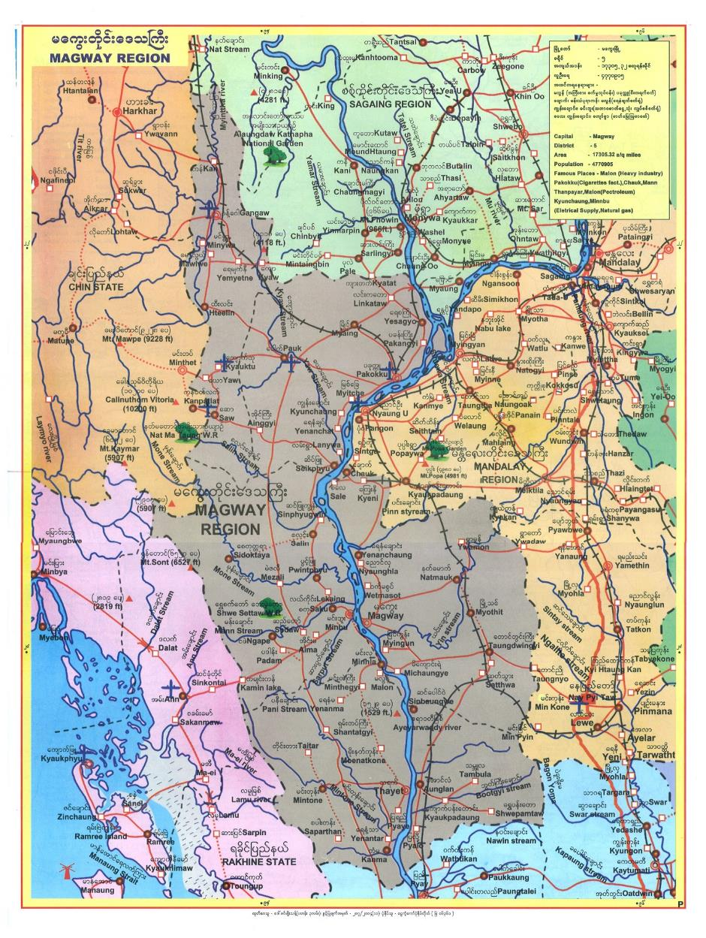

Annex 2: List of available data:

|  |  |  |  |  |  |
| --- | --- | --- | --- | --- | --- |
| Data | Source | Level |  | Language | Date |
| Number of destroyed latrines and water points  Number of HHs / People affected  Number of water disinfected | DoH | Township  Rural Health center | Pwintbyu | Myanmar | 16 August 2015 |
| Total number of schools and affected / damaged schools  Number of students | MOE | Township | Pwintbyu  Sidoktaya |  | 19 August 2015 |
| Damaged building schools and facilities (including latrines) and their estimated cost | MOE | Township | Pwintbyu  Sidoktaya |  | 19 August 2015 |
| Estimated cost of cleaning of schools and facilities (including latrines) | MOE | Township | Pwintbyu  Sidoktaya |  | 19 August 2015 |
| Name of severely affected villages and their population | DOH | Township | Sidoktaya  Pwintbyu |  |  |
| Name of schools and student population | MOE | Township | Pwintbyu  Sidoktaya |  |  |

Annex 3 (following pages): pictures

|  |  |
| --- | --- |
| C:\Didier\WASH Emergency\Aout 2015\Flooding\Pics\Pic FRom Save\IMG_6306.JPG | C:\Didier\WASH Emergency\Aout 2015\Flooding\Pics\P8190112.JPG |
| Temporary schools following flooding (above) and severely affected schools (below) | |

|  |  |
| --- | --- |
| C:\Didier\WASH Emergency\Aout 2015\Flooding\Pics\P8190061.JPG | C:\Didier\WASH Emergency\Aout 2015\Flooding\Pics\P8190062.JPG |
| C:\Didier\WASH Emergency\Aout 2015\Flooding\Pics\P8190067.JPG | C:\Didier\WASH Emergency\Aout 2015\Flooding\Pics\P8190068.JPG |
| Damaged latrines in a severely affected school | |

|  |  |
| --- | --- |
| C:\Didier\WASH Emergency\Aout 2015\Flooding\Pics\P8190128.JPG | C:\Didier\WASH Emergency\Aout 2015\Flooding\Pics\P8190123.JPG |
| Example of severely affected village | |
| C:\Didier\WASH Emergency\Aout 2015\Flooding\Pics\P8190130.JPG | C:\Didier\WASH Emergency\Aout 2015\Flooding\Pics\P8190124.JPG |

1. The principal product of Magway Region is [petroleum](https://en.wikipedia.org/wiki/Petroleum). It produces most of the oil and [natural gas](https://en.wikipedia.org/wiki/Natural_gas) in Burma.  Magway Region produces also a large quantity of [edible oil](https://en.wikipedia.org/wiki/Edible_oil) as well as petroleum, hence gaining a reputation as the "oil pot of Myanmar". Agriculture is also important. The major crops are sesame and [groundnut](https://en.wikipedia.org/wiki/Peanut). Magway has almost no tourist industry. *“Wikipedia source”* [↑](#footnote-ref-1)
2. *“Myanmar: A country prone to a range of natural disasters – OCHA – August 2013”* [↑](#footnote-ref-2)
3. (Source: DRD). [↑](#footnote-ref-3)
4. (Source: DRD). [↑](#footnote-ref-4)
5. (Source: DRD). [↑](#footnote-ref-5)