Chin state
July / august 2015 Landslide
Situation report 25th August

Produced by: WASH cluster
Organization: UNICEF
Location: Chin – Hakha
Month: August 2015
Resources: http://www.themimu.info/emergencies/wash-cluster

Background

- The all 9 townships of Chin state have been affected by landslide. 4 townships from Mindut district in Southern Chin state and 5 township from Hakha and Phalam district in Northern Chin state.
- Totally, 5 people died. Some Cows and Buffalos also died and missed. 55 schools, 28 religious buildings, 38 others buildings, 2 small dam, 303 bridges and 6039 acres of farming lands have been damaged around Chin state.
- Chin state Government shared as 3558 HH, 17585 people have been affected by landslid
- Heavy rain occurred continuously nearly 3 weeks in Chin state and the whole Myanmar since beginning of end of July to beginning of August 2015. A water was saturated at the upper part of Chin Mountain and it allowed easily to occur landslide at every part of Chin state.
- Most of townships in Chin state were located on the top of mountains. A landslide was damaged most of the main road of Chin state, villages and downtown area.

- According to landslide occurring, there have 3 kinds of affected people in chin as below;
- People who have their land situated at landslide prone area and need to resettle them to a new place. Currently, those are living in emergency relief camps.
- People who have their land affected partially by landslide and they need to move another place near their original villages.
- People who have blocking in their original villages due to main road access damaged by landslide. Some can access by motorbike, some can access by walking only. Hard to collect the actual affected for these people and need to find a way for more information.
- Currently, very limited information of No. 2 and 3 people as to know exactly what happened in their villages because of road access still blocking at some part of Chin state.
- If heavy rain coming again the potential landslide risk has still occur in several part of Chin state.
- Landslide was happened regularly in Chin state but this time affected was very huge. Local old aged people said, normally 20 year per 1 time the landslide was occurred but this time affected he didn’t saw in the past.

Scope of damages
Urban areas

Currently, there have 10 temporary emergency relief camps in Hakha and Diddim. State Government forming the emergency rescue committee and assigned the members of it at each relief camps. Relief and resettlement department (RRD), Department of Rural Department (DRD), Department of Health (DoH), state Cultural Department, Immigration Department and MRCS have involved in that rescue committee. Health Department set up temporary heath centre services at each camps.
Water
No | Township | Total no. of camps | HH | PP | # of GFS need to maintenance | # of GFS need | remark
1 | Hakha | 8 | 1108 | 5150 | 5 | 1 | People from 2 camps will be relocate again to a new temporary place, some are living as a host
2 | Diddim | 2 | 79 | 429 |  | 1

GFS is the main water source for water supply in 10 emergency relief camps but most are using only for domestic. All GFS have need to upgrade to collect drinking water purpose and to sufficient for all people.
5 out of 8 GFS from Hakha have need to maintenance as pipe line extension, intake and water storage tank construction, tap stands. 1 is need to construct as a new because of it water source was catching from a small stream, it was depend on raining if rain stops GFS couldn’t catch up.
Diddim local authorities will be relocated the existing 2 camps soon. New GFS construction have gap in that new relocation site.
Local CSO named Chin Youth Organization has distributing drinking water on daily in some camps and 1 time per 2 day in some. World Vision-Diddim has also distributed drinking water in 2 camps at Diddim.
Sanitation

Latrine
NO | Township | # of camps | HH | PP | # of existing latrines | # of latrines need to upgrade | # of new latrines need due to theoretically | Remark
1 | Hakha | 8 | 1108 | 5150 | 83 | 58 | 257 | Needs of new latrine may be less because of some are living as a host
2 | Diddim | 2 | 79 | 429 | 14 | - | 79 | New latrine construction need according to these people will relocate to new place
UNICEF supported through with state Health department (SHD) in emergency latrines construction at all camps. The emergencies latrines were not accessible easily for children, disable and old aged people. Because of most of latrines constructed at the slope of a mountain. The road was slipping when there raining.
58 out of 83 was as the emergency latrines and those are need to upgrade as fly proof latrines and roads access to latrines were also need to maintained in Hakha.
Theoretically, 257 new latrines are needed in Hakha camps but some are living as host families. It may be less to construct in Hakha. Currently, total no. of who living as a host family information didn’t registered yet in camps level.
Diddim local authorities will relocate the affected people to a new place soon as a village. New latrine needs might be house hold construction.
Open defecation was found around the latrines and it was done by children shared by camp in charge at Hakha camps.
Health department used a lime for bad smelling.
Bathing & Hand washing space
Now, there have no gender separated bathing places and People were took bathing at water storage tank, go to the surrounding houses and streams.
Hand washing practice wasn’t seen in all camps.
Hygiene Awareness and Hygiene kit
Due to no WASH agencies in Hakha, there haven’t hygiene promotion sessions in all camps since camp opening. People living in a hall type without privacy therefore their living condition wasn’t hygienic.
MRCS shared 60 hygiene kit were already distributed but they don’t mentioned where it is. SCI have a plan to distribute about 600 hygiene kit and till to now 100 kit have been arrived to Hakah and they will discuss with local CSO for targeting people who have most affected and will be distribute it. Anyway, HK distribution still need for others townships.

Rural areas

The table below provides the number of affected villages and mainly Gravity flow system damaged information in most affected townships of Chin state.

NO | Township | Afftected villages | HH | PP | Remark
1 | Htan Ta Lan | 2 | 121 | 344
2 | Hakha | 1 | 22 | 157
2 | Phalam | 22 | 1561 | 8002
3 | Diddim | 4 | 313 | 1445
4 | Matupi | 2 | 105 | 583
5 | Kanpetlet | 2 | 45 | 307
6 | Paletwa | 9 | 585 | 3604

GI, PVC, HDPE which had used in GFS have been damaged, water storage tanks and some water sources have been eroded in those villages. State DRD estimated renovation and maintenance cost for damaged GFS and sending it information to National Level. There have no exactly plan to implement till to now.
The information of damaged latrines and others WASH facilities of these villages didn’t known exactly yet.

School

The table below provides the number of damaged school latrines in most affected townships of Chin state.

NO | Township | # of latrines damaged by landslide | # of GFS pipe line damaged by landslide | Estimated cost for only latrines (million-MMK) | Remark
1 | Hakha | 18 |  | 9
2 | Phalam | 2 |  | 1
3 | Diddim | 4 | 2 | 2
4 | Tonzang | 8 |  | 4
5 | Mindat | 2 |  | 1
6 | Matupi | 13 |  | 6.5
7 | Kanpetlet | 5 |  | 2.5
8 | Paletwa | 14 |  | 7

DoE shared they couldn’t rebuild those latrines and some private donor (like KBZ bank) came to visit them and consulted to support but it also not sure yet.

Health Centre
There haven’t much damaged WASH facilities among in health centre shared by State Health Department. DoH conducting chlorine treatment in water storage tanks and water points at the existing 8 emergency relief camps in Hakha. Also with cash support of UNICEF they built about 80 latrines in all camps of Hakha.

Response so far
- The Local authorities set up the emergency relief camps in Hakha and Diddim for the landslide affected people in northern part of Chin state.
- DRD take role as camp managing in 1 camp at Hakha.
- DoH implemented chlorine treatment at water sources and latrines construction supported by UNICEF at all camps which situated in Hakha.
- MRCS has distributed WASH NFI for some people.
- SCI has preparing to fill the gap of WASH NFI needs of Northern Chin state. And also constructed 10 latrines at No. 2 camp in Diddim.
- Chin Youth Group from Hakha distributing drinking water at all camps of Hakha.
- World Vision (Diddim) distributed drinking water in 2 camps at Diddim. And also trying to do WASH assessment at remote area of Diddim.
- All agencies involved during conducting MIRA assessment for the whole chin state.
- WASH coordination meeting in Hakha on 19th August, in Phalam on 22nd August and in Diddim on 23rd August.

Humanitarian situation

Setting | Situation | Recommended actions | Comments
Emergency relief camps | Water supply have sufficient but if water sources and rain stop there may be water shortage. Existing latrines coverage is enough. Lack of Hygiene awareness sessions, bathing and hand washing facilities. | The existing GFS need to upgrade and may be needed 1 or 2 new GFS construction. Latrines should improve as child and disable friendly. Hygiene awareness sessions are urgent need to do. Bathing and hand washing facilities should install as a standard. | All camps may take long about 6 months. Because of the Gov. couldn’t allocate the land for people till to end of raining season
Affected villages (with no exactly information | The information of villages which affected by landslide doesn’t have accurate, total no. of affected villages can get from state Gov. but not easy to apply for WASH intervention activities. Depend of raining it information has continually changed | To follow up with local CSOs, LNGO to do WASH assessment especially for affected villages. Small scale fund should raise to do WASH assessment for villages.
Schools | School latrines and GFS have been damaged by landslide. | Latrines construction should consider which have been damaged by landslide. 2 GFS need to renovate.
Health centers | Almost of WASH facilities didn’t damaged in Health centre. | RWCT should consider for health centre for more water coverage

Other recommendations
- To prepare WASH intervention planning for 2 new temporary relocation site in Hakha
- Small scale fund might be needed to do WASH assessment in affected villages
- To consider Ceramic water distribution because of water sources were turbid in raining season
- Hygiene awareness sessions are urgent needed in all camps
- To consider RWCT around in Chin state because of people have used rain water, it was functioned in some place and raining season was long about 5 months (June-October)
- To consider also for solid waste management
- Standard shelter should provide if the existing camps extend to 6 month
Challenges;
- No WASH experience agency in Hakha
- Most of GFS water source have potential land slide risk
- Open defecation problem in almost of the camps
- Due to hardly road access material cost may be higher than the others area
- Hard wood, Bamboo are very hard to buy in Hakha
- Potential Landslide risk occur beside on the main road from Kalay to Hakha
- All of restaurants, shops have closed at every Sunday.
- Most of villages have hard to access
- Protection and others social support have gaps

Summary,
The Chin state government has finding a new land where Geologist recommended to relocate the most affected people in Chin. 1/3 of Hakha town has landslide risk. State Government has to address the urgent need of affected people. Local CSOs, NGOs and private donors have also try to support the gaps.

As WASH sector is concerned, priority should be given to:
- Need to visit to the villages where didn’t get yet information especially situating at hard to reach area
- Small scale fund might be needed to do WASH assessment in remote area
- To improve water quality in temporary camps
- Hygiene promotion activities
- Complement and Support Government authorities for the new relocate places
- Others water supply system such as RWCT should consider for water coverage
- People living condition in existing camps with no privacy, others social impacts might be affected
- Do No Harm approach should use while implement WASH intervention in villages relocation place

Annex 1: Map of Chin State
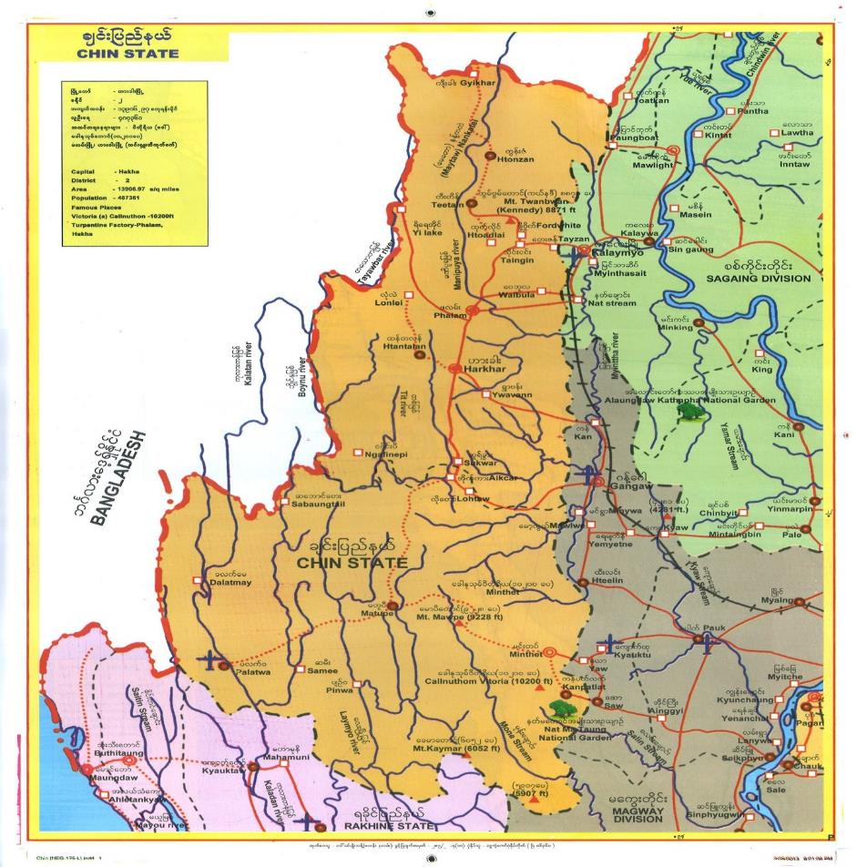

Annex 2: List of available data:

Data | Source | Level |  | Language
Number of destroyed latrines in Schools | DoE | State Department of Education | Hakha | Myanmar
# of affected HH and GFS damaged | DRD | State Department of Rural Developemnt | Hakha
# of affected HH, PP, # of school, building, farming damaged | GAD | State GAD | Hakha

Annex 3 (following pages): pictures
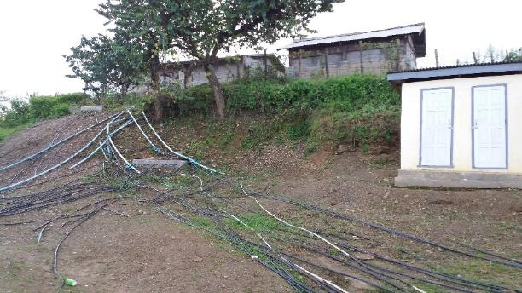 | 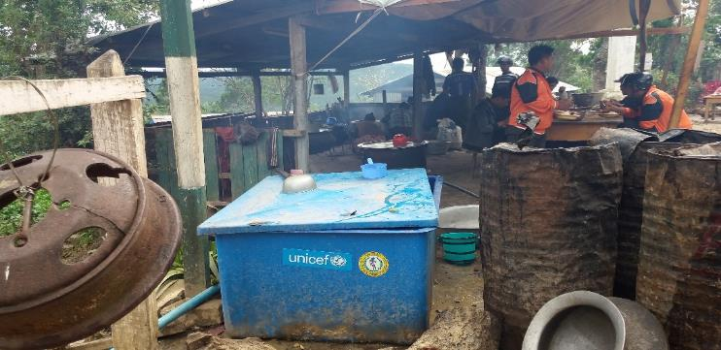
Pipe line and water storage tank are using in existing camps for water supply

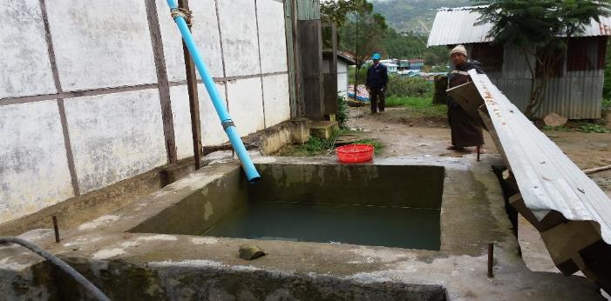 | 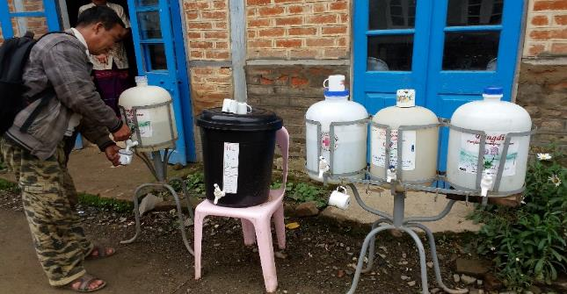
Rain water is using where not enough with township municipal pipe line | Drinking water distributing by Local CSO

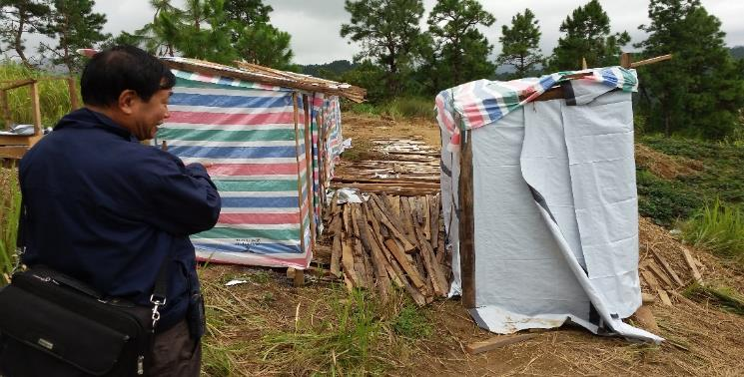 | 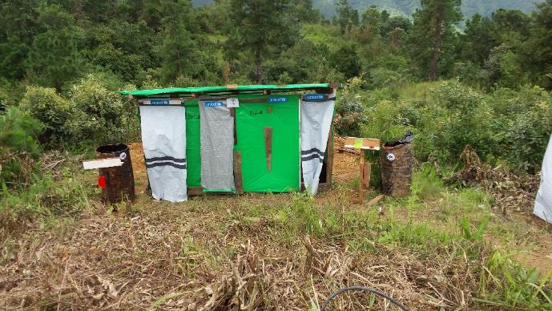
Emergency Latrines constructed by state health department with UNICEF fund support
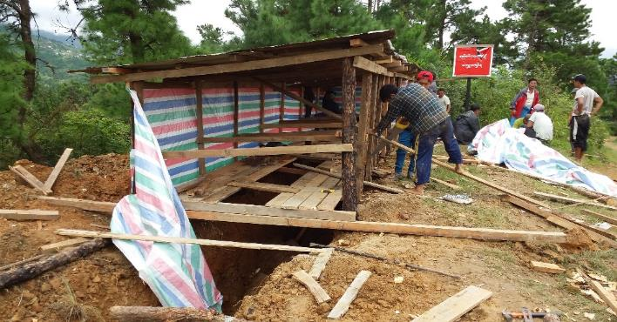 | 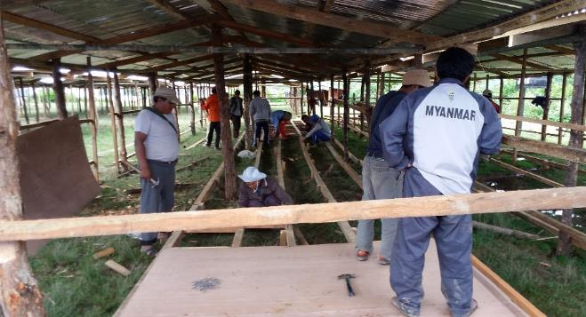
Local community constructing shelter and emergency latrines by themselves in new temporary place (for 300 HH)

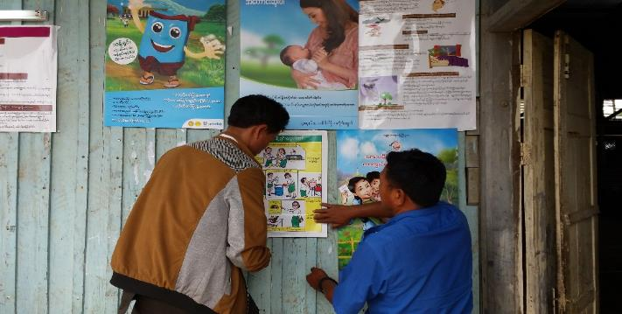 | 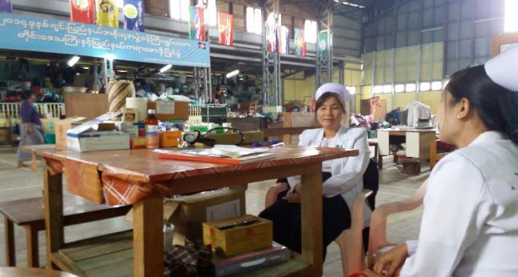
Awareness Poster walling in relief camps | 24 hours Health care service in relief camp
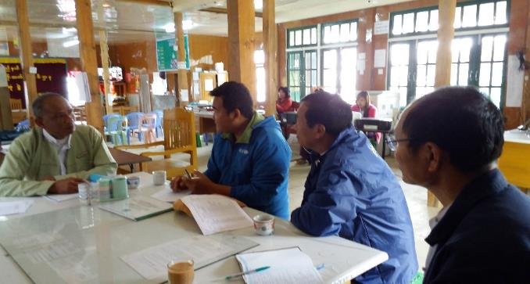 | 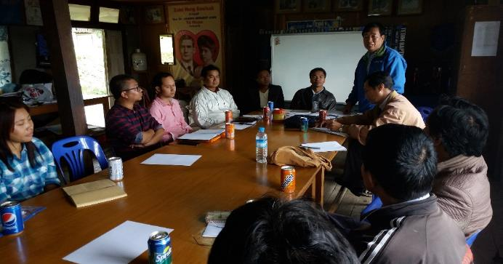
Meeting with Department of Rural Development (DRD) | WASH Coordination meeting with Local CSOs, LNGO and INGO staffs

(Source: DRD).
(Source: DoE).

