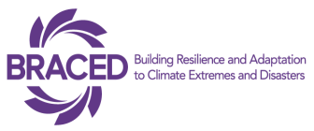
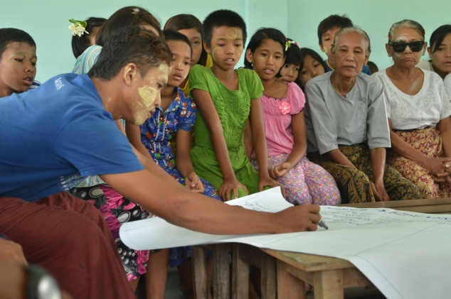
Using evidence in community decision making for resilience building
Leik Tin Village of Kyauk Phyu Township is situated in southern Rakhine, along the Bay of Bengal on the East coast of Myanmar. As with much of Myanmar, the village receives 95% of its annual rainfall from the South West Monsoon period between May and September.
Leik Tin community members developing a hazard timeline
Farmers in the village are reliant on this rainfall to grow rice during the monsoon season. However, members of the Village Disaster Management Committee (VDMC) – a community based organization - explained to Plan and the Community Development Association field teams how higher intensity rains combined with high tides and coastal flooding have been threatening their paddy crops in recent years, bringing saline water into their fields.
Further to this, the community has been experiencing warmer and drier hot seasons affecting the availability of drinking water in the village ponds.
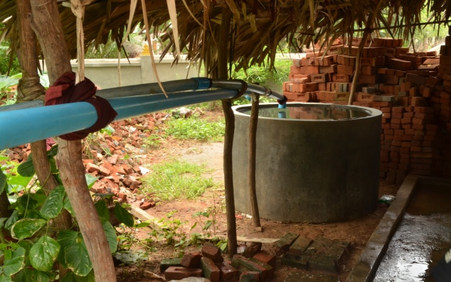
Another village, Sue Yit Tan in the central dry zone of central Myanmar in Meiktila Township has also been facing different challenges resulting from increasingly unpredictable rainfall and water scarcity. In addition, the village have also suffered with high salinity of many of the newly dug water wells; as a result, the community is finding it increasingly difficult to access sufficient drinking water and water for irrigation during the dry months.
The Plan International led BRACED Myanmar Alliance with Action Aid, World Vision, Myanmar Environment Institute, BBC Media Action and UN Habitat has developed a Community Resilience Assessment and Action Handbook and is currently piloting it in communities across different climatic zones of Myanmar. Alliance partners have been testing the use of tools and data collection techniques in these communities.
Rain water collection being used to supplement saline water wells in Sue Yit Tan village

The Resilience Assessment identifies the underlying drivers of vulnerability in communities and specifies what climate extremes and disasters ( i.e rapid and/or slow onset) the community is exposed to and how different people (men, women, boys and girls) are affected by understanding the different sensitivities within the community. The tool identifies both disaster and climate related sensitivities as well as highlighting the wider shocks and stresses the community are vulnerable to. In addition the tool also helps assess capacities within communities identifying existing strengths that can be built upon. This data is then used to identify and prioritise actions for strengthening resilience to disasters and climate change.
The piloting work in Leik Thin and Sue Yit Tan has highlighted the need for better access to climate and weather information with which to ensure evidence based community decision making for resilience. Improving communities’ access to accurate climate and weather information will help them plan their seasonal planting, diversify their livelihoods options, and better prepare for disasters such as flooding by protecting their assets on time..
Understanding the importance of using evidence based climate information, the BRACED Myanmar Alliance has partnered with the Regional Integrated Multi Hazard Early Warning Systems (RIMES) and the Myanmar Department of Meteorology and Hydrology (DMH) to review historical data from weather stations to assess the return periods of extreme events and develop weather and climate profiles for the BRACED target townships. RIMES and DMH facilitated a training for BRACED field staff on how to integrate climate and weather information into community resilience assessments.
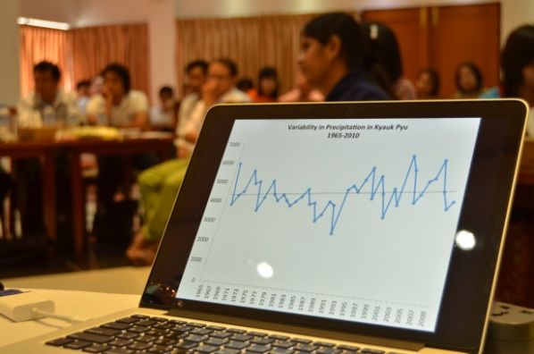
Climate and weather information is key to developing scenarios for communities with which to make decisions on key community resources, livelihoods and plans. By comparing community perceptions information and validating this against historical trends and weather/climate forecasts, BRACED Myanmar Alliance partner will support communities to develop evidence based resilience action plans to address climate extreme events.
The BRACED Myanmar Alliance recognizes the challenge of accessing future climate projections and scenarios and the skills required to be able to interpret this information for decision making. The Alliance has developed the Community Resilience Assessment and Action Handbook, which has been translated into Myanmar language to help guide communities and field staff on how to collect and analyse resilience information. The manual provides easy to use templates and guidance on how to use different tools and techniques to understand hazards, vulnerabilities and capacities with which to design resilience actions. The handbook follows the steps highlighted in figure 1.
BRACED Myanmar team being trained by Department of Meteorology and Hydrology and RIMES on how to use weather and climate information for decision making

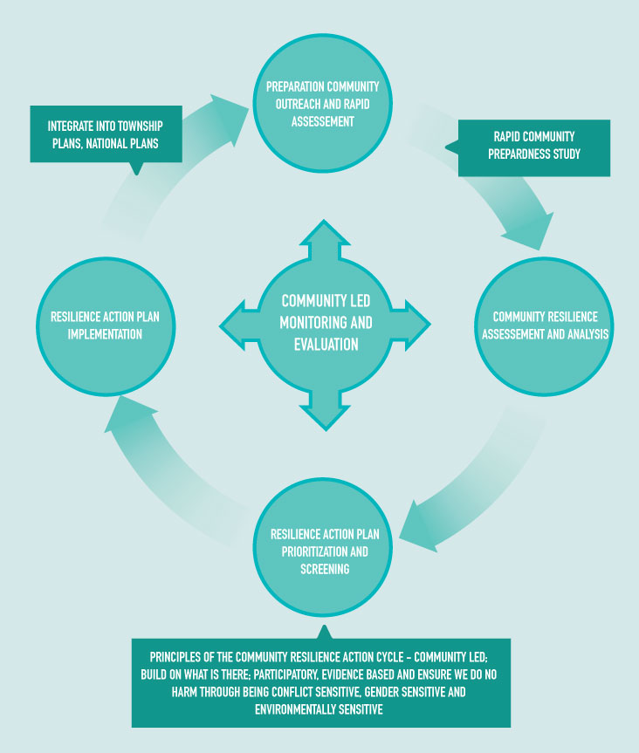
The handbook emphasises the use of secondary and scientific data to validate community information and develop scenarios to support community decision making.
As a result of the resilience assessment, BRACED Alliance target communities have started identifying key resilience measures including support for construction of rowing boats in Mawlamyine Township in the southern coastal area that has been hit by recent severe flooding across Myanmar. Access to boats can save lives during floods and improve access to water and food for communities during these events.
The assessment will now be rolled out across 8 townships of Myanmar and various resilience strengthening activities implemented across the 155 BRACED villages.
Figure 1: BRACED Community Resilience Action Cycle

