RAKHINE WASH Cluster

Acute Watery Diarrhea (AWD)

Preparedness and Response Plan - March 2015

Objective of the AWD Preparedness and Response Plan
The purpose of the AWD response plan is to establish a minimum service provision based on specific mechanism for AWD outbreaks risk in order to prevent from outbreak and control the extent and spread of the outbreaks.
The overall Wash cluster position is first at all to have a reactive preventive response when increase of usual diarrhea trend are observed, rather than waiting for the health cluster declaration of an outbreak, and looking at the potential sources of contamination.
The document details the activities to implement by every agency, in every locations. Protocols, guidelines and materials to ensure the response are provided in appendix.
Agencies may go above and beyond the minimum level of service detailed here, but should not provide less.
The document has been elaborated in consultation with Health and nutrition sectors. However keep focus on the Wash cluster mandate and expertise, taking in consideration cross cutting issue.
The plan is developed based on empirical knowledge of the situation, based on past 2 years of assistance to the population, while it suffer of lack of evidence based analysis related to absence of proper surveillance system and global trend analysis for which the Wash cluster to do not assume responsibility.
The scope of the document is related to the HRP target, with specific concern on camp setting, environment prone to water born disease due to the living condition, density of population, access to services… where the risk is defined high. However the Wash cluster population target being 50% in villages, all recommendation are also applicable in that environment. Furthermore, even if the preventive approach won’t be applicable in same extend, non-targeted HRP area are concern by the plan in case of outbreak.

Contents
1 Objective of the AWD Preparedness and Response Plan 1
3 Communication flow 3
4 Preparedness and Response Plan 3
4.1 Targets 3
4.2 Timeframe 4
4.3 Total numbers and WASH focal point 4
4.4 Preparedness 4
4.5 Response 5
Appendix 1 What is Acute Watery Diarrhea? 7
Appendix 2 WASH AWD hygiene kit 8
Appendix 3 Available Chlorine products usages and chlorine concentration required levels 9
Appendix 4 How to chlorinate water for drinking with HTH 10
Appendix 5 Specific design for latrines in flooded areas 12
Appendix 6 Key Hygiene Promotion Messages for AWD 14
Appendix 7 Report form 16
Appendix 8 IEC materials available 17
Appendix 9 Training Toolkit for HP and CHW 18
Appendix 10 Water, Hygiene and Sanitation in CTC/CTU 20
Appendix 11 Nutrition Recommendations for cholera children 25

Communication flow
Past year experiences demonstrate the importance of clear communication pipe definition, and respect in order to avoid:
- Hysterical situation on non-verified situation
- Avoiding tension between sectors
- Avoiding confusion between intervenient
- Avoiding miss communication with Health authorities
- Avoiding emergency response every second day based on dramatization
Communication principle:
- The Wash focal agency in place remain in charge of the situation and is the key informant for the wash cluster
- If staff of the Wash cluster focal agency observed abnormal situation, or it the team analysis a risk, the Wash focal agency inform the Wash cluster coordinator, who will liaise with the health cluster
- The wash focal agency is in charge to coordinate and cross check information with the Health focal agency in the location (and share analysis to the wash cluster)
- If the Health cluster is inform about ta situation, it should inform immediately the Wash cluster, who will liaise with the Wash focal agency
- Wash cluster take the responsibility with the health cluster to call for specific coordination meeting, and organize join assessment with the concern field actors
- The health cluster is in charge to declare an outbreak, but communication on usual situation should be shared with Wash cluster to allow preventive measure
- Health cluster is in charge to produce regular analysis and trend of Diarrhea
- CCCM/Camp management should be included in the process of information sharing and included in response mechanism
- Transparency toward concern authorities should be concretize through sharing information process: Direction of Heath, DRD

Preparedness and Response Plan

The single most important principle for preventing AWD transmission: Keep faecal matter away from water and food and kill AWD bacteria that has contaminated food or water prior to consumption.
The overall response objective is to control the extent of the outbreak and prevent the spread of AWD.

Targets
100% of the population in high and medium risk areas with the minimum interventions are covered.
For detail risk areas assessment, please refer to “High AWD risk areas and key dates of AWD” from SHD/Health Cluster. According to SHD/Health Cluster, all camps in Rakhine state are to be considered high risk areas in terms of AWD outbreaks. No risk assessment for villages had been done by SHD/Health Cluster.
However, the WASH Cluster recommends considering the risks level in the following table.

RISK LEVEL | PLACE
High | All IDP camps, Town, Markets, Public places: religious sites, schools, ...  CTC/CTU, health centers, …
Medium | Villages

Table 1 – Medium and high risk areas for AWD

Timeframe
Preparedness and coordination must be considered as a continuous action along the year, aiming at establishing the necessary mechanisms for response and continuous monitoring and reporting of the situation.
From a confirmation of increasing trend of Diarrhea:
- Specific action during minimum a week, ending when trend decrease observed
- During 2 week in case of flooding during the raining season
From the confirmation of outbreak or upon request by Health partners or by Health authorities:
- In high risk areas until the end of the rainy season
- In Medium risk areas: three weeks after the last confirmed case within the township

Total numbers and WASH focal point
Populations at risk of AWD:
- 143 167 people in IDP camps
- XXX people in Villages close to IDP camps (no assessment is available)

Preparedness
Preparedness and coordination must be considered as a continuous action along the year, aiming at establishing the necessary mechanisms for response and continuous monitoring and reporting of the situation.

INDICATORS | ACTIVITIES | FURTHER INFORMATION
Identified WASH Focal point agencies per location is available  # of reports of diarrhoea suspected cases  # and location of chlorine and AWD hygiene kits available and compared to target population  # of staff/volunteers/workers trained on AWD and capable of undertaking response actions  # of trained religious or community leaders on how to keep people safe in gatherings  # of trained food vendors on environmental health and food safety  # of drug vendors on recognizing signs of AWD, ORS usage (homemade or from market) and orienting patients to health assistance | Monitor and report any suspected diarrhoea case to Health Cluster  Preposition chlorine, and aquatab and WASH AWD hygiene kit and other contingency stock (not AWD specific) (ORS stock is under health responsibility)  Specific AWD IEC materials are designed, approved by SHD and printed in sufficient numbers  Train on appropriate procedures for disinfecting areas and materials soiled with faeces and vomit, communication techniques and the use of IEC materials.  Training should include information on case identification/case finding and referral.  Appropriate number should be one community mobilizers per 500 households. Target gender balance for community mobilizers is 40% female  Train religious and community leaders, community health workers on how to keep people safe at gatherings (safe food and personal hygiene practices, with special emphasis on safe handling of dead bodies.  Train food providers on environmental health and food safety.  Train drug vendors and traditional healers on recognizing signs of AWD, ORS usage (homemade or from market) and orienting patients to health assistance  Share available AWD material –such as HP material, and short guides for schools, feeding centers, child friendly spaces | What is AWD? In Appendix 1  AWD hygiene kit content in Appendix 2  Available Chlorine products in Appendix 3  Key hygiene promotion messages in Appendix 6  Report form in Appendix 7  Training Toolkit for HP and CHW in Appendix 9

Response
The response aims at controlling an increasing trend of diarrhea cases and in worth cases the extent of the outbreak and prevent the spread of AWD.
In case of unusual increase of Diarrhea rates, the main measures requested are:
- Ensure access to treated water to all population, preferably chlorinated water, or treated with reagent (e.g: Aquateb/PURE)
- Re-enforcement of H.E messages, including nutrition messages
- Systematize Water quality testing at all water point
- Track closely with health actors the diarrhea cases, and share trend vision
- Secure necessary sanitation facilities
Those measure are applicable and recommended in case of flooding, before any trend analysis of diarrhea, in a preventive approach.

Objective 1 - People access and use safe water supply for all purposes but specially for drinking and cooking
% of people having access to chlorinated water for drinking and other purposes.
ACTIVITIES | FURTHER INFORMATION
Distribute supplies for household water treatment including water containers and Aquatabs/PUR to all households in the affected area, as immediate action, until :  Either, Undertake bucket chlorination at all water points (boreholes, wells)  Or, In areas where water supply systems are not available, provide safe drinking water through water trucking or centralised treatment and distribution.  Monitor water quality at water distribution points and household level  Identifying potential sources of contamination | AWD hygiene kit content in Appendix 2  Available chlorine products and required of chlorine levels in Appendix 3  Chlorination of drinking water in Appendix 4
Objective 2 - Risk of AWD transmission through excreta (faeces and vomit) is reduced by appropriate disposal
% of people having access to appropriate sanitation facilities for excreta disposal [including disposal of children’s and babies faeces]
ACTIVITIES | FURTHER INFORMATION
Built emergency latrines and hand washing facilities if coverage is not enough, including in public places  Spray chlorinated solution daily in public latrines, public places (markets, schools, gathering points as religious sites).  Spray chlorinated solution in CTC/CTU and health centres receiving AWD patients. | Latrines design in Appendix 8  Available chlorine products and required of chlorine levels in Appendix 3
Objective 3 – Risk of AWD transmission is reduced through hygiene practices
% of people receiving AWD related hygiene promotion
ACTIVITIES | FURTHER INFORMATION
Distribute supplies for households in the affected area including body and laundry soap for at least one month  Disseminate AWD preventive and response messages through various communication channels (mass media, interpersonal communication, through schools, etc.).  Undertake communication and community mobilization activities to promote hand washing with soap and exclusive usage of chlorinated water for drinking, stop open defecation.  Undertake communication and community mobilization activities to promote proper hygiene measures in gatherings.  Provide and maintain hand washing stations (ensuring soap is always available) as a complement of communal/public sanitation facilities (at markets, schools, and other institutions) and next to food preparation and serving / eating areas.  Support activities on solid waste management, collection and disposal, with particular attention to markets and other public spaces | What is AWD in Appendix 1  Minimum hygiene kit content in Appendix 2  Key hygiene promotion messages in Appendix 6
Infants are given safe fluids and food :  Provide health and hygiene education messages into all interventions at the community and facility level on how to ensure safe infant and young child feeding  Reinforce awareness of breast feeding through counselling | What is AWD in Appendix 5  Key hygiene promotion messages in Appendix 6  Rakhine nutrition sector AWD guidance note in Appendix 8
- What is Acute Watery Diarrhea?

AWD information for the public
  - What is AWD?
It is a human disease, starting with a sudden onset of numerous watery stools, often combined with vomiting. It leads to dehydration and death if not treated quickly.
  - What do you have to know about AWD?
It’s a very contagious disease, but can be treated easily and quickly.
Of those who develop the disease, 80% will have illness with diarrhea, which can be treated with ORS.
Of the people who develop typical AWD normally less than 20% will suffer from dehydration. These cases should be taken to a health facility. EARLY TREATMENT IS ESSENTIAL.
  - When do you suspect AWD?
As soon as you have watery diarrhea or watery stools.
  - How can you get AWD?
- By drinking water from unsafe sources – rivers, open wells, water pans - that have not been chlorinated.
- By drinking water that has become contaminated because of the way, it was transported or stored.
- By eating food contaminated during or after preparation.
- By eating fruits that have not been peeled and washed.
  - How is AWD transmitted?
The main mode of transmission is through contaminated food or drinking water. Faeces and vomit are infectious. AWD can be transmitted from person to person in areas of dense populations and poor sanitation and hygiene, such as poor urban areas and IDP camps (5F diagram). Persons with asymptomatic infections play an important role in the transmission of the infection.
  - What to do in case of suspected AWD?
- Give the person extra fluids preferably ORS
- Take the patient immediately to a health center
AWD information – more technical
  - What is AWD?
AWD is one type of diarrheal disease caused by infection of the intestine with the bacterium Vibrio cholerae present in faecally contaminated water or food. AWD is primarily linked to consumption of contaminated water or food.
Both children and adults can get infected. Patients develop very severe watery diarrhea and vomiting from 6 hours to 5 days after exposure to the bacterium. In these cases, the loss of large amounts of fluids can rapidly lead to severe dehydration. In the absence of adequate treatment, death can occur within hours. People with low immunity – such as malnourished children or people living with HIV – are at a greater risk of death if infected.
There are three clinical types of diarrhea caused by a number of different organisms:
- acute watery diarrhea – lasts several hours or days, and includes AWD;
- acute bloody diarrhea – also called dysentery; and
- chronic diarrhea – lasts longer than a month
Surveillance systems should be able to rapidly detect an increase in reported cases of acute watery diarrhea. Such an increase should trigger efforts to determine the source of transmission and ensure implementation of control measures in the affected area.
  - Potential locations for outbreaks include:
- Locations of previous outbreaks (hot spots)
- Area where sanitation facilities are located within 20 m of water sources
- An environment with availability of water and poor food handling practices
- Inadequate sanitation
- A population living in crowded conditions
- Where people use drinking water of poor quality
- High poverty and malnutrition
- Coastal areas, areas around water bodies and around transport links.

- WASH AWD hygiene kit
The WASH AWD hygiene will be distributed to affected households
This kit will cover the needs of consumables for one month:
Items | Standards | Use | Quantity per kit | Pckg | Unit price (MMK) * | Total (MMK) | Total (USD)
Jerrycan (4 gallon) plastic | 1 piece / kit | For water storage, with lid and tap. It must be washable inside | 1 | pieces | 2350 | 2350 | 2,35
Water bucket ( 4 gallon) | 1 piece / kit | For water transport | 1 | pieces | 1950 | 1950 | 1,95
Soap, body | 250g / person / month |  | 12 | pieces of 125g | 315 | 3780 | 3,78
Soap, laundry | 200g / person / month |  | 5 | pieces of 250g | 162 | 810 | 0,81
Aquatabs | Equivalent to treat 20 litres / day / household | Treatment of drinking water | 31 | tablets | 100 | 3100 | 3,10
ORS sachet + Zinc compliment |  | Rehydration until reaching medical services | 2 | sachets | 500 | 1000 | 1,00
TOTAL COST PER KIT* |  |  |  |  |  | 12990 | 12,99

- Available Chlorine products usages and chlorine concentration required levels
From ACF Haiti 2011 based on Sphere 201 and MSF 2004

Usages | Vomit, excreta, corpses, shoes | Floors, latrines, waste,… | House, bedcloth, car seats, cloths, … | Hands, skin, dishes | Fruits and vegetables washing, Drinking
Chlorine concentration | 2% | 0,5% | 0,2% | 0,05% | 0,5 mg/l
Stability | Solution is stable one week | Solution is stable 24h | Solution is stable 24h | Solution is stable 24h
HTH 70% for a 20 liters bucket | 600 gr = 40 tablespoons | 150 gr = 10 tablespoons | 60 gr = 4 tablespoons | 15 gr = 1 tablespoon | Do not use directly for drinking water
Aquatab 67mg |  |  |  |  | 2 tablets
Alternatives to investigate :
- Bleach powder - can be found in Rakhine and a few people uses it for cleaning. No tests have been done yet.
- Domestic chlorine can be found in Sittwe, thai supplier. No tests have been done yet
- How to chlorinate water for drinking with HTH
The first step in the chlorination process is to make a stock solution. To make a stock solution you need to use 1 level tablespoon to every liter of water. The stock solution is what you will use to chlorinate water. Do not keep the stock solution for more than 1 week. Do not store chlorine or stock solutions in metal containers, or in direct sunlight.
How much stock solution is required?
When you add chlorine to water, the chlorine starts to kill off bacteria. If the water is clean, no chlorine is used. If the water is very contaminated all of the chlorine may be used up, and there still may be more bacteria left, because the amount of chlorine used was insufficient. When chlorinating drinking water it is important to know how much chlorine is needed to kill all the bacteria, because we want to leave extra to protect the water from further contamination. This extra is called the Free Residual Chlorine (FRC), and in cholera outbreaks, we want this to be 0.5mg/l – that is 0.5milligrams of chlorine remaining for each litre of water. Residual chlorine levels can be measured with a pool tester/comparator. The method of determining how much chlorine is required is called the jar test.
Jar Test
The main method of determining the chlorine demand of the water is as follows:
      - Prepare a 1% Stock Solution of chlorine (1 level table spoon of HTH in 1 ltr of water)
      - Fill 4 non-metal buckets with 10L each of water to be treated
      - Add an increasing volume of 1% stock solution of chlorine to each bucket using a syringe e.g.
- 1st Bucket: 1ml of 1% Stock solution
- 2nd Bucket: 1.5ml of 1% Stock solution
- 3rd Bucket: 2ml of 1% Stock solution
- 4th Bucket: 2.5ml of 1% Stock solution
      - Stir each bucket for 30seconds to ensure the chlorine solution is properly mixed
- Wait a minimum of 30 minutes contact time – VERY IMPORTANT
- Measure the levels of Free Residual Chlorine in each bucket
- Choose the bucket, which gives approximately 0.5mg/L FRC.
- It may be necessary to repeat the test if the water has high chlorine demand. In this case, you would put 3ml of 1% Stock solution in the first bucket, 3.5ml in the second, 4ml until a FRC of 0.5mg/l is obtained). You may need to repeat this process a third time if necessary
Use this result to calculate the amount of 1% stock solution to add to the water in the individual water containers.
The amount of 1% stock solution to add to each individual water container varies depending on the volume of the container. The amount needs to be adjusted as follows:
Amount of stock solution = Amount of stock solution for 10 liters x Volume of individual container (in liters)
for individual container 10
For example:
If 10 litres water requires 3 ml of 1% Stock solution:
5 litres water requires 3 x 5 / 10 = 1.5 ml
20 litres water requires 3 x 20 / 10 = 6 ml
Always recheck the chlorine demand periodically, especially when the water source is changed or known to vary or when new batch of HTH is used. This will ensure that the FRC level is maintained. Note that the strength of HTH will reduce over time when stored at high temperatures.
Table 2 gives some guidelines for estimating the volume of different types of individual containers.

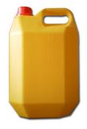 | 5 litre
 | 10 litre
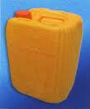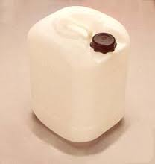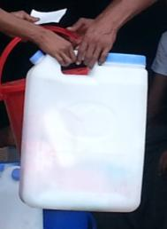  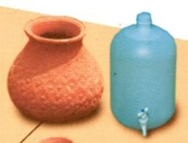 | 20 litre
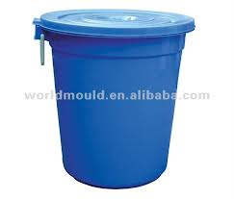 | 30 litres
Table 2 - Approximate volumes of different water containers
- Specific design for latrines in flooded areas
From RAT-assessment 16.03.13- Other designs can be found in the RAT-Assessment document
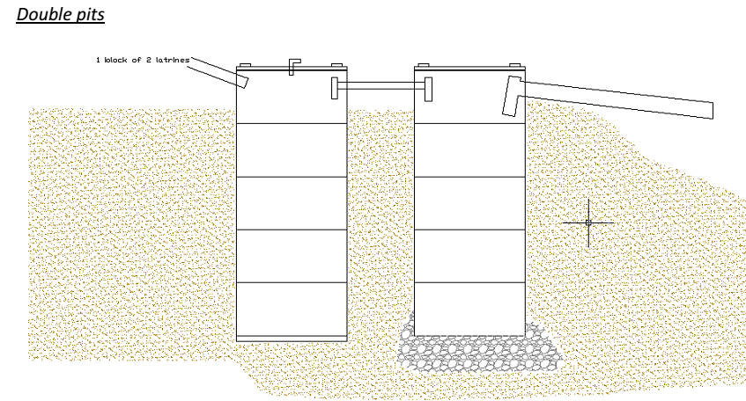
Figure 1 - Concrete rings latrine pits for one block of two latrines. Outlet to soak away, elevated infiltration trench or directly into paddy fields. Concrete covers; pits heads 1-2 ft above ground level as per flooding level
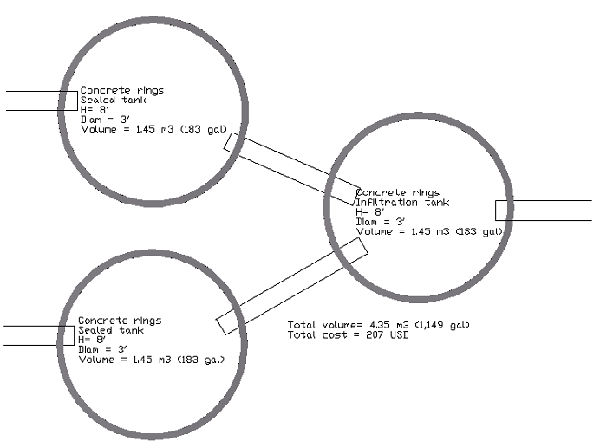
Figure 2- Plan view
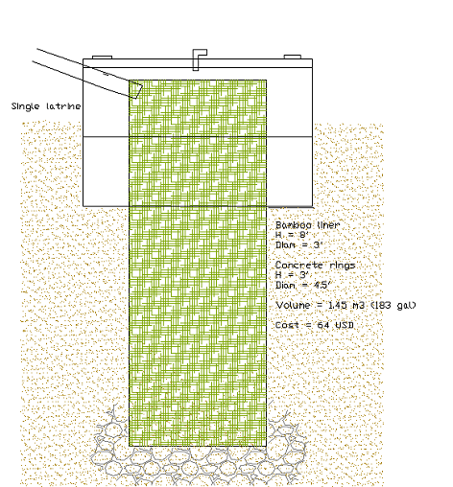
Figure 3 - Infiltration bamboo mat latrine pit. Flood resistant, needs to be decommissioned once full. Pits head 1-2ft above ground level as per flood level
- Key Hygiene Promotion Messages for AWD
OUTPUTS | KEY MESSAGES | KEY ACTIVITIES or BEHAVIOURS
People use a safe water supply for drinking | Only drink safe water | Use only chlorinated water for drinking, making juices and ice  Store treated water safely in a covered container with a tap; to prevent contamination, do not introduce hands or objects into the stored water. If water must be dipped out, use a dedicated clean implement, such as a ladle.
The environment is free from excreta because people dispose of it safely | Dispose of all faeces safely (in a latrine or by burying it) | Always use a latrine or toilet  If you don’t have a latrine, bury all faeces including babies’ and children’s
People wash their hands with soap and water at the critical times | Wash hands with soap and water | Wash your hands with soap and water at the critical times:  - After going to the toilet  - After wiping a child’s bottom  - Before eating  - Before feeding a child  - Before preparing food  - Before handling water  - After looking after a sick person or a dead body  Dry your hands in the air (not using a towel or cloth)
Households, communities, institutions and food outlets practice safe food hygiene | Prepare food safely | Wash hands with soap and water before preparing food  Always serve cooked food whilst it is hot – including food that is reheated  Wash with chlorinated water all fruit and vegetables that are eaten raw before eating; prefer peeled or cooked vegetables.  Cover all food to protect it from flies and other insects  Clean all utensils with treated water and soap; dry and store in a safe place  Provide hand-washing facilities with soap in restaurants and canteens and promote their use  Only sell unpeeled and unsliced fruits or vegetables
Infants are given safe fluids and food | Protect your children by feeding them safely | Exclusively breastfeed babies under 6 months old. AWD is not transmitted in breast milk  Continue breastfeeding older infants as well as providing complementary food prepared hygienically  Wash hands with soap and water before feeding your children
Environmental hygiene is adhered to in markets and other public places | Keep the environment clean in markets and other public places | Don’t throw rubbish into drains  Throw your rubbish in the bins provided  Don’t throw your flying toilets (plastic bags containing faeces) into the public drains – use the special bins provided
Children and adults who have vomiting and diarrhoea are effectively rehydrated | It is critical to stay hydrated. The lost body fluids must be recovered | Prepare ORS using safe water to anyone who has diarrhoea or vomiting, include zinc for 15 years old or younger  If you don’t have ORS, keep giving the person homemade ORS or just plain water (which is not a treatment but will help the person to not dehydrate as quickly)  If you have frequent watery diarrhoea, you may have AWD. Do not panic. AWD can be cured. Go to a doctor or clinic immediately. Drink as much as you can on the way.  For teachers, community leaders : keep in mind that some cases may be asymptomatic, do not decrease efforts in hygiene practices
Households know where to get ORS and how to prepare and use it | ORS can help to prevent dehydration and death | Packets of ORS can be found in most shops, markets, and pharmacies  If you have a sachet of ORS, do the following:  - Wash your hands with soap (or ash) before preparing the mixture  - Put the contents of the ORS packet in a clean covered container. Add one litre of clean water and stir. Too little water could make the diarrhea worse  - Add water only. Do not add ORS to milk, soup, fruit juice or soft drinks. Do not add sugar  - Stir well, and drink it/feed it to the child from a clean cup. Do not use a bottle. Give one glass after each episode of diarrhea  - Store prepared ORS safely and you can use this mixture for up to 24 hours after you have made it. After this any unused mixture must be thrown away  Homemade ORS can be made with 1 litre of treated water, 6 teaspoons of sugar and ½ teaspoon of salt
Households are not ashamed of getting AWD and seek help promptly | AWD is nothing to be ashamed of | Don't be scared or ashamed of AWD. It can be treated easily if you get medical help quickly.
Items contaminated with infected vomit and faeces are safely disinfected | Disinfect areas and materials soiled with vomit and faeces | Disinfect areas of the floor or furniture soiled with vomit or faeces with water and chlorine or with soap and water  Wash clothes and bed linen of people who have had diarrhoea and vomiting in water with added chlorine or boil them and dry them in the sun  Do not wash soiled clothes or bed linen in open water sources or near to improved water sources  If the transport taking a sick person to a health facility becomes soiled, wash it with water and chlorine
Precautions to prevent AWD transmission are taken at funerals and when handling dead bodies | Keep people safe at funerals | If food is provided, the people who prepare the body must not also prepare the food  Everyone at a funeral during a AWD outbreak must wash their hands with soap:  - After going to the latrine  - After touching the body if it is an important custom  - Before eating food or drinking  Hand-washing facilities with soap are provided and everyone is encouraged to use them
Households and institutions are enabled to practice safe hygiene and use ORS effectively | Use the NFIs/supplies as intended | Use the supplies / NFIs provided to improve hygiene. If Aquatabs or other treatment product are included, provide information and ensure population knows how to use it  Use the ORS sachets when someone has diarrhoea and vomiting making it with safe water
- Report form

- IEC materials available

To heavy ion the document to be request at UNICEF Sittwe office.
- Training Toolkit for HP and CHW
Rapid training of HPs and Community Mobilizers, include specific AWD preparedness and response. Agencies that do not have the capacity to undertake training can request support from other approved agencies who are experienced in HP training. Available trainings as part of Emergency HP Training Toolkit are :
Acute Watery Diarrhoea (AWD) Prevention & Preparedness Training for Public Health Promoters
14-15 March 2013 – Rakhine state - Oxfam, SHD, SI, IRC, SCI, ACF, MSF

SESSIONS | RESOURCE PERSON
2. EPIDEMIOLOGY & BACKGROUND  2.1 AWD background information in Rakhine  2.2 AWD epidemiology and its transmission routes  2.2 Risk factors | State Health Department
3. PRE-OUTBREAK PHASE  3.1 AWD preparedness and action plans  3.2 Key components of a good AWD preparedness plan | Oxfam
4. TRANSITION FROM PREPAREDNESS TO FOCUSED INTERVENTION  4.1 Triggers to signal the start of a AWD outbreak  4.2 Initial assessment and investigation of an outbreak  4.3 Making quick sense out of initial data  4.4 Health authorities Protocol | Oxfam  Save the Children  State Health Department
5. INTERVENTION  5.1 Identifying high-risk areas  5.2 Reducing the epidemic spread  Improving water quantity and quality  Sanitation  AWD (AWD)-focused community hygiene education  AWD prevention kits  5.3 WASH in CTCs  5.4 ORT Point in areas far from CTCs  5.5 Burial of the dead  5.6 Activities in market places and other communal gathering places | Unicef  Save the Children/ACF  Oxfam  MSF
6. COMMUNITY ENGAGEMENT  6.1 Getting your message across | Oxfam, Save the Children, ACF
7. MONITORING  7.1 Monitoring programme activities  7.2 Monitoring framework | Oxfam
9. CO-ORDINATION  9.1 National and field co-ordination committees | State Health Department

AWD - Prevention & Preparedness Training for Public Health Engineers
Sittwe 10-11 May 2013 – Oxfam, ACF, Save the Children
- Refresh on AWD
- Water testing: turbidity, bacteriology, residual chlorine, pH
- Water treatment: filtration, chlorination, flocculation, coagulation – at source and household level
- Objective and topics of the 2 day trainings
- Brief on water quality analysis in emergency situations

Hygiene promotion agent training
5 days – Solidarites International
- What is hygiene promotion and hygiene improvement?
- How do you do hygiene promotion?
- Safe practice of personal hygiene
- Community Lead Sanitation for emergency/Community Lead Total Sanitation
- Clean mass campaign and Environmental hygiene
- IEC materials and tools for facilitating participation and accountability

- Water, Hygiene and Sanitation in CTC/CTU
From MSF AWD guidelines 2004
WATER SUPPLY
Water Quantity
- CTC/CTUs – 60 litres/patient/day
- Oral Rehydration Points – 10 litres/patient/day
Water Quality
- Water for consumption in a CTC/CTU should be chlorinated to give a residual of:
  - 0.2-0.5 mg/l where pH < 8 or
  - 0.4-1 mg/l where pH is ≥8
- Water can only be effectively chlorinated if turbidity is < 5 NTU and up to 20 NTU for minimum periods in times of emergency.
Water Storage
In principle, the quantity of water stored in a CTC/CTU should be sufficient for 3 days autonomy.
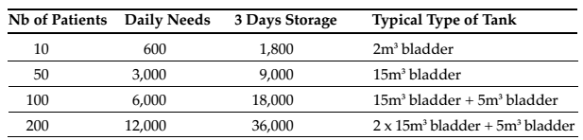
Table 3 – Water quantity
CHLORINE SOLUTIONS FOR DISINFECTION
Quantity of chlorine generating product per patient per day for all needs (including storage/preparedness): approximately 100g of HTH/patient/day.
Preparation and storage of drinking water and disinfections solutions
It is advisable that only one person is in charge of preparing the different solutions per shift. Often 125 litre containers with taps are used in the centres. These should be clearly marked with the solution that it is used for, to avoid accidents. Different coloured containers can also be used to call attention to the different concentrations.
All containers used should be fitted with a lid and tap for hygienic access to the solutions. Additional quantities of all the solutions are stored in the neutral area.
HYGIENE
Movement through the facility
- Fence the CTC/CTU and place a guard at entrance/exit:
- to indicate the centre (physical barrier)
- to show people were they are allowed to enter
- to make sure that not everyone enters the center
- to control that everybody follows hygiene rules
- to avoid that animals have access to the centre
- Patients and caregivers should enter through the patient entrance where their feet/shoes will be disinfected with a 0.2 % solution by a sprayer preferably or footbath
- They will then be asked to wash their hands upon entry at the container provided
- The vehicle bringing the patient should be cleaned and disinfected before leaving the centre with 0.05% solution. Advice should also be given to caregivers on how to clean soiled areas of their houses
- Soiled clothes should then be removed in the shower area and patients (via caregivers) provided with 0.05% solution for this initial bathing, and clean gowns provided. Clothes will then be taken to the laundry area for washing in 0.2 % solution.
- On moving through the different areas, feet should be sprayed or footbaths used
- Hand-washing is provided in all wards, especially for medical staff before, between and after attending to patients.
- Staff and caregivers should enter through the neutral area with the same process of spraying/footbaths and hand-washing.
- Staff and caregivers should change or put on protective clothing
- Staff should consume food in the staff room, washing hands first.
- On leaving the centre, protective clothing should be removed and left in the basket/area provided
- Hand-washing should be performed and feet sprayed on exit from the centre

Sprayer and footbaths
The most important time for spraying of feet is upon entrance and exit from the centre to avoid contamination in and out of the centre. The spraying of all areas is to make staff and visitors aware of the contamination they are potentially bringing into the different areas.
Footbaths are rather inefficient as disinfectants, as they become dirty very quickly. Therefore, spraying is preferred. Footbaths should be trays with material/sponge soaked in 0.2 % solution and changed twice per day or when the material appears dirty. Spraying and footbaths can also be important psychological barriers between the outside and the centre.
It is important to note that after chlorine solution preparation, the calcium deposits at the bottom of the container should not be used, particularly in the sprayers, as this will cause blockages. Sprayers adapted to resist strong concentrations of chlorine should be used.
Bathing areas
- 1 shower room per 50 patients or caregivers /minimum 2 (male/female) in each area of the centre
- Minimum 2 shower rooms (m/f) for staff in neutral area
- Bathing areas should be connected to a grease trap and a soakaway that is contained inside the CTC/CTU
- The patient shower areas should be big enough for a minimum of 2 persons (caregiver and patient). The use of a sprayer may be useful for cleaning patients and initially soaking clothes on arrival. Care must be taken to preserve the dignity of patients during this process.

Hand washing
Located at all latrines, all tents (patient and administrative), kitchen, mortuary, waste area
Concentration: 0.05% chlorine solution
Hand-washing is one of the most effective ways to prevent the transmission of AWD amongst patients, caregivers and staff. Hygiene rules must be set for working in the kitchen (e.g. for washing hands before preparation or handling of food). All drip trays for hand-washing should be emptied into the soakaways or latrines.
Promotion of hygiene in CTC/CTU
Hygiene should be promoted among the staff and caregivers to make them aware of the rules related to hygiene and the dangers of not adhering to them. To ensure this is done, a hygiene promoter should be employed.
- Promotion should concentrate on staff and caregivers in the CTC/CTU, emphasising:
- How to clean the patient/care giver’s home that has been soiled with excreta/vomit
- Hand-washing after dealing with each patient or after handling contaminated items
- Hand-washing after defecation and before handling or eating food
- Changing into protective clothing upon entering the area. On leaving, protective clothing should be removed in the CTC/CTU for washing on site and not taken home
- Only kitchen staff allowed into the kitchen area
- Promotion for patients and caregivers prior to discharge should emphasise:
- Any neighbour/family member should seek early treatment at the centre upon presenting symptoms (as defined in the case definition used)
- Washing hands after defecation and before handling food
- Using the cleanest available water, and hygienic storage of water in the home
- Eating food hot
- Other issues related to transmission in the present AWD epidemic
Protective clothing
Protective clothing should be made available for all staff working in the centre, including boots and overalls that can be easily removed before leaving the centre. Gloves should also be made available for those manipulating blood, chlorine and the chlorinated solutions. Gowns or clothes should be made available for patients on hospitalisation after bathing. Sets of clothing should also be made available for caregivers and visitors to the centre. These should also be kept and washed in the centre.
Food hygiene
Strict rules should be set for those preparing and serving food including:
- Upon entering the kitchen (each time), hand-washing must be carried out
- Food must be stored so that it is only handled by kitchen staff
- Only kitchen staff is allowed inside the kitchen
- Only kitchen staff is to serve food
- Dishes should be rinsed initially in a 0.05% solution then washed by normal methods
- Food provided by relatives (in CTUs) should be handled following the same hygiene criteria.
Laundry
The laundry area should be located in the area producing the most contaminated waste and should wash soiled materials from the entire centre. This will include: blankets, gowns, protective clothing. Where sinks are not available, large plastic tubs will need to be made available.
Materials should be immersed and disinfected first in 0.2 % chlorine solution for 10 minutes, then washed as usual and hung to dry.
Cleaning the facility
Floors of the centre should be made of concrete or covered with plastic sheeting for easier cleaning. Squeeze-mops or similar should be used with 0.2 % chlorine solution to disinfect the ward floors up to 4 times per day, depending on the movement through the wards.
Walls around patients, where not solid, can be cleaned as necessary using 0.2 % chlorine solution in a sprayer, taking care to clean preferably when patients are not around. AWD beds should be sprayed with 0.2 % chlorine solution as appropriate and between each occupancy.
Latrines should be cleaned several times a day with 0.2 % chlorine solution with mops and or/sprayed. This includes the slabs and the walls up to 1 m (or height of splashes). There is no need to pour additional chlorine into the latrine.
SANITATION
Excreta disposal
Toilettes/Latrines
- 1 latrine/20 patients or caregivers in Observation/Screening and Recovery, minimum 2 latrines (male/female);
- 1 latrine/50 patients in Hospitalisation (most won’t use them), minimum
- 2 latrines (male/female);
- 2 latrines minimum (male/female) for staff in Neutral area.
Plastic slabs are useful in an emergency as they are fast to install and easy to clean.
Toilets should be independent and not connected to the main sewer system (this helps to contain the vibrio cholerae).
Buckets for AWD beds
Since most of the hospitalised patients will not be able to use a latrine, buckets (10-15 litres) should be placed under the hole in the AWD bed and at the bedside for vomit. The bucket can be raised on a block to prevent splashing of the surrounding area. A number of buckets should also be provided for the Observation area.
Approximately 1 cm of 2 % chlorine solution should be put into the bucket before placement. The bucket may be emptied into the toilet/latrine.
Note : latrines or toilets connected to a septic tank: chlorine will destroy bacterial activities and therefore the natural decomposition. It is preferable empty the buckets with 2% chlorine solution into a temporary pit.
Ambulance and vehicle cleaning
Transport should be cleaned by centre staff with a 0.05 % chlorine solution. Be aware that if the inside of the vehicle is not plastic or similar, there may be effects (chlorine residue) on the material.
Vehicles fitted with anti-mine protection (ballistic blankets) may be sensitive to water and chlorine.
Waste water
The most contaminated waste water will come from the mortuary, showers, laundry and kitchen washing area. It is therefore important to ensure that the waste water from this area is disposed of in soakaways after first going through grease traps (so that the soakaway does not become clogged).
If possible, the CTC should be located on a slight incline, so that rainfall can be easily drained from the area. Drains should be constructed around the outside of each of the structures in the centre to canalise rainfall and drain out of the CTC/CTU. While rainwater run-off may contain some contamination, it is considered to be of low risk.
It is not usually feasible to dispose of all water from a rainfall event and therefore arrangements must be made to collect rainwater from the CTC and drain out where possible, to an existing drainage system.
Vector control
Where vector transmitted diseases exist and are of concern in the area of the AWD epidemic, implementing appropriate vector control measures is recommended. This may include:
- general hygiene measures (e.g. cleanliness, washing and exposure of bedding to direct sunlight)
- source reduction in terms of prevention of breeding or elimination of breeding sites (e.g. effective excreta disposal, solid waste management, waste water management)
- Other methods may include, spraying residual insecticide, fly traps etc.
In areas where malaria is a problem, bed nets are often recommended in medical structures. However, in a CTC/CTU the use of bed nets is not appropriate because of the access that medical staff need to have to the patient. Therefore other methods must be sought.
Indoors residual spraying is often recommended, but the material to be sprayed (e.g. concrete, plastic, tent), must be compatible with the insecticide.
WASTE MANAGEMENT
Segregation and storage
There will be different types of waste produced in the CTC/CTU which needs to be disposed of correctly in order to reduce both transmission of vibrio cholerae, and other diseases related to medical waste (e.g. hepatitis B, tetanus, HIV). Waste can be divided for segregation and disposal purposes into 3 categories:
- Softs: cottons, gauze, plastics, syringes, paper (waste – contaminated or uncontaminated that can be burned)
- Organic: food residues, human tissue (waste that cannot be burned)
- Sharps: needles, lancets, ampoules, glass (waste that can cause injury and transmit disease if not disposed of appropriately)
There should therefore be three different types of containers assigned and labelled for the different waste:
- Softs and organic waste can be disposed in a waste bin with a lid that is washable.
- Sharp Waste: should be disposed in a puncture-proof plastic container. The lid, with a V shaped opening is glued (e.g. empty tablet plastic container). The container, once full, is disposed directly into the pit and replaced by a new one. Safety boxes can also be used to collect sharps and syringes with needles (no need to separate).The safety box, when full, should be incinerated on top of a grill, placed on the sharp pit to allow all remaining metals and ashes to fall through into the pit. Safety boxes should not be incinerated into a drum burner.
Waste zone
A waste area is planned within the CTC and comprises of:
- a drum burner (with a dry area to store the bins) – to burn softs
- an organic pit (with a lid to prevent flies/mosquitoes) – for organic waste and the ash produced from the burner
- a sharps pit to receive the containers collecting the needles, lancets, ampoules etc. The pit ideally should be lined so that it is fully enclosed. If safety boxes are used, a grill should be placed on the top of the pit.
Unless the CTC is located within the grounds of a medical structure whose staff wishes to continue using the waste zone, upon closure of the CTC, the organics pit should be backfilled and the sharps filled with concrete or similar to encapsulate the sharps and to protect the future users of the land.
MORTUARY
The mortuary should be located alongside the waste zone. A closed tent (plastic, material) should be for corpses to prevent access to the body. The mortuary structure should enable effective cleaning inside, with drainage canals that flow into a soakaway pit (body fluids are likely to be highly contaminated). It should have an entrance from inside the CTC and an exit to allow collection of the body.
If a CTU does not have the possibility to build up a Morgue, rapid burial should be promoted. The body will be prepared following the same criteria:
- The body should be moved as soon as possible to the mortuary as fluids will start to evacuate the body.
- Disinfection of the body should be done inside the mortuary, with 2% chlorine solution. All orifices should be plugged with cotton soaked in the 2% chlorine solution as soon as possible
- Where body bags are available, they should be used to transport the body for burial. If not available, the body can be wrapped in, a cloth sheet soaked in 2% chlorine.
- Where many bodies must be stored, quicklime (calcium oxide, CaO) can be used to dry up and neutralise liquids and reduce the odours produced.
- Nutrition Recommendations for cholera children
(see attached file)

