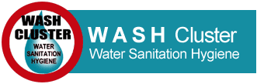

WASH CLUSTER STRATEGIC OPERATIONAL FRAMEWORK

RAKHINE AND KACHIN STATES IDP CRISIS RESPONSE

2015

©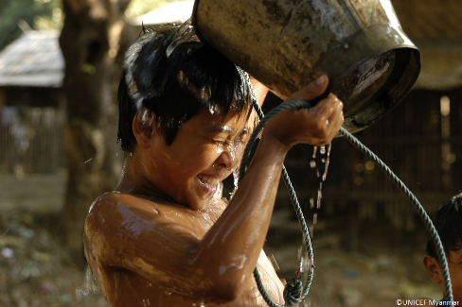





# WASH CLUSTER OBJECTIVES RAKHINE AND KACHIN

Objective 1:

Target population has equitable and sustainable access to sufficient quantity of safe drinking and domestic water

Objective 2

Target population has equitable access to safe and sustainable sanitation and live in a non-contaminated environment

Objective 3

Target population adopts basic personal and community hygiene practices

# TARGET POPULATION AND COST

## RAKHINE

|  |  |  |  |  |
| --- | --- | --- | --- | --- |
| WASH target population | HRP  People in need | | Caseload  Targeted by WASH | |
| IDP in camps | 116,183 | | 114,392 | |
| IDP in host families | 8,158 | | 13,724 | |
| IDP in village of origin | 14,969 | | 11,194 | |
| Non-IDP Hosting villages | 100,000 | | 100,000 | |
| Non-IDP Surrounding villages |  | |
| Non-IDP Crisis Affected | 177,290 | | 70,000 | |
| Total | **416,600** | | **309,310** | |

|  |  |
| --- | --- |
| *Rakhine Operational cost (USD):* | *16,522,962* |

## KACHIN AND NORTHERN SHAN

|  |  |
| --- | --- |
| WASH Target population | Caseload |
| IDP in Camps GCA | 49,658 |
| IDP in Camp NGCA | 43,457 |
| Villages | 20,000 |
| Small scale emergency | 14 000 |
| Resettled/Returnees | 10,000 |
| Total Beneficiaries targeted | 137,115 |

|  |  |
| --- | --- |
| *Kachin Operational cost (USD):* | *9,882,176* |

# TABLE OF CONTENTS

WASH CLUSTER OBJECTIVES RAKHINE AND KACHIN 2

TARGET POPULATION AND COST 3

RAKHINE 3

KACHIN AND NORTHERN SHAN 3

TABLE OF CONTENTS 4

OVERALL WASH CLUSTER MECHANISM & PERFORMANCE 6

Introduction 6

WASH Cluster role 6

Institutional framework 7

WASH Cluster Structure 9

Rakhine State 9

Kachin State and Northern Shan 10

Strategic advisory group (SAG) 11

Working Group approach 11

WASH cluster partners 12

Coordination challenges 13

Cluster Analysis Capacity 14

Inter-sectoral coordination 15

WASH Cluster Communication tools 17

Summary performance 2014 18

Humanitarian Principles and Principles of partnership 18

Transition and Exit strategy 19

WASH CLUSTER WORK PLAN 2015 20

RAKHINE WASH CLUSTER STRATEGIC FRAMEWORK 21

Background context 21

Current WASH situation 22

Location coverage of WASH actors 23

Equitable and sustainable access to sufficient quantity of safe drinking and domestic water 23

Equitable access to safe and sustainable sanitation and to a non-contaminated environment 26

Improvement of hygiene practices and behaviors change 28

Mainstreaming of cross cutting issues in the WASH response 30

Opportunities for possible transition from emergency to development 30

Strengthening of relations and empowerment of authorities 31

Approaches validated 32

“One NGO focal point per location” 32

Do No Harm and conflict-prevention 32

Develop hydrogeological knowledge 34

Towards self-reliance and community empowerment 34

Concepts to be improved 36

Priorities identified 36

Water 36

Sanitation 37

Hygiene promotion and change behavior methodologies 37

Cross cutting issues 37

Emergency Response Preparedness 37

Advocacy 38

Locations to prioritize 38

Target population review 38

Background context 41

**Early recovery and durable solutions** 42

Increase of WASH actor’s presence in IDPs locations 43

A more balanced response in 2014 43

**WASH related authorities in Kachin** 45

Equitable and sustainable access to sufficient quantity of safe drinking and domestic water 45

**Securing water quality access** 45

Upgrading sanitation facilities 46

Desludging 47

**Solid Waste management** 48

Hygiene promotion and WASH NFI distribution 48

“Focal point for full package” 51

“Capacity development” 52

“Equity approach 54

“Community empowerment” 54

“Host communities and WASH in Schools for Do No Harm” 54

“Township authority partnership” 54

Link with development 55

Target population review 57

# OVERALL WASH CLUSTER MECHANISM & PERFORMANCE

## Introduction

The WASH cluster was activated in Myanmar at the end of December 2012, together with the Health and the Shelter clusters to address both the Kachin and Rakhine crises. The decision was taken following the second major clashes in Rakhine, which intensified the need for humanitarian assistance, and as such, increased the humanitarian emergency response capacity need throughout the country, including an already consequent case load in Kachin increasing progressively since 2011.

It was expected that cluster activation would last at least until the end of 2013. However, both crises have become protracted humanitarian situations; in Kachin many people have been displaced for over two years, and what was supposed to be a transitional period in Rakhine will last until political and humanitarian initiatives can lead to a return of IDPs to a safer environment.

This document details the strategy for 2015, based on the 2014 strategy, agreed by the WASH Cluster partners, following in-depth exchanges throughout field WASH Cluster Strategy workshops organised independently for each crisis with field actors, and consolidated with national WASH Cluster partners.

The strategy revision process followed the agenda of the Myanmar Humanitarian Response Plan (HRP), led by OCHA and validated by the Humanitarian Country Team (HCT). The WASH cluster strategy provides all necessary documentation and detail to feed both Kachin and Rakhine Emergency WASH response in respect of the HRP previously validated.

|  |
| --- |
| **This WASH cluster Strategy aims to:**   * Define or re-orientate the most appropriate WASH response for the affected population based on lessons learnt and context evolution, * Identify the necessary improvements of coordination mechanisms, through the Cluster system, supporting rationalisation of the responses * Ensure a measurable approach of the actions, to increase the accountability of the responses toward beneficiaries and donors * Support donors and WASH actors in their project definitions by communicating on the main priorities identified and the approaches recommended, by filling the gaps, and by quantifying the funding needed to ensure beneficiaries’ dignity * Support the overall humanitarian response definition under the umbrella of the Humanitarian Country Team (HCT) |

## WASH Cluster role

The structure and the functioning of the WASH Cluster are detailed in the Myanmar WASH Cluster Terms of Reference (see annex 01). The WASH Cluster is hosted by the WASH Cluster Lead agency, UNICEF. The Cluster is based on the collective participation of all WASH actors, while its design remains flexible depending on the context and the needs to address: Changes to the strategy are made through collaboration and results are mutually agreed upon. The UNICEF-assigned WASH Cluster Lead coordinates the national WASH Cluster and liaises with the government, but all objectives defined in that strategy are the result of collective decision-making to ensure a stronger impact and results for beneficiaries.

Due to geographical access and movement constraints in the country, WASH actors have developed strong resources at field level, creating a well-functioning, decentralised coordination mechanism, allowing most decisions to be taken directly on the field with the support of the sub-cluster coordinator, and without excessive coordination between actors in Yangon. Until mid-2013 national WASH representation from the NGOs in Yangon proved to be challenging, though this has improved progressively in 2014, and active attendance to monthly national WASH cluster meeting observed. However it remains challenging at National level to develop more synergies between actors, being most of the time supporting the field activities.

However all partners agree on the need and expectation towards the national Cluster which should concentrate on the following:

* Advocacy within inter-sectoral cluster, HCT, governmental platform
* Liaison with relevant authorities for WASH in emergency, preparedness and contingency,… at national level
* Support on strategic positioning when needed or requested, based on Cluster mandate definition and existing global standards
* Support on capitalisation and consolidation of standardised key documents
* Development of tools, harmonised country-wide when possible
* Information management and global analysis
* Inter-sectoral coordination at national level
* Conflict resolution when no consensus found
* Donor relationships to support strategy deployment

## Institutional framework

The WASH sector in Myanmar falls under the responsibility of numerous Ministries, but lies primar­ily with the “Ministry of Health” (MoH), “Ministry of Livestock, Fisheries and Rural Development” (MoLFRD), and the “Ministry of Border Affairs” (MoBA). The first through the “Environmental Sanitation Department” (EDS) for sanitation and “the Central Health Education Bureau” (CHEB) for hygiene promotion, the second for rural water and the latter for drinking water supply infrastructure in certain border regions.

The “Department of Rural Development” (DRD), under MoLFRD, is responsible for the construction of infrastructure, including drinking water supply, in rural and semi-rural areas, while from 2014 it will also be taking on responsibility for rural sanitation in parallel to the Environmental Sanitation ESD of the MoH. Urban water supply is managed at city.

From 1993 to 2011, several Environmental Health Programs were implemented under the National Health Plan regarding community water supply, sanitation and air/water pollution controls. The Ministry of Health has been organising community engagement events for several decades.

Water resources management including water use is the responsibility of the “Ministry of Agriculture and Irrigation” (MoAI), includes the monitoring of water quality parameters such as arsenic in drinking water supplies through the Water Resources Utilisation Department (WRUD). However water quality also falls under the National Health Laboratory (NHL), the Food and Drug Administration (FDA), Occupation Health Division (OHD) and the ESD, all departments of the MoH, as well the Myanmar Science and Technology Research Department (MSTRD) among other. To date there has been little coordination between the different departments, but the ESD is planning to take the overall lead and finalise the development of the Myanmar Water Quality Guidelines, which have been in progress since the late 90’s.

The “Ministry of Education” plays a key role in WASH community education programs including WASH in Schools, which is integrated with DRR into the life skills curriculum, and Global Hand Washing Day.

The WASH sector has formed a WASH Thematic Group (WTG), composed of most of the international and local agencies involved in the WASH sector in Myanmar. The WTG meets every second month in Yangon with a view to developing a coordinated approach to WASH across the country, with sub‐groups focused on areas such as emergencies, hygiene promotion and gender issues. The WASH Thematic Group preceded Cyclone Nargis but its membership has grown since. The WASH cluster was originally referred as the “WASH in Emergency” group, and considered as sub-group of the broader Myanmar WTG. This dynamic hasn’t been consolidated or used very extensively, but remains a good future opportunity to improve coordination with the authorities, and also to inform future exit strategy development.

So far, due to the complexity of the national organisation for the WASH sector shared between different Ministries, National WASH Cluster meetings do not liaise with any national authorities, neither from Yangon or Nay Pi Daw. However this has been identified in 2014 as a development to be addressed, which could better support advocacy concerns in constructive collaboration, and also ensure a transfer of competencies on emergency (incorporate cluster standard developed and deployed in Myanmar to national standards and policies). An opportunity exists to start this process through joining with the WASH Thematic Group (WTG) planning twice a year to meet in Nay PI Daw with authorities. In addition linkage can be developed based on Emergency Preparedness while the government attempt to consolidate their overall approach, and specific sub-comities has been designated per sectors. While, the structure still need to be consolidated, the bridge between National structure and international agency to be re-enforced as clearly shown during the 2014 SIMEX.

Coordination with authorities in Kachin will be re-enforced, with the double challenge to liaise with both State authorities ethnic armed forces organisation. The main interlocutor has been so far the Department of Rural Development (DRD). The DRD will co-lead the WASH cluster in 2015 and coordination with others WASH related authorities will be pursued

In opposition, in Rakhine State the Cluster has been co-led until October 2013 by Reconstruction and Relocation Sub-Committee (RRSC) on a weekly basis, while relocation process was on-going and strongly mainstream by local authorities. End of 2013, it was commonly agreed with RRSC to alternate their presence, due to their overload of meetings and the need for WASH actors to have independent exchanges for more technical and approach-oriented discussions. The collaboration remained close, including DRD, to support the sectors upon request. In addition, while in Mars 2014 clashes happened forcing WASH partners to stand by their activity, DRD collaborated and directly supported some live saving activities.

Globally, either at state or national level, closer collaboration with authorities should be a major priority for the cluster, and influence the way of working in WASH Emergency in order to:

* Better advocate technically for WASH emergency standards
* Better integrate national policy development in transitional emergency context (ex: Village approach)
* Better define a LRRD (link Relief rehabilitation to development) phase including authorities
* Better build prerequisite for exit strategy
* Transfer of specific activities to local authorities
* Better sharing plan process and join need analysis
* …

In order to better initiate or re-enforce collaboration with the authorities, the annex xxx, present the overall governmental structure related to WASH development in the country, with specific focus on emergency.

## WASH Cluster Structure

The cluster is composed of:

* The National Cluster platform, led by an international UNICEF resource (NWCC)
* 1 sub-cluster in both Rakhine and Kachin State, each one led by an international UNICEF resources
* Kachin, due to geographical constraints has developed a second sub-cluster in Bamaw District
* One UNICEF cluster consultant is located in Northern Shan to ensure basic situation monitoring

In 2013 the humanitarian country trategy did not include Northern Rakhine State (NRS) (Maundaw and Buthdaung townships) while concentrating that first year on the directly conflict-affected population. In 2014 NRS was included in the SRP 2014, due to the high vulnerability demonstrated. However, the WASH Cluster did not succeed in 2014 to develop direct support for NRS, mainly due to low sharing information process from actors intervening there but also insufficient Cluster capacity to visit the area, while March events also jeopardised that needed focus. The 2015 work plan related to Rakhine will better take in consideration the expected support needed for NRS, while development approach is, however, foreseen to better support the situation analysis associated with advocacy for the extremely vulnerable area.

In the Kachin response plan one specificity should be noticed: From the beginning Northern Shan state is legitimately included in the response, as facing the same context and conflict roots than Kachin. However, it also challenges the WASH cluster coordination responsibility, while the area is not logistically connected to the other area (only by crossing Chinese border). The caseload is lower than the other areas, but coordination mechanism remains anyway to be consolidated.

The Sub-cluster coordinator’s double-hatted responsibilities with UNICEF Emergency, has created some confusion among WASH partners in 2013. Recruitment has been performed for an international UNICEF staff-member dedicated to the WASH Cluster for Rakhine sub-clusters, which will facilitate to identify UNICEF as any other WASH Cluster partner.

Taking into account the specific needs identified in the 2014 Strategy, the following positions have been developed:

* In Rakhine 1 Monitoring and evaluation team, led by an international stand by partner resource (ACC)
* In Kachin, 1 Capacity building officer, led by an stand by partner international (MSB)

So far it lead to the following target organogram:

### Rakhine State

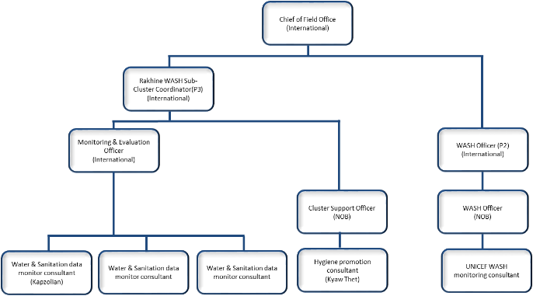

### Kachin State and Northern Shan

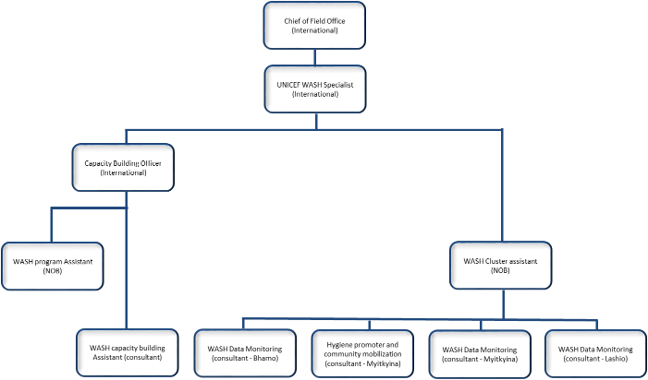

This target organisation depends on UNICEF WASH Emergency financial means availability and is not yet financially covered for 2015.

A Regional WASH Cluster adviser (Care stand by partner, ECHO funded) is based in Bangkok, re-enforcing cluster leadership and bringing technical support through direct missions when requested. This resource is fully integrated in the cluster work plan (Annex 02).

WASH cluster meetings are organised bi-weekly in Rakhine state, and monthly in Kachin and Northern Shan States.

## Strategic advisory group (SAG)

Attempts were made to set up a SAG at the beginning of 2013 in Yangon. Unfortunately since partners concentrated their resources at field level, too low attendance to the Yangon Cluster did not make relevant to constitute that consultancy group, while so far the Yangon cluster is covering finally the SAG ToR.

In addition, based on Google groups set-up, exchange can be reactive and participative, while those online tools are planned to be deeply exploited in 2015.

## Working Group approach

The working group approach has been launched in both sub-clusters since the cluster activation. In 2014, the Working Group (WG) principle has been reviewed and formalised in global ToR (annexe 03).

The principle of the WG is to provide technical support and to develop specific thematic issues identified by the WASH cluster, and to propose a draft positioning, based on field experience, to the sub-cluster for collective validation by all actors. In some cases, the positioning has to be proposed to the national WASH cluster when harmonisation has to be questioned between Kachin and Rakhine, when subjects are rather strategic than technical, or when they need to be cross-checked with international guidelines or consulted with specific donors position. In any case reactive validation and capitalisation, consolidation, diffusion and promotion are expected from the wash cluster coordinators.

These working groups should not be a sub-coordination platform of the operation but only focus on technical thematic and supporting in methodology.

In 2014, the dynamic of the WG slowed down in Rakhine State, following March events, but still the following are under collective exchange:

* Village approach
* Hygiene promotion
* Monitoring and evaluation

In Kachin, the WG topics have been chosen and split between Bamaw and Miykthyina sub-cluster:

* Technical design
* Household water treatment
* Desludging

During the strategic review consultations all topics expected to be addressed are integrated in the WC work plan (annexe 02).

The following one has been consolidated in 2014 either in positioning, guidance or lesson learn paper:

* Village approach in the humanitarian scope
* Semi-permanent latrines design
* Desludging im emergency setting
* Menstruation management
* Emergency latrine and Bathing space for contingency
* Ceramic filter standardised approach
* Hygiene kit strategy and guidance
* IEC materials
* Pond construction and rehabilitation
* Child friendly latrines
* …

These Myanmar WASH cluster guidance reflect the collective position validated and are expected to be applied in the response plan. Most of them will have to be re-evaluated in 2015 based on the lessons learnt, but also following the context changes.

## WASH cluster partners

In Rakhine State, the following INGOs are present and participate actively in the Sub-Cluster:

* Action Contre la Faim (ACF)
* Consortium of Dutch NGOs (CDN)
* Danish Refugee Council (DRC)
* International Rescue Committee (IRC)
* Oxfam
* Relief International (RI)
* Save the Children (SCI)
* Solidarités International (SI)

In Kachin, local NGO are present and represent important coverage for the response, independently or in consortium with INGOs, all participate in the Kachin Sub-Cluster:

* KBC
* KMSS
* Metta
* Shalom
* Community based organisation non-registered
* AVSI
* CESVI
* Oxfam
* Save the Children (SCI)
* Solidarités International (SI)

## Coordination challenges

Partner representation in Yangon reached its full capacity in 2014 and had a fluctuant attendance along the year. The commitment of the partners is strong and supportive, however their capacity to participate to more regular or thematic exchanges remain limited due to a legitimate prioritisation of the field operation, requiring in addition complex plan with Travel Authorisation.

Then it is planned to reduce the meeting frequency, in relation also with the WASH Thematic Group, the needs beyond informative meeting, the opportunities to liaise with authorities in Nay Pi Daw As followed:

|  |  |  |  |  |  |  |  |  |  |  |  |  |
| --- | --- | --- | --- | --- | --- | --- | --- | --- | --- | --- | --- | --- |
|  | Jan | Feb | Mars | April | May | June | July | August | Sept. | Oct. | Nov. | Dec. |
| Cluster |  | Ad-Hoc cluster strategy | X |  | X |  | X |  | X |  | X |  |
| WTG |  | X |  | X |  |  |  | X |  | X |  |  |
| NPT |  |  |  |  |  | X |  |  |  |  |  | X |

The Sub-cluster in Rakhine is very dynamic, with high attendance and active participation of the partners. However, WASH Cluster partners begun to be overburden after the events of March, collective strategic orientation slowed down and had to be stimulated. In addition the sub-cluster should be able to bring leadership in the NRS response.

The cluster performance led to an absolute absence of overlapping, and a reactive gap identification – geographical but also thematic. Emergency preparedness and response have been developed based on partners’ capacity through a backup strategy respecting the “one NGO per location” policy. As mentioned, the coordination with the authorities is positive and fruitful, but remains too opportunistic from both sides.

In Kachin, actor coordination remains more challenging due to geographical constraints, and access restrictions (NGA), but also limited capacity of actors to participate in coordination mechanisms. While local NGOs are identified as a great value and strength to the cluster, the cluster should still motivate them about the added value it can bring in the rationalisation and coordination of the response to beneficiaries. Capacity building of actors developed in 2014 for, and upon the demand of the local NGOs, increase the exchange between the actors, sharing experience, and training capacities, defining a better collective approach than in 2013, and common understanding of coordination mechanism.

However the cluster should still increase its leadership in sub-cluster defined, especially in Bamaw district concentrating a high numbers of actors (and beneficiaries).

## Cluster Analysis Capacity

So far, the main sources for situation analysis are:

* Various country data, reports and maps
* 4W (annex 04): Well-used with a 100% NGO response rate, allowing a good mapping of interventions and related gaps and needs
* A financial matrix is developed within the 4W database
* Working Group analysis in the field
* Partners’ evaluation and assessment reports
* Cluster meetings, inter-sectoral meetings (national and at state level)
* Exchange and bilateral debate with partners
* Field assessments
* Cluster monitoring (under proper development)

The need to go beyond simple quantitative data collection provided by partners, based on activities and through tools such as SPHERE standard, was identified in 2014 strategy. To respond to that need both sub-clusters have developed specific monitoring methodology (annex XX & XXX) allowing more systematic and methodological monitoring in the camps and villages targeted, based on health risk analysis related to WASH minimum standards. Water quality systems has been also included in the whole monitoring methodology. For that purpose, the cluster recruited, through UNICEF, a full time international during 12 months to support the monitoring system development and information management in Rakhine, position that should end in March 2015 while the process is planned to be in place and run with the team.

Assessment availability remains still too poor, due to low information sharing, but also a lack of completed assessments. The development of common assessments, more extensive than the OCHA multi-sectoral initial rapid assessment (MIRA) applicable only in emergency (validated and applied by the WASH cluster), but also of assessment mapping and collective plans to cover the lack of knowledge still have to be further supported by the cluster. The UNICEF cluster team should also be in capacity in 2015 to conduct independent evaluations.

Capitalization on past experiences requires continuous work, and will be supported by the cluster through lessons learnt workshop, exchange of information and update of the guidance notes.

## Inter-sectoral coordination

* The WASH cluster and sub-cluster coordinators participate in the inter-sectoral platforms at both the state and Yangon level
* During these meetings, the Clusters and sectors should advocate more on action follow up, whereas the WASH cluster should formalize topics to be addressed at these platforms
* Coordination at field level is bilateral with other sectors and well-developed (with topics summarized in table below)
* A specific link should be developed with the Food Security sector, Livelihoods sub-working group and Early Recovery Network, while in both response plans it appears that a better understanding of livelihoods opportunities and, in some cases, a linkage to economic support to beneficiaries will benefit and intersect with WASH actions, while former Early recovery sector did respond to those question during the past years.

|  |  |  |
| --- | --- | --- |
| Sector | Lead agency | Common interests |
| Shelter | UNHCR | Close coordination between these two clusters through:   * Attendance at each-other’s cluster meetings; * Joint field visits; * Joint planning of specific interventions * Joint cluster meetings and/or working groups to discuss specific cross-cutting issues.   With substantial shelter maintenance and individual accommodation building currently being planned, it is essential that site planning is done, taking into consideration WASH needs.  In Kachin, specific common interests for durable solution and final IDP resettlement. As some small-scale returns and permanent housing at point of displacement is envisaged, ensuring that WASH facilities and shelter are well-coordinated in terms of implementation before IDPs returns should be compulsory to provide adequate and sustainable returns.  In Rakhine, Shelter and WASH clusters are sharing the same concerns about maintenance of the facilities, the impact of lack of firewood, eventual relocation actions and a shared interest to coordinate with Early Recovery Network to step in in a coordinated way to re-enforce response sustainability. |
| CCCM | UNHCR | Empowerment of community-based organizations with WASH issues and development of social mobilization around infrastructures are crucial in 2015 in order to raise beneficiaries’ sense of ownership. This community approach should be harmonized with the existing camp management existing structures.  The incentives for camp-based workers should be harmonized camp by camp. |
| NFI | UNHCR | Since mid-2013 the WASH cluster is responsible to report on hygiene kits progress to NFI cluster. The reporting process should be re-enforced and the modes of deployment should be shared, and harmonized if possible.  In Rakhine, the common need to understand the market dynamic related to NFI was identified for more effectively address the needs of the beneficiaries. A multi-sectorial market assessment and household basket study would guide the future distributions – targeting vulnerable and the distribution methods – vouchers, items |
| Health | WHO | WASH cluster performance is very closely related to health impact and the responsibility of response to an outbreak is shared by WASH and Health, requiring a close coordination and fluid information sharing.  In Rakhine, sharing of health data started at the end of 2013 allowing the trend analysis per township. The share of Health surveillance data, although stopped after the March events, has resumed. Developments are still expected in coordination about the data quality, completion and clarity, orientation for the interpretation of the data and overall analysis of the public health situation. The update of AWD response plan will also be in coordination with Health Cluster.  So far there is no direct Health Cluster presence in Kachin. To be followed up in Yangon |
| Protection | UNHCR | In Rakhine, “do no harm” approach including specific concerns about gender and people with special needs issues has been developed during 2014 and further development is planned in 2015 in coordination with the protection sector. In order to address child safety in the camps, in particular related to WASH infrastructure, close links between WASH and Protection are being developed and integrate systematic basic safety topics in Hygiene promotion modules. Specific gender issues in WASH remain of concern and will continue to be addressed in strong link with the Protection Working Group and GenCap advisor. |
| Education | UNICEF | WASH actions should systematically tackle the WASH needs of all temporary learning spaces or schools and should be done by WASH actors, in coordination with needs identified by the Education sector  Village approach should develop WASH in School Approach based on national policy currently under development |
| Food security/livelihoods | WFP/FAO/UNDP | To re-enforce WASH impact, and support conflict sensitive approach, coordination and support with the Food security sector should be developed. |
| Early Recovery network | UNDP | The WASH action need a stronger link to, coordination and technical support from Early Recovery Network, while WASH can participate in villages and avoid pull factors in camps, favoring return as part of a multi-sectoral approach, and leading communities to more self-sufficiency. |
| Communication with Communities | OCHA | In Rakhine, WASH intervention needs the support from CwC to improve the information flow between actors and communities, improve behavior change communication, enhance participation of all different groups, vulnerable in particular. |
| Advocacy | OCHA/HACG | Participate directly to develop policies, case study sharing, alerts and sectorial priority definitions |
| Nutrition | UNICEF | Develop an integrated approach for NRS (Northern Rakhine State) and integrate systematic basic nutrition topics in Hygiene promotion modules. |

Durable solution, in both Kachin and Rakhine, should be defined under the umbrella of HCT/OCHA in a strong inter-sectorial coordination approach, in order to communicate in one voice to the authorities, who should lead the process, following durable solutions principle. Kachin humanitarian community has already conceptualized the approach to be endorsed by the authorities while operationalization of different phases should follow.

In Rakhine, the situation remains unclear about the re-localization process and conditions of the affected populations, although at the time of writing a reduce number of IDP are on the process to receive a durable accommodation.

## WASH Cluster Communication tools

The following tools are currently used:

* WASH cluster Google groups : National, Rakhine, Kachin and Yangon
* Monthly SnapshotsMIMU Web site [*http://www.themimu.info/emergencies/wash-cluster*](http://www.themimu.info/emergencies/wash-cluster)
* Consolidated 4W monthly analysis
* Sub-cluster monthly report
* Minutes of meetings

The Google groups allow immediate and collaborative sharing of information (Minutes, agendas, partners exchange, Documentation sharing). “Yangon” google is planned to be consolidated beginning of 2015 to better respond to the need of an interactive on-line exchange.

WASH cluster information is hosted on MIMU website.

In addition to the minutes or monthly analysis shared, the Web site also allows the Cluster to share all technical packages, designs and guidelines, position papers consolidated as well as evaluations or studies produced by the partners.

Production of guidance or stance paper should continue in 2015.The ownership and usage of the technical guidelines and positioning papers produced by the WASH cluster should be better disseminated to ensure a better adhesion of partners to minimum standards. The Working groups’ involvement should be better stimulated by the Cluster, especially on capitalization and formalization of the tools produced, while those groups play a key role in such development.

The documentation, and the recommendations, consolidated through this process is aimed also to reach donor agreement, to allow future project definition, to easy exchange with authorities and to ease the transition to development based on experience.

## Summary performance 2014

The WASH Cluster update the “*Cluster performance review*” (annexe 09) in January based on standardised IASC and global cluster tools. It was done by the national and sub national WASH cluster coordinators and the regional WASH cluster adviser (based in Bangkok).

To ease exchange and ensure feedback from the WASH cluster partners, the following SWOT analysis attempts to synthetize the main conclusions, while it is expected in the first 2015 quarter that a “Monkey survey” will be set up on line in order to allow a more objective analysis.

|  |  |
| --- | --- |
| **Strengths** | **Weaknesses** |
| * Good set of actors in the field * WASH cluster UNICEF structure re-enforced * Coordination and IM tools in place * Donors interest (to be confirmed) * LNGOs active (Kachin) * Capacity building process in Kachin * Do no harm approach well defined * Emerging Water quality capacity in Rakhine * Cluster harmonized monitoring systems under development and set up on-going | * WG in place low productivity * Little number of assessments and situation analysis * Lack of sharing analysis/study * Lack of national coordination and national Governmental counterpart identification * Cluster evaluation capacity to enhance |
| **Risks** | **Opportunities** |
| * Humanitarian access * Deviation of the aid * Lack of sharing plan from authorities * Protracted crises * Technical challenges on emergency exit strategy * Exit strategy | Cluster Monitoring system at field level to be adequately deployed   * Inter-cluster re-enforcement (CCCM & Health) * Advocacy with HCT * Regional Support (RECA + UNICEF REWS) * Lessons learnt (Social mobilization & HP) * Preparedness and Contingency to developed |

## Humanitarian Principles and Principles of partnership

The WASH Cluster principles are based on the Global Humanitarian Platform, created in July 2006, bringing together UN and non-UN humanitarian organizations on an equal foot. The organizational members of the WASH Cluster agree to base their partnership on the Principles of Partnership.

In addition to that, members of the WASH Cluster agree to respect:

* The Code of Conduct for the International Red Cross and Red Crescent Movement and Non-Governmental Organisations (NGOs) in Disaster Relief
* The Do No Harm approach developed by CDA Collaborative Learning Projects

## Transition and Exit strategy

No time frame has been set yet for the phase-out of the WASH Cluster while both emergencies have become protracted. The following criteria can be considered to initiate the deactivation:

* The number of IDPs decreased by 80%. The majority of the population have returned home, and WASH early recovery activities have been successfully initiated in the returnees’ communities.
* There are no more significant security/protection risks likely to trigger new population displacements.
* The WASH Cluster strategy was implemented in the majority of the camps, meaning that:
  + WASH Minimum packages have been provided in 80% of the target sites
  + The strategy indicators have been measured regularly and eventually achieved
  + The maintenance is sustainable with government support
* All non-sustainable activities such as water trucking or hygiene kit distribution have been completed, or replaced by a more sustainable system i.e. durable water source such as protected wells.
* The “WASH in emergency” coordination mechanism has been successfully handed over to the WASH Thematic Group, and/or the local authorities.
* Lessons learnt from the current emergency have been documented, and all tools developed by the current WASH Cluster (Strategy, Evaluation report, 4W matrix, technical design…) are archived in such a way that they can be easily available for partners for future emergency, through the Myanmar Government, the MIMU, the RECA and UNICEF REWS.
* A WASH contingency plan for future disasters is finalized, and integrated into a multi-sector contingency plan.

Despite difficulties to foresee the evolution of the future situation in both emergencies, the approach should take strongly into consideration, first steps or good orientation openings toward a path for progressive withdrawal of external humanitarian assistance.

However, 2014 have seen some transitional changes while development actors and/or project start to step in both Kachin and Rakhine which should allow and motivate a switch in intervention modalities for some populations. Such new opportunities should also stimulate a fine tuning of the humanitarian sphere of intervention, in collaboration with development actors, leading to a withdrawing and hand over of some location/target population.

The following principle should be applied:

* Exit strategy is not in the context a one year strategy, but straight action allowing a better positioning during the coming years
* Do no Harm approaches must be considered thoroughly
* Based on the principle that the government should be responsible for responding to the population needs, and at some stage take up direct response

Then the following actions should be already developed in 2015:

* Develop a clear message to authorities, in coordination with OCHA, about responsibilities and future expectations
* Develop more practical exchange with local and national authorities, leading to experience sharing and development of emergency standards
* Improve life conditions of affected population and develop self-sufficient capacities
* Link the development of WASH emergency facilities to longer term township needs (ex: desludging sites benefit all communities)

## WASH CLUSTER WORK PLAN 2015

Following the WASH cluster performance review and identification with the cluster partners of the developments needed, all strategic development related to the cluster itself, supports expected and collective tasks to perform are consolidated in the Cluster Work Plan **(annex 02).**

# RAKHINE WASH CLUSTER STRATEGIC FRAMEWORK

## Background context

The conflict in Rakhine State, opposing Muslim minorities and ethnic Rakhine has displaced over 140,000 people in 9 townships, and impacted badly many host communities as well as the whole local economic system. A first wave of displacement occurred in June 2012, after which large camps were set-up in and around the state capital, Sittwe. A second wave of violence and displacement occurred in October 2012, triggering movement of population in and around Sittwe camps, as well as the creation of new large camps in other townships, namely Pauk Taw, Kyauk Phyu, Mrauk U, Kyawtaw, Mymbia, Rathedaung, Rameree and Myebon.

In some cases, populations have settled near their former burned down villages. In these large camps (up to 15,000 IDPs), emergency WASH activities are implemented, in a difficult climate of communal tensions. Only light non-permanent WASH facilities were built at the opening of the camps in early 2012, but agencies have progressively replaced them by more permanent structures able to cope with the yearly rainy season and risk of flooding. In 2014, within the “Do No Harm” perspective, the intervention slowly expanded to the villages neighbouring the camps and affected sites.

On the 26th and 27th March 2014, riots in Sittwe town hit the UN and NGOs, perceived by the local community as biased and providing assistance to only one category of the population. The humanitarian community faced considerable damages to offices, warehouses and equipment and number of personnel was temporarily evacuated from the State. After the riots, the presence of WASH actors in Rakhine was much reduced and their operational capacity was heavily truncated. In addition, the access to the field was impossible during a month, with the exception of few short field visits and remained intermittent until the end of August for some townships such as Rathedaung and Pauk Taw. Following events, the Emergency Coordination Committee (ECC), including government and community representatives, was formalized at Union State and Township levels, with the overall objective to facilitate coordination of the response. During a first phase of set up, roles and responsibilities have been fluctuant, while common expectations still need to be aligned between civil society expectation, conflict sensitive approach and humanitarian principles.

Following the riots in March, a new working environment developed with an exacerbated necessity to mainstream conflict-sensitivity among the humanitarian community, approach already launched in the WASH sector since the beginning of 2014 but remained low visibility at that time, with a stronger scrutinizing from the authorities in the daily interventions and a permanent attention from the local community that advocates for a more balanced action by the UN and NGOs. In some cases, communities and township authorities have shown resistance or have rejected the intervention

The Government of the Union of Myanmar released in September a draft action plan for Rakhine State suggesting the possibility of imminent relocations; although the effective implementation of the plan in this form has not happened, the exchange with the State authorities was affected, in particular with regards to land availability for new infrastructures in the existing camps. The Rakhine State Government (RSG) has informed that the action plan is currently under discussion and the complete version would be released soon. However, the RSG has recently approved the relocation of the IDP in the urban camp of Set Yon Su 1 in Sittwe to long-term individual accommodation and a new site for the IDPs of Set Yon Su 3 is currently under identification. The Minister of Transport and Communication has also suggested that affected household living in their point of origin – for instance in Kyaw Taw, Minbya and Mrauk-U - could receive a materials package to build long-term individual houses in the near future. For the rest of conflict-affected townships, the action plan is strongly linked to the ongoing verification process, for which no timeline has been communicated.

Figure 1 - Rakhine conflict-affected area[1]

## Current WASH situation

The relocation process initiated by the Government, and supported by the Shelter cluster through long houses construction, led to massive movements and tensions during the first semester of 2013. The number of camps in Sittwe had through this process been reduced from 41 to 21 and the relocation led to an increased need for semi-permanent WASH facilities in the new IDP sites in order to protect the ground water and reduce the risk of contamination. A large majority of the camps are located in flood-prone areas, often directly in paddy fields. Despite efforts of coordination between WASH, Shelter, and CCCM clusters, site planning including WASH remained very challenging, delaying by several weeks the construction of WASH facilities.

The events in March 2014 brought limited and intermittent access to the field and a new working environment. The normal delivery of services was not been possible during several months, producing long delays in the implementation of infrastructure, which, added to the rainy season environment, brought additional complexity to the intervention. On one hand, the completion of the infrastructures in the camps was heavily delayed and, on the other hand, the existing infrastructures reached their life span.

Deployment of WASH flood-proof infrastructure remains still a challenge as camps offer limited space for facilities, dismantling of facilities for firewood… The shelter being finished, the construction of WASH facilities goes along with high amounts of money exchanged – compensation of landowners for plots where the facilities sit and construction contracts – and pressure to grant contracts, threats/action to destroy facilities or even to harm staff are addressed to the field teams permanently. Camp Management Committees (CMCs) play a huge role in applying this pressure. CCCM Cluster and authorities have been aware of such challenges but haven’t so far found a viable solution.

In the sensitive environment of Rakhine state, the WASH cluster had since 2014 promoted the inclusion of neighbouring villages within the response, systematically encompassing a do-no-harm approach throughout all project stages. While support to IDPs continues, in a conflict-sensitive manner, fragile communities, witness of the humanitarian action, should be targeted, acknowledging their vulnerability in terms of health associated with pre-existing poor sanitation conditions. After the events in March, the progress towards these villages was temporarily stopped and impeded by the community itself or by the local authorities. The framework of the intervention in villages has been further developed during 2014, based on field experiences and an evolving context and at the end of 2014[2], the WASH action targets an equal proportion of beneficiaries in villages than in camps, with adapted activities aiming at increasing the community self-reliance.

There is a need to place more focus where possible to improve the precarious public health situation experienced by the surrounding villages, particularly in Northern Rakhine State (NRS), which has particularly acute WASH and nutrition needs. Due to the weakness of the wash cluster to capture better the NRS situation so far, the following analysis will exlude NRS, while same effort and analysis remain expected in 2015.

### Location coverage of WASH actors

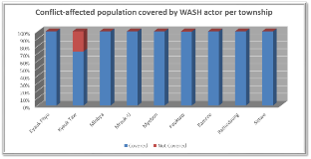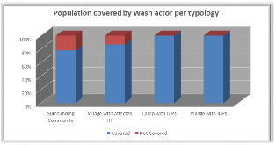

So far, only three conflict affected sites in Kyauk Taw township (estimated 1244 IDPs), have not had any WASH actors providing services except for some emergency latrines provided by the DRD. This township has been long a gap for the WASH due to the local community resistance to accept international actors, posing administrative constrains and requiring a slower approach. Finally, current September 2014, a first phase of intervention could start intended more to build the relationship with the communities and early 2015 a second phase of WASH interventions will be possible.

One conflict affected site in Pauk Taw (Ba Wunn Chaung Wa Su – 97 IDPs) has refused the support from WASH actor since September 2013. Other areas remain very difficult to access for different reasons (ex: Pauk Taw difficult in terms of logistics) and difficulties or even security constrains (ex: Meybon). A response in Rathedaung has been launched in October 2013 but has faced severe disturbances after the March 2014 events, but is a good case study on the difficulties in deploying appropriate and unrushed assistance in such remote townships while a conflict sensitive approach and community acceptance have to be addressed first and with patience. WASH operations have resumed late 2014.

### Equitable and sustainable access to sufficient quantity of safe drinking and domestic water

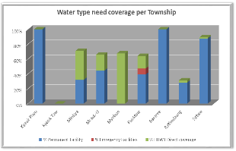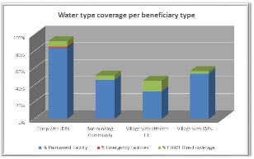

Figure 2 – Water needs coverage per township (left) and per type of beneficiary (right)

The dependency on emergency waters supply has been reduced, although not eliminated. In some locations, the emergency systems are progressively been replaced by more semi-permanent networks, and when possible protected sources are being constructed or rehabilitated.

Nevertheless, in particular in Pauk Taw township, 16 000 individuals remain extremely vulnerable and dependent on emergency water supply - Water boating or pumping from remote ponds at the end of the dry season. Indeed, the local geological environment does not allow the creation of shallow boreholes or spring catchments. Rain water harvesting systems have been tested in some locations with the aim to mitigate this gap. However, if the population stays in those locations, the research of more permanent water sources, supported by environmental and hydrogeological studies, remains mandatory to secure the access to enough water along the year.

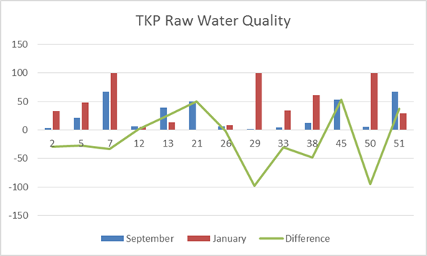

Figure 3 – Water test results for raw water in Tet Kel Pyien camp (Sittwe) compared over time[3]

The geological environment in Rakhine state is very complex and complete different conditions are found in locations only a couple of kilometers apart. The quality and the sources of water are therefore very different – shallow underground water in sandy solid, surface water and rain water collected in ponds. Regular test of raw water quality are currently being performed by some actors and is meant to be expanded in order to monitor the contamination levels in the sources. Initial water test results indicate that there is no visible pattern of contamination of the ground water between rainy and dry season and borehole water is often also contaminated. While the impact of water point upgrade on the level of contamination still needs to be explored, prevention measures should be deployed permanently – software and hardware. In addition, the presence of nitrate as the most commonly found chemical and the partial absence of arsenic may have impacts on the long-term health and must be further analyzed.

Rain water collected in traditional ponds are from far the most common water source in Rakhine state, and communities rely on them. Therefore, with the objective to increase their storage capacity, ponds are currently being upgraded – enlarged, deepened, raised, and to reduce the contamination risk, there are being equipped with fences to prevent animals to approach and jetties or pontoons. This interventions is in general very welcomed by the beneficiaries. Tentatives to line ponds to reduce the infiltration have been tested but require further investigation to become effective. In camps, where international minimum standards of WASH services apply, the water collected in ponds does not respond to the safe water supply on its own - distribution systems (emergency and semi-permanent) disinfecting the water prior to delivery are mandatory.

Alternatively, ceramic water filters (CWF) as complementary household water treatment system are being deployed as decided in 2014 and initial results show a good acceptance and appropriate usage of them[4],[5],[6],[7],[8].

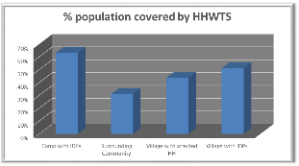Household water treatment system were already identified in 2013 as possible solution - based on past Myanmar experiences and population knowledge – as a mean to cope with water quality management in the protracted context of Rakhine state. In 2014, the Wash Cluster developed guidance[9] for implementation in emergency context, defining the scope and highlighting the risks and the limitations of the approach. The CWF appears to be an appropriate alternative and immediate solution when the geology of the area does not allow rapid creation of a protected water point, and a complementary solution in camp and village to the existing safe protected water sources.

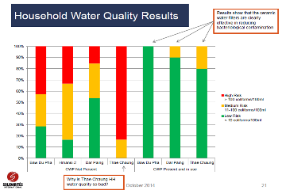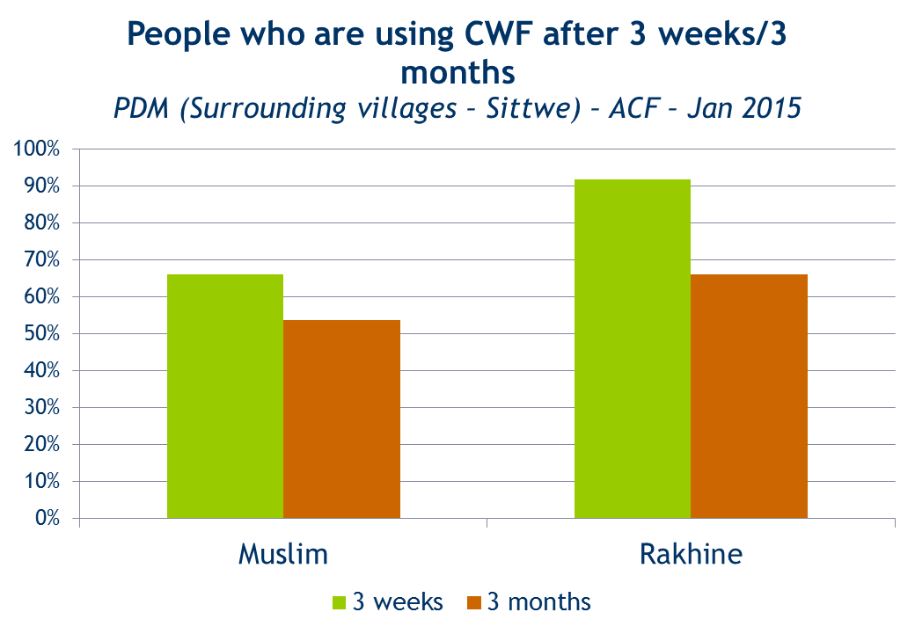

During 2014, the CWF has been deployed, the initial results indicate that there is good acceptance[10] of the filters by the communities. This also appears to be an interesting activity to support community acceptance - easy to implement, blanket coverage, high impact on health. Water quality tests at household level[11] show a dramatic difference in levels of *E. Coli* between the households using a CWF and the ones not using it. Low flow rate, rumors and misperceptions or the lack of space in the accommodation tend to discourage its use over time, highlighting the necessity to deploy a strong soft component and a frequent follow-up linked with safe water promotion activities. The preparation prior to distribution is crucial and needs early involvement of community and its leaders.

These are encouraging initial results also highlight opportunities for improvement[12] and nevertheless, the overall evaluation of the approach decided by the WASH collective is yet to be done – efficiency of the filters overtime must be studied and sustainability of the strategy in a context where the filters are not available in the local market is questionable.

The overall goals of the WASH cluster however remain to provide sustainable solutions through protected water points, in particular for high density zones where the public health risk is higher. The quality of infrastructures and their capacity to reduce the contamination risk as much as possible remains of concern as there is a general lack of local capacity and previous investment to build protected water points, including government and private sector - usage of international standards for boreholes and wells including adapted gravel packing, lining and protecting superstructure is not common in Myanmar and needs to be developed, commonly accepted usage of untreated pond water as sole source of drinking water needs to continue to be challenged by the sector, new creative alternatives such as spring catchments need to be explored, while clear opportunities exist and should be ambitiously catch by wash partners

### Equitable access to safe and sustainable sanitation and to a non-contaminated environment

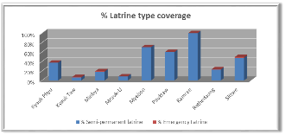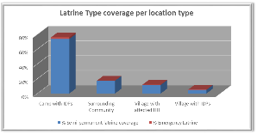

***In camp-settings,*** the shift from emergency latrines to semi-permanent infrastructures is almost completed and the overall coverage, following a 1:20 ratio is close to achieved. The availability of space in some sites, nevertheless, does not allow the construction of additional latrines. The current design deployed throughout 2013 and 2014 follows the semi-permanent concrete-pit design[13]. The life-span of the superstructures has shown to be short, which added to the lack of firewood and consequent theft of materials by the IDPs, implies a permanent need of repair. With the objective to maintain their functionality and ease their maintenance by the community, the usage for parts of the structure of materials with a longer durability and reduced disludging frequency – for example larger pits, concrete floor slabs, thin sheet walls – are needed. Following lessons learnt, the safety of the infrastructures, latrine pits covers in particular, must incorporate strict safety guidelines and the child-friendly design[14] still need revision to better incorporate children feed-back. The initial results[15],[16],[17],[18],[19] show that, although adults use regularly the latrines, children and elderly still do not dispose safely of feaces. The related WASH Cluster guidelines will be updated to incorporate experience and refine recommendations.

The completion and increased usage of the latrines in the camps led to the need of disludging and treatment systems. The WASH partners have set in place in Sittwe Township a complete mechanism[20] of latrines disludging, transport of sludge and treatment at the Sludge Treatment Station in Say Tha Ma Gyi. The management of sludge in Sittwe directly by local government departments, such as DRD or TDC, has been identified by the WASH Cluster since 2013 and remains a point of advocacy. The treatment of sludge in other townships is under implementation through on-site units, as transport is challenging. The latrines design needs to be revised to adapt to the specificities – geology and logistics, of these locations.

In camps, the solid waste management is organized by the wash actor by mobilizing volunteers and community, and, with very few exceptions, the environmental conditions are acceptable. The implementation of incinerators[21] allowing a safe final treatment of the waste remains to be expanded to most of the camps. The drainage of waste and rain water, wherever possible, has been deployed using long-term materials such as bricks; most of the camps, however, are in flood – prone areas or paddy fields- making simply impossible to drain the water. Specific infrastructure such as laundry slabs have also been deployed by some partners after consultation[22] of the beneficiaries.

***In villages***, the WASH Cluster promotes the construction of latrines through community mobilization and the provision of some supplies, according to the specifics of the location and the materials and skills available locally, 2014 lessons-learnt[23] show good opportunities if proper community communication is followed. Bamboo-pits latrines, wherever is possible in relation to the risks of groundwater contamination, are a sustainable solution, in line with the recommendations from the Minister of Health and that allows the communities to actively participate to the sanitation effort and gain self-reliance.

### Improvement of hygiene practices and behaviors change

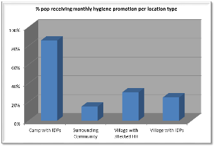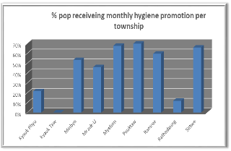

Hygiene promotion has proven to be very challenging, considering the poor pre-existing hygiene practices and knowledge of risks among the beneficiaries - Rakhine State has one of the highest levels of open defecation in the country[24]- but also the high demand in training and development among the national staff. The very different origins and backgrounds of the beneficiaries – from urban or rural origin, various different levels of education, often illiterate, different environment and access to services - do not allow a standard approach for all. The evaluation of hygiene behavior through Knowledge, Attitude and Practice surveys has been deployed for the first time in 2014 allowing a finer understanding of the beneficiaries, and the fine identification of gaps that need addressing.

The IDP living in camps are today more frequently exposed to hygiene promotion initiatives compared to villagers. There is also a difference as well in the degree of knowledge of IDP and affected households compared to the non-affected families, within a village. The latter have only recently being targeted by hygiene promotion in line with the WASH Cluster recommendations. The beneficiary profile is not homogeneous from one location to another, requiring a flexible approach and adapted messages in each case. The development of appropriate approaches and methods requires the direct implication and guidance of experienced program managers, whose prioritization in 2014 has been severely impacted by a rapid evolving context, challenging field access and delayed infrastructure completion. The usage of creative methodologies allowing strengthened participation of beneficiaries and their involvement into their own triggering of behavior change are currently being developed collectively by the WASH Cluster partners.

In 2013 and 2014, the target population of hygiene kits has been the affected households in camps or villages – all IDP were entitled to a full hygiene kit every year and a monthly replenishment, hosting families as well. The refining of the hygiene kit strategy[25] collectively by all the partners, based on post-distribution monitoring results[26], and WASH agencies analysis, includes the definition of criteria for the population entitled to kits based on geographical context (per township) and based on vulnerability. In Sittwe Township, beneficiaries sell mainly the sanitary pads and the body soap in the markets in order to afford other services such as food items, medicine and education showing that the hygiene kits deserve rather a livelihoods aim than hygiene need.

In 2015, the WASH Cluster collective decided to limit the hygiene kits distribution to IDP in camps only. An inter-sectorial coordination, in particular with NFI Cluster and Livelihoods working group, should be adopted, in particular related to a better understanding of the local market dynamics and the household basket share, and the feasibility of usage alternatives such as voucher systems will be explored. In other townships, although, there are examples of cases where all items distributed are used by the beneficiaries, the access to markets is variable and requires more detailed study. The lack of livelihoods opportunities for the IDP population leads to a dependency on WASH interventions as part of incoming generating activities: Hygiene kits are sold immediately in the markets, latrine cleaning as income. This dependency will not change unless other actors bring targeted livelihoods opportunities.

The WASH Cluster continues to promote the systematic promotion of hygiene for all individuals and in all locations, addressed to the whole community – with specific objectives and methods for women, men, girls, boys, elders and people with disabilities. The strategy is oriented towards behavior change – through positive deviance and barriers braking. During 2014, the overview of the different hygiene promotion methodologies that the WASH actors are currently using[27] made by the WASH Cluster showed important disparities - topics being tackled, use of direct dissemination or peer-to-peer, segregation of audience by gender or by age, involvement of community leaders and measurement of results. It also highlighted opportunities to improve the outcomes through development of capacities of WASH staff and further stimulation of collective sharing of methods and tools[28] (IEC materials …).

The formalization of a framework for hygiene promotion[29] will provide orientation and allow a methodological approach, based on a finer understanding of the audience, and a systematic monitoring, in particular through studies and KAP surveys. The design of the campaign based on the specificities of the location, and including the distribution of items in relation to the topics – soap and other hygiene items - as encouragement, stimulation or reward allows regaining interest, accelerating behavior change, and empowers beneficiaries. The hygiene promotion – soft component – must be included in the overall WASH program at all stages. While general experience and capacity of the WASH staff still needs to be developed, several methodologies – social marketing currently piloted by Oxfam[30] or participatory approaches – have been pre-identified as interesting tools to explore and adapt to the Rakhine context.

### Mainstreaming of cross cutting issues in the WASH response

Several studies[31],[32] in 2013 and 2014 showed a need for additional consideration of gender sensitivity in the WASH programming. In camps, latrines and bathing spaces are often reported as areas of concern for safety and security, largely due to damage, lack of gender segregation, of lighting or locks. In 2014, “do no harm” approach including specific concerns about gender and people with special needs issues has been developed[33] and further development is planned in 2015 in coordination with the Protection Working Group. The WASH actors have invested efforts in improving the organization of the latrines and safety through solar lightning and adapting the content of the hygiene kits to integrate gender. The WASH Cluster has developed guidelines for a better consideration of menstrual hygiene[34] and is working closely with the Inter-Agency Gender Advisor to further sensitize the field teams to gender issues and refine the operationalization recommendations related to gender across all activities.

Although actors have included a number of features within the latrines specially designed for people with disabilities – including larger access and rails - recent assessments[35],[36] coincide in the fact that vulnerable beneficiaries are not satisfied with the WASH infrastructure in the camps. In August 2014, the an Accountability to Affected Populations survey[37] led by Global WASH Cluster highlighted a number of weaknesses in the eyes of the beneficiaries towards the WASH action – lack of formal complaints mechanisms, poor transparency and information sharing related to project goals and objectives, expected results, time frame, summary of finances and poor participation of children and adults with disabilities, women and girls in routine consultations. The WASH Cluster in partnership with OCHA Communication with Communities department will seek to address these weaknesses and continue monitor­ing the compliance with WASH Minimum Commitments for the Safety and Dignity of Affected People[38].

### Opportunities for possible transition from emergency to development

After over two years of the intervention, villages that were affected by the conflict – hosting IDPs or families affected, show signs indicating that their WASH condition is similar to what it was before the conflict and, in some aspects even better than the neighbouring villages. Communities show a level of behaviour change achieved – accepted and appropriate usage of ceramic filters, usage and community maintenance of latrines and basic public health knowledge, community mechanisms have also been maintained in the cases of affected people in or near their point of origin.

Although the Government plan for Rakhine State is not yet communicated, some assessments[39] and pieces of information shared by the line Minister[40] tend to suggest a plan for relocation in long-term individual accommodation of some communities to the point of origin. This could be seen as a first opportunity to transition through a hand-over to the development actors. However, the question should not be seen from the WASH perspective only and an inter-sectorial analysis and positioning is required to advise the HCT. The humanitarian scope would therefore be restricted to camps and some other specific locations.

The relocation to long-term accommodation of some population, the leadership of AHCT/OCHA for an inter-sectorial approach is crucial. Particularly, WASH and Shelter cluster must progress in a joint manner, joint site planning, and coordination of actions to avoid reproducing the experiences in 2012 and 2013. Shelter Cluster has identified possible options for the coming months as per recent exchanges with Government that will need attention, in particular, related to the communities in or near point of origin where Government suggest that a material package for construction of individual houses is planned. Both clusters continue advocating for a joint planning, analysis, fund raising and implementation with Government. In these locations, the humanitarian support should seek at supporting the last phase prior to disengaging.

### Strengthening of relations and empowerment of authorities

The Rakhine State Government (RSG) is the primary responsible for all the people in Rakhine. Increased collaboration will allow to communicate plans and projects and better integrate them. There are already several examples of specific activities that RSG has taken in action. The emergency water boating for Ah Nauk Ye camp (Pauk Taw) at the end of the dry season was a successful intervention in collaboration between DRD with SI in 2014 and will continue in 2015. In Mrauk-U, **the Township administrator provided pans and pipes for latrines repair and offered to provide more upon request by the conflict-affected community.**

Other activities - solid waste management, sludge treatment, pond rehabilitation - have been identified as good opportunities to encourage the RSG to take leadership. In order to enhance the relationship with Government, the WASH Cluster has mapped governmental structures[41] and will in the future map their capacity, share WASH Cluster documentation and exchange on technical topics – guidelines, lessons learnt. Finally, the links between RSG and UNICEF development projects are currently being reinforced, aiming at a more sustainable approach and capacity building in bringing national policy at state level. The technical engagement with RSG, beyond coordination, is not restricted to DRD, while a stronger bridge should be developed with the State Health Department, through the Health cluster or directly. Hygiene promotion initiatives have been a good opportunity to initiate such a relationship, while also rapid wash response for Diarrheal risk remains of concern.

Collaboration with the authorities should not be only at state level, while Township administrator should be engaged to support project implementation and, to some extent, to contribute to its definition, planning and evaluation. Transparent and permanent communication among all the different actors is then strongly necessary, included in a process of building mutual confidence at medium term and repeatedly requested by the RRSC.

## Approaches validated

### “One NGO focal point per location”

As validated in the WASH Cluster Strategy in 2013, one WASH actor is in charge per camp, and in 2014, extended to one actor per location (camp or village). The WASH actor in the location or site has the responsibility to develop a full WASH package approach - on all sub-WASH thematic issues -, aiming to fully cover the beneficiaries’ WASH needs.

Each NGO also has the responsibility to be coherent in their geographical coverage ambitions, according to their capacity and realistic financial expectations. The risk to have NGOs covering (too) large areas, but finally responding in each locality only sporadically should be avoided: First at all because a "full package approach" per location should be deployed, and secondly because it biases the coverage analysis and restricts potential new comers with additional means to offer support for a quicker and smoother response to beneficiaries’ needs.

The back-up approach in place in 2013 and was used after the March events. Defined through the 4W, it allows coordinating external and temporary support to an actor facing difficulties due to unforeseen events. Ideally that back-up support is requested spontaneously through the cluster, with primary consideration being for beneficiary wellbeing, or can be triggered by the cluster itself, based on monitoring/evaluation evidence.

To facilitate such positioning, and offer also clarity to donors, the NGO mapping per location was done (see annex 12). Such exercise will allow the cluster to progressively identify gaps in the coming months. Indeed, so far all areas seem to be well covered, but donor support is not yet confirmed to the full extent needed.

### Do No Harm and conflict-prevention

The approach developed below aims at avoiding 3 different negative possible effects - creating stress between Camps and surrounding communities, by developing better access to WASH services in camps, creating a pull effect towards camps by developing better access to WASH services in camps, which counter produces the overall humanitarian strategy defined and creating/exacerbating stress between different communities, by developing WASH services for only one group considered directly affected.

The WASH actors first, and the humanitarian community after, clearly identified the necessity to increase the action in the host and surrounding communities. Regarding terminology, the WASH cluster decided to consider the following definitions:

* Village with IDPs: Villages hosting IDPs from other villages affected following the inter-communal clashes
* Village with affected households: Villages having suffered from the inter-communal violence, with house destruction, with families registered by UNHCR
* Surrounding Villages: Villages in the vicinity of the camps.

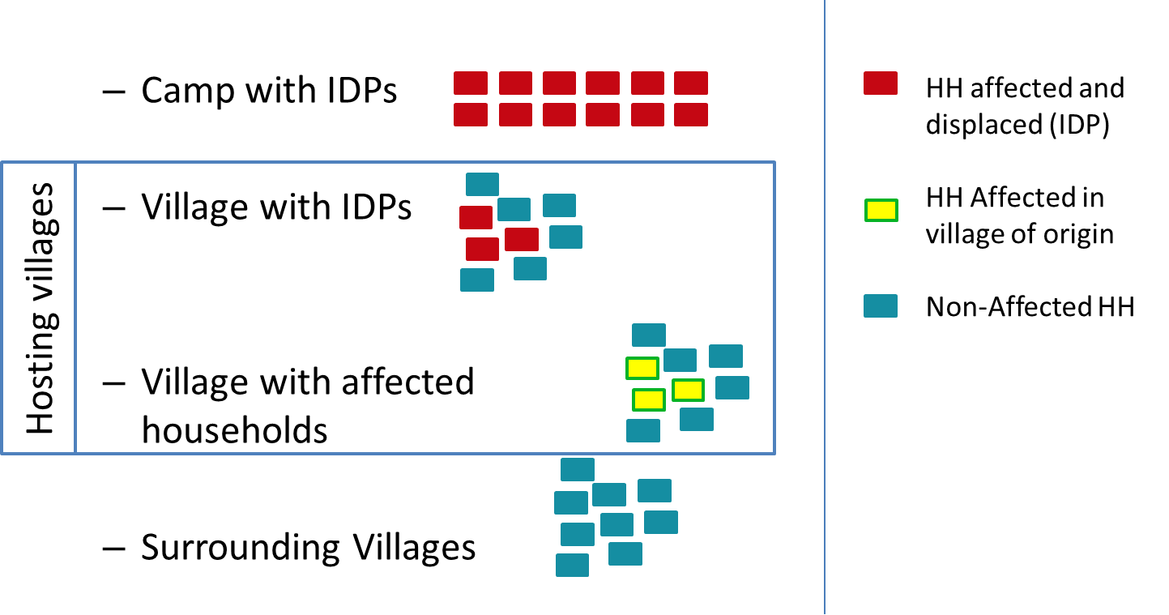

Figure 4 – WASH Cluster site typology definition

An attempt to identify the surrounding villages to target was done by OCHA in August 2014 based on conflict sensitivity and not on vulnerability. The main criteria proposed included village tract affected by the conflict, multi-ethnic village tract, resources shared by both communities. However, the micro-dynamics at village level and expectations at township level appeared to be extremely linked to the specific actor concerned and their sector. There was not possible to conclude from an inter-sector perspective.

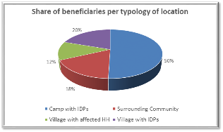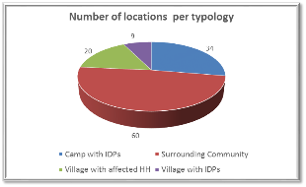

Figure 5 – Share of beneficiaries and location per typology

Thus, the WASH actors have initiated the selection of sites, case by case. The figure shows the population and the number of sites per typology – half of the WASH beneficiaries are currently in villages, and almost 75% of the intervention sites are villages.

The WASH action in villages is however at various stages in those locations. Villages with affected households or IDPs have received assistance for some years not, although not all the villagers always benefitted from it, in some occasions only the affected households did. Surrounding villages were considered in a later step and in addition, community and local authorities approach take time to ensure acceptance. Lessons learned have shown that the villagers must first accept and understand the purpose of intervention - actors’ rushing to aid the most vulnerable generally causes loss of access a few months later due to community resistances. The WASH Cluster collective agreed to deploy the same WASH intervention in village context, disregards of it was a directly affected village, a host village or a surrounding community and using as much as possible, developmental concepts and tools. In particular, WASH is schools, in collaboration with UNICEF and the WASH in schools policy under development at National level, should aim at addressing the lack of capacity and skills to organize efficient operation and maintenance of infrastructure.

The identification of villages to be targeted by the WASH cluster is on-going, based on conflict sensitivity. The approach to selected locations will vary depending on the many variables - location, needs, access, etc. The required technical objectives in terms of needs coverage differ from SPHERE guidelines. In July 2014, the WASH Cluster defined the scope of the intervention in villages in Rakhine state[42].

The fine tuning of the intervention in villages is yet to be done, based on lessons-learnt from the current action, and developed through a technical working group. The production of guidelines for low-cost latrines designs in line with the Ministry of Health recommendations and providing a potential for sustainability is ongoing.

### Develop hydrogeological knowledge

In addition to the scarcity of water at the end of each dry season leading to implementation of emergency water supplies, the quality of infrastructures and their capacity to reduce the contamination risk as much as possible remains of concern. In order to secure the permanent access to protected water, permanent solutions need to be found. With the aim to develop the hydrogeological knowledge of the WASH sector, data related to water sources – including geo-positioning, key parameters and water quality - will be collected by all the WASH actors. This will allow the creation of maps delineating different hydrogeological environments in the state, to guidance appropriate interventions for each of the hydrogeological environment, to offer a tool for seasonal analysis, to prepare an eventual hand-over of the water sources knowledge to DRD, etc. The WASH Cluster initiated in 2014 collaboration with “Hydrogeology Without Borders” to develop the tools to collect this data and provide guidance on hydrogeological analysis. The WASH actors, in a collective effort, will contribute to gather this knowledge.

### Towards self-reliance and community empowerment

Community participation is crucial in any management system to encourage self-reliance of beneficiaries, contribute to increase their autonomisation towards services provided and contribute to some extent to restitute affected people’s dignity. In the context, community-managed infrastructure is the best option for ensuring sustainability. Opportunities and solutions widely vary from location to location, and depend on the type of infrastructure, the community capacity and organization and on the humanitarian and governance context.

The IDP in urban camps in Sittwe show a certain financial capacity and willingness to purchase water when the supply of the network is not sufficient. This shows a potential for cost-recovery schemes to be developed for water supply but also for solid and human waste management. In a join plan with the local authorities, such as scheme could evolve towards a livelihoods opportunities and/or pilot for future urban mechanisms

The absence of livelihood opportunities, added to the restriction of movement, leads to high stress on infrastructure in rural camps and the dismantlement of facilities for firewood, jeopardizing the energy invested and lowering considerably the impact of the WASH action. The upgrade of latrines with more long-lasting items, modification of designs to more appropriate solutions will ease their maintenance by the community and will develop a sense of ownership, to a future hand-over of responsibilities for their upkeep and phase-out of latrine cleaning payment by the WASH actors. In these protracted crisis, success of such social approaches remains nevertheless highly dependent on appropriate livelihood parallel activity to support resilience development of the IDP.

The allocation of latrines per families in the camps – allowing phase-out of payment – was initiated, although not successful or feasible everywhere. The main barriers include limited coverage or poor distribution of facilities across camps and necessity of strong guidance by agencies to organize the allocation. In addition, limited hygiene knowledge has a direct impact on the prioritization by IDPs between private facilities and income, in some cases, latrine cleaning stipend is the main source of household income. In areas with high density of population, simultaneous phase-out in all locations is required to limit the tensions between IDP of different camps. The high number of unfunctional handpump offers also an opportunity to develop, through training and tools support, a certain level of social management of water.

This social approach should be harmonized with the existing camp management structures. Wash users’ groups have been in most of the cases created by the WASH actors before the CCCM activity deployment. These are the key element for an active and permanent social mobilization in the benefit of all IDP. These community-based groups must now be linked to the camp management structures, follow the same principles and act as a part of them. The terms of reference of the WASH users’ group[43] have been developed, remaining the linkage with the overall camp management structures.

There are several valuable examples of spontaneous or triggered but effective social management by the population in camp-like settings.. All these instances of social management of resources, even in complex emergency settings, should be, in one hand, encouraged and supported and, on the other hand, reported and expanded.

In the context of villages, Government-created community-based groups exist – Village Development Committees (VDC) – and should be engaged from the earlier stages of the intervention. In addition, empowerment of beneficiaries may also involve the recruitment and training of village people - mobilization happens within the village families, finer understanding of the local power dynamics, knowledge about availability of resources and capacities. Enhanced transparency towards the village and its leaders about the objectives and the activities of the action has proven[44] to lead to acceptance and buy-in of communities.

In order to enhance the WASH actors’ engagement with the communities, the support from the Communication with Communities from OCHA will provide better options related to information flow between agency and beneficiaries to empower communities to make sound decisions regarding how they allocate resource, behavior change communication, evaluate participatory processes and suggest improvements and support to communication planning.

### Concepts to be improved

Some of the designs have proven to be inappropriate to the culture and to the communities and are currently not used for the intended use. In particular, the following items require deeper consultations with the beneficiaries to revise the design and reach the expected outcomes:

* Hand-washing facilities: the current design of one facility for 10 latrines is rarely used. Indeed, if they do, Muslim communities wash their hands after defecation inside the latrine with the water they carry for flushing.
* Rain water harvesting systems for drinking water: where initially implemented in locations where only rain water is available as a mitigation measure for water scarcity with the intention to reduce the pressure on pond water at the end and the beginning of the rainy season. However, the system itself did not bring an added value for the IDP compared to water collection directly from the CGI roof and the systems have been dismantled in most of the cases to re-use the wood and the drums for other purposes.
* Bathing space in camps: although the design[45] was done through several community consultations and focus groups[46],[47] and meantto address the specific needs of girls and women, communal bathing spaces have not been used by women. Often abandoned, dismantled for firewood or used for various inappropriate purposes, the communal bathing spaces do not seem to provide the required privacy or security expected by the beneficiaries. The WASH actors are currently implementing a simple concept of individual shower to be installed either in the shelter unit or next to it. The challenge linked to the drainage of every single shower is yet to be tackled.
* Child-friendly latrine: although the initial design was done through consultation with children, there is a need of revision to better incorporate children feed-back.

## Priorities identified

### Water

* Upgrade of water facilities to technical minimum standards allowing to preserve the quality of the resource, in both camps and villages, either permanent or emergency infrastructure
* Expansion of monitoring of Water quality to all locations
* Identification of reliable alternative sources to emergency water supply through hydrological and/or environmental surveys
* Social management of water resources and future maintenance (user’s group, capacity building, ownership)
* Expansion of monitoring Household treatment solutions such as ceramic filters and evaluate overall intervention
* Support and promote community-led maintenance and repair of non-functional infrastructure

### Sanitation

* Upgrade/Repair of latrines to maintain functionality
* Development of on-site sludge treatment systems in remote townships
* Fine-tune a financially viable approach for villages
* Social management - Allocation of latrines per families (phase out payment of latrine cleaners)
* Systematic implementation of waste management mechanism with incineration as final treatment
* Systematic access to facilities for Disabled/Elder

### Hygiene promotion and change behavior methodologies

* Systematic Hygiene promotion approach in all locations to all individuals
* Evolution of HP approach to regain interest, accelerate behavior change, empower beneficiaries
* Increase collective knowledge and understanding through studies, surveys and assessments related to the sub-sector
* Ensure beneficiary needs definitions are linked to technical approaches
* Gender mainstreaming - segregated sessions, specific topics, adapted tools…
* Adapt Hygiene Kit strategy to better address needs of the most vulnerable, in link with livelihoods opportunities, township specific
* Develop social mobilization, through outreach workers, peer-to-peer, specific groups
* Collective share of tools and methods (IEC)

### Cross cutting issues

* Gender should be mainstreamed in all technical and social approaches and monitored through adapted tools, while it is a major issue still not addressed enough
* Systematic access to facilities and full involvement in social aspects for Disabled/Elder
* Better integration of livelihoods analysis to be developed
* Improve representation, participation and decision-making of vulnerable groups - children and adults with disabilities, women and girls - in all WASH technical and social initiatives
* Accountability and beneficiaries feed-back integration in relation to the WASH activities
* Promote transparency and information sharing related to project goals and objectives, expected results and time frame

### Emergency Response Preparedness

Rakhine is at high risk of cyclones, which occur primarily in either May or October/November. In the frame of the Emergency Response Preparedness (ERP) and the yearly revision of the plan facilitated by OCHA, a Rakhine WASH Cluster Contingency plan was created in 2014 but needs to be consolidated, while new guidance are expected form OCHA in 2015 to be finalized before end of April.

At the WASH Cluster level, aside of the three-monthly stock and human resources updates, the WASH actors have also jointly organized an “emergency water treatment station set-up and operation” training to increase the staff capacity to respond. The organization of the training was the opportunity to identify weaknesses in emergency response capacity of the WASH Cluster partners - not enough equipment is available in Sittwe for emergency response, no knowledge related to emergency response among local authorities.

The development of the ERP in 2015 and its declination to the WASH sector should be done in a joint effort with the Rakhine State Government in order to enhance its operationalization and efficiency. Among its key features, the Rakhine WASH ERP will include the update of the existing AWD Preparedness and Response plan[48], the continued promotion of a back-up mechanism, as recommended after the AWD risk assessment[49] in 2013. This mechanism allows a temporary support between WASH actors, without interfering and disrupting one of the key sectorial objectives of providing WASH services in an uninterrupted and successful manner - one focal NGO per camp. Indeed, camps needs are very rationally covered each day, without any overlapping, in coordination between actors with support of the cluster.

### Advocacy

* Active participation and contribution at field and Yangon levels to all key messages related to humanitarian access
* Transparently inform and document the WASH conditions of the beneficiaries on a regular basis to RSG and international community
* Reinforce collaboration with RRSC to address commonly land issue, and ensure common problem resolution
* Promotion of development actors and donors to join the effort in Rakhine
* Promote inter-agency durable frame work for relocation of IDPs, in collaboration with authorities Rakhine Action Plan

### Locations to prioritize

* Maintain the coverage of camps by WASH actor.
* Reinforce coverage of villages in a conflict-sensitive manner – target communities witnessing of the humanitarian action, acknowledging their vulnerability in terms of health associated with pre-existing poor sanitation conditions.
* Kyaw Taw – 3 affected location never covered
* Myebon Township
* Pauk Taw – Emergency water supply from march to June – until permanent alternative is found

## Target population review

The WASH cluster target population is within the Myanmar Humanitarian Response Plan boundaries of population affected by the conflict. The population displaced or affected is estimated by the CCCM Cluster to 138,622 persons: 116,183 in camps and 23,127 in villages (14,969 in village of origin, 8,158 in host families). In addition, 50 415 persons live in the villages that host IDPs and Affected families. Indeed the WASH intervention cannot target only the affected individuals in a village environment, but should aim at a holistic approach of the village needs[50].

The target population evolved in 2014 towards a more inter-sectorial “Do No Harm” approach, expected to be more “conflict sensitive”, leading to the inclusion of communities surrounding affected locations or camps. The lack of assessment results, launched at the end of 2013, roughly estimates an additional 50,000 persons to target. However the way to target such population won’t be oriented on full coverage, but much more partial and more community driven based.

The HRP attempts to tackle also the Northern Rakhine State population (NRS) – Rathedaung, Maungdaw and Buthidaung townships, identified also in very high humanitarian risk regarding malnutrition rates, where WASH is identified as one of the possible roots causes, and being also affected by the conflict events. However, the same type of response cannot be defined, by identifying very specific micro-targets for who to raise WASH standards with direct action, while the situation in a strictly WASH needs approach would need a more long term development in response through, for example, township development plans. Any WASH response should be defined through an integrated approach with the nutrition sector, remaining to be defined, based at least on mapping, priorities and assessments. However this strategy is an opportunity to raise pragmatically the concerns, stimulate exchanges and analysis on the situation, where the cluster can bring support in coordination, capitalisation, evaluation, and advocacy process. 177,290 extremely vulnerable people have been estimated in the Myanmar Humanitarian Response Plan.

Then, the total target population in Rakhine for the WASH Sector is estimated to 309 310 persons summarised in the table below:

|  |  |  |
| --- | --- | --- |
| WASH target population | HRP  People in need | Caseload  Targeted by WASH |
| IDP in camps | 116,183 | 114,392 |
| IDP in host families | 8,158 | 13,724 |
| IDP in village of origin | 14,969 | 11,194 |
| Non-IDP Hosting villages | 100,000 | 100,000 |
| Non-IDP Surrounding villages |  |
| Non-IDP Crisis Affected | 177,290 | 70,000 |
| Total | **416,600** | **309,310** |

(Annex 10 offer a break down per location of the beneficiaries)



**KACHIN WASH CLUSTER STRATEGIC FRAMEWORK**

## Background context

The current armed conflict in Kachin and North Shan State, opposing the Governmental Army and rebel groups, began in June 2011, and has resulted in the displacement of some 120,000 IDPs in camps in both governmental controlled (GCA) and non-government controlled (NGCA) areas.

The Kachin and NSS IDPs are faced with protracted displacement, while some IDPs have been displaced multiple times. For those in situations of protracted displacement, the lack of access to livelihoods and vocational opportunities is a major issues that makes IDPs depending of Humanitarian assistance.

Local NGOs continue to play a leading role in the humanitarian response across Kachin and northern Shan especially in NGCA where local WASH actors are in the front line of the humanitarian response.

From late 2013 until September 2014, there were major improvements in access to the areas beyond Government control for international humanitarian organizations, with the Government authorizing more than 20 cross-line missions. These missions enabled the WASH actors to undertake monitoring fields visits and assessments, to undertake WASH coordination meetings and to distribute WASH NFIs.

However, at the end of 2014, a military conflict in Laiza area led to the stop of humanitarian cross line missions limiting access to humanitarian actors and jeopardizing the on-going WASH projects in the concerned area.

Regular resurgence of military action remains a key threat to population in Kachin and northern Shan. In addition and the overall humanitarian situation in 2014 has seen regular small scale emergencies requesting WASH humanitarian response from WASH cluster

In 2014, about 4 major events required specific mobilization and coordination of the WASH cluster beyond regular humanitarian response. These events include cholera outbreak rumours following one lethal diarrhoea case of under 5 children in South Kachin and diarrhoea cases outbreak leading to the hospitalization of about 20 people, violence outbreak at the border of Kachin and North Shan States leading to the displacement of about 2700 people and to the creation of three new IDPs locations, landslide in IDP camps affecting about 600 people and fire in one IDP camp affecting more than 400 people.

Then at the beginning in 2015 new fighting in Hpakant area led to the displacement of more than 1000 people and its related humanitarian WASH needs.

The humanitarian WASH response following these small scale emergencies included WASH assessment, WASH NFIs distribution, construction of new WASH facilities, hygiene promotion activities, and coordination meetings between WASH cluster members. Security issues, geographical spread of IDPs locations, restricted access to the concerned areas and overall communication challenges made the WASH interventions more complex than what could be expected from small scale emergencies

The protracted crisis in Kachin and NSS, involving regular small scale emergencies, requires from WASH actors working in both emergency and post-emergency settings.

The deterioration of the overall humanitarian situation at the end of 2014 and 2015 in Kachin and NSS, reasserted the protracted nature of Kachin crisis and may eventually lead to additional IDPs. No massive returns or relocations scenario is expected in 2015.

Under these circumstances, the WASH programmatic activities in 2015 should aim at increasing the sustainability of existing WASH facilities in affected areas, monitoring the WASH situation in current IDPs locations, and strengthening the operational capacity of local actors to face small scale emergencies.

### Early recovery and durable solutions

Since the onset on the conflict early recovery components have been mainstreamed into WASH activities. The HP activities accompanying hardware facility construction, the upgrading of wash facilities to more permanent designs, the mobilization of community and capacity development of wash actors have contributed to sustain the interventions

Although the overall humanitarian situation has been not conducive to the development of WASH durables solutions, the WASH cluster, based on international humanitarian principles of durable solutions, will continue to be engaged into inter-sector coordination mechanisms to design a framework of WASH durable solutions to be prepared for any future return or permanent re-setlement.

During 2014, the Kachin State Government took the initiative to resettle 113 households from camps out­side Myitkyina to a newly-built village called Pa La Na.

### Increase of WASH actor’s presence in IDPs locations

The presence of WASH actors with on-going WASH projects has been increasing significantly in IDPs camps in 2014 with a peak in the middle of the year where 97,5% of the total IDPs camp population was targeted by a WASH project . At the end of 2013, WASH actors were present in only 52% of the total IDPs locations against 76% at the end of 2014, through 12 WASH projects undertaken by 11 WASH focal agencies. Red Cross Movement, WASH-related authorities and private sector and UN agencies contributed also to the overall WASH humanitarian response through miscellaneous interventions.

At the end of 2014, the 16 IDPs locations without WASH focal agency, out of a total of 171, were 9 villages and 6 camps. The WASH situation in these locations needs to be assessed.

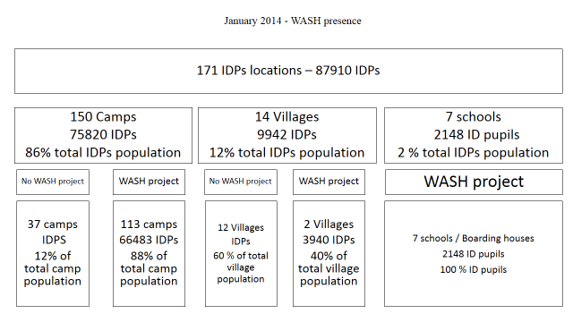

Although the overall security situation in Kachin didn’t facilitate field visits, assessments in villages hosting IDPs or surrounding IDPs camps have been undertaken by the WASH cluster members and findings are in the process to be consolidated. The presence of WASH actors with WASH projects remains low in villages and should be strengthened based on identified needs.

### A more balanced response in 2014

The strong discrepancy of water coverage between IDPs camps of GCA and NGCA observed in December 2013 (86% water coverage in GCA against 40% in NGCA – source: 4W December 2013) has been greatly addressed by the WASH cluster members over 2014. Then in December 2014, the water coverage was almost similar in GCA and NGCA with a respective coverage of 98% and 97% (4W December 2014)

Then despite the restricted access to NGCA, and thanks notably to the efforts of local NGOs, no major discrepancy is now to be noted in terms of quantitative coverage between GCAs and NGCAs. Based on the figures provided by the December 2014 4W matrix, the WASH humanitarian response appears to be balanced between GCA and NGCAs. It has to be noted that the impact of HP activities is however not well documented due to restricted access and that no comparison between GCA and NGCA is available.

The overall quantitative water coverage remains however higher than the sanitation one and 2015 should clearly focus on the remaining quantitative sanitation facilities needs to address the discrepancy between water and sanitation responses.

From December 2013 to December 2014, the overall water coverage has increased from 63% in December 2013 to 97%, the latrine coverage has increased from 58% to 80% and the overall bathing facilities coverage from 12% to 43% in the IDPs camps of Kachin and NSS.

A slowdown of sanitation coverage progress has been observed at the end of 2014 that can be partially attributed to land availability issues but also to limitation in terms of fund availability.

The increased presence of WASH actors and projects combined with the 100% coverage and WASH focal agency approaches as well as the consolidation of 4W matrix as a monitoring tool surely contributed to increase significantly the WASH facilities coverage in IDPs camps of Kachin and NSS over 2014[51].

Priority should be given to IDPs locations with remaining sanitation needs to better apprehend the real needs and practical feasibility to reach 100% approach in terms of coverage.

### WASH related authorities in Kachin

In Kachin, the coordination with the new created Department of Rural Development (DRD) has been initiated and strengthened over 2014. DRD is under the Ministry of Livestock, Fisheries and Rural Development and with responsibilities including roads and bridges; electricity; and rural water supply. This strengthened coordination will lead to the co-chairing of the WASH sub-cluster with the Department of Rural Development (DRD) in 2015 first in Myitkyina and Bhamo. This co-chairing will include joint preparation of agenda, co-facilitating, and joint minutes reporting

The co-chairing of the WASH cluster with DRD will be an opportunity to enhance the local WASH capacity to manage emergency WASH responses to affected people in line with national and international humanitarian standards. It should also progressively enable to better link development and emergency WASH issues by create linkage between other wash related authorities and developmental WASH actors.

The two main government stakeholders with respect to Rural WASH are department of Rural Development (DRD) and Department of Health (DoH). Township development Committee/Authority (TDC/TDA) focus on WASH in peri-urban/urban context.

Coordination has been reinforced mainly through bilateral meetings with the Department of Health whose responsibilities include notably the promotion of sanitation and basic hygiene. Then the Relief and Resettlement Department, although being not a WASH actor has been regularly participating to the WASH cluster meetings and efforts should be pursued to ensure that RRD is also part of the overall WASH coordination mechanism in Kachin. Finally The Township Development Committee (TDC) participated to some Technical Working Groups notably in Myitkyina in order to contribute to the overall technical discussions.

As for the liaison with non-state WASH related authorities it has been limited in 2014 given the poor access to NGCA.

## Equitable and sustainable access to sufficient quantity of safe drinking and domestic water

### Securing water quality access

Besides the excellent quantitative water coverage, securing the quality of water delivered to the IDP remains a challenge in Kachin and NSS

A pilot monitoring campaign undertaken by the WASH cluster members from August to December 2014 in 95 IDPs camps shows then that 33% of monitored hand-dugs wells and 27% of monitored spring catchments are prone to seasonal water shortage. Besides, most of the monitored WASH facilities would be subject to low or high level of turbidity. Based on this monitoring campaign, most of the water facilities would be not appropriately protected against faecal contamination raising a health concerns in the high density population camps of Kachin and NSS.

|  |  |
| --- | --- |
|  |  |

The technical upgrading of water facilities, combined with appropriate operation and maintenance activities remain a prerequisite to improve their overall sustainability and the related water quality.

Besides the technical upgrading of water facilities, the distribution of CWF at Household level, accompanied with HP activities has been also undertaken by some WASH agencies to secure water quality and the point of use.

Although, some water quality testing have been carried out by some WASH focal agencies, the bacteriological quality checking of water provided to the IDPs is not yet a systematic approach at the cluster level. Trainings of local WASH actors on water quality testing in 2014 and on-going purchase of water testing equipment by local actors should enable to develop further the water quality monitoring approach in 2015.

***Equitable access to safe and sustainable sanitation and to a non-contaminated environment***

### Upgrading sanitation facilities

The semi-permanent latrines coverage has increased from 36% in December 2013 to 51% in December 2014 in the documented IDPs camps of Kachin and NSS where more than 2300 semi-permanent latrines are currently in use. The promotion of latrines equipped with water seals and enabling proper confinement of excreta remains challenging in Kachin and NSS where many IDPs are using anal cleansing items not compatible with such design. The graph below comes from the WASH monitoring undertaken in 95 IDPs camps from august to December 2014

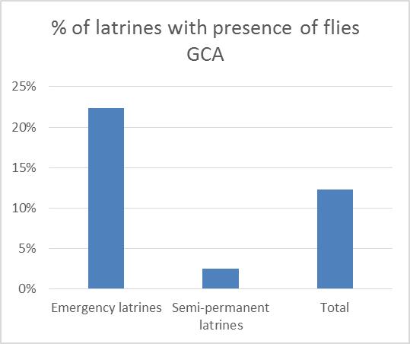

This increase of semi-permanent latrines coverage contributes notably to better address protection issues and enables also to consider desludging activities

### Desludging

The quasi absence of desludging actors and appropriate solutions combined with the prohibitive desludging cost prevents most of the IDPs from desludging the latrines and therefore lead to out of use emergency latrines that need to be decommissioned.

The desludging of latrines is a major challenge in Kachin. It is today undertaken trough two different channels:

* Although obsolete, some municipalities have one desludging truck that can be used for the IDPs settlements located nearby
* Some informal desludgers without any adequate equipment and not properly trained provide occasionally desludging services

The cost of desludging is usually supported by NGOs, religious institutions and rarely by IDPs themselves who can hardly afford such expenses.

The research of desludging solutions have been part of the efforts of the WASH cluster members in 2014 through notably the development of a specific Technical Working Group. The members of this TWG carried out an assessment aiming at identifying the main opportunities and barriers for desludging activities. Land issue for excreta disposal sites is amongst the major issues that the WASH cluster will have to look at in coordination with local authorities to facilitate and scale up desludging activities in 2015.

Decommissioning of latrines have been carried out in 2014 by wash focal agencies in order to limit the risk of disease outbreaks and to allow proper living conditions in IDPs locations.

Sanitation challenges are too complex to be considered only from emergency aspect and should be obviously considered with local authorities and developmental partners in order to address the sanitation chain in a whole.

### Solid Waste management

Solid waste management remains also challenging, despite an observed social organisation for sanitation in camps, leading to good care of the facilities and cleanliness of the camps. Waste is often dumped in a camp zone defined for that purpose, but without adequate collection systems. Incineration, mainly in open air, does not occur during the raining season. The following are identified:

* More systematic deployment of incinerators, where township authorises (refuse in urban areas)
* Several camps successfully linked with township services, despite own capacity limitations, in relation with the services provided to the host community: such approach should be supported
* Private services are contracted by the camp representative: This can also be supported

***Improvement of hygiene practices and behaviors change***

### Hygiene promotion and WASH NFI distribution

Based on the findings of a rapid assessment on hygiene promotion approaches and tools for WASH response undertaken in June 2014 in Kachin state, it appears that 90% of WASH focal agencies in GCA are using some participatory methods coming from PHAST approach. Social marketing approach has been also piloted in some IDPs locations. Among the most common participatory methods used by agencies are: community mapping’ exercises, focus group discussions, exercises using visual aids to stimulate discussion and mobilisation activities such as three-pile sorting, chain of contamination, and pocket chart voting. In NGCA, the limited presence in the IDPs locations would prevent from using participatory approaches. While some focal agencies have included KAP surveys in their programmatic activities, the time and HR consuming in emergency settings have been the main reasons mentioned by the WASH agencies for not carrying out systematically KAP surveys. In 2014, a KAP survey template has been developed by the participants of a dedicated TWG on HP and aiming at supporting the HP teams of the WASH agencies to initiate KAP survey. Besides, trainings on Hygiene promotion approach in emergency has been given in 2014 to nearly 100 staff from NGOs and local authorities. Then, a joint Basic KAP survey has been undertaken from August 2014 by the WASH cluster coordination team and wash focal agencies targeting a total of 410 interviewees. The findings of this basic KAP survey are in the process of being consolidated.

As for the hygiene kits the coverage was 47% in December 2014. The voucher approach has been introduced, experimented and partially documented in 2014 by one WASH agency and proved to be an interesting solution to be scale up based of the local context. Besides vouchers approach, others alternatives WASH NFI distribution ways should be also considered in 2015 notably during hygiene promotion sessions.

Then a better knowledge of socio-economic profile of IDPs as well as of WASH NFI market availability is required to be able to shift from blanket to more targeted distribution reaching the most deprived population. Blanket distribution should be used in 2015 only for emergency situation or for specific cases where targeting distribution cannot be considered due to conflict sensitive and do not harm approach. The copying mechanisms of IDPs to get locally some WASH NFI should be better documented and post distribution monitoring should be carried out.

Monthly WASH NFI’s such as soap and sanitary pads will be increasingly difficult to fund. There is a need for more livelihoods support where possible to increase the economic status of IDP’s in order to be able to afford such items without WASH sector external support.

***Operation and maintenance of WASH facilities***

The graph below provides the main responsible structures for O&M of wash facilities in GCA based on the monitoring in 95 IDPs camps.

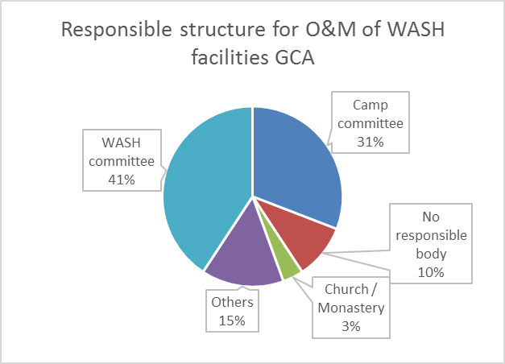

The “others” category include mainly some volunteers who take care about WASH facilities. Only 7% of structures would collect money on a regular base to ensure the O&M of the WASH facilities

In several camps water is provided though borehole equipped with fuel generator and connected to water tank. However, such systems require specific maintenance, and above all, high running costs. Those running costs won’t be addressable in the longer term by the WASH sector and should be addressed rather through community mobilisation or CCCM support.

The sustainability of O&M of wash facilities should be gradually developed through:

* The upgrading of facilities
* The reinforcement of management structures with strong coordination of shelter / CCCM cluster
* The community mobilization
* Clear communication campaign to communities

The WASH running costs should be better documented camp to camp and addressed in a more sustainable way. The Early Recovery sector could play a major role in collaboration with CCCM and WASH clusters to support beneficiary daily needs through the promotion of economic relief and self-sufficiency.

***WASH monitoring***

In Kachin, from the onset of WASH cluster activation in January 2013, a standard WASH Cluster 4Ws matrix has been designed in order to gather data on who is doing what, where, and when (4Ws). WASH agencies started input the data manually using a excel spreadsheet with the support of WASH cluster monitors to get familiar with the tool.

The development of this 4W matrix has been undertaken in parallel with the promotion of “One WASH focal agency per IDPs location” approach in order to rationalize WASH interventions. The 4Ws matrix remained until recently the main tool used in Kachin and NSS to provide the overall quantitative WASH situation analysis in IDPs locations and to ensure planning and monitoring of WASH programmatic activities and related funding raising.

This 4W matrix is a crucial tool in the Kachin and NSS as the conflict resume in 2011 led to the formation of about 170 IDPs locations geographically spread over two states and with limited access due to either logistical or political constraints.

The 4Ws matrix tools allowed so far to:

* identify the main quantitative WASH gaps trough an analysis of need coverage related to Sphere or context adapted standard,
* Support a proper geographical repartition of intervention preventing overlapping between WASH actors and optimizing the response coverage
* Offer a time frame of project coverage per location
* Geo-reference the project coverage and needs coverage
* Inform about the financial coverage of the HRP
* Inform about the sector performance toward the HRP objective and indicators
* …

However it is agreed between the wash cluster members that this basic monitoring system, mainly based on self-reporting, is insufficient to evaluate deeply enough the evolving IDPs needs in terms of WASH access, being too much quantitative based information, while the performance of the wash sectors should be evaluate toward a more outcomes results that the quantitative coverage by facilities.

Situation should be better inform with such consideration:

* Water quality access at water point and household level
* Water point meeting minimum technical standard to raise water quality access
* General facilities (latrines, bathroom…) minimum standard to meet expectation and proper usage of beneficiaries, including gender consideration, child access, sanitary condition, … and ensuring coverage analysis with real “functioning’ facilities to come closer to the definition of “used” facilities
* Taking then in consideration in the situation analysis the acceptance and satisfaction of community target through a more accountability approach toward beneficiaries
* Measure in an accountable way the results of soft Wash component as Hygiene promotion, social organization, self-reliance for maintenance of infrastructure…

Wash monitoring in GCA is supported by a set of National NGOs, who have full access to those areas, working through community-based organisations and permitting at least minimum response to the IDPs. However those local NGOs are requesting more support in terms of capacity building, for technical development

A monitoring methodology and tools will be developed in first quarterly of 2015, based on pilot monitoring phase in 2014 and with a strong component of capacity development of local actors and authorities. The role of camp committees into WASH situation monitoring needs to be further considered in 2015.

***WASH / CCCM / NFI***

The inter-sectoral coordination between WASH and shelter clusters has been reinforced through the setting up of quarterly Join WASH / Cluster meetings and through the joint development of WASH & Shelter proposals.

The coordination between wash and shelter clusters needs to be continued in the following areas of interventions:

* Maintenance and operation of hardware facilities
* Monitoring of humanitarian situation in IDPs camps
* Construction of shelters in new IDPs locations: Joint assessment and planning are needed in order avoiding any gap in the provision of wash facilities

***WASH & Protection***

Given the overall humanitarian situation of Kachin and NSS, the WASH cluster will continue coordinating closely with the protection sector in order to mainstream protection issues into WASH programmatic actvities. Coordination with CP sub sector will be carried out concerning boarding schools and boarding houses issues. Opportunities of training of wash members by OCHA GENCAP will be look at

***Approaches validated:***

### “Focal point for full package”

The approach to be followed is to have only one actor per location (camp or Host communities) which has the responsibility to develop a full WASH package approach, including all sub-WASH thematic issues, and with the aim to fully cover beneficiary needs. Indeed each NGO also has the responsibility to be coherent in their geographical coverage ambitions in accordance to their capacity and realistic funds expectations. The risk exists to have NGOs covering (too) large an area, but finally responding in each locality sporadically should be avoided: First of all because a "full package approach" per location should be deployed, and secondly because it biases the coverage analysis and restricts potential new incomers with additional means to offer support for a quicker response to the needs. Camp and/or WASH committees should be aware about WASH focal agencies approach.

### “Capacity development”

The strategy for capacity development will be pursued with a strong emphasis on WASH situation monitoring and analysis.

The objective of capacity building should be:

* Improve quality of infrastructure developed
* Enhance exchanges on experience and expertise between local and international NGOs
* Re-enforce gap identification and priority identification based on improvement of information management
* Gain capacity and flexibility for emergency, through technical and coordination re-enforcement

The WASH emergency responses in Kachin and Northern Shan states have been implemented mainly by Local WASH organizations who have regular access to conflict affected locations including Non-government controlled areas. Prior to the conflict, these Local organizations did not have strong experience in emergency WASH response. With the establishment of WASH Sub-cluster coordination for Kachin and Northern Shan states, develop the technical capacity of Local organizations was taken as one of the main objectives of the cluster.

Following the identification of capacity needs, a capacity development strategy/approach has been defined indicating the various activities, expected outputs and outcomes, as shown in the diagram below.

Increased technical capacity of Local NGOs and gov’t authorities to be able to respond to emergency WASH needs in accordance with Sphere standards and WASH cluster strategy

Contribute to enhancing the capacity of the affected community to be able to manage and sustain the WASH services in IDP camps, host communities, schools, and health centers

WASH partners’ Technical knowledge and skill on Emergency WASH response and preparedness enhanced monitoring

WASH standards and technical guidelines developed and shared with WASH cluster

Improved quality of WASH data in IDP camps

Technical trainings related to water, sanitation and hygiene; Proposal development; Project planning, monitoring, and reporting; Provide Tools/templates for project planning, monitoring, and reporting;

Establish TWGs, Develop ToR with the TWGs; Provide technical guidance during TWG meetings, review products of TWGs and provide feedbacks

Develop tools for WASH Data collection and analysis; and provide technical guidance and, training to WASH monitors,

**Impact**

**Outcome**

**Outputs**

**Activities**

Best practice and lessons learning documentation improved

Provide template for best practice documentation. Review the best practices and provide technical feedback; organizing workshops for sharing best practices

The WASH capacity development intervention is a key component of the WASH cluster coordination objective that was initiated based on WASH partners’ request, and reinforced by a need assessments. Significant progress has been made towards improving knowledge, skills, technical documents & information access among WASH actors in Kachin and NSS. The capacity assessment conducted in 2014 showed the diverse needs of Local WASH partners as well as government counterparts in terms of technical WASH capacities (such as technical knowledge, best practices, standardization, and WASH data availability& sharing). Capacity development should be continued in 2015 and focus on monitoring activities and preparation and response to small scale emergencies

### “Equity approach

The most deprived groups should be identified and targeted in priority. A focalisation on most acute needs should be addressed by each partner. Specific vulnerable groups or specific geographical areas should be identified in order to optimize the WASH interventions and maximize their impact.

### “Community empowerment”

Community members should participate in all stages of WASH programmatic activities and accountability beneficiaries system should be set up. WASH focal agencies approach should be better communicated to communities and communication channels between IDPs and humanitarian agencies should be reinforced. Communities should be further empowered with WASH issues.

### “Host communities and WASH in Schools for Do No Harm”

So far the intervention concentrates 100% on camps (or communal structures harbouring IDPs, such as churches, temples…). Regrettably, low concern has been given to the Do No Harm approach, while indeed the communities are not originally in conflictive relationship. However, a misbalance in the development of facilities can put at risk social relations as in any context.

In addition, often camps are in vicinity or even integrated spatially in to host villages. A direct consequence observed was the sharing of school facilities, putting stress on existing village structures.

WASH in Schools has been identified and agreed by WASH partners to be good entry point, for minimum support of host communities, offering direct intervention for the host community related to IDP presence.

### “Township authority partnership”

For different needs identified, as desludging and solid waste management, in finally a “structured” environment, except on conflict frontline, several solutions can be developed with the authorities in charge, and more especially with township. Those activities underline possible linkages between emergency and development.

### Link with development

Technical standards developed in IDPs locations should be in line with national standards and policies. Technical solutions implemented in IDPs locations should be potentially scalable in development settings. Focus should be given on community mobilization and appropriate and sustainable technological options should be look at in the protracted crisis of Kachin and NSS context

***Priorities identified***

***Water***

* Develop adapted solution to uncovered camps
* Water facilities in camps should be updgraded rapidly and stick to international standards defined in term of quality whatever is the technical solution, including emergency services
* Social organization and future maintenance to be re-enforced in targeting more autonomisation (link CCCM)
* Water quality monitoring systems to be defined quickly with cluster support
* Technical solutions, through hydrological and/or environmental surveys should define exit strategy of emergency services
* Home treatment solutions, such as ceramic filters, to be better monitored to evaluate relevancy of approach expansion

***Sanitation***

* Continue the needs coverage of semi-permanent latrines in camps targeting 100% coverage
* Latrine desludging procedures to develop related to the environment
* Desludging sites to be developed where needed
* Incinerator approach to be extended

***Hygiene promotion***

* Systematic Hygiene promotion approach in all locations with re-enforcement in NGCA
* Promotion of standardized tools (IEC in Kachin developed and available)
* Increase the study (ex: KAP and formative research) related to the sub-sector

***Community mobilization***

* Better document the WASH running cost in each IDP locations
* Develop social mobilization, through volunteers approach in all camps
* Continue the coordination with shelter /CCCM cluster to ensure maintenance of infrastrucutes in IDPs locations

***Hygiene NFI’s***

* Assessment of external NFI need based on economic analysis and closely linked to livelihoods sector, including prioritization and exit strategies
* Distribution of goods in kind (soap, sanitary pads etc.) to GCA areas with functioning markets should be assessed as to whether a market based voucher system could be more effective. A WASH EMMA training and practical to investigate this will be held in February and open to all WASH and livelihoods actors.

***Emergency preparedness***

Kachin is not very much prone to natural disaster, even if heavy rains can impact location with landslide and infrastructure in a small extent.

2014 events has reminded the instability of the context, highlighted by sudden population movements following armed clashes. This clearly reminds us that the WASH cluster should retain rapid response capacity for emergencies. These needs are most of the time small scale, less than 5,000 persons, and need relational flexibility in the intervention mechanisms used in each case. Local NGO are at the forefront of the response and have better access to the areas of conflict, but usually lack the capacity and funds to provide an adequate response, while collaboration with international NGO through the cluster could define appropriate mechanisms, for rapid response. Access constraints to non-government controlled areas are the largest obstacle in Kachin State, with access often granted at the last minute and for a short period re-enforce the need to have reactive and flexible response plan.

The WASH cluster will ensure a proper response plan for emergency situations based on:

* Stock piling consolidation, ensuring minimum contingency stock through partners
* Re-enforced assessments and information management during such events
* Definition of a formalised intervention process

The strategy (see chapter target population) identifies so far a minimum response capacity for 20,000 new IDPs.

***Advocacy***

* The WASH cluster, as any other sector, should continue to advocate for full access to beneficiaries in all areas
* While the cross-line mission has been a useful mechanism to partially cover the gap of direct access, the cluster should continue to consider such possibility no more than an adaptation mechanism, unsatisfactory as a whole. Direct access remains the objective. Also it is agreed that cross line missions should not at all be considered as a visibility tools for humanitarian provisionand in consequences the cluster will strongly support the analysis of needs prior to cross line missions, which should not overlap existing projects (ex: Distribution) and disrupt WASH partners’ programming

***Locations to prioritize:***

* NGCA is set as a priority, but some remote areas in GCA should also be considered carefully (geographical cluster approach preferred)
* Uncovered areas, camps, new shelter locations should be highly prioritized to top-up standard.
* Some locations in 4W are un-documented (31) but do not mean that coverage of needs are 0%: assessment of those areas are also a priority to consolidate the needs mapping that is already well developed
* 4W should be used now by partners as the basis of any priority needs identification

## Target population review

The WASH cluster target population remains in line with the Myanmar Humanitarian Strategic plan boundaries of target population affected by the conflict.

The strategy targeted both Kachin and Norhern Shan state.

The IDPs population identify is around 104,361 persons (89,361 registered, 10,000 IDPs staying with host community, 5,000 unregistered)

The Myanmar Humanitarian plan also identified 20,000 members of the host community.

The WASH sector will attend to response to the needs of the 89,361 registered beneficiaries spread in between GCA and NGCA camps.

The strategy tends to developed also small scale emergency response mechanisms to respond to maximum 20,000 potential new beneficiaries in the coming years.

In regards with Do No Harm approaches 80 schools, for a maximum of 10,000 students in host communities are expected to benefit from the wash action.

So far it is difficult to foresee a wave of returns by the IDPs to their original living location. However it is considered that in the actual condition a maximum of 5% [52]of IDP return can be expected. Then it has been considered with the WASH actor that a specific strategy cannot be draw at that stage for supporting IDP resettlement following return. However the WASH Cluster remains attentive to any context changes which can change the tendencies, and will start considering future stance for massive return while local NGO has already started developing strategic approaches based on different scenarios.

Those considerations lead to the following summary:

|  |  |
| --- | --- |
| Target population | Case load |
| IDP in Camps GCA | 39,392 |
| IDP in Camp NGCA | 49,969 |
| Small scale emergency | 20 000 |
| Student | 10,000 |
| Total Beneficiaries targeted | 119,361 |

(Annex 11 offer a break down per location of the beneficiaries)



1. 4W December 2014
2. “Village approach in Rakhine humanitarian context” – WASH Cluster – July 2014
3. “Water quality results (Sittwe)” – WASH Cluster workshop – SCI – January 2015
4. Knowledge, Attitudes and Practices survey (Ohn Taw Gyi South camp in Sittwe) – Malteser – March 2014
5. Knowledge, Attitudes and Practices survey (camps and village in Pauk Taw) – SI - November 2014
6. Knowledge, Attitudes and Practices survey (Villages in Sittwe) – ACF/OXFAM/SCI/SI - September 2014
7. Knowledge, Attitudes and Practices survey (Rural Camps in Sittwe) – ACF/CDN/DRC/OXFAM/SCI/SI - March 2014
8. Knowledge, Attitudes and Practices survey (Urban Camps in Sittwe) – OXFAM - June 2014
9. “Stance paper on ceramic water filter” – WASH Cluster – May 2014
10. Post-Distribution Monitoring of CWF – ACF January 2015, SI November 2014, OXFAM October 2014
11. Water quality test results (rural Sittwe camps) – SI October 2014, SCI – XXXX 2014
12. “Lessons-learnt related to CWF” - WASH Cluster workshop – CDN – January 2015
13. “Standardized Semi-Permanent Adult Latrine” – WASH Cluster – March 2014
14. “Standardized semi-permanent child latrine” – WASH Cluster – March 2014
15. Knowledge, Attitudes and Practices survey (Ohn Taw Gyi South camp in Sittwe) – Malteser – March 2014
16. Knowledge, Attitudes and Practices survey (camps and village in Pauk Taw) – SI - November 2014
17. Knowledge, Attitudes and Practices survey (Villages in Sittwe) – ACF/OXFAM/SCI/SI - September 2014
18. Knowledge, Attitudes and Practices survey (Rural Camps in Sittwe) – ACF/CDN/DRC/OXFAM/SCI/SI - March 2014
19. Knowledge, Attitudes and Practices survey (Urban Camps in Sittwe) – OXFAM - June 2014
20. “Standard desludging procedures” – WASH Cluster – June 2014
21. “Standard solid waste management system in camp” – WASH Cluster – June 2014
22. FGD Laundry slabs (Dar Paing – Sittwe) – SI – September 2013
23. “Village approach : ACF Project example” - WASH Cluster workshop –January 2015
24. Multiple Indicator Cluster Surveys (MICS) and Millennium Development Goals (MDG) Indicators, Myanmar, 2009-2010
25. Hygiene kit strategy – WASH Cluster – under revision
26. PDM Sittwe and Pauk Taw camps – SI August 2014, SCI September 2014, OXFAM September 2014SI October 2014
27. “Overview of current hygiene promotion approaches from WASH agencies in Rakhine State” – WASH Cluster – October 2014
28. “Standard IEC materials” – WASH Cluster – June 2014
29. “Hygiene promotion guidance note” – WASH Cluster – under development
30. “Implementation of Social Marketing Tools in Public Health Promotion” - WASH Cluster workshop – OXFAM – January 2015
31. Gender Analysis of Water Health and Sanitation Emergency Response in Rakhine State – WASH Cluster – October 2013
32. “Women’s Protection and Empowerment Initial Rapid Assessment, Women and girls’ safety in Sittwe IDP camps” – IRC October 2014
33. “Sittwe WASH Cluster Protection Mainstreaming Checklist” – WASH Cluster/PWG – June 2014
34. “Menstrual hygiene management” – WASH Cluster –June 2014
35. “Participatory Assessment (AGDM)” – Multi-sector assessment led by the Protection Working Group - December 2014
36. Draft “M&E monthly report” – WASH Cluster – December 2014
37. Accountability to Affected Populations in Kachin, Northern Shan and Rakhine states – Global WASH Cluster – November 2014
38. WASH Minimum Commitments for the Safety and Dignity of Affected People - Global WASH Cluster - September 2014
39. “Evaluation in Minbya and Mrauk-U townships” – WASH Cluster - December 2014
40. Minister of Transport and Communication presentation at the WASH Cluster workshop – January 2015
41. Government structures – WASH Cluster – under development
42. “Village approach in Rakhine humanitarian context” – WASH Cluster – July 2014 
43. “WASH users’ groups – Terms of Reference” – WASH Cluster – July 2014
44. “Current WASH Interventions in Rathedaung villages” – WASH Cluster workshop – IRC – January 2015
45. “Standardised Bathing Facilities” – WASH Cluster – March 2014
46. FGD Bathing spaces (Baw Du Pha – Sittwe) – SI – September 2013
47. FGD Bathing spaces (Ohn Taw Gyi camps – Sittwe) – Malteser - August 2013
48. AWD Preparedness and Response plan – WASH Cluster – August 2013
49. AWD Risk assessment – ACF/OXFAM – September 2013
50. “Village approach in Rakhine humanitarian context” – WASH Cluster – July 2014
51. *Changes has been made in 2014 on number of users per bathing facility and calculations methodology contributed also to impact overall WASH coverage.*
52. OCHA Kachin workshop conclusion