1. GENERAL INFORMATION

taxGaxGowif;tcsuftvuf

Reporting Agency:  rdkif;tEÅ&m,fynmay; tpD&ifcHpm trSwf |  | Contact person:  tpD&ifcHol
Date of report:  tpD&ifcHonfhaeU |  | Reporting Period:  tpD&ifcHonfh umv
Information Source: |  | Case Verified (Y/N)

2. VICTIM INFORMATION
xdckduf'Pf&m&olESifhoufqkdifonhfowif;tcsuftvuf
Name:  trnf |  | Status  'Pf&m&oltajctae | Ο Injured 'Pf&m& Ο Killed aoqkH;
Sex:  usm;^r | Ο Male usm; Ο Female r | Age at the time of incident  arG;aeYouú&mZf
Date and Time of Incident |  | Literacy pmwwfajrmufrI | Ο Literate pmwwf  Ο Illiterate pmrwwf
Geographical reference | State/region jynfe,f ^ wdkif;a'oMuD;
 | District c&dkif
 | Township jrdKUe,f
 | Village Tract aus;&Gmtkyfpk
Permanent Address:
tjrJwrf;ae&yfvdyfpm ESifh aetdrf\ pcef;cstrSwf
Ethnicity:  vlrsdK;-rsdK;EG,fpk | □ Bamar Arm □ Chin csif; □Kachin ucsif□Kayah u,m; □Kayin u&if □Mon rGef □ Rakhine &ckdif □Shan &Srf; □ Other, please specify: tjcm;rsdK;EG,f (&Sif;vif;az:jyay;&ef)
Home Status at Time  of Accident:  xdckdufrSKjzpfay:onhftcsdef üaexkdifrSKtajctae | Ο Refugee 'ku©onf Ο Returnee Xmaejyefvmol Ο IDP &Gmykef;&Gma&Smif Ο Settled tajccs aexkdifaeol
Occupation at Time of Accident:  xdckdufrSKjzpfay:onhftcsdef ü4if;\ tvkyftukdif | Ο NGO tpkd;&r[kwfaomtzJGYtpnf; Ο Military ppfrSKxrf; Ο Police jynfolY&J Ο Government Official tpkd;&0efxrf; Ο Company ukrÜPD0efxrf; Ο Deminer rkdif;&Sif;orm; Ο Farmer v,form; Ο Labourer tvkyform; Ο Fisherman wHigonf Ο Driver,mOfarmif; Ο Unemployed tvkyfvufrhJ Ο Student ausmif;om; Ο Religious Leader bmoma&;acgif;aqmif  Ο Unknown tvkyftukdifrod Ο Not applicable twdtusr&dS  Ο Other, please specify: tjcm; (tao;pdyfaz:jy&ef) ______________________________

3. ACCIDENT DETAILS rawmfwqxdckdufrSKtajctae tao;pdyfaz:jycsufrsm;
Type of area where the accident took place:  rawmfwqxdckdufrSKjzpf ay:onhfa'otrsdK;tpm; | □ Field v,fuGif; □ Forest opfawm □ Grazing land pm;usufajr □ Village aus;&Gm □ Military area wyfe,fajr □ Agricultural area v,f,moD;ESHpkdufysdK;&majr □ Path ajcvQifvloGm;vrf; □ Road for vehicles armfawmf,Ofrsm;oGm;vm&mvrf; □ Residential area vlae&yf&Gm □ Riverbank jrpfurf;yg; □ Roadside vrf;ab; □ Infrastructure tajccHtaqmuftOD;  □ Other (specify):tjcm; (az:jyvkdonfukd &Sif;vif;az:jyay;&ef) ______________________________
Activity at the time of the accident?  rawmfwqxdckdufrIjzpfcsdef wGifvkyfukdifaqmif&Guf aerIukdaz:jyay;&ef | □ Traveling by vehicle armfawmfum;jzifhc&D;oGm;aepOf □ Traveling on foot ajcvQifc&D;oGm;aepOf □ Tampering pyfpyfpkpkjzifhpl;prf;vkdívma&mufpOf □ Farming v,f,mvkyfukdifxGef,ufaepOf □ Military duty ppfzufqkdif&mwm0efxrf;aqmifpOf □ Tending animals/livestock uRJEGm;wd&pämefponfrsm;xdrf;ausmif;aepOf □ Collection of fire wood xif;acGaepOf □ Collection of water aomufokH;a&o,faepOf □ Demining  rkdif;&Sif;vif;aepOf □ Hunting trJvkdufpOf □ Playing/Recreation aqmhupm;pOf ^ tyef;ajztem;,laepOf □ Passing/Standing nearby jzwfoef;oGm;pOf ^ acwÅ apmifhqkdif;aepOf □ Unknown tusdK;taMumif;rodEdkifjcif;  □ Other (please specify): tjcm; (tao;pdyfaz:jy&ef) ______________________________
How often did the person go to the accident site?  rawmfwqxdckdufrSKjzpf yGm;onhfae&mokdY 4if;yk*¾dKvf rMumcP oGm;avh&dSr&dS | Ο More than once a day waeYvQifwMudrfru Ο Once a day waeYvQifwMudrfom  Ο Several times a week or less wygwfvQiftMudrfrsm;pGm okdYr[kwf tenf;i,f  Ο Never before ,cifuoGm;vmzl;jcif;r&dS
Did the person know that the area was dangerous?  4if;yk*¾dKvf taejzifh ,if; ae&mrSmtEÅ&,f &dSonf[k odae chJygovm; | Ο Yes odygonf Ο No rodyg | Did the person receive MRE lessons?  4if;yk*¾dKvf onf rkdif; tEÅ&m,fynm ay; oifwef; wufzl; jcif;&dS r&dS/ | Ο Yes &dS Ο No r&dS
If the person knew that the area was dangerous, why did he/she go there?  4if;yk*¾dKvfonftEÅ&,f&dS ae&mrSef; odaeygurnfonhf twGuf xkdae&mukdoGm;&ygovJ/ | □ No other access tjcm;a&G;cs,f&efvrf;aMumif;r&dSjcif; □ Economic necessity pm;0wfaea&;twGuftvkyfvkyf&efrjzpf raeoGm;&jcif; □ Peer pressure wriftwif;tMuyfoGm;ckdif;jcif; □ Other (please specify):tjcm; (tao;pdyfaz:jy&ef)
Device that caused the accident:  rawmfwqxdcdkufrIjzpfap onfh ypönf;trsdK;trnf | □ AP Mine vlaorkdif; □ AV Mine ,mOfzsufrkdif; □ ERW aygufuGJapEdkifaomppfusefypönf; □ Sub-munitions xyfqifhaygufuGJapaomvufeufrsm; □ IED…. □ Unknown trsdK;tpm;raz:jyEdkifonhftjcm;ypönf;rsm;
First medical facility reached?  tOD;qkH;a&muf&Sdonhfaq;0g; ukorItpDtpOf? | Ο Clinic aq;ay;cef; Ο Hospital aq;&kH  Ο Other (please specify): tjcm; (tao;pdyfaz:jy&ef) | Time until first facility reached?  tOD;qHk; ae&mokd h a&muf&Sd onfhMumjrifhcsdef

Time until first hospital reached?  OD;qkH;aq;&kHokdYa&muf&dS onhftcsdef |  | Name of first hospital?  tOD;qkH;a&muf&dS onhfaq;&kH\trnf
Has the victim received support?  'gPf&m&olrS rnfonfhyHhydk;rI &&Sdygoenf;/ | □ Medical aq;0g; □ Rehabilitation jyefvnfoefpGrf;ap&efyHhydk;rIay;jcif;  □ Prosthetic ajcwk? vufwk  □ Psychological pdwfydkif;qdkif&myhHydk;rI  □ Livelihood toufarG;0rf;ausmif;  □ Other (please specify): ;tjcm; (&SdvQif tao;pdwf az:jy&ef)

4. INJURIES 5. &&dSonhf'Pf&mrsm;
ukdk,ft8Fgtpdyftykdif;qkH;&SHkk;jcif;
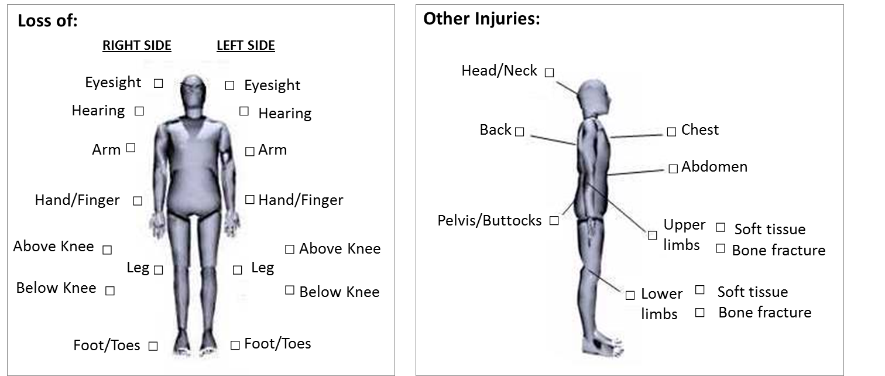
vuf,mbuf
'l;txuf
vuf^vufacsmif;
jrifuGif;
ajc axguf
vufarmif;
ukd,fcE¨m atmuf ykdif;
ukd,f cE¨m tay: ykdif;
0rf;Adkuf
&iftkH
ajcaxguf^ajcacsmif; rsm;

OD;acgif;^vnfyif;
'l;txuf
tjcm;xdckduf'gPf&m&rSKrsm;
'l;atmuf
vuf^vufacsmif;
Ajcaxguf^ajc acsmif;rsm;
ajcaxmuf
'l;atmuf
vufarmif;
tjum;tm&kH
tjum;tm&kH
jrifuGif;
t&kd;usdK;jcif;
tom;rQif
t&kd;usdK;jcif;
tom;rQif
aygifqpfcGuf^ wifyg;
aemufausm
vuf0Jbuf

Remarks/Additional Information: rSwfcsuf ^ tjcm;xyfwdk;owif;tcsuftvuf ______________________________________________________________________________________________________________________________________________________________________________________________________________________________________________________________

If the person was killed, specify location of death: 5.1 'gPf&m&&dSolaoqkH;oGm;ygu rnfonhfae&mwGifaoqkH;aMumif;az:jyay;&ef?
In-site jzpfyGm;onhfae&mü Ο At health care facility usef;rma&;aq;ukocef;ü Ο During transport to health care facility usef;rma&;aq;ukocef;okdYvlemukdo,f,loGm;pOf

5. TO BE ENTERED BY THE INFORMATION MANAGEMENT DEPARTMENT
uGyfuJa&;XmepdyfrS jznhfoGif;a&;om;ay;&ef

Date Report Received  tpD&ifcHpm&&dSonhfaeYpGJ^{G} |  | IMSMA Victim ID:  xdckdufrSK IMSMA tnTef;eHygwf
Data Entry by:  owif;tcsuftvufrsm; a&;oGif;ol |  | Remarks

