Information Sources For Severe Natural Events
Myanmar | 9 May 2013
1. Tropical Storm Risk (TSR)  http://www.tropicalstormrisk.com/tracker/dynamic/main.html  Tracks all current tropical storms around the world, complete with map, storm characteristics, and projected route. Also provides email alerts and probable threats up to 5 days ahead. | 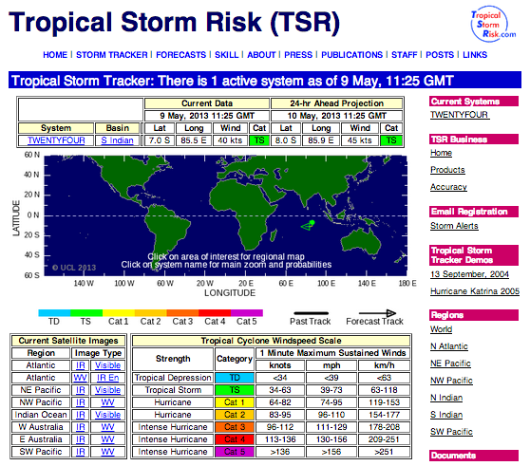
2. Global Disaster Alert and Coordination System (GDACS)  http://www.gdacs.org/  Provides latest disaster alerts, including an overview map of all recent and ongoing severe natural events, including earthquakes and tropical storms. Storm information includes route maps, information on projected and actual impact, and media analysis. The site also has an alert system, and a restricted section for UN staff that provides more detailed reports on select events. | 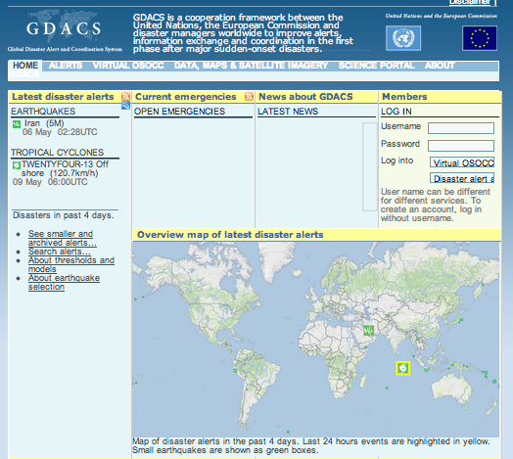
3. Pacific Disaster Centre  http://www.pdc.org  Provides a global map of recent and ongoing natural disasters and events. A route map and description of the event is also provided. The website also has alerts and free mobile apps which can be downloaded to provide alerts to your phone. | 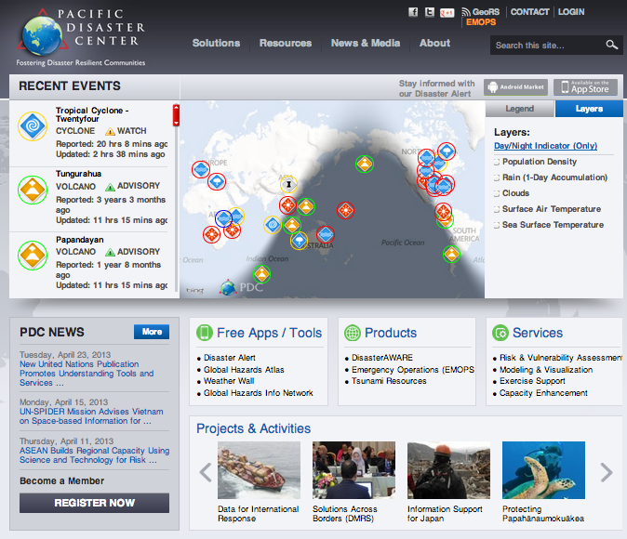
4. Department of Meteorology and Hydrology (Myanmar)  http://www.moezala.gov.mm/index.php?option=com_content&view=article&id=98&Itemid=3&lang=en  Includes weather forecasts, natural event warnings, and satellite imagery of events affecting the country. | 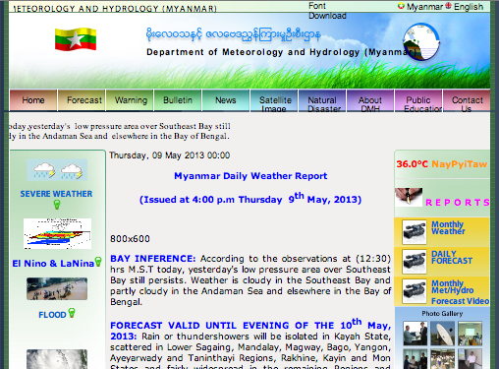
5. MM Weather Blog (MMR Only)  http://blog.mmweather.com/  In Myanmar only, provides information on natural events affecting the country, including earthquakes, storms, rains and floods, and provides a local weather forecast. | 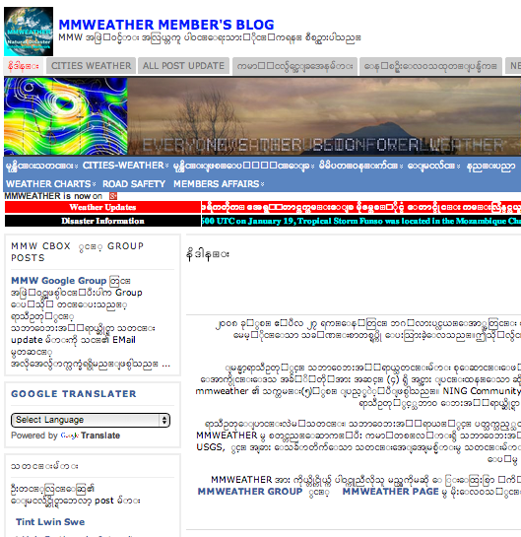
6. Foreca  http://www.foreca.com/Myanmar/Rangoon  Provides a daily forecast and up to a 10-day outlook on weather in Myanmar, complete with projected wind speeds and rainfall. | 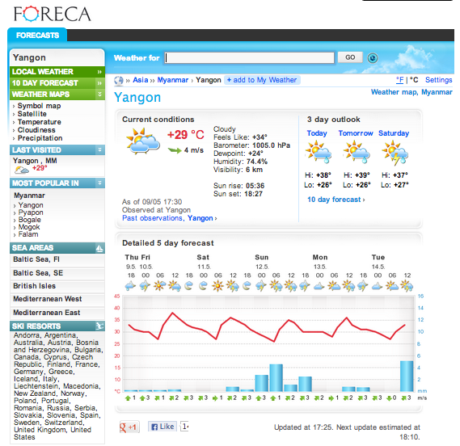
7. National Hurricane Center  http://www.nhc.noaa.gov/  A US-centric hurricane watch service, this also covers links to meteorological services around the world. | 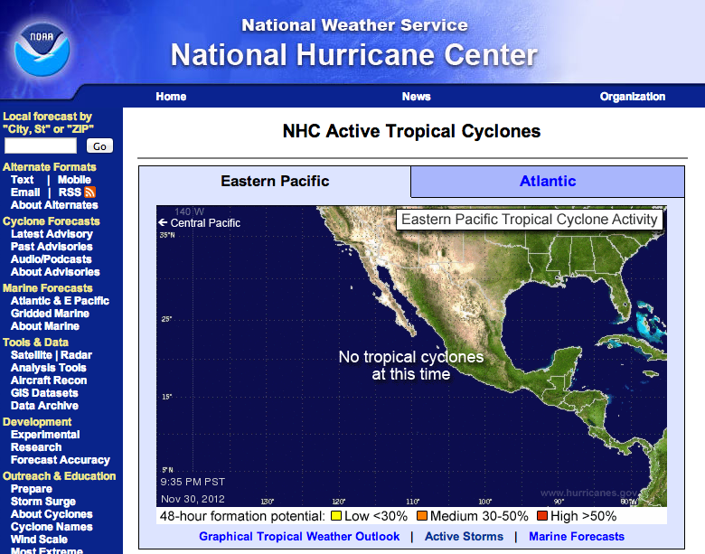
8. WUnderground  http://www.wunderground.com/  Weather forcasts by location, includes satellite imagery and the weather outlook. Also includes a section on severe weather and active storms. | 