KACHIN and NORTHERN SHAN
Monthly report
CLUSTER MID TERM REVIEW
July 2015

Produced by: Kachin & North Shan Wash Sub Cluster team

Organization: UNICEF, following Wash cluster review 1 day workshop and associated with 1 day join Wash/Shelter workshop

Location: Myitkyina

Month: First semester 2015

Resources: http://www.themimu.info/emergencies/wash-cluster

Executive summary

- Regular armed clashes that led to small scale displacements of about 2000 people in Kachin and NSS since the beginning of 2015. Recurrent small scale emergencies,

- At the end of June 2015, only 20 IDPs camp out of 152 (13%) are not targeted by WASH actors, If no new additional wash projects are developed, the number of non-WASH targeted camps will raise to 37 in July then to 45 in August. However, there are pending WASH projects waiting for approval in about 55 IDPs locations,

- The total WASH funds received for 2015 are 2,478,434 USD. The operational cost of WASH response has been estimated to 9,882,176 USD for 2015 which shows the level of WASH funding in Kachin (25%),

- A remaining need of 86 latrinesin 9 IDPs camps located in 5 different townships. Three out of these 9 locations are located in hard to reach areas,

- A total of 6 gravity flow systems need to be upgraded in three different township,

- There are still 11 locations concerned by water shortage issues, during dry season

- No significant unaddressed WASH needs in under monitored areas but the situation needs to be followed up closely,

- WASH NFI approach to be addressed at intersector level to defined targeted approach

- Special attention needs to be brought to the biggest camps while the smallest ones have more linkage and integration with urban environment,

- Need to integrate maintenance of infrastructures in more join approach with CCCCM/Camp management, with consideration of running cost: to be elaborated jointly with IOM and CCCM cluster with strong focus on join capacity development of camp management

- WASH response in the communities surrounding the IDPs camps remain weak but better analysis of the overall situation launched

- Capacity development of WASH cluster to focus on monitoring and evaluation activities

Contents
1 Small scale displacements 5
2 Wash projects and funding 5
3 WASH facilities coverage 6
3.1 Exhaustive and balanced response 6
4 Residual addressable needs 6
4.1 Latrines 7
4.2 GFS infrastructures 7
4.3 Water shortage 7
4.4 Under monitored areas 9
4.5 WASH and Shelter needs 10
4.6 WASH NFI Needs 10
4.7 Camp size 11
4.8 Maintenance of WASH facilities 12
4.9 Host Families 12
5 Capacity development 13
5.1 Capacity development planned activities 13
5.2 Monitoring and evaluation framework 15
5.3 Training plan 15

- Main events

WASH cluster meetings / workshops
- WASH coordination meeting in NSS on 26th may with the participation of 5 WASH focal agencies (SCI, Metta, KBC, KMSS and UNICEF),
- One TWG dealing with technical standard and HTWS has been held in Bhamo on 28th May 15. 21 staff from governmental authorities (DRD, DOH, RRD and TDC) and humanitarian agencies (Metta, KBC, CESVI, SI, UNHCR and UNOCHA) participated to this Technical Working Group,
- On 5th June, participation of Kachin and NSS WASH cluster team to the half –yearly WASH Thematic Group organized by national DRD authorities in NPT with the support of UNICEF
- On 10th June, Joint quarterly WASH / Shelter Cluster meeting including 35 participants from 16 Humanitarian agencies and WASH related governmental authorities,
- On 11th June, mid-term WASH cluster strategic review workshop including 29 participants from 14 humanitarian agencies and WASH related governmental authorities,

WASH assessment / Field visit monitoring
- WASH assessment by the WASH cluster team in IDPs boarding house near Daw Hpone Yang, Bhamo area
- WASH cluster team participated to a rapid UNICEF led multi-sectorial assessment in Namtit situated in WA region from 28th – 30th May 15.
- Field visit monitoring of national and Kachin NSS WASH cluster team in North Shan. One of the main finding of this assessment is that the WASH coordination needs to be reinforced in NSS.

4W Capacity development
- Technical support of wash cluster team to two local partners including proposal development support, data consolidation and analysis, and KAP survey methodology
- Technical inputs have been provided to shelter cluster to incorporate Rain Water Harvesting System (RWHS) with new gutter system for new shelter design.
- Training to 12 participants from Shalom, KBC, Metta, KMSS, DRD and DPH teams on KAP process and analysis.

- Mid-term WASH cluster review

Small scale displacements
Armed clashes led to the displacement of about 2000 people in Kachin and NSS since the beginning of 2015. The diagram below summarizes the main events over the last 6 months

Wash projects and funding
At the end of June 2015, only 20 IDPs camp out of 152 (13%) are not targeted by WASH actors.
If no new additional wash projects are developed, the number of non-WASH targeted camps will raise to 37 in July then to 45 in August. However, there are pending WASH projects waiting for approval in about 55 IDPs locations.

The graph below provides the changes in terms of WASH funding in Kachin and NSS

The total funds received for 2015 are 2,478,434 USD. The operational cost of WASH response has been estimated to 9,882,176 USD for 2015 that shows the underfunding of WASH response in Kachin.

WASH facilities coverage

Exhaustive and balanced response
More than four years following the conflict, the quantitative water and sanitation facilities coverage reached its peak. The field constraints (land availability and ownership issues, socio-cultural background, technical considerations) prevent today from constructing more facilities to reach a theoretical 100% coverage.

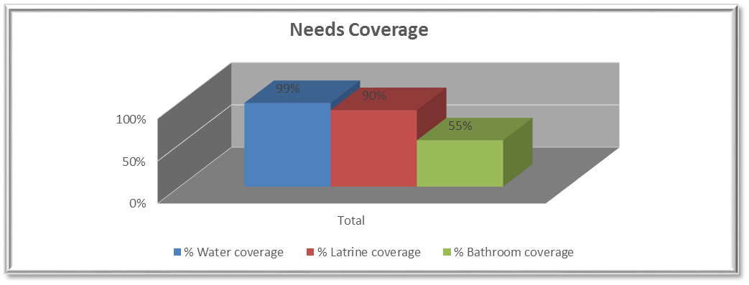

Although slight differences in terms water and sanitation coverage can be observed, the WASH response is balanced and there are no significant discrepancies between:
- GCA and NGA,
- Rural and urban areas,
- Small, medium, large, big, massive camps,
- the 10 geographical clusters defined by WASH cluster,
- the 18 townships affected by the crisis
- Hard to reach areas and accessible areas

There are therefore no significant needs for WASH facilities construction in Kachin and NSS except residual needs. However the second semester of 2015 and 2016 risk to face camp relocation, due to the ending of the land (see chapter Shelter and Wash needs)

Residual addressable needs
Some few residual addressable gaps of WASH infrastructures remain due to a combination of factors including insufficient previous WASH funding, difficulties of access to intervention areas, and changing overall humanitarian situation (displacements, increase of IDPs number, and decongestion of IDPs camps….)

The tables below provides an estimation of the current unaddressed remaining needs for two main Water and sanitation facilitates (latrines and GFS) based on 2015 4W June matrix, bilateral discussions with concerned WASH focal agencies and WASH cluster field monitoring visits. The locations where needs have been identified but where there is an on-going or will be a WASH project are not mentioned here.

Latrines
In some locations of Kachin and NSS such mountainous areas, areas near china border where construction materials are expensive, locations with individual HH latrines, the construction of semi-permanent latrines is not possible or relevant. Therefore it is not possible to promote semi-permanent latrines everywhere and notably within these settings. Instead, the concept “village latrines, equipped with banmboo pit, and mainly build with local materials, is considered. The below estimation of remaining latrines needs take into account this fact.
This estimation provides a total number of 86 latrines needed in 9 IDPs camps. There are pending WASH proposals in these 9 locations located in 5 different townships. Three out of these 9 locations are located in hard to reach areas.
Township | Site | Type | Hard to reach areas | Actual Focal point Agency | End of coverage | Latrines needs
Chipwi | Chipwi KBC camp | GCA | yes | Shalom | 31-Jul-15 | 11
Chipwi | Lhaovao Baptist Church (LBC) | GCA | yes | Shalom | 31-Jul-15 | 7
Myitkyina | Shatapru Thida Aye Baptist Church | GCA | Yes | Shalom | 15-Jul-15 | 2
Waingmaw | Qtr. 2 Lhaovo Baptist Church | GCA | No | Shalom | 15-Jul-15 | 2
Waingmaw | Qtr. 3 Mu-yin Baptist Church | GCA | No | Shalom | 15-Jul-15 | 1
Waingmaw | Waingmaw AG Church | GCA | No | Shalom | 15-Jul-15 | 3
Namkham | Nam Hkam - Nay Win Ni (Palawng) | GCA | No | SCI | 30-Aug-15 | 16
Mansi | Man Wing Baptist Church* | GCA | No | SCI | 30-Aug-15 | 4
Mansi | Man Wing Catholic Church* | GCA | No | SCI | 30-Aug-15 | 40

GFS infrastructures
A total of 6 gravity flow systems need to be upgraded in three different township.
Township | Site | type | Hard to reach areas | Actual Focal point Agency | End of coverage | GFS upgrading
Momauk | Nhkawng Pa | NGCA | No | WPN | 30-Aug-15 | 1
Namkham | Nam Hkam (KBC Jaw Wang) | GCA | No | SCI | 30-Aug-15 | 1
Namkham | Nam Hkam - Nay Win Ni (Palawng) | GCA | No | SCI | 30-Aug-15 | 1
Mansi | Man Wing Baptist Church* | GCA | No | SCI | 30-Aug-15 | 1
Mansi | MWG -RC2 | GCA | No | SCI | 30-Aug-15 | 1
Mansi | Man Wing Catholic Church* | GCA | No | SCI | 30-Aug-15 | 1

Water shortage
In December 2014, the WASH cluster identified a list of 32 locations prone to water shortage during dry seasons.
The table below provides an update of the situation in July 2015
The green color indicates that the location are currently covered by a WASH project implying that water shortage issues are addressed. The situation of Hpakant is specific as the overall current geographical and humanitarian setting (presence of jade mining activities with seasonal impact on ground water level) prevents from addressing permanently water shortage issues
The orange colour indicates IDPs locations where water shortage remains an issue and where the absence or nature of WASH projects doesn’t enable to address water shortage issues.
There are still 11 locations still concerned by water shortage issues

No | Township | Camp name | WASH focal agency | HDW | BH | Spring/stream
1 | Myitkyina | Pa Dauk Myaing | KMSS | X
2 |  | Maw Hpawn Hka Nan Baptist church | Shalom | X
3 |  | Maw Hpawn Laovao Baptist Church | Shalom | X
4 |  | Tat Kone Emanuel Church | Shalom |  | x
5 | Bahmo  To be covered | Htoi San Church | Metta | X | x |  | Not covered
6 |  | Lisu Boarding House | Metta | X
7 |  | Aung Thar Church | Metta | X | x
8 | Mohnyin | St. Patrick Catholic Church | KMSS
9 | HpaKant | 5 ward Baptist church Lone Khin | Shalom | X
10 |  | Hmaw Wan, Anglican | Shalom | X
11 |  | Baptist Church, Hmaw Si Sar(Lon Khin) | Shalom | X
12 |  | Chin Church, Seik Mu | Shalom | X
13 |  | Maw Wan, Mu-yin Baptist Church | Shalom | X
14 |  | 5 Ward Baptist Church(lon Khin) | Shalom | X
15 |  | Baptist Church, Naung Hmee VT | Shalom | X | x
16 |  | Rawan Baptist Church, Maw Shan Vil., Seik Mu | Shalom |  |  | X
17 |  | AG Church, Maw Wan | Shalom |  |  | X
18 |  | Nam Ma Phyit, COC | Shalom |  |  | X
19 |  | Lisu Baptist Church, Maw Shan Vil,. Seik Mu | Shalom |  |  | X
20 | Momauk | Agritural Compound (KBC) | Metta | X
21 |  | Nhkawng Pa | WPN |  |  | x
22 | Waing Maw | Woi Chyai | Metta
23 | Mansi | Lana Zup Ja * | WPN |  |  | X
24 | Kutkai | Mungji Pa Dabang (Baptist Church) | Metta |  |  | X
25 |  | Mungji Pa Dabang (RC Church) | KMSS |  |  | X
26 |  | Kutkai downtown (KBC Church) | Metta |  |  | X
27 |  | Kutkai downtown (RC Church) | KMSS |  |  | X
28 |  | Nam Hpak Ka Mare | Metta |  |  | X
29 | Muse | Muse RC Church | KMSS |  |  | X
30 | Nam Kham | Nam Hkam - Nay Win Ni (Palawng) | SCI |  |  | X
31 | Manton | Mandung - RC | KMSS |  |  | X
32 |  | Mandung - Jinghpaw | Metta |  |  | X

Under monitored areas
A list of underserved / monitored areas within Kachin and Northern Shan States was prepared at the Inter-Cluster Coordination Meeting on 28 April 2015 with inputs from all Cluster/Sector Leads. 13 out of the 16 locations are currently covered by a WASH project. Although the situation needs to be closely followed up, and as there is a good presence of WASH actors, there are no significant unaddressed WASH needs within under monitored areas. However locations such Hpare Hkyer / BP6 remains of concerns as the overall setting s of this camps doesn’t enable to install sustainable WASH facilities.
In terms of presence of WASH actors and wash projects, the situation within under monitored areas is as followed:

State | Township | GCA/NGCA | Camp Name | WASH needs
Kachin | Shwegu | NGCA | Lawk Awng Mare D. (Sinbo Area) | Covered by KMSS & Trocaire
Kachin | Waingmaw | NGCA | Hkau Shau (BP 12) | KBC and OXFAM already currently cover the needs
Kachin | Waingmaw | NGCA | Maga Yang | KBC and OXFAM already currently cover the needs
Kachin | Waingmaw | NGCA | Zai Awng / Mung Ga Zup | KBC and OXFAM already currently cover the needs
Kachin | Chipwi | NGCA | Hpare Hkyer - BP6 | KBC and OXFAM already currently cover the needs
Kachin | Waingmaw | NGCA | Pajau / Jan Mai | KBC and OXFAM already currently cover the needs
Kachin | Waingmaw | NGCA | Post 6 Camp | Covered by KMSS & Trocaire
Shan North | Hseni | NGCA | Narte | Currently covered by Metta
Shan North | Kutkai | NGCA | Mungji Pa Dabang (KBC) | Currently covered by Metta
Shan North | Kutkai | NGCA | Mungji Pa Dabang (RC) | Covered by KMSS & Trocaire
Shan North | Manton | GCA | Mandung - Jinghpaw | Currently covered by Metta
Shan North | Manton | GCA | Mandung - RC | Currently covered by KMSS with Trocaire
Shan North | Muse | NGCA | Hpai Kawng Mare | No information about this area
Shan North | Muse | NGCA | Munekoe Pa (Giwang) - Hka San (Mung Go Pa ) | To be checked
Shan North | Namtu | GCA | Nam Tu Baptist | Currently covered by Metta
Shan North | Namtu | GCA | Nam Tu RC | No information about this area (KMSS Lashio)

WASH and Shelter needs
WASH and shelter cluster agreed to pursue the “habitat” approach that implies efforts from both clusters to adequately plan WASH needs related to shelter and to promote as much as possible the simultaneity of WASH and shelter construction
Through join working sessions the two clusters identified three scenarios where additional WASH infrastructures may be needed:
New camps as a consequences of armed clashesGiven the fluidity of situation and lack of visibility within the Kachin and NSS context, both clusters agree that the IDPs locations created following armed clashes will be considered as temporary locations during the two first months and that only emergence infrastructures will be therefore provided during this time. These locations will be then assessed by protection sector and eventually validated as an established temporary locations requiring more semi-permanent solution
Three main camps concerned by this scenario: Kude Maw KBC camp in Hpakant, Nam Zalat camp in Hseni and Pang Ku camp in Kutkai townships. These three camps are already targeted by a WASH project.

- New camps due to IDPs movement from Temporary location to another temporary locations.
This scenario has been already discussed at previous inter cluster sector level and a positioning note has been released by shelter/WASH/Protection cluster/ sectors and that insists on the centrality of the protection. There is an increasing trend for these movements and the centrality of protection for these locations has been reasserted during the WASH cluster mid-term review.
The unpredictability of these movements is a real challenge in terms of planning and funding for both WASH and shelter and there is no current existing list of locations to be eventually concerned by this scenario

There is currently one location in Lwegel where IDPs may be asked to leave and to be relocated in another camp.

- Extension, upgrading or reorganization of shelter within IDP camps
Given the land availability issue in Kachin it is unlikely that there will be significant extensions of shelters on new allocated land. Instead, replacement of old shelters by new ones, and construction / reorganization of new shelters in existing camps are likely to happen and don’t require additional WASH infrastructures. There are ongoing discussions with Shelter implementing partners and Camp Management committees to confirm the needs for shelter construction in numerous locations of Kachin and NSS.

WASH and shelter clusters will keep coordinating to identify the shelter locations and WASH related needs

WASH NFI Needs
Since we are now entering in the 4th years of displacement, it is not possible anymore to carry out blanket distribution for NFI. The WaSH cluster members already gave up with the principle of blanket distribution of hygiene items during the WASH cluster review at the beginning of 2015.

Recommendations for the second semester of 2015 are:

- Looking for common NFI distribution approach for all sectors / clusters
- Distribution to the most needed groups rather than stopping the WASH NFI distribution,
- Ensuring dignity of IDPs notably through improvement of livelihoods opportunities rather than distribution,
- Fixing some criteria vulnerability such access to livelihoods opportunities, accessibility to local markets…
- Consider some WASH NFI distribution as an incentive during hygiene awareness sessions,
- Promotion of vocational trainings to IDPs in order to produce soaps

Camp size
The table and graphs below provide the distribution of camps according to their size and to their population.

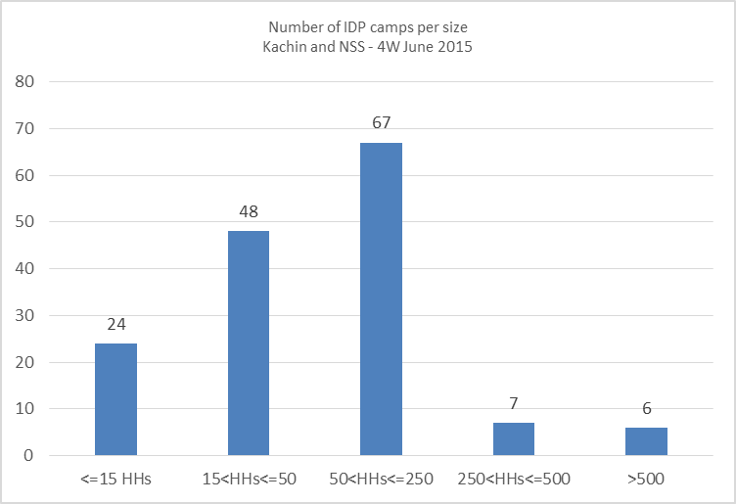 | IDPs camp size Number of IDps camps % (out of total camps) % Population (out of total population)  <=15 HHs 24 16% 1%  15<HHs<=50 48 32% 10%  50<HHs<=250 67 44% 45%  250<HHs<=500 7 5% 15%  >500 6 4% 28%
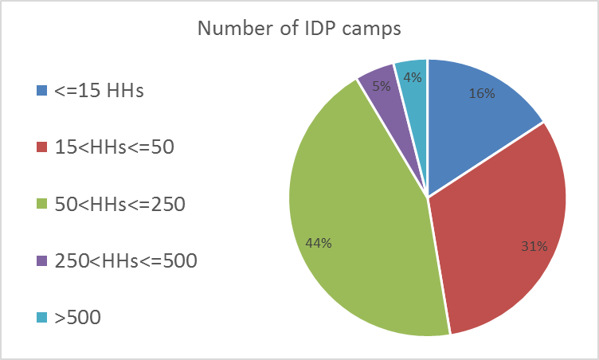 | 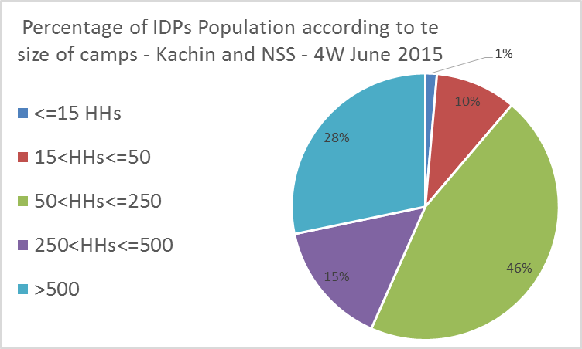
Source: 4W June 2015

Small camps
There are 24 IDPs camp with a size less than 15 Households and hosting 1% of the total IDP population.
There are 48 IDPs camp with a size between 15 and 50 HHs and hosting 10% of the total IDP population.
These 72 camps represent 47% of the total IDPs camps and host only 11% of the total IDP population. These small IDPs camps are mainly located in urban GCA.
Despite the small caseload of IDPs, the number and geographical spread of these small size IDPs locations are mobilizing the WASH and shelter actors. Yet, the remaining humanitarian and management are different from bigger IDPs locations. Given their limited size and their comparative easier access to basic services and local market and job opportunities, it is relevant to consider a specific strategy for these small IDPs locations. Merging small into big camps is not a solution as the wellbeing, dignity and security of people should be looked at first. Instead, a robust assessment of the remaining needs and of the copying mechanisms should be carried out in these small camps in order to design an appropriate response. Besides, the designation of a location as IDPs camp should be based on a minimum number of IDPs. For these small IDPs locations, integration with the surrounding urban environment and communities should be look at as a priority.

Medium camps
44% of IDPs camps have a size between 50 and 250 HHs. In these locations, camp committee structures need to be further strengthened to ensure the proper operation and maintenance of infrastructures in both WASH and shelters.

Big camps
13 IDPs camps (9% of total camps), located in four townships (Waingmaw, Momauk, Mansi, Bhamo) have a size bigger than 250 HHs and host 28% of the total ID population. Half of these IDP camps is located in NGCA. The big size of these camps complicates the humanitarian response. Water infrastructures patterns are more complex, operation and maintenance such desludging and decommissioning require further attention and overall wash situation needs to be followed up closely to prevent any water related diseases outbreak.

Besides the size of IDPs camps, it is also crucial to further consolidate the data population of the camps with the CCCM. Indeed, it appears that the numbers of IDPs really living within the camp don’t always match with the ones who are registered. This discrepancy affects the humanitarian plan and response of WASH actors.

Maintenance of WASH facilities
Given the current WASH facilities coverage and the protracted crisis of Kachin and NSS, the maintenance and operation of WASH facilities are of critical importance. Within this context, the WASH cluster strategy is to move gradually to the self-reliance of the IDPs communities regarding the WASH running cost. This self-reliance requires:
- Empowerment of the Camp committee including mainstreaming of WASH running cost into the CCCM
- Join (WASH, Shelter / CCCM / NFI clusters and IOM) capacity development of CCCM and WASH focal agencies

For the specific case of desludging, the WASH cluster is pursuing its efforts to look for local appropriate solutions. Amongst the on-going initiatives taken over the last 6 months are:
- Pending pilot project of excreta disposal site in North Kachin waiting for local authorities approval,
- Coordination with potential donor interested by sanitation projects for the development of DEWATs solutions,
- Coordination with local township authorities (TDC,TDA, RRD, DRD, DoH)
- Sanitation survey to be carried out in south Kachin

Host Families
WASH response in the communities surrounding the IDPs camps remain extremely weak. The field visits carried out by the WASH cluster team within Host families of Bhamo during the second quarter of 2014 didn’t enable to highlight urgent WASH needs in terms of infrastructures. General lack of information about host families has been partially address with a second assessment carried out by CESVI during the first quarter of 2015 in Bhamo. This survey shows that the WASH situation within host families is heterogeneous and that there are punctual WASH needs due to the general underdevelopment of the infrastructures. Needs for Hygiene promotion activities and securing water quality have been identified within communities.

The WASH cluster strategy for the host families includes:

- Better understanding and documentation of the overall background of surrounding communities (origin of IDPs, WASH situation of both Host and Hosted families, Impact on WASH situation of IDP camps on surrounding communities, Impact or presence of hosted families within the surrounding communities..),
- Joint assessment with the head of ward / village of the WASH situation of the most vulnerable HHs living in the surrounding communities
- Better geographical mapping of schools and health centers
- Focus on public facilities impacted by the presence of surrounding IDPs camps (schools and health centers)
- In terms of response, priority to Hygiene promotion, water quality and community mobilization rather than hardware
- Work with WASH related authorities and developmental partners

Capacity development

Capacity development planned activities
The capacity development activities of the cluster will be pursued according the strategic plan that has been designed at the beginning of 2015.
The planned activities for the second semester of 2015 are provided in the following page

Outputs | Activities
Output 1:  WASH Partners' Technical knowledge and skills on Emergency WASH response and preparedness enhanced | Conduct technical gap and training need assessment
 | Update and share WASH cluster Kachin & NSS training plan
 | Preparation and facilitation of technical trainings related to WASH emergency response
 | Accompany local partners for the development of WASH proposals through proper WASH situation analysis and beneficiaries identification
 | Support the capacity development component of ERF mechanisms within the WASH cluster of Kachin and NSS
 | Ad Hoc bilateral support of WASH local partners on a need basis on specific identified needs
 | Training of WASH cluster members on project planning, monitoring, and reporting project cycle management
 | Liaise with local universities to explore possibilities of WASH module inclusion into academic institutions
 | Coordinate with other sectors / clusters to ensure coherence, complementarity and synergies of capacity development activities
 | Advise and support state, district and township WASH related authorities on WASH data collection
 | Mainstream capacity development activities with joint field evaluations
 | Promote internal capacity development within WASH focal agencies
 | Carry out a training on Information management (Excel data base, GIS)
 | Identify eventual critical needed external resources
 | Carried out joint field visit monitoring with local authorities and local partners
Ouput 2:  Best practice and lesson learning documentation improved | Promote the development, consolidation and sharing of products aiming at capitalizing on lessons learned and experience
 | Identify critical topics / issues that needs to be capitalized on
 | Support WASH cluster members for the production of technical briefs
 | Develop a specific work plan for the capitalization of best practices and lessons learned
 | Technical support to WASH pilot project in Kachin and NSS
 | Organize a second lesson learned workshop
Ouput 3:  WASH standards and technical guidelines developed and shared with WASH cluster | Provide technical guidance through participation to the three exiting TWGs in Kachin for the production of standards , guidelines adapted to the Kachin and NSS context
 | Review of TWG deliverables
 | Support the WASH cluster members for the development of desludging solutions through situation analysis, field assessment, working sessions with local authorities and wash focal agencies
 | Review and consolidate existing water quality monitoring practices to set up a water quality monitoring system and methodology within the WASH cluster of Kachin and NSS
 | Promote Water Safety Plan approach at IDP camps level through the operationalization of wash cluster evaluation framework
 | Ensure proper dissemination and understanding of existing national WASH standards
 | Conduct technical gaps analysis
Output 4:  Improved Quality of WASH data in IDP camps | Finalization of WASH Cluster evaluation methodology incorporating feedbacks from WASH cluster partners
 | Led and supervise the WASH cluster evaluation activities as defined by the WASH cluster evaluation framework
 | Train WASH monitors, WASH focal agencies staff and DRD staff to field evaluation technics, data collection and data entry
 | Train the local WASH agency staff on interviews technics (semi-structured interviews, Focus groups discussions) and data consolidation and analysis
 | Review of existing WASH data collection
 | Revise KAP survey format and train local WASH focal agencies on KAP survey data entry consolidation and analysis
 | Develop, update needed evaluation tools and templates
 | Technical guidance, follow up and support the WASH cluster monitors team for evaluation activities

Monitoring and evaluation framework
Given the protracted crisis of Kachin and NSS, capacity development activities will focus on the monitoring and evaluation activities.The main objectives of the WASH cluster monitoring and evaluation framework are:
- Support the overall strategic framework of WASH cluster and decision making process,
- Ensure the continuity of access to WASH facilities and services,
- Support the WASH focal agencies for the identification of WASH needs and related interventions,
- Empower the Camp committee and IDP communities with WASH issues,
- Develop the capacity of WASH actors including local authorities, WASH focal agencies and camp committees for PME activities

The table below summarizes the main components of the monitoring and evaluation framework:

 | Activity | Product | WASH actor in charge | Frequency
I | Mapping of geographical WASH needs coverage | 4W | WASH focal agencies & WASH cluster team | Monthly
II | WASH surveillance | WASH surveillance report | WASH cluster team | Complete round every 6 months
III | Water quality monitoring | Water quality monitoring report | WASH sector with data consolidation by WASH cluster team | Monthly
IV | Rapid WASH response evaluation | IDP camp evaluation report | WASH cluster team accompanied by WASH focal agencies and local authorities | On a need basis

Training plan

The tentative training plan for the WASH cluster at the second semester of 2015 is given in following page

Sr. # | Name of Training | Month | Date | Location | Organized by | Status | No. of Participants | Participating Partners
1 | Hygiene Promotion Training | June | 11-12 | Myitkyina | OXFAM | Completed | 19 | KMSS, KBC, HPA, Shalom, Oxfam and Plan
2 | KAP Syrvey Process, data entry and analysis | June | 18 | Myitkyina | WASH Cluster | Completed | 12 | ADRA, KMSS, KBC, Shalom, DRD and DPH
3 | Hygiene Promotion Training | June | 22-26 | Bhamo | Trocaire Fund | Completed | 20 | Trocaire , KMSS
4 | Hygiene Promotion Training | July | 1-3 | Myitkyina | OXFAM | Completed | 32 | Shalom
5 | Internal coaching to consultants on WASH Monitoring | July | 1 | Myitkyina | WASH Cluster | Completed | 3 | UNICEF
6 | Hygiene Promotion Training | July | 11-12 | Myitkyina | ADRA | Planned | 15 | ADRA, KBC
7 | Data management Training | July | 20 | Myitkyina | WASH Cluster | Planned | 10
8 | PCA Orientation | July | 21 | Myitkyina | WASH Cluster | Planned | 10
9 | Data management Training | July | 23 | Bhamo | WASH Cluster | Planned | 10
10 | Training on GFS designing | July | 22-24 | Bhamo | WASH Cluster | Planned | 14 | DRD, CESVI, SI, Metta
11 | Data management Training | July | 28 | Lashio | WASH Cluster | Planned | 10
12 | Water quality Surveillance, identify high risk water points at IDP camps, WSP | July | 17-18 | Laiza | OXFAM | Planned |  | HPA, OXFAM
13 | WASH in School | July | 19-20 | Laiza | OXFAM | Planned |  | HPA, OXFAM
14 | WASH Monitoring | July | 19-20 | Laiza | OXFAM | Planned |  | HPA, OXFAM
15 | Hygiene Promotion in Emergency | July | 20-21 | Laiza | OXFAM | Planned |  | HPA, OXFAM
16 | Desludging operators training including Health Hazard and safety hygiene | August | 22-24 | Myitkyina | OXFAM | Tentative Plan |  | OXFAM, KBC, Shalom
17 | Basic Knowledge on WASH for camp volunteers (ToT training) | August |  | Myitkyina | OXFAM | Tentative Plan |  | OXFAM, KBC, Shalom
18 | Household water treatment options | September | 15-18 | Myitkyina and NGCA | OXFAM | Tentative Plan |  | OXFAM, KBC, Shalom
19 | Camp WASH committee management ToT training | September / November |  | Myitkyina and NGCA | OXFAM | Tentative Plan |  | OXFAM, KBC, Shalom
20 | Training on IEC production and guideline including effective communication channel | October | 22-23 | Myitkyina | OXFAM | Tentative Plan |  | OXFAM, KBC, Shalom
21 | O&M training for WASH among the camps | November | 15-18 | Myitkyina and NGCA | OXFAM | Tentative Plan |  | OXFAM
22 | Community Mobilization | November |  | Myitkyina | OXFAM | Tentative Plan |  | OXFAM
23 | Sanitation Promotion (SaniFOAM or PHAST or CLTS) | November |  | Myitkyina | OXFAM | Tentative Plan |  | OXFAM
24 | WASH and Marketing training | December |  | Myitkyina | OXFAM | Tentative Plan |  | OXFAM
25 | WASH Project cycle management including Monitoring | December |  | Myitkyina | OXFAM | Tentative Plan |  | OXFAM

Main Priorities for next month
- Start the collection and consolidation of water quality data from WASH cluster members
- Complete the WASH training needed for water quality monitoring
- Follow up the humanitarian situation especially in Hpakant and Lwegel areas
- Fine tune the estimation of the remaining WASH infrastructures needs in IDPs locations with Shelter cluster

Produced by the WASH members
- Namthit Assessment report (UNICEF / WASH cluster)
- Host families assessment report in South Kachin (CESVI)
- WASH Gaps in NGCA (OXFAM)
- Formative research on Hygiene promotion (OXFAM)
- Updated list of WASH & Shelter gaps (WASH and Shelter clusters)
- 4w matrix (WASH cluster)
- Detail of RWHS for new shelter design (WASH & Shelter clusters)

