**STANDARD SOLID WASTE MANAGEMENT SYSTEM**

**IN CAMP**

|  |
| --- |
| Produced by: WASH Cluster  Specific support : Save the Children & RI  Subject: Sanitation-Waste Management  Created: November2013  Updated: June 2014  Resource: http://www.themimu.info/emergencies/wash-cluster |

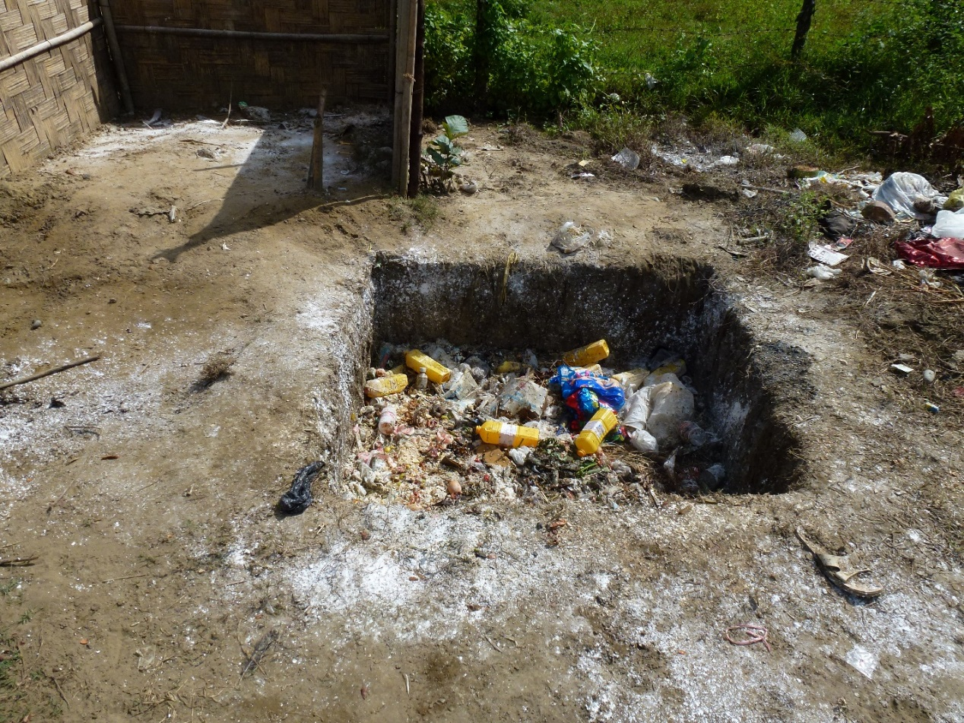

 

Background

The purpose of this document is to consolidate the set-up of proper waste management system in the targeted populations in camp and mobilize the resources available. The overall waste management system across Myanmar is still weak and the similar situation is also present in the targeted populations. The absence of public services, even in the surrounding host communities, rarely allows connecting camp waste management with waste collection system.

Moreover, almost all WASH agencies typically focus more on the water and sanitation than waste management in the onset of an emergency. The lack of knowledge of the targeted populations about the proper waste management and its negative impact on the health and surrounding environment accentuate even more the need to strongly tackle that issue.

Therefore, this document is to highlight the need and importance of waste management system and constitute an initial working platform for all WASH actors to improve or modify as necessary their future intervention. This proposed designed is considered applicable for Camp environment in both Rakhine and Kachin emergency.

This document is subjected to change based on the regular review and inputs from the field situation.

Negative Impact of Solid Waste

Waste is produced every day and if left unattended, it can pose public health risks to the affected population and can have a detrimental impact on the environment such as breeding of the flies and rodents, polluting the surface and ground water sources, increase risk of flooding and favour the infectious disease transmission. Moreover, the improper waste management can have long-term adverse effects on the environment and can cause air-borne, water-borne and vector-borne diseases.

At a glance on Solid Waste Management system in emergency

The situation in emergency is considerably different in the urban and rural settings.In urban setting, there are existing solid waste management systems such as scavenging trucks for waste collection and communal waste collection points. Although the existing system is not without flawlessness (coverage, punctuality and improper dumping site etc.), there is a certain level of solid waste management system available in the urban setting especially in Kachin. In general, the main responsible department for the solid waste management is the township development affairs and there are gaps present in the existing system. As there is lack of detail analysis available on the performance of the existing solid waste management system, the main gaps generally range from the lack of knowledge, technical capacity and financial resources to the consistent policy at all levels (national, state, district, township and villages).

In rural setting, there are local customs to manage solid waste in the targeted population. The typical pattern is the burning of the solid waste and reusing the degradable waste as fertilizer and animal food. However, there is a total lack of proper management on the non-degradable waste products especially the plastics and other waste products (metal, glass, rubber and wood etc.) . The situation is totally managed by the local solutions which are generally non-systematic, non-sustainable and unsafe. Although the annual waste production rate is relatively small when compared with the urban setting, the majority of the population resides at the rural areas and hence, makes the problem worst. In conclusion, it is obvious that the solid waste management system is spontaneously addressed inadequately if not supported and re-organized with external support.

However, the most common interventions currently implemented are the distribution of household waste containers, collection points, dumping, waste disposal pit and incinerator. However, improvements are required throughout the solid waste management system. The following is the feasible standard waste management system in the targeted populations.

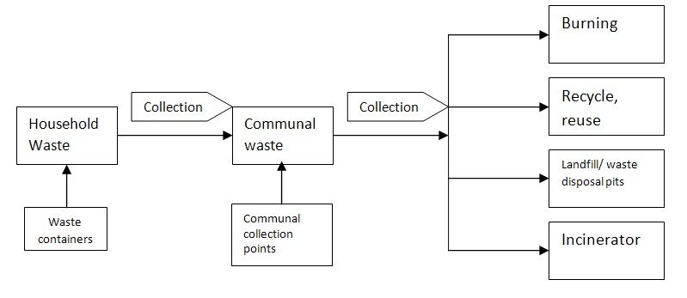

Figure 1 Flowchart of Solid Waste in Rakhine

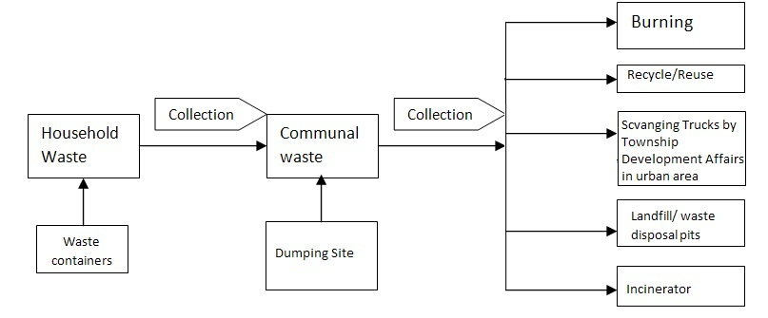

Figure 2 Flowchart of Solid Waste in Kachin

Table 1 Feasible Standard Solid Waste Management system in the targeted populations

|  |  |  |  |  |
| --- | --- | --- | --- | --- |
| No. | Method | Benefits | Risks | Regulations |
| 1. | Burning | Require no technical capacity  No operation cost | Fire hazards  Air pollution  Health hazards to surroundings | Normally, burning of the waste is not allowed by law. |
| 2. | Recycle/ reuse (paper, glass, plastic, metal, wood etc.) | Green method  No or low operation cost  Require no or low technical capacity  Can gain small amount of profits  Reduce the amount of waste products | Improper application may lead to adverse effects (eg. lead poisoning, needle stick injury etc.) | No regulations yet |
| 3. | Landfill/Waste disposal pits | Low operation cost  Require low to moderate technical capacity | High possibilities of ground water contamination  Space requirement  Health risk to the surroundings  Sources for breeding vectors (rodents, flies etc.) | Approval for Land use may require.  No regulations yet |
| 4. | Incinerator | Require moderate to high technical capacity  Moderate operation cost  Require trained workers | Air pollution  Health risk to the surroundings  Improper application may lead to adverse effects. Eg. (Fire hazard) | No regulations yet |
| 5. | Solid Waste Collection by Services from Township Development Affairs | Need continuing link with the authorities from township development affairs  Low to moderate cost  Require official requisition for every collection  Only for urban area | Punctuality  Infrequent collection may overflow the solid waste | May need to pay (tax) for the services. |

A number of interventions are defined to improve the current solid waste management system. The current interventions by WASH actors may need to have continuous monitoring and evaluation. Despite the lack of strong rules and regulations and lack of existing system in the targeted areas, WASH agencies should initiate to improve the solid waste management system to minimize the negative impacts on the environment. Although the level of implementation on the solid waste management system is greatly differ from one area to another, the solid waste management should be a priority in where there is high likelihood of prolonged settlement.

Table 2 Key interventions and activities for solid waste management

|  |  |  |
| --- | --- | --- |
| No. | Key interventions | Key activities |
| 1. | Assessment on waste management | * Type and volume of household waste * Mapping the waste disposal site * Recycle/reuse mechanism * Management on health care waste products |
| 2. | Awareness raising on the waste management | * Develop the IEC materials * Hygiene promotion activities * Environmental cleaning campaign |
| 3. | Household level waste management | * Distribution of waste containers * Hygiene promotion activities |
| 4. | Communal level waste management | * Construction of waste collection points * Distribution of large waste containers * Establish the waste collection mechanism/system (eg. pushcarts) * Training of workers * Construction of waste disposal pits or incinerators |
| 5. | Health care waste management | * Reinforce the existing mechanism * Expand the coverage |

Waste disposal pits

Waste which cannot be recycled or reused should be bury in a pit (waste disposal pit). Waste disposal pit is an easy and effective method of solid waste management system and can be used in the emergency situation. However, it is very important for any waste disposal pit to meet the minimum standard to ensure the health hazards and pollution are minimum. The volume and life span of waste disposal pit can vary depending on the type of soil, the ground water level, the available space and the volume of waste produced in a targeted population. The location of the waste disposal pits should be selected in consultation of the community. The following points are defined as guidance notes for a waste disposal pit (WDP).

* WDP should be located at least 30 m away from the drinking water sources.
* WDP should be located at least 20 m away from dwellings/kitchen areas.
* The depth of the WDP should be well above the ground water level (at least 0.5 metre).
* WDP should be fenced around to prevent children and animal entering the pits, to prevent the risk of falls.
* The base of the WDP should be sealed with clay or impervious rock where there is increase risk of ground water contamination.
* WDP should be covered with lid or compacted with a 0.3 metre layer of soil for every 0.6 thickness of waste.
* The rim/edge of the WDP should be elevated from the ground level to prevent surface water runoff. Keep earth mound.



Figure 1Waste Disposal pit (Side View)

Incinerator

The use of incinerator is recognized as an appropriate solution for solid waste management in this protractile nature of conflict and is recommended for the contaminated dry waste products such as soiled clothing, syringes, needles and other health care products. The use of incinerator should be limited to the contaminated dry waste products where possible. The following design and BOQ of the incinerator developed by Save the Children is proposed as the standardized Myanamar WASH cluster design to be replicated. The cost of incinerator is around 1900 USD. The approval for Land use should be obtained from the local authorities. The location should be defined after consultation with the community.

The current design can incinerate *20 kg of dry waste per hour* and run 12 hours per day for daily. The solid waste is collected by waste management team (*5 waste collectors per 1 incinerator*). One incinerator currently *covers 60-70 shelters*. There are 2 waste collecting containers per shelter. The waste is collected by push carts. The collected waste is separated at the incinerator compound by the waste management team. The non-solid waste is then buried in the waste disposal pit in the incinerator compound and the separated waste is then dried under the sunlight. Then, the operator put the waste into the incinerator. The waste management team are trained and equipped with the personal protection equipment and measures. The waste collectors are paid *2000 MMK for one shift* (6 hours in 1 shift). However, further discussion is still required to understand the coverage of one incinerator.

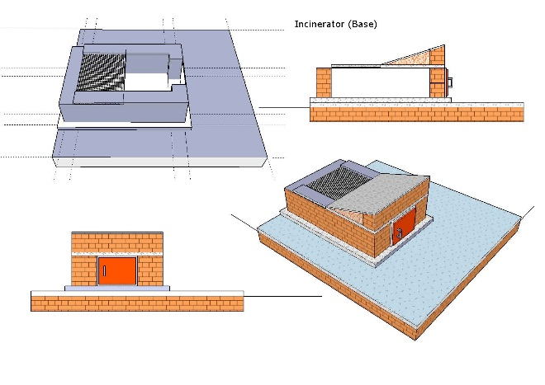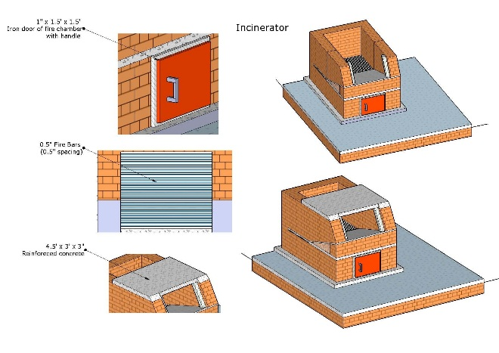

Figure 3 Incinerator (Base)

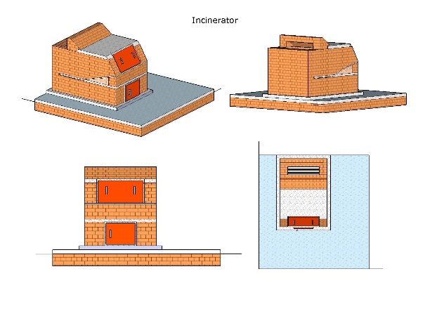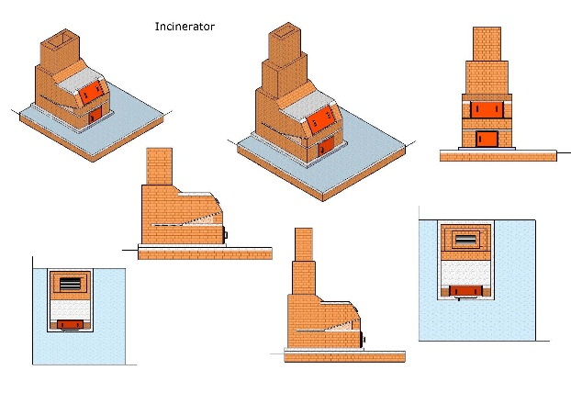

Figure 4 Incinerator (Base of Chimney)

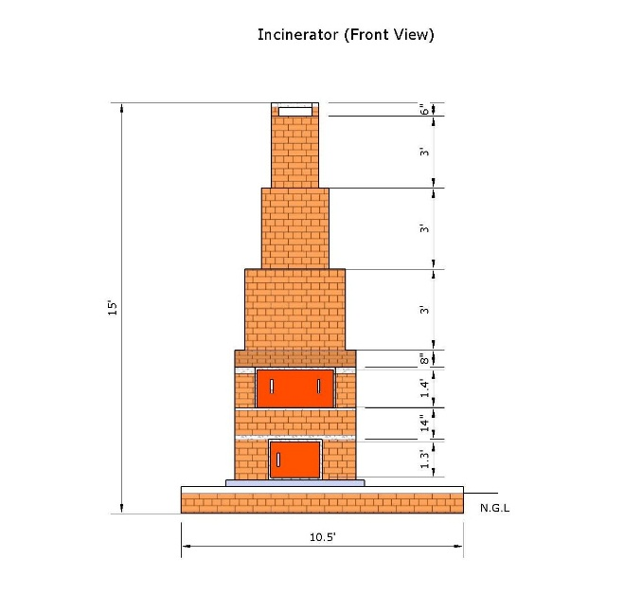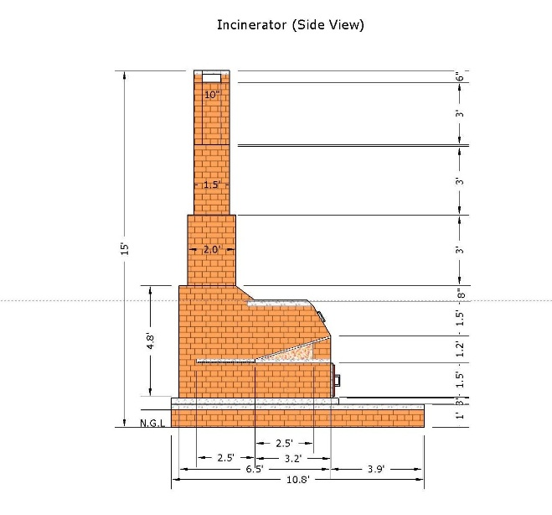

Figure 5 Incinerator including chimney (Side views)

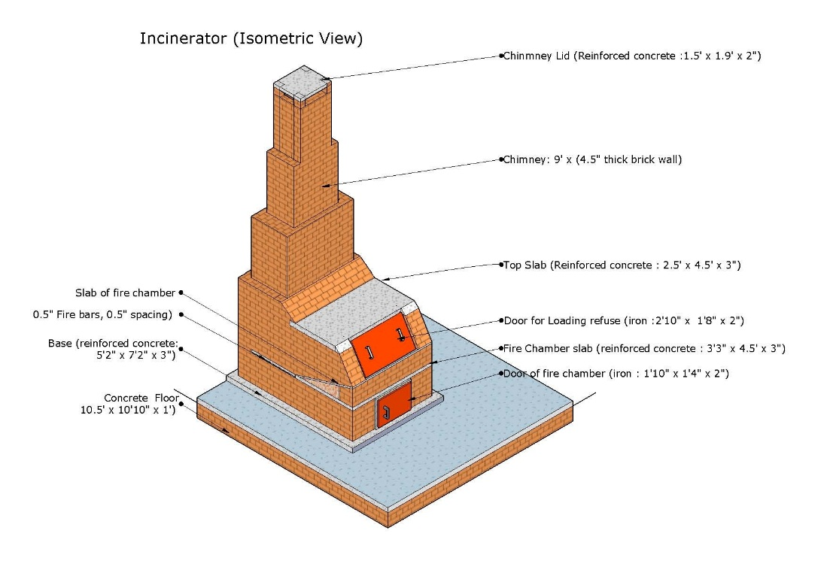

Figure 6 Incinerator (Isometric View)

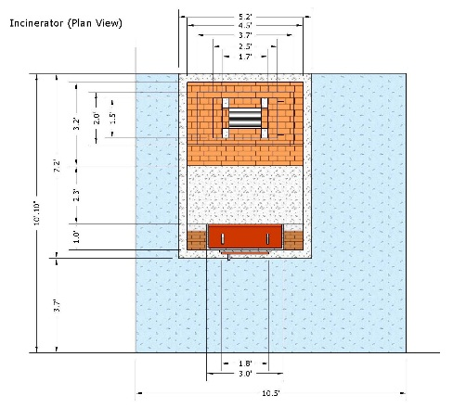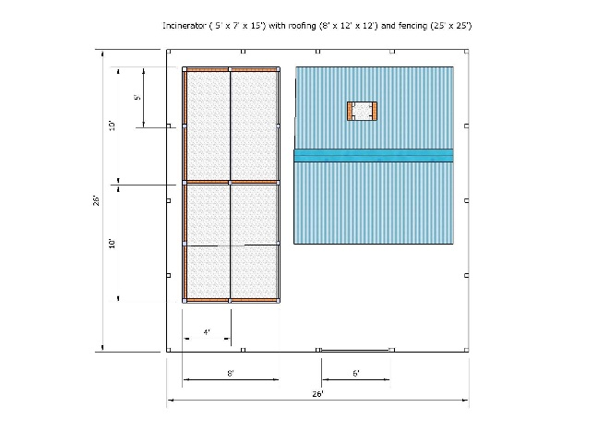

Figure 7 Incinerator Compound (Plan view)

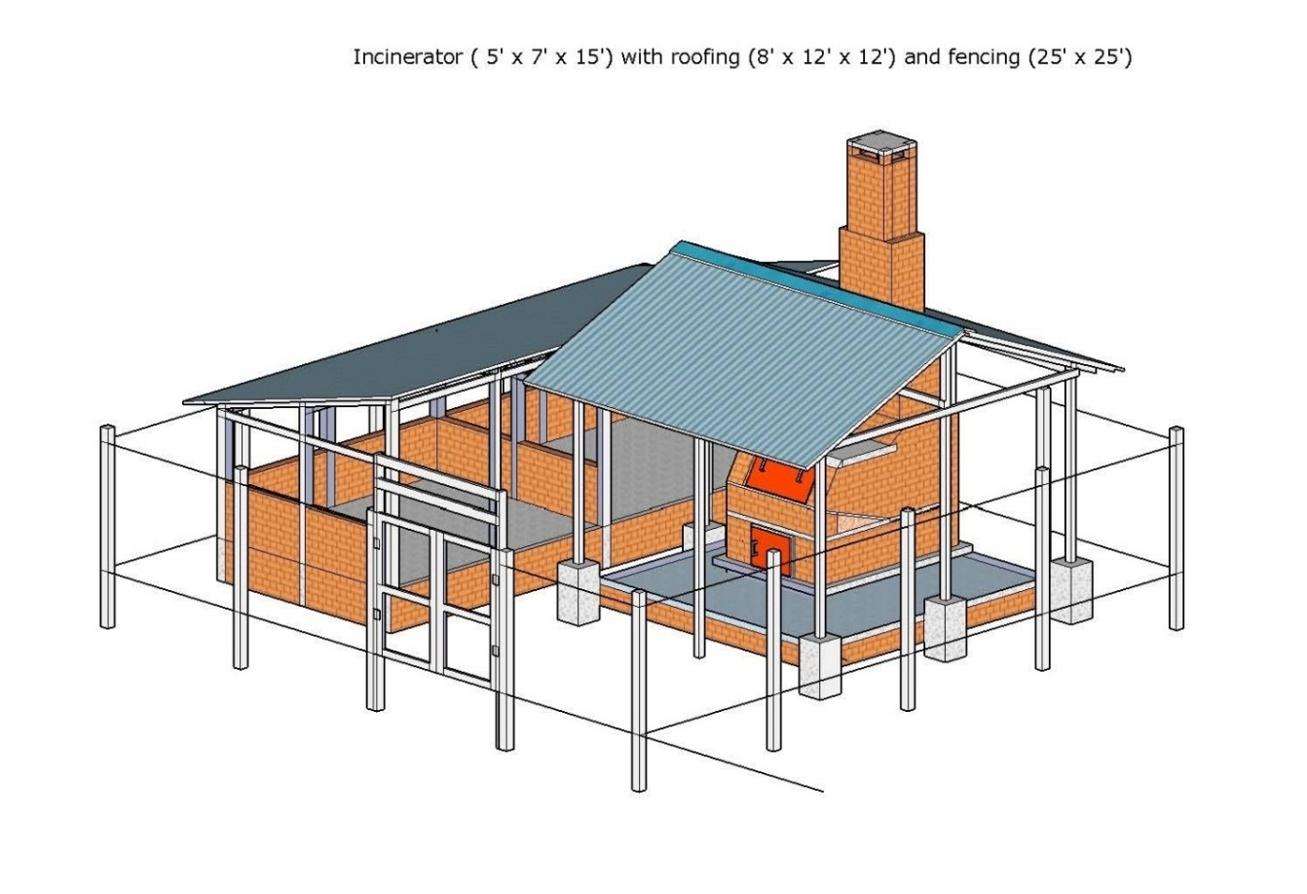

Figure 8 Incinerator compound (Isometric view)

Table 3 Bill of Quantity (Incinerator)

|  |  |  |  |  |  |  |  |
| --- | --- | --- | --- | --- | --- | --- | --- |
| No. | Particular | Quantity | Rate (MMK) | Per | Amount (MMK) | Amount (USD) | Remark |
| 1 | Cement | 34 | 6600 | bag | 224400 | 236 | Incinerator |
| 2 | Sand | 2 | 15000 | sud. | 30000 | 32 | Incinerator |
| 3 | Gravel | 1 | 75000 | sud. | 75000 | 79 | Incinerator |
| 4 | **Brick (Fire resistant brick)** | 4000 | 90 | no. | 360000 | 379 | Incinerator |
| 5 | Broken brick | 2 | 25000 | sud. | 50000 | 53 | Incinerator |
| 6 | 1/2" fire bar (iron) | 200 | 400 | ft | 80000 | 84 | Incinerator |
| 7 | 1/4" Iron coin | 20 | 2000 | viss | 40000 | 42 | Incinerator |
| 8 | 18 G binding wire | 1 | 3000 | viss | 3000 | 3 | Incinerator |
| 9 | 14 G bi di i14 G binding wire | 33 | 3000 | iviss | 9000 | 9 | Incinerator |
| 10 | 2" x 2" Iron Square Mesh | 3 | 40000 | roll | 120000 | 126 | Incinerator |
| 11 | Iron door (1'10" x 1'4" x 2") with handle and hinge | 1 | 6000 | no. | 6000 | 6 | Incinerator |
| 12 | Iron door (2'10" x 1'8" x 2") with handle | 1 | 10000 | no. | 10000 | 11 | Incinerator |
| 13 | concrete footing (1.5' x 1.5' x 2') | 6 | 4000 | no. | 24000 | 25 | Incinerator |
| 14 | Concrete post (7') | 26 | 4000 | no. | 104000 | 109 | Incinerator |
| 15 | 4" x2" x9' x (2 nos) timber4 x 2 x 9 x (2 nos) timber | 0.02 | 300000 | ton | 6000 | 6 | Incinerator compound |
| 16 | 4" x 2" x 6' x (2 nos) timber | 0.013 | 300000 | ton | 4000 | 4 | Incinerator compound |
| 17 | 3" x 3" x 8' x (19 nos) timber | 0.19 | 300000 | ton | 57000 | 60 | Incinerator compound |
| 18 | 3" x 3" x 10' x (2 nos) timber | 0.025 | 300000 | ton | 7500 | 8 | Incinerator compound |
| 19 | 3" x 2" x 12' x (6 nos) timber | 0.06 | 300000 | ton | 18000 | 19 | Incinerator compound |
| 20 | 3" x 2" x 10' x (6 nos) timber | 0.05 | 300000 | ton | 15000 | 16 | Incinerator compound |
| 21 | 3" x 2" x 6' x (8 nos) timber( ) | 0.04 | 300000 | ton | 12000 | 13 | Incinerator compound |
| 22 | 3" x 1.5" x 8' x (5 nos) timber | 0.033 | 300000 | ton | 10000 | 11 | Incinerator compound |
| 23 | 3" x 1.5" x 12' x (6 nos) timber | 0.045 | 300000 | ton | 13500 | 14 | Incinerator compound |
| 24 | 3" x 1.5" x 10' x (6 nos) timber | 0.038 | 300000 | ton | 11250 | 12 | Incinerator compound |
| 25 | Zinc Sheet 10' | 10 | 3500 | sheet | 35000 | 37 | Incinerator compound |
| 26 | Zinc Sheet 7' | 12 | 3000 | sheet | 36000 | 38 | Incinerator compound |
| 27 | Plane Zinc Sheet | 12 | 500 | ft | 6000 | 6 | Incinerator compound |
| 28 | Nail + Roofing nail | 2 | 3000 | viss | 6000 | 6 | Incinerator compound |
| 29 | Bolt, hinge, handle | 1 | 2000 | pair | 2000 | 2 | Incinerator compound |
| 30 | 2" borehole Handpump | 1 | 100000 | unit | 100000 | 105 | Incinerator compound |
| 31 | Mason | 20 | 4000 | person | 80000 | 84 | Labour for construction |
| 32 | Carpenter | 12 | 3000 | person | 36000 | 38 | Labour for construction |
| 33 | Worker | 50 | 2500 | person | 125000 | 132 | Labour for construction |
|  | Total | | | | 1715650 | 1806 |  |
|  | Contingencies 5 % | | | | 85783 | 90 |  |
|  | Grand Total | | | | 1801433 | 18,960 |  |
|  | **Approximated amount** | | | | **1800000** | 19,000 | USD |

The following design of incinerator can also be considered as an appropriate temporary solution for solid waste management especially in the areas where there is difficult to get land approval or limited space. The following design can also be used as a mobile unit of temporary waste reducer where it is not possible to construct a more permanent incinerator. However, the volume of the waste can be handled by this temporary waste reducer is limited and thus, it should be aimed to provide this type of incinerator for every 15 shelters.

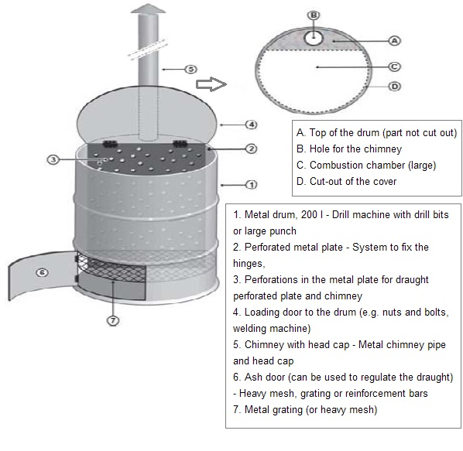

Figure 9 Temporary Incinerator

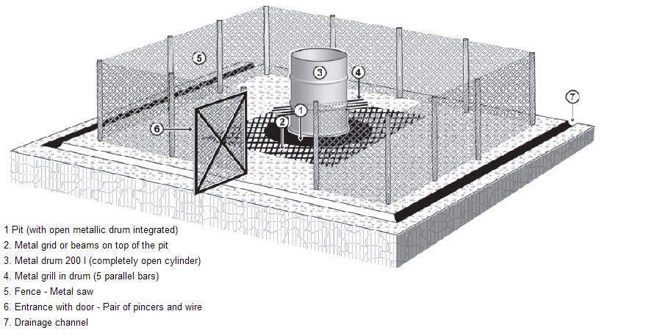

Figure 10 Temporary Incinerator with compound (Isometric view)

|  |  |  |  |  |  |  |
| --- | --- | --- | --- | --- | --- | --- |
| Description | Quantity | Unit | Estimated | Currency | Estimated | Currency |
|  |  |  | Unit Price |  | Total Price |  |
| Brick | 4000 | pcs | 65 | MMK | 260,000 | MMK |
| cement | 17 | Bags | 8,600 | MMK | 146,200 | MMK |
| Sand | 270 | Bags | 450 | MMK | 121,500 | MMK |
| Gravel | 80 | pcs | 1400 | MMK | 112,000 | MMK |
| wood (pyinkado) (5''x5''x10ft) | 6 | pcs | 35200 | MMK | 211,200 | MMK |
| wood (pyinkado) (5''x5''x13ft) | 2 | pcs | 48000 | MMK | 96,000 | MMK |
| wood (in-kanyin) (5''x2''x15ft) | 7 | pcs | 8800 | MMK | 61,600 | MMK |
| wood (in-kanyin) (4''x2''x15ft) | 12 | pcs | 6800 | MMK | 81,600 | MMK |
| wood (in-kanyin) (3''x2''x18ft) | 12 | pcs | 6000 | MMK | 72,000 | MMK |
| wood (in-kanyin) (3''x2''x15ft) | 15 | pcs | 5100 | MMK | 76,500 | MMK |
| wood (in-kanyin) (2''x1''x15ft) | 240 | ft | 150 | MMK | 36,000 | MMK |
| wood (in-kanyin) (6''x1/2''x18ft) | 12 | pcs | 3800 | MMK | 45,600 | MMK |
| G.I Plain Sheet (8ft x4 ft ) | 3 | pcs | 11000 | MMK | 33,000 | MMK |
| G.I Roofing Sheet (6 ft) | 40 | pcs | 6600 | MMK | 264,000 | MMK |
| Roofing Nail 2'' with washer | 3 | viss | 2200 | MMK | 6,600 | MMK |
| Fencing Wire mesh (5ft width) | 80 | ft | 2200 | MMK | 176,000 | MMK |
| Angle flat M.S bar(2''widthx1.5ft) | 8 | pcs | 1600 | MMK | 12,800 | MMK |
| Bolts & Nuts (1/2''Diax6'' length) | 20 | pcs | 550 | MMK | 11,000 | MMK |
| 1/2''plain Washer | 50 | pcs | 100 | MMK | 5,000 | MMK |
| Bolts & Nuts (1/2''Diax 8'' length) | 3 | pcs | 700 | MMK | 2,100 | MMK |
| Fire Brick (2.5''x4.5''x9'') | 200 | pcs | 450 | MMK | 90,000 | MMK |
| Fire cement (25 Kg) | 3 | Bags | 6600 | MMK | 19800 | MMK |
| Angle Iron (1.25''x1.25''x3mm) M.S | 70 | ft | 3000 | MMK | 210,000 | MMK |
| 'C '' Channel(4''x2''x5mm) M.S | 18 | ft | 4000 | MMK | 72,000 | MMK |
| Flat Bar (1.5''widthx3mm thick)M.S | 10 | ft | 700 | MMK | 7,000 | MMK |
| M.S Sheet (5 ft x4 ft x3mm ) | 1 | sheet | 88000 | MMK | 88,000 | MMK |
| M.S Round Bar (3/4'' Dia) | 10 | ft | 1700 | MMK | 17,000 | MMK |
| M.S Round Bar (3/8'' Dia) | 30 | ft | 1100 | MMK | 33,000 | MMK |
| M.S Round Bar (1/5'' Dia) | 30 | ft | 1400 | MMK | 42,000 | MMK |
| Fire Proof Cloths (1.5 ft Wx3 ft l) | 1 | sheet | 3300 | MMK | 3,300 | MMK |
| Stainless steel wire rope (5 mm Dia) | 160 | ft | 1650 | MMK | 264,000 | MMK |
| 4'' Turnbuckle | 4 | pcs | 3850 | MMK | 15400 | MMK |
| 4'' M.S Hook | 4 | pcs | 1650 | MMK | 6,600 | MMK |
| 6'' Dia M.S Pipe (5.8Mx3mm t) | 1 | pcs | 111000 | MMK | 111,000 | MMK |
| 1''M.S pipe (10 ft x 3mm t ) | 1 | pcs | 22000 | MMK | 22,000 | MMK |
| 4''M.S pipe (1 ft length) | 1 | pcs | 5500 | MMK | 5,500 | MMK |
| M.S Bolts & Nuts 4''length | 24 | pcs | 440 | MMK | 10,560 | MMK |
| 4''M.S Plain Washer | 48 | pcs | 30 | MMK | 1,440 | MMK |
| Nail 4'' | 1 | viss | 2200 | MMK | 2,200 | MMK |
| Nail 3.5'' | 3 | viss | 2200 | MMK | 6600 | MMK |
| Nail 3'' | 2 | viss | 2200 | MMK | 4400 | MMK |
| Nail 2.5'' | 2 | viss | 3300 | MMK | 6,600 | MMK |
| Nail 1.5'' | 1 | viss | 3300 | MMK | 3,300 | MMK |
| Primer Paint (Red Oxide ) (5 ) Gal | 2 | Can | 55000 | MMK | 110,000 | MMK |
|  |  |  | Total Amount |  | 2,982,400 | MMK |

For the operation of the incinerator, the following steps should be applied:

* Remove the ashes of the previous cycle via the ash door and discard them in the residues pits.
* Open the loading door and put some paper, cardboard and other combustibles ( e.g. dry firewood, dry coconut shells). Some kerosene can be added as well to ease the lighting of the fire.
* Light the paper and cardboard through the ash door. Once the light takes off, close the ash door
* Put a small batch of soft waste via the loading door when the fire is burning well.
* Close the loading door immediately. Add combustibles when the fire is dying.
* Keep monitoring the combustion and add small batch of soft waste.
* Let the fire die out by itself. Repeat the cycle as mentioned above.

Main Findings & Lesson Learned

This section will be updated after the thorough review on the current level of solid waste management system.

Recommendations

1. The need and importance of the solid waste management system should be advocated at the State, District and Township level.
2. A capacity building/technical workshop should be conducted together with the government to find out the most appropriate and sustainable solutions for the solid waste management system for the IDP/community.
3. Awareness raising about the solid waste management through the hygiene promotion activities should be done at the IDP/community level.
4. WASH implementing agencies should mobilize more resources for the solid waste management activities.
5. Assessment on the current waste management system (type, volume, handling, collection, disposal, recycling and treatment) should be done.
6. Good practices from the IDP/community should be encouraged and the weakness from the good practices should be evaluated and modified accordingly. For example, coating animal feaces and leaves debris to the piece of wood to be used as firewood.
7. Simple low-cost waste management system should be set-up and operated to minimize the negative impact on the health of the IDP/community and environment.
8. WASH Cluster and all WASH actors should explore on how to build up the involvement of the private sector and to initiate opportunities for the small scale businesses.

Reference Documents

1. Joos Van Den Noortgate & Peter Maes and et al, MSF, 2012, Public Health Engineering in Precarious Situations (2nd Edition)
2. Jonathan Rouse and Bob Reed, WHO, 2011, Solid Waste Management in Emergencies prepared by WEDC
3. Paul Woodson, Solid Waste Disposal Fact Sheet, East Central University