Pond Construction and Rehabilitation

A Myanmar experience with special reference to delta region

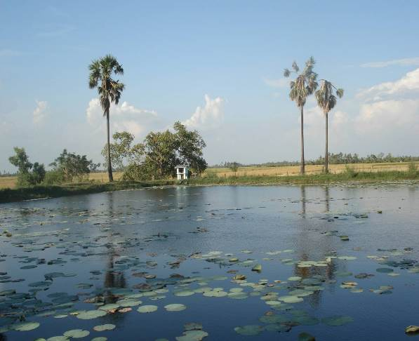

Nyunt Lwin

WASH Consultant

UNICEF WASH Section

March 2009 – Yangon 

Contents

1.0. INTRODUCTION...................................................................................................4
1.1. Objectives……………………………………………………………………………5
1.2. Categories of land in rural area of Myanmar….............................................5
1.3. Community mobilization.................................................................................6
1.4. Cash for Work Scheme…………………………………………………………....7
2.0. Components and design criteria of pond.........................................................8
2.1. Embankment height .......................................................................................8
2.2. Crest width of embankment..…………………………………………………… 9
2.3. Cut-off trench.................................................................................................10
2.4. Stability of slope............................................................................................10
2.5. Freeboard……………………………………………………………….………….10
2.6. Overflow / spillway…………………………………………………….………….10
2.7. Access methods ...........................................................................................11
2.8. Protection…………………………………………………………………………..12
3.0. Pond construction methods ............................................................................12
3.1. Types of pond …………………………………………………….......................12
3.2. Artificial recharge………………………………………………………..……….14
3.3. Site selection and investigations ………………………...............................14
3.4. Site preparation / clearing….........................................................................15
3.5. Storage calculation / Rainfall / PET and soil drainage ..............................15
3.6. Classification of soils...................................................................................16
3.7. Compaction and soil moisture content.......................................................18
3.8. Rehabilitation of pond……………………………………………………………20
3.9. Water quality testing…………………………………………………………......21
3.10. Operation and maintenance…………………………………………………...21
3.11. Estimates for pond construction……………………………………………..21
4.0. Pond lining and sealing methods……………………………………….………27
4.1. Clay linings and sealing of the pond floor……………………………………22
4.2. Bentonite linings…………………………………………………………………..23
4.3. Synthetic linings…………………………………………………………………...24
4.4. Lime treatment of soil for lining…………………….......................................27
4.4.1. The chemistry of lime treatment.............................................................27
4.4.2. Soil classification and assessment of suitability for lime
Stabilization…………………………………………………………………...28
4.4.3. Lime treatment requirements……………...............................................29
4.4.4. Lime safety precautions…………………………………………………….31
5.0. Conclusion.........................................................................................................34
6.0. References .......................................................................................................34
Appendices
Tables:
Table 1: Pond construction plan..................................................................................7
Table 2: Soil classification by particle size …………...................................................9
Table 3: Minimum criteria for membranes.................................................................24

Figures:
Figure 1: Typical section of earth dam…………………….……………………………...9
Figure 2: Embankment pond section…………………………………………………….12
Figure 3: Excavated pond section…….………………………………………………….13
Figure 4: 10 year’s average rainfall of Labutta Township, Ayeyarwady Division…...15
Figure5: Synthetic liner application in pond……………………………….………….....26
Figure 6: Layout plan for 100’ x 100’ pond ……………………………..……………….32
Figure 7: Layout plan for 100’ x 200’ pond ……………………………………………...33
Figure 8: Soil classification and plastic limit…………………………………………..…36
Figure 9: Site clearing for pond construction…………………………………………….37
Figure 10: Pipe level survey for pond construction…………….……………………….37
Figure 11a: Measurement and survey for pond rehabilitation…………………………38
Figure 11b: Measurement and survey for pond rehabilitation…………………………38
Figure 12: Cut off trench……..…………………………………………………………….39
Figure 13a: Community participation in pond rehabilitation……….…………………. 39
Figure 13b: Community participation in pond rehabilitation…….……………………. 40
Figure 14: Pond earthworks……………………………………………………………….40
Figure 15: Compaction with roller………………………………………………………...41
Figure 16: Compaction with tractor..……………………………………………………..41
Figure 17: Pumping out for pond rehabilitation………………………………………….42
Figure 18: Rehabilitation of pond…………………………………………………………42
Figure 19: Compaction of embankment………………………………………………….43
Figure 20: Completed embankment and steps………………………………………….43
Figure 21: Clay filling for impervious blanket………………………………………..…..44
Figure 22: Scarification of soil for lime stabilization…………………………………….44
Figure 23: Quick lime application…………………………………………………………45
Figure 24: Hydrating lime with water……………………………………………………..45
Figure 25: Compaction by ramming………………………………………………………46
Figure 26: Channel overflow construction…….…………………………………………46
Figure 27: Completed overflow construction…….……………………………………...47

1.0. INTRODUCTION

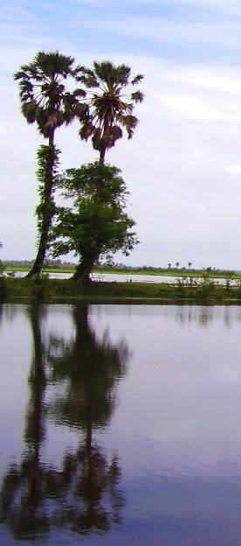
The use of ponds in Myanmar dated back to the time memorial. Most of the Myanmar people take pride and believe that is a meritorious deed for donation of a pond for the public use. The word, rehabilitation of the pond in Myanmar, is same as the meaning of changing to a good Karma.
Prior to the Cyclone Nargis, most communities in the affected areas sourced drinking water through self provision arrangements, such as communal rain water ponds, and storing the water in rainwater harvesting jars / tanks. Thus the most dependable water source in delta area is the surface water pond. The cyclone, however, salinated the ponds and destroyed rainwater harvesting systems, UNICEF estimates that 13 percent of ponds in Yangon and 43 percent of ponds in Ayeyarwady division were rendered unusable.
There is an urgent need to clean and refill the ponds during the first few months so that the communities have enough water for drinking and domestic purposes to get them through the upcoming dry season and beyond these efforts it must be supplemented by increasing the water storage capacity in the villages. This can be fulfilled by rehabilitation and construction ponds. Safe water use can be promoted through hygienic water handling and point of use treatment in the households.

In Ayeyarwady Division most of the ponds were constructed indigenously and a few numbers of them can be regarded as drinking water pond mainly due to the quality of the water, turbidity and probably upward seepage of slightly saline groundwater. According to the observations and interviews within the rural settings in the area there has been little or no attention to the impervious lining of the pond flooring and upstream side embankments. This paper tries to highlight this important factor of the pond construction, in this particular part of the country.
Sealing of pond flooring and upstream side embankments being common in the upper Myanmar area not only because of the saline groundwater infiltration, but also the soil nature in the area is granular in nature and in places are sandy horizons due to the geological formations in the area. There is a need to seal off the precious water by means of lining with highly plastic clay and impervious materials. This sealing method was found in some of the ancient ponds in Mandalay, Sagaing and Magwe Divisions. The practical know how of this clay lining / blanketing in the community was jointly used with cow dung in some places where its application is known to increase the viscosity of the clay material.
This presentation on the construction of ponds do not only articulate and emphasized on the technical part, but also highlighting the importance of community participation and inclusion of the most vulnerable people in all aspects of the construction phases of a rural water pond.

1.1. Objectives

The objectives underlying the construction and rehabilitation of the water storage ponds in the cyclone-affected areas is to provide sufficient water supply to the inhabitants and on the other hand will enhance the overall management of the community through participatory approaches. More over during the construction phase it will provide household’s income to vulnerable families by creating cash for work schemes. Government incomplete records show that there were at least 4,540 ponds in the affected area. To the estimated 3.5 million inhabitants of the region the provision of new water sources will definitely improved their livelihoods and their hygienic conditions.
The following long term objectives aim to address the issues and achieve results of water, sanitation, hygiene and related capacity development for the communities affected by cyclone Nargis.
- All people in the Nargis affected areas have access to sufficient water of acceptable quality for drinking, cooking, personal and domestic hygiene
- Communities are adequately empowered to plan, develop, operate, maintain and monitor the performance of their water, sanitation and hygiene projects
- Water, sanitation and hygiene functions in a well coordinated framework including data and information management by strengthened and enhanced strategic partnerships alliances with stakeholders.

Rainwater harvesting ponds could be one of community water storage options. The work of manually constructing ponds is known to the people and could be achieved in a few weeks. Importantly, the construction exercise could become an ideal source of alternative income generation for the identified vulnerable families, in the immediate dry season. Appropriate pond location, with proximity to drainage line, would have to be selected and surveyed before commencing the pond construction activity.

1.2. Categories of land in rural area of Myanmar

The categories of land in rural Myanmar as defined by Settlements and Land Records Department of Ministry of Agriculture and Irrigation are as follows:

- Village land
- Religious land
- Agriculture land
- Grazing land
- Vacant land
If the pond construction or the enlargement of the pond falls in the agriculture, grazing or (vacant) land categories there is a need to apply a permission through Township Land Committee to utilize the land area for the purpose, which in official terms is named as La Na – 39 applications. The application is then verified and approved by the District PDC. This process can take considerable time (at least two - three months) and need to discuss thoroughly with the village and township level PDCs.
It is more advisable to seek other type of land categories for this purpose which needs only local agreement documents like donation or relinquishment of the property.

1.3. Community mobilization

After the mobilization of the community, the action plan or the time schedule for the construction of the pond should be documented together with the community and the village water committee.
Community participation is very much important in this kind of activities in light of these following factors:

- A strong level of engagement with local people in pond construction is critical to effective operations. It is also a basic means of demonstrating accountability.

- As pond construction / rehabilitation are common in the Ayeyarwady Delta region, local know-how for this manual operation is high. Agencies involve in the activities should properly introduce the technical parameters and important components of the pond; this will in turn transfer appropriate technology to the people and strengthened the local capacity.

- While men are typically involved in direct pond construction / rehabilitation, women are more involved then men in collecting, storing and treating water. Understanding women’s needs and views, and taking them into consideration, is important point for a successful implementation of the pond.

Table (1): Pond Construction Plan

Description | Week-1 | Week-2 | Week-3 | Week-4 | Who | Remarks
Community mobilization / Site selection / Agreement for land donation
Site clearing / preparation/ investigation
Materials Collection / transportation

Earth works
Cutoff trench
Filling and compaction
Embankment construction
Clay sealing / lime treatment
Side slopes completion
Finishing
Overflow construction
Access construction
Grass planting
Operation and maintenance plan

1.4. Cash for Work Scheme

As the cyclone affected families is in need of resources as well as cash for their livelihoods, the cash for work schemes created by the pond construction activities can provide 50 – 100 families for at least two weeks of income through the earthwork excavations and manual works for the completion. They could use a proportion of their earning in the purchase of the much needed household water before the monsoon season begins.
Current labour costs need to be consulted with the local agencies and government departments to conform with the situation in the area.

2.0. Components and design criteria of pond

The basic principle of design is to produce a satisfactory functional structure at a
minimum cost. To minimize the cost, the pond should be designed for maximum utilization of the most economical materials available. The operational/maintenance cost also needs due consideration.
To ensure safety and stability of the pond embankment during all phases of construction and operation the following criteria must be met:
1) The embankment should be safe against overtopping during occurrence of the inflow
design flood by the provision of sufficient overflow / spillway and outlet works capacity.
2) The slopes of the embankment must be stable during construction and also under
conditions of reservoir operation including rapid draw down of the reservoir.
3) Seepage flow through the embankment and foundation must be controlled so that no internal erosion and sloughing takes place.
4) The embankment must be safe against overtopping by wave action against erosion and the crest and downstream slopes must be protected against erosion due to wind and rain.
5) The pond floor area is sufficiently lined with proper impervious layer to significantly reduce the seepage loss and preventing the upward infiltration of saline water from the near surface water table.
If these criteria are satisfied, the embankment and the floor area will be safe provided proper construction methods are adopted. The design procedures may, however, vary depending upon the purpose of design, size and importance of the structure, and the complexity of the problem.
The materials should preferably be taken from the reservoir area; different parts of the side of the area should be examined so that the most suitable soils are located (soil textures will vary according to the extent of the area). The following materials should be avoided: organic material — including topsoil — decomposing material, material with roots or stones.
A need to strip topsoil because it contains organic matter (such as roots) which prevents proper compaction and may provide seepage routes (piping) once the organic matter has decayed.

The various design components of the pond include (a) height of embankment, (b) top width, (c) foundation including key trench or cut-off, (d) side slopes, (e) free board, (f) overflow and (g) access method. To compare with the small earthen dam a typical cross section was shown in Figure-1.

2.1. Embankment height:

The height of embankment should be selected in such a way that the cost of pond per unit of storage is minimum. In small earth dams the depth-capacity curve and the area-capacity curve are used to determine the most suitable height for a given storage volume. Whereas, in the pond embankments it was calculated from the average annual rainfall plus the safety factor for an earthen embankment. The height of earthen embankments in delta should not exceed 10 – 12 feet (3 – 4 meters).

Figure-1: Typical section of earth dam

2.2. Crest width of embankment:

A minimum crest width should be that width which will provide a safe percolation gradient through the embankment at the level of a full reservoir. Because of the practical difficulties in determining this factor the crest width is as rule determined empirically and the following formula is recommended for small earth fill dams:

W = H/5 + 1.5 (this formula is for metric units)

Where:

W = embankment crest width
H = embankment height

A design height of 10 feet (3.05 m) was assumed and according to the formula:

W = 3.05/5 +1.5
= 2 .11 meters

The calculated minimum crest width is 2.11 meters (6.9 feet) and the design in the following chapters for delta area pond the crest width was set for 10 feet. Thus it is obvious that the design width is adequate and safe as an embankment.

2.3. Cut off trench

The purpose of the cut off trench / key is to join the impervious stratum in the foundation with the base of the embankment. The most common type of key is constructed of compacted plastic clay material. A trench, also called key / cut off trench, is cut parallel to the central line of the embankment to a depth that extends well into the impervious layer (ideally in the delta area this will be about 3 feet and need to increase accordingly to the test pit lithology results). The trench should have a bottom width of not less than 3 feet, adequate to allow the use of tools and to attain proper compaction.
The backfill shall be compacted with rollers, or hand tampers to assure maximum density and minimum permeability.

2.4. Stability of slope

Slope ratio
According to the experience in construction ponds throughout Myanmar the largest pond size constructed is about 4 acres and height more than 30 feet will require a slope ratio of 3:1, but also a saddle berm or an abutment on the downstream side of the embankment due to the construction materials and the possible seepage from the downstream side toe.
For the general soil conditions commonly found in delta region the most appropriate ratio will be 3:1 where space permits and in some cases where space is a problem 2.5:1 will be the minimum required slope ratio for the optimum stability.

2.5. Free board

It is the added height of the structure provided as a safety factor to prevent waves and runoff from storms greater than the design frequency from overtopping the embankment. It is the vertical distance between the elevation of the highest flood level and top level of the embankment after all settlement has taken place. It depends upon the height as well as length of the embankment. Normally, 10-15 percent is added as free board to the highest flood level of the dam. Minimum free board of 50 cm is provided for length of pond up to 400 m, 75 cm for length between 400 to 800 m and 100 cm for length more than 800 m.

2.6. Overflow

A properly design overflow can be used for the optimum protection of the embankment. It can be constructed from stones / bricks / laterite blocks available within the local area. The general design for the delta region will be maximum width of 5 feet and 1 foot depth from the crest of the embankment (this is for the more commonly found pond size of 0.25 – 1 acre). It can theoretically drain (45) cubic feet of water per second (assumed velocity 1 ft/sec) which is well above the torrential rainfall intensity at any given point in the delta region. The freeboard for the common size ponds in the area will be appropriate between 1 – 1.5 feet whereas increased freeboard should be required for large area ponds (> 2 acres).

2.7. Access Methods

The need for determining the proper access method to the pond water is important for the possible contamination of the water. The following methods were available and used in the ponds throughout Myanmar:

- Steps and jetty combined
- Floating jetty
- Siphoning / gravity method
- Water withdrawal by pumps / handpumps / footpumps
- Filter box and stilling well

1) Steps

Steps are commonly incorporated in the ponds throughout Myanmar. This is regarded as one of the essential component of the pond by the indigenous people, it can be found in most of the donated ponds and especially to those at or near the pagoda / monastery compounds in Myanmar. Normally a jetty is installed into the pond area via steps to make easy access to the water. Steps construction materials can vary widely according to locally available materials but more often with the brick masonry type.
Steps should be ideally constructed in ponds which can fulfill the following tasks:

- Access to the water without disturbing the embankment
- A dual purpose step / overflow can be constructed with a proper design.
- To prevent / minimize manmade contamination while drawing water.

2) Floating jetty

Floating jetty is a ramp or a walkway fastened to a floating buoy (plastic / MS drum or a square welded MS tank). It can be used for access to water which can rise and fall according to the water level in the pond. This type of access will need regular maintenance to ensure the safety and durability of the materials.

3) Siphoning / Gravity method

This method can be applicable where the pond is situated in the high ground and the village or the water out let is at lower level. The total head difference should be significant to allow the piping network feasible.

4) Engine pumps / hand pumps / pedal pumps

This method can be used where there are caretakers for maintaining the equipments. Spare parts availability and management of the water system is one of the issues governing the sustainability.

5) Slow sand filter / Filter box / stilling well

Slow sand filter installed at or near the bank of pond, which does not dry up in the dry season. The water from the pond is lifted by a manually operated hand pump to feed the filter bed, which is raised from ground, and the treated water is collected through tap(s).
Filter box was used mainly to reduce the turbidity of the water (coarse sand and gravel filter materials). It normally applies to conditions where the impounded water is highly turbid due to the runoff from the embankments / soil layers.
A gravity outlet can be constructed, using a screened inlet or a filter box on the bed of the reservoir area, and a pipe below the embankment connected to a stilling well.
Stilling wells are constructed near the embankment of the pond which can be use for access to water by means of rope and bucket.
Problems can arise with seepage through poorly compacted material beside the pipe and difficulty in repairing if a pipe was damaged.

2.8. Protection / Fencing

In most of the communities in the rural area, people prefer setting up a fencing system to prevent animals entering the water storage area. Although it has nothing to do much with the quality improvement of the water it is worthwhile to consider it with the community contribution and some assistance from the project.
Local materials like bamboo bracing and timber posts can be utilized for low cost fencing, but it will last only for few years (with good maintenance it will last up to five years) whereas the concrete post and barb wire or chicken mesh / chain link fencing may last up to 10 – 15 years.

3.0. Pond construction

3.1. Types of pond

The water harvesting structures of various types are known by different names in the country such as ponds, small earthen dams, irrigation tanks, stop dams etc. The most common water harvesting structures are of two types: a) embankment type ponds and b) excavated or dugout type ponds for flat topography.
The digging season for ponds is usually during the driest months from February – Mid May thus allowing to handle the pond floor area more effectively.

Embankment pond
An embankment pond can be formed by constructing an embankment in an area where the depression is deep enough to provide a water depth of at least 5 ft (or) in a selected location.
Ideally most of the ponds in the delta area should be constructed by this type as the high groundwater with salinity can interfere with the water quality of the pond. In the field conditions, stripping off the first 1-3 feet level of soil should be required as there are two governing factors to carry out this task, firstly is the relatively sandy portion of the soil need to remove, secondly there is a need of soil volume to construct the embankment as the borrow soil is difficult in places of delta regionFigure - 2: Embankment pond section

Excavated pond

An excavated pond can be constructed by digging a dugout area, typically in relatively flat topography areas. The actual digging in places could not exceed depths 3 – 5 feet, due to the saline groundwater presence in shallow depths of the area. The peripherals of the digging area of the pond should be sloped so as to prevent erosion and the degree of slope required should be around 30 – 45 degree. There is also a need to provide a space of at least 3’ as a landing before the upstream side toe of the embankment (Figure: Plan of 100’x 200’, 100’ x 100’ pond) this is to prevent direct settling of sediments to the pond floor.
In practice the actual pond construction in the delta area could be a mix of these two types. The attention need to emphasize on the effective sealing of the pond floor area and if necessary the inner toe and side walls of the embankment.

Figure - 3: Excavated pond section

3.2. Artificial Recharge

The increased contamination of near surface saline groundwater in delta area is
causing great concern to the fresh water aquifer in certain depths as well as the surface water storage facilities like ponds. The component of rainfall contribution as infiltration to groundwater is assumed varying from 3-25 per cent in different hydrogeological situations and it can be thus supplemented by artificial recharging. Factors affecting groundwater recharge are: a ) availability, source and quality of water, b) nature of surface soil, c) depth of aquifer, d) geologic structure and capacity of groundwater reservoir, e) presence of aquicludes, e) movement of groundwater, f) location of withdrawal area, and g) pattern of pumping draft. For planning and development of groundwater through natural or artificial recharge, necessary investigations should be carried out. Artificial recharge is defined as the process of replenishing underground formations by augmenting the surface water storage. The direct surface methods of artificial recharge include flooding, ditch and furrow, basins, stream channel modification and over irrigation whereas the direct sub-surface methods include injection of water into natural openings in the aquifer, pits or shafts and wells. The induced recharge is accomplished by withdrawing groundwater at a location adjacent to a river or lake so that lowering of the groundwater level will induce water to enter the ground from the surface source. For estimation of groundwater recharge, ground water level fluctuation, tracer techniques or indirect methods may be employed. All soil and water conservation measures help in augmenting the groundwater recharge by inducing the infiltration rate and increasing the opportunity time. These measures include contour bunds, graded bunds, bench terraces, trenches, percolation ponds, check dams/gully plugs, and other agronomical and biological practices.
If a proper project can be set up for the artificial or natural recharge it will be most beneficial for the delta region in the longer term. This will in turn push the saline water intrusion wedge and enhance storage of fresh water in the upper most aquifers.

3.3. Site selection and investigations

Ponds function only as well as their setting allows. Soil composition is one of the most significant factors in siting a pond. The soil should have low permeability and good compaction. Typically, this includes a high clay content and relatively low organic content. Soils described as gravelly or loamy and highly organic are usually unsuitable for pond construction without special provisions.

The selection of a suitable site for pond construction is very important and this should be finalized after discussion and consultation with all stakeholders in the community. In order to fulfill the water quantity required for the community, the size of the pond should be determined together with the people at the community meeting. Cost and timing for completion is also an important point to be considered.

The soil test pits (soil profile) should be carried out at four inner corners of the pond area and most preferably in the center. Ideally the test pit depth should be around 5 – 7 feet for the delta conditions. Every single foot of the test pit should be recorded in terms of lithology / water table / saturation level. A reasonable size of sample also needs to be taken.

3.4. Site Preparation / Clearing

Areas designated for borrow areas, embankment, and structural works shall be cleared, grubbed and stripped of topsoil. All trees, vegetation, roots, organic matters and other objectionable material shall be removed. All trees shall be cleared and grubbed within 15 feet of the toe of the embankment. Areas to be covered by the pond / reservoir will be cleared of all trees, brush, logs, fences, rubbish and other objectionable material.

3.5. Storage calculations / Rainfall / PET

Storage calculations

Storage and water balance calculations for ponds are different to impounding dams, it relies on the annual rainfall and the balance were calculated on the Potential Evapotranspiration (PET) and soil drainage based on actual (measured) saturated hydraulic conductivity (K_{sat}). Thornthwaite method(1948) can be use to calculate the PET in a given area, the method requires information on mean monthly temperature and mean monthly sunshine days.
The general water availability (water balance) can be calculated after the deduction of the PET and soil drainage. 30% PET and soil drainage is assumed in the delta area of Myanmar (verbal discussions at meetings PET is assumed at 900 mm per annum)
After PET and drainage loss, the 100’x100’x12’ size pond can serve approximately (1,000) people at 3.3 gallons (15 liters) per capita per day for (6) months, whereas 100’x200’x12’ size pond can serve approximately (2,000) people.

Rainfall and PET of the area

The rainfall distribution in the delta region is more or less similar except some variations from the south to the north, the variation ranges from 100 – 150 inches per annum.
Rainwater is available in sufficient quantity to cover basic water supply needs from May to October. The rainwater is harvested either at household level in the form of roof-water collection systems or at the community level in the form of excavated ponds.
Stored rainwater in large communal ponds remains the major source for drinking and domestic water supply during the dry season period (November to April) for most areas of Labutta, Bogalay Ngapudaw and Pyapon.

Figure-4: 10 years average rainfall of Laputta Township, Ayeyarwady Division

The above graph provides 10 year average of rainy days and rainfall in Labutta Township. It indicates that the rainfall is spread over an average 118 rainy days during 6 monsoon months. The rainfall peaks during July & August with nearly 30” inches of rain each month and wanes by October. The average annual rainfall is 132 inches in the Laputta Township. There are less than 10 rainy days with only 2.73 inches of rain from December to April.

Potential evapotranspiration (PET) can be calculated with the most commonly use Thornthwaite method (1948). However, it requires information on “mean monthly temperature” and “mean monthly sunshine hours” and it will be more convenient to utilize an assumed PET and drainage loss for the delta region for water balance calculations. According to the experience in the area the 30 percent of PET and drainage loss will be appropriate for the water balance calculations and will be applied throughout this document.

3.6. Classification of soils

Classification of soil is essential in siting the pond construction and determining the proper type of soil material required for use in sealing pond floor area and the embankment. The majority of soil type common in the delta area is clay and clayey sand base material and organic soils in some places close to the vegetation covered land areas.

(Braja M. Das: 1998, Principles of Geotechnical Engineering, PWS Publishing Company)

For information there are three basic categories of soil:
viz: Granular, Clay, and Organic.

A. Granular Soil is best defined as a sandy type of material. These gritty, non-cohesive, particles consist of grains as small as .002 inches in diameter.

B. Clay Soil consists of very fine smooth and cohesive, plate-like, particles
derived from the decomposition of rock.

C. Organic Soil, like Loam or Peat, is derived from plant decay. This type
of material is not normally acceptable for construction applications unless
properly mixed with either Granular or Clay.

Sand and silt ( granular). Mineral grains down to .002 inch. When squeezed in the hand and then released, a dry soil will fall apart; a moist one will not.
Sandy loam and silt loam( cohesive). Mix t u res of fine sand and clay. Loams have a soft, fluffy feel. They are lumpy when dry but can be pulverized easily. When we t they are cohesive; casts can be handled easily without
b re a k a g e.
C l a y ( cohesive) . Particle sizes are the finest of any soil. The particles are scale-like and slide on one another with minimum friction. Clays are naturally plastic.

Soil Classification by Particle Size (Granular vs. Fine-grained materials)

There are two methods of soil classification based on particle or grain size: the Unified Soil Classification System (USCS) and the American Association of State Highway and Transportation Officials (AASHTO).

Table (2): Soil classification by particle size (from Das, 2002)

Classification System | Grain size in mm (Sieve no.)
 | Gravel | Sand | Silt | Clay
AASHTO | 76.2 to  2 (10) | 2 (10) to  0.075 (200) | 0.075 (200) to  0.002 | <0.002
USCS (USACE, USBR, and  ASTM) | 76.2 to  4.75 (4) | 4.75 (4) to  0.075 (200) | Fines (i.e., silts and clays)  <0.075 (200)

Suitability of soil conditions

Soil conditions or textures are very important in embankment constructions. Especially where embankments are intended for impounding water. Care should be taken in certain soil types for embankment ponds. Sand and silt are ideally not suitable for either embankment or pond floor and should be mix with clay to a desired amount. The mixture should be judged upon the availability of the plastic clay soils whether in site or transported.
Black soil types, especially organic or peat soils should be avoided and whenever encountered these soil types should be stripped off and refill with clayey soil.
A soil texture or a plastic limit test is applicable for the field conditions and can be easily carried out by persons with no engineering background (Figure - 8: Soil classification and plastic limit)
Generally, clay soils will hold water whereas sandy soil will not. If the selected site have sandy, permeable soil then it will need to construct the pond with a liner. The texture of soil can be determine with bare hands and a spray bottle of water. Take approximately 2 teaspoons of the soil in one hand. Lightly spray the soil with water from spray bottle. Generally, if the soil can form into a ribbon between the thumb and forefinger that is 5-centimeters or longer before it breaks, then it was a clay. If the soil sample falls apart when wet and cannot be formed into a ribbon between the thumb and forefinger then it is a sandy soil. Most soils will be some combination of sand, silt, and clay.

3.7. Compaction and soil moisture content

Compaction of soil

Compaction is important in the construction of earthen embankments / floor area of the pond. This process is essential in the pond construction and should be taken special consideration. Most of the local or indigenous construction of pond in the area ignores this part and let the soil compacted naturally by passing through one or two rainy seasons. Compaction with a suitable impervious layer and undertaken properly according to the technical steps can enhance the efficiency of the pond by means of very low downward filtration and preventing upward filtration of saline groundwater.

Compaction differs from consolidation of soil, which is the reduction of voids in a saturated soil over time due to the expulsion of water. The process of compaction alters and improves the engineering properties of soils. Since it is expensive and time consuming to determine these properties, they are often estimated through the water content and degree of compactness of a soil mass.

Compaction is the process of reducing soil volume when force is applied. External compressive forces increase soil density by moving or rearranging soil particles closer
together while forcing out any air that has been trapped between those particles.
When soils are compacted to a denser state, they will exhibit higher strength, lower compressibility, and lower permeability. The extent to which soil can be compacted depends upon four factors:

1. Types of Soil
2. Properties of Soil
3. Soil Moisture Content
4. Compaction Energy Applied

The proper mix of moisture in soil is extremely critical when attempting to achieve
proper compaction. Inadequate moisture equals inadequate compaction while
excess moisture may leave water filled voids resulting in a weak load bearing
condition. The correct amount of moisture is critical for soil particles to slide by
each other during any compaction process.
In the delta area the compaction is most likely to be carried out by ramming with manpower and in some cases it can be done by a roller, pulled by animal or a tractor.

The importance of the water content of a soil

The fundamental theory behind present impact compaction tests was first proposed by Proctor (1933a) to aid in the compaction control of earth dams. Compactive forces are resisted by friction between soil particles and water in the soil voids acts as a lubricant to reduce these frictional forces. At water contents less than this optimum water content, an increase in the water content would result in a higher dry unit weight due to increased lubrication.
At water contents above this optimum water content, the applied compactive effort would not be able to expel air or water, and thus the dry unit weights obtained would be less than that found at the optimum water content.
For embankment construction, this optimum water content with the minimum percentage of voids was desirable for two reasons (Proctor, 1933a). First, less water would be required to saturate the soil; thus less lubrication would occur and the fill would have greater stability. Second, a fill with the minimum amount of voids would result in a more watertight embankment.

The importance of water content on the compaction process was discussed and when compacting granular soils, the issue becomes even more important because these soils are frequently free-draining materials. Hence, there are actually two water contents of concern, one at the time of compaction that lubricates and facilitates the rearrangements of soil particles as compaction is taking place and a second water content that exists in the compacted soil after compaction. In cohesive soils, these two water contents are usually very close to each other while in granular soils they could be quite different if the soil is free draining. Typically, the water content after compaction is less because water in the voids either drains to the soil below or in warm or windy conditions evaporates into the atmosphere. The water content at the time of compaction is of exceptional importance in effectively compacting the soil. The water content of soil after compaction is of great importance in establishing the dry unit weight of the compacted soil from the measured total unit weight of the compacted soil.

3.8. Rehabilitation of ponds

Rehabilitation of pond is more often required in the affected townships of Ayeyarwady and Yangon Divisions, this is because the existing ponds in the area has proven for the usefulness as a drinking source and will need further improvements due to :
- A need to enlarge the volume to fulfill the water needs of the community
- A proper pond sealing method is required
Calculations need for determining the effective storage of the pond to be rehabilitated. The practical sizes for the renovation will be possible to utilize the 100’ x 100’ or 100’ x 200’ sizes which can serve population of 1000 and 2000 respectively for a period of (6) months.
Care should be taken while stripping off the sludge layer in the old ponds. This should be ideally not more than six inches to one foot according to the presence of the sludge layer, a special attention to avoid taking off the original impervious layer in the pond.
Soil test should be carried out to know the bed soil conditions and if encountering a sandy layer special care should be taken to seal off the pervious layer with proper impervious materials.

The sealing can be done with impervious clay layer or other additives materials (e.g. lime) to treat the original soil layer. Experience in the sandy horizons of the pond floor reveals that thickness of 1 – 1.5 feet of compacted impervious clay layer is sufficient for a pond depth of 12 – 15 feet. (Refer to sealing layer thickness calculations)
An additive such as quick lime is recommended for modifying or stabilizing the clayey soil and enhancing the load bearing capacity and reducing the permeability.

In the dry zone area experience, strengthening and enhancing the water sealing effects of the side walls of the embankment (upstream side) is also required to prevent the filtration losses of the impounded water. In the delta region due to the high cost of the construction and the availability of technical know how and difficulties in convenient access to proper plastic clay this can be applicable only to the limited region of the pond as the inner toe area of the embankment.

The costs for rehabilitation of a pond may vary widely depending upon the size of the enlarged area modification of the embankment, pond sealing/lining requirements, access and overflow construction.

There is a possibility of determining to the nearest expenditure by estimating in lump sum group of earthwork, plus inclusion of all components of requirements as a general case. (i.e. linings / lime treatment / compaction / modification of embankments, pumping out needs, etc.) Say like 100 suds plus requirements, 200 suds plus requirements……… so on and so forth.

3.9. Pond Water Quality Monitoring and Testing

Acceptable levels of salinity in water supplies depend upon local custom and previous exposure to salinity content. Conductivity meters can be used to determine salinity and in most cases the local susceptibility to salinity is around 250 – 450 micro Siemens / cm.
Testing for e-coli bacteria in pond water is most useful when part of a health and hygiene promotion campaign on safe household water treatment. There is a need to make sure that test results are available from both the water source (pond) and from storage containers at random households.
Other parameters for water testing should also carry out where ever possible for important minerals like Arsenic (As), Lead (Pb), Fluoride (F) and compounds like NO2 and NO3. Although it is known to be absent of the hazardous chemicals like Arsenic it is worthwhile to carry out a random testing in each of the Delta Townships.

3.10. Operation and Maintenance

An operation and maintenance of the pond should be incorporated during the community action plan. An inspection checklist should be included as part of the plan and performed at least annually. De-silting and sludge removal can be undertaken as part of the operation and maintenance at appropriate period, care need to be taken not to damage the pond lining / sealing/ treated layer. Records of pond construction should be documented properly together with the maintenance and major repairs.

3.11. Estimates for pond construction

Estimates for ponds were prepared based on two common sizes of pond which is most prevailing in the delta area, viz, 100’ x 100’ and 100’ x 200’. The types of pond found in the delta area are embankment pond and excavated pond. In practice a mix type of these ponds are constructed in the area, according to the following factors:

- Limited excavation depth due to saline water presence near surface in some places.
- Difficulty of borrow soil availability in sites (a need to excavate soil from the pond storage area to a safe depth)
- Borrow soils can be available only in paddy fields / plots close to the site.
- Difficult and expensive to transport borrow soil from a distance.

Site investigations were essential and the excavation of soils should be according to the lithologic nature of the site. Normally sand layers up to 3 – 5 feet could be removed, provided there is an impervious layer (clay materials) with significant thickness (~ 2 feet) directly underneath. If it was not the case care should be taken not to strip off the impervious layer at or near the ground level.
Earthworks estimates were prepared according to the design but in real ground conditions minor deductions are sometimes difficult to cut and there may be some variation of earth volume during the cut and fill process, according to these factors there is a need to include a contingency which does not exceed 10 percent of a total cost estimate.
This will speed up the implementation in the field where the calculations for the minor deductions can be omitted. Those minor deductions were corrections for the trapezoidal cut-off trench and for the inner slope of the pond storage area. The cost estimations were included in the annexes and were based on the current local rates after consultations with the various agencies and people. These estimations implies only to the delta area of Myanmar.

Earthworks

The earthworks requirement for the different sizes of ponds depends largely on the crest width, height and the slope ratio. The estimates of the total soil requirements in a 100’ x 200’ storage area pond with a height of (10’) and the slope ratio of 3:1 can be calculated as (830) sudrums (1 sudrum is a measurement, generally used in earth works and is equivalent to 100 cubic feet).

4.0. Pond lining and sealing methods

4.1. Clay linings and sealing of the pond floor

The soil nature and the water table conditions in delta area are different from the other part of the country and needs special attention to the pond floor. The soil nature in some places will be sandy or organic soil types and needs impermeable material to prevent seepage losses of the impounded water. On the other hand the water table is high in most of the places and the ground water itself is slightly saline to saline and needs impervious layers to prevent it from contamination with the fresh water in the pond.
Pond areas containing high percentages of coarse grained soils, but lacking enough clay to prevent excessive seepage, can be sealed by blanketing. Blanket the entire area over which water is to be impounded as well as the upstream slope of the embankment. The blanket should consist of a well-graded material containing at least 50 percent clay. The requirements for good blanket material are about the same as those described for earth embankments. Usually material for the blanket can be obtained from a borrow area close enough to the pond to permit transporting at a reasonable or low cost.

The compacted clay seal should be not less than 12 inches thick where less than 10 feet of water is to be impounded. Seepage losses vary directly with the depth of water impounded over an area; there is a need to increase the thickness of the compacted seal proportionately if the depth of water impounded exceeds 10 feet or more. The thickness of the compacted seal can be determined using the following equation.

k x H
d = ———
(v-k)
where:

d = thickness of compacted seal (ft)
k = coefficient of permeability of compacted seal, which is
assumed to be 0.003 feet per day unless testing is done
H = water depth
v = allowable specific discharge which is assumed to be
0.028 feet per day unless otherwise specified

(from Crawford County SWCD, Indiana, USA)

Some drawbacks of using clay liners in Delta area.

- Difficulty to find suitable plastic clay in some of the area.
- The problem with long-finned eel (Anguilla nebulosa) in places of delta area which burrows through the clay liner.

4.2. Bentonite linings

Bentonite is a rock formed of highly colloidal and plastic clays composed mainly of montmorillonite, a clay mineral of the smectite group, and is produced by in situ devitrification of volcanic ash. In addition to montmorillonite, bentonite may contain feldspar, cristobalite, and crystalline quartz. The special properties of bentonite are an ability to form thixotrophic gels with water, an ability to absorb large quantities of water, and a high cation exchange capacity.

Bentonite can be used as a liner for a pond or waste impoundment consisting of a compacted soil-bentonite mixture. The purpose is to reduce seepage losses from ponds or waste impoundments for water conservation and environmental protection.
The minimum thickness of the finished compacted liner shall be 6 inches. The bentonite shall be best if it was a sodium bentonite with a free swell of at least 22 milliliters as measured by ASTM Standard Test Method D5890.

Application Rate. For ponds, in the absence of laboratory tests or field performance data on soils similar to those to be treated, the minimum application of finely ground bentonite per 1-inch thickness of constructed liner shall be:

Pervious Soil  Description | Application rate  (lb/ft²)
Silts | 0.375
Silty Sands | 0.5
Clean Sands | 0.625

(After NRCS, 2001)

Liner Thickness. In the absence of more detailed testing and analyses, liner thickness shall be according to the following table:

Water Depth  (feet) | Liner Thickness  (inches)
8 or less | 6
8.1 - 16 | 12
16.1 – 24 | 18
24.1 – 30 | 24
(After NRCS, 2001)

The liner shall be protected against desiccation cracking, the effects of water surface fluctuation, wave action and should be at least 6 inches of compacted soil cover shall be placed over the soil-bentonite liner.

For protection against bentonite dust, personnel on site during bentonite application and mixing should wear mask and goggles.

4.3. Synthetic linings

The possible use of synthetic and membrane liners in the delta region is discussed in this chapter. In general geo-membrane type liners could be employed in ponds of the area under favourable conditions. The practicability of this method is doubtful in some circumstances as the services availability and technical expertise is very much limited in the rural areas. The thermal sealing of the PVC liner can be only possible in larger towns in the delta or in the capital cities. The only available sealing method in most of the towns in this region is sewing with nylon or other durable thread, although this is proven for certain temporary water storage with tarpaulin or plastic sheets, it will need special attention for larger water storage facilities which is deeper than 6 – 8 feet. In the process of applying synthetic liners the water storage area should be prepared prior to the laying of the PVC liner. Utmost care should be taken as the laying process can be only obtained through man power (no application equipments available in the rural area for this process).
A small trench / collar at the peripherals of the liner are required and back fill with soil to anchor the ends. It is also advisable to cover the entire liner with 6-9 inches of clay soil cover to avoid accidental damage to the liner while accessing water or any other type of maneuvering inside the pond.

Some important factors to consider utilizing this method are as follows:
- A flexible membrane is a manufactured hydraulic barrier consisting of a functionally continuous sheet of synthetic, or partially synthetic, flexible material. Materials commonly used as pond liners are: High Density and Linear Low Density Polyethylene (HDPE and LLDPE), Polyvinyl Chloride (PVC), geo-synthetic clay liner (GCL), and synthetic rubber (EPDM).

- HDPE, LLDPE, PVC, and EPDM liners are fabricated of separate panels that are joined by thermal or chemical fusion methods. Specialized equipment and skilled installers are required for proper seaming and installation. All seams must be tested and certified. For these reasons, installation of plastic and rubber membranes is generally beyond the capabilities of laborers. Soil cover layers are sometimes used on plastic and rubber liners for protection also.

- Gas from organic material or other sources can sometimes build up underneath membranes causing the liner to float to the surface of the pond. Provisions for venting the gas from beneath the liner must be provided when it is suspected that this may be a problem. A high ground water table could also cause damage to the liner.

- For operation and maintenance, flexible membranes must be protected during access periods. Animals must be excluded from the liner. Repairs must be made immediately when damage to the liner occurs.

Safety Precautions

- Non-protected ponds with synthetic liners present an additional safety concern over unlined ponds. The steep sides of the pond and slick surface of liner materials make it very difficult for humans or animals to climb from the pond. Ropes attached to posts and spaced at regular intervals around the perimeter of the pond will provide a means for humans to climb from the pond. Lined structures should be fenced for safety and to prevent damage to the liner from livestock, wildlife, pets and special precaution needed on children entering the pond area.

Figure-5 : Synthetic liner application in pond

Table (3): Minimum criteria for membranes

Type | Limiting Parameter
 | Waste water | Clear water
HDPE | 40 mil | 30 mil
LLDPE | 40 mil | 20 mil
PVC | 30 mil | 20 mil
GCL | 0.75 lb/sqft (bentonite)
EPDM | 45 mil
PP (reinforced) | 36 mil | 24 mil
PP (un- reinforced) | 40 mil | 20 mil
RPE | NR | 24 mil
1 mil = 1/1000 of an inch
Cover soil: PVC and GCL liners shall be covered with a minimum of 12 inches of soil. Cover soil may be used on other liners but is not required.

HDPE – High Density Polyethylene Geomembrane
LLDPE – Linear Density Polyethylene Geomembrane
PVC – Polyvinly Chloride Geomembrane
GCL – Geosynthetic Clay Liner
EPDM – Synthetic Rubber Geomembrane
PP – Polypropylene Geomembrane
RPE – Reinforced Polyethylene Geomembrane
NR – Not recommended

4.4. Lime treatment of soil for lining

Lime treatment for soils dates back to ancient times and it was being practiced in this country for many centuries. Most of the treatment methods are for the construction industry and very little or no records at all on modification / stabilization of the soil in the earthen storage ponds. Some attempts were made in the ponds in the dry zone area and there have been virtually no records / documents found for these experiments. More records have been found in relating to the aquaculture ponds whereas the application methods only related to microorganism removal and enhancement of the food chain system. The literature in lime treatment of soils have been extensively developed and utilized in construction industry, especially for the roads subgrades and foundations.

This technical paper attempts to encourage using lime treatment of soils in the drinking water pond construction in the delta region of Myanmar which will greatly enhance the quality as well as quantity of the impounded water in the storage by means of lowering the downward infiltration and contamination from the saline water table. The testing of this methodology in the experimental ponds of delta area will greatly contribute to the effective sealing of the pond floor, the application, curing and compaction procedures which can be undertaken with a relatively simple application and moderate costs for a more reliable and effective water storage pond.
The detail methodology for the lime modification / stabilization methods were thoroughly discussed and mentioned to determine the practicality of this method to incorporated in the pond sealing methods in the delta region.
The different classes of the lime products are not available in Myanmar and a commercially available quick lime only can be utilized in this purpose.

4.4.1. The Chemistry of Lime Treatment

When lime and water are added to a clay soil, chemical reactions begin to occur almost immediately.

1. Drying: If quicklime is used, it immediately hydrates (i.e., chemically combines with water) and releases heat. Soils are dried, because water present in the soil participates in this reaction, and because the heat generated can evaporate additional moisture. The hydrated lime produced by these initial reactions will subsequently react with clay particles (discussed below). These subsequent reactions will slowly produce additional drying because they reduce the soil’s moisture holding capacity. If hydrated lime or hydrated lime slurry is used instead of quicklime, drying occurs only through the chemical changes in the soil that reduce its capacity to hold water and increase its stability.

2. Modification: After initial mixing, the calcium ions (Ca++) from hydrated lime migrate to the surface of the clay particles and displace water and other ions. The soil becomes friable and granular, making it easier to work and compact. At this stage the Plasticity Index of the soil decreases dramatically, as does its tendency to swell and shrink. The process, which is called “flocculation and agglomeration," generally occurs in a matter of hours.

3. Stabilization: When adequate quantities of lime and water are added, the pH of the soil quickly increases to above 10.5, which enables the clay particles to break down. Determining the amount of lime necessary is part of the design process and is approximated by tests such as the Eades and Grim test (ASTM D6276). Silica and alumina are released and react with calcium from the lime to form calcium-silicate-hydrates (CSH) and calcium-aluminate-hydrates (CAH). CSH and CAH are cementitious products similar to those formed in Portland cement. They form the matrix that contributes to the strength of lime-stabilized soil layers. As this matrix forms, the soil is transformed from a sandy, granular material to a hard, relatively impermeable layer with significant load bearing capacity. The process begins within hours and can continue for years in a properly designed system. The matrix formed is permanent, durable, and significantly impermeable, producing a structural layer that is both strong and flexible. Soil stabilization significantly changes the characteristics of a soil to produce long-term permanent strength and stability, particularly with respect to the action of water and frost

4.4.2. Soil Classification and Assessment of Suitability for Lime
Stabilization

A need to determine whether the soil has at least 25% passing the 75-μm (micron) sieve and has a plasticity index (PI) of at least 10. The reactivity of lime with soil is predicated on the type and the amount of clay minerals present in the soil. Soils with organic contents exceeding 1% by weight are difficult to stabilize or may require uneconomical quantities of lime in stabilization.

As a rule of thumb, for a 1-foot stabilized layer of most soils, 1 percent hydrated lime corresponds to about 10 pounds/square yard; 2 percent to 20 pounds/square yard; etc. However, this may vary from 8 to 14 pounds/square for 1 percent application, depending on the soil type. In delta area the stabilization depth required is between 0.5 – 1.0 feet, thus the lime application will be 0.55 lb/sqft – 1.1 lb/sqft. Field trial testing in clayey soil (PI > 10) shows effective stabilization by utilizing 1.1 lb / sqft lime treatment.
The lime treatment cost (lime 1.1 lb/sqft) for average pond size of 100’ x 100’ is not more than 12% of the total construction cost.

Embankment Stabilization

Often, inferior or overly wet borrow materials are used to construct embankments. Lime treatment can be used to stabilize these soils either when they are first constructed, or as part of repairing failed embankments. Usually, the unstable soil is needed to move to a mixing area. For soils with high clay content, lime is used; whereas for soils with low clay content, lime-pozzolan (e.g., fly ash) mixtures are used. These treated soils should have water content 1 to 3 percent above optimum to ensure that the lime reaction has enough water for completion. After mixing, watering, and mellowing, the material is returned to the embankment, shaped, and compacted to its desired level.

Plasticity Index (PI)

The Plasticity Index (PI) is a measure of how much water a soil can absorb before dissolving into a solution. The higher the number, the more plastic and weaker the material. Plastic soils containing clay have PIs of 10 to 50 or more. Generally, lime will react with such soils to significantly reduce the PI and create material with structural strength. Soils with PIs less than 10 generally do not react as readily with lime, although there are exceptions.
The PI is measured by two of the most simple tests in soil mechanics: the liquid limit and the plastic limit; the difference between the two is the Plasticity Index—see ASTM D4318-00 “Standard Test Methods for Liquid Limit, Plastic Limit, and Plasticity Index of Soils.” The tests are performed on material passing the 425-mm (No. 40) sieve. Each test measures the moisture content of the soil under certain conditions. Laboratory equipment such as a drying oven and weighing scales are required for both tests. The liquid limit test uses a simple apparatus. The plastic limit test requires hand rolling a thread of soil, kneading it, rolling it again, and repeating the procedure until the soil thread crumbles. The moisture content at this stage is the plastic limit.
The simplified plastic limit test is shown in Figure – 8.

4.4.3. LIME TREATMENT REQUIREMENTS

Lime treatment for stabilizing the soil layer is shown below;
These are the technical requirements for a subgrade and were mentioned only as reference purposes. The actual lime stabilization of the pond floor may differ in compaction equipments and will not include testing.

Site preparation for lime treatment

Clean debris from area to be stabilized. Perform clearing and grubbing to a depth of (6) inches. Remove rocks larger than 75 mm 3 inches. Inspect original ground for adequacy for the forthcoming compactive effort of lime treatment work.

Scarification

After obtaining required line and grade,. Remove organic materials such as stumps and roots. Remove rocks larger than 75 mm 3 inches.
After site preparation, scarify and partially pulverize the subgrade / pond floor and spread lime. Blend lime into subgrade to required depth as indicated. Apply lime and water only to those areas where mixing operations can be completed during the same working day. Accomplish application and mixing of lime by the dry placing method.

Dry Lime – Bags
Bagged lime is ideally used for smaller projects. These bags can be delivered and evenly spaced for the required distribution.
After the bags are properly placed, they are slit with a knife or shovel and the lime is dumped into piles or into transverse windrows across the pond floor. The lime is then leveled by hand raking or the use of a spike-tooth harrow or drag pulled by a small tractor may be used to level the lime. Generally, two passes are required. Immediately thereafter, the lime is sprinkled with water.
Disadvantages of the bag method over the dry bulk and slurry methods include higher cost of lime (due to costs of bagging), greater labor costs due to considerable extra physical handling, and slower operation. Despite these disadvantages, however, bagged lime may still be practical for small projects like pond floor sealing, secondary roads, smaller areas of commercial projects, and maintenance (patching).
Spread and distribute lime at a uniform rate with protection from wind as an important distribution and timing criteria. Prevent dry lime from blowing by adding water to lime or by other suitable means.

Preliminary Mixing and Watering

Distribute lime uniformly by mixing and pulverizing subgrade. During mixing, add water to subgrade to provide a moisture content of 5 percent above optimum moisture content of material and to insure chemical action of lime and subgrade materials. Mixing shall continue until it has produced a homogeneous, uniform mixture of lime, soil, and water.
Continue mixing or remixing operations, until material is free of streaks or pockets of lime and mixture is uniform. After initial mixing, shape and roll subgrade lightly to seal surface in order to reduce evaporation of moisture and lime carbonation.

Compaction

Compact lime-treated material, immediately after the final mixing. Aerate or sprinkle as necessary to provide optimum moisture content during compaction. Compact lime-treated material to maximum density at optimum moisture content in accordance with ASTM D 1557, Method D. Surface upon completion shall be smooth and conform to indicated section and established lines and grades. Perform initial compaction with sheepsfoot roller or other suitable roller. Perform final rolling by means of sheepsfoot, steel-tired, or pneumatic rollers.

Curing

Cure lime-treated material for 72 hours. During curing period, add water and soil curing seal to surface to maintain moisture content of mixture at five percent above optimum water content.
Keep surface damp by sprinkling and use rollers to keep surface knitted together (preventing surface cracks) until following course of material is placed.

4.4.4. Lime Safety Precautions

Worker Safety
Lime, particularly quicklime, is an alkaline material that is reactive in the presence of moisture. Workers handling lime must be trained and wear proper protective equipment. Soil applications can create exposure to airborne lime dust, which should be avoided.
Eye Hazards—Lime can cause severe eye irritation or burning, including permanent damage. Eye protection (safety glasses and/or face shield) should be worn where there is a risk of lime exposure. Contact lenses should not be worn when working with lime products.

First Aid
The following guidelines are general in nature.
If skin contact occurs, brush off dry lime and then wash exposed skin with large amounts of water. If skin burns occur, administer first aid and seek medical attention, if necessary.
If lime comes in contact with the eyes, they should first be flushed with large amounts of water. Seek medical attention immediately after administering first aid.
For inhalation, remove exposed person to fresh air. Seek medical attention immediately after administering first aid.

Figure-6: Layout plan for 100’ x 100’ pond

Figure-6: Layout plan for 100’ x 200’ pond

5.0 SUMMARY / CONCLUSION

The water supply in the delta region mostly relies on the rain water harvesting and surface storage facilities. There is a need to properly address the situation and enhance the storage capacity and the sealing properties of the existing ponds in the area. It will greatly assist in the water usage pattern of the area and thus improve the sanitation and hygienic conditions of the inhabitants, especially the life of the women and children.
There are very few agencies concentrating on the technical aspects of the requirements of the proper pond construction methods in Myanmar. Some efforts were seen in NRS where a particular INGO is addressing these technical provisions in new pond constructions.
The special emphasis should be given to the effective sealing of the pond floor and embankment upstream side toes, while most of the activity in the past being concentrating in the access method and protection of the pond.
The traditional method of growing lotus in the ponds is reasonable and might even assist in lowering the PET of the particular pond. Some indigenous methods of controlling the water quality in ponds are worthwhile to study, and it will in turn contributing to all rural community in Myanmar.

References

- Project documents, ECHO - Save the Children Water and Sanitation Project, Waw Township, Bago Division, 1999 – 2002.

- Project documents, ECHO – CARE Myanmar Follow up Water and Sanitation Project, MMR-046, Monywa, Sagaing Division, 2003 – 2004.

- Project documents, World Vision International, ADP Project, Dawei, Tanintharyi Division, 2004.

- Das, Braja M., 1998, Principles of Geotechnical Engineering, PWS Publishing Company.

- Building a pond, Crawford County SWCD, In 47118, USA.

- Mulholland, W.M., 1987, General guidelines for the design of small homogeneous earth fill dams, Waikato Catchment Board Technical Report.

- Nelson, K.D., 1985, Design and Construction of Small Earth Dams, Inkata, Melbourne.

- NRCS, NHCP, 2001, Pond sealing or lining, Bentonite treatment, CODE 521C.

- Method specification for soil – lime, 2008, California Soil Stabilization Association.

- National Lime Association, 2004, Lime Stabilization & Lime Modification, Arlington, Virginia, USA.

- Proctor, R.R., (1933a), Fundamental principles of soil compaction, Engineering News-Record, Vol.-111, No.9, pp 245 – 248.

Figure - 8 : Soil classification and Plastic Limit

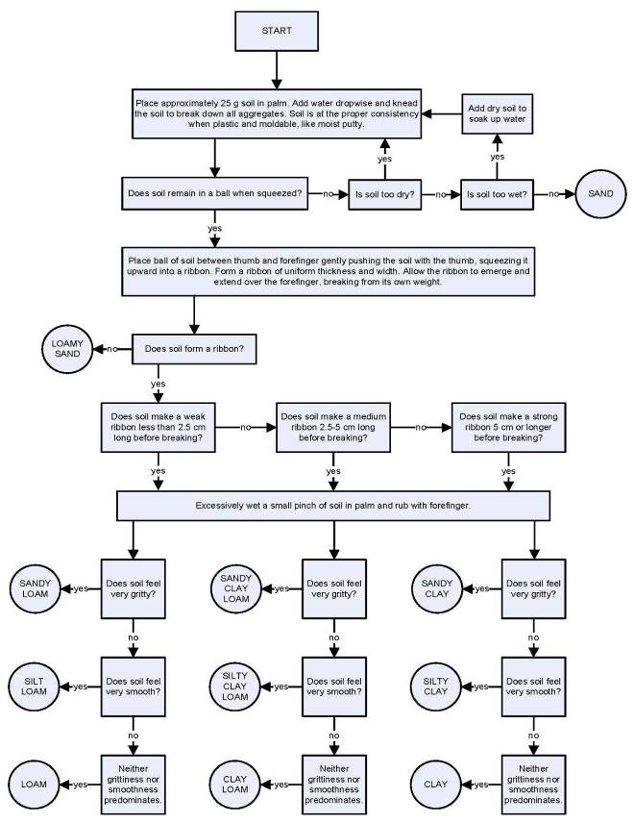

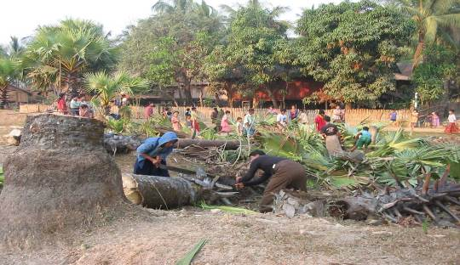

Figure-9: Site clearing for pond construction

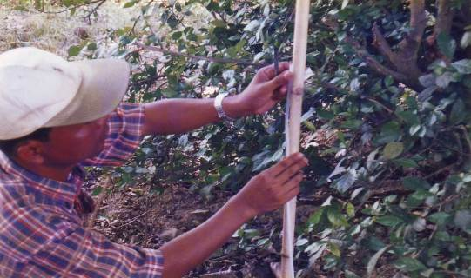

Figure - 10: Pipe level survey for pond construction

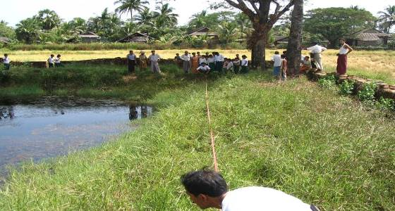

Figure – 11a: Measurement and survey for pond rehabilitation

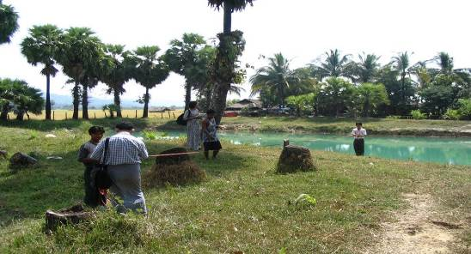

Figure – 11b: Measurement and survey for pond rehabilitation

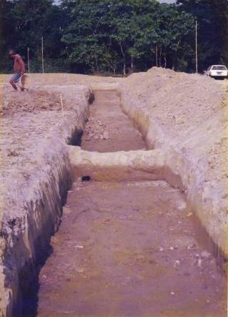

Figure - 12: Cut off trench

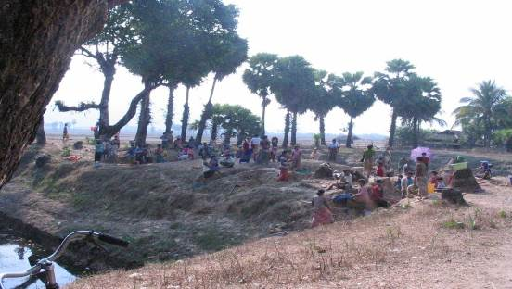

Figure – 13a: Community participation in pond rehabilitation

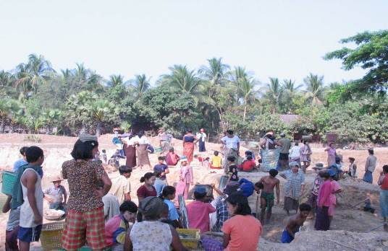

Figure – 13b: Community participation in pond earthworks

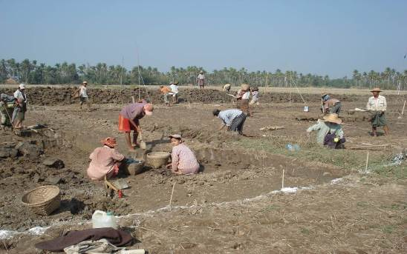

Figure - 14: Pond earthworks

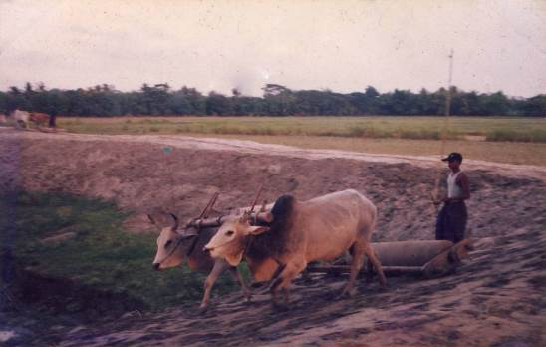

Figure - 15: Compaction with roller

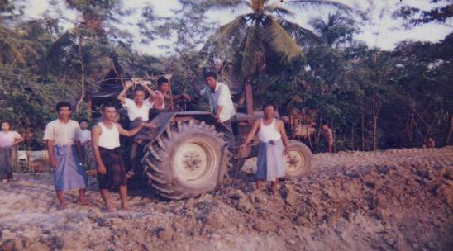

Figure - 16: Compaction with tractor

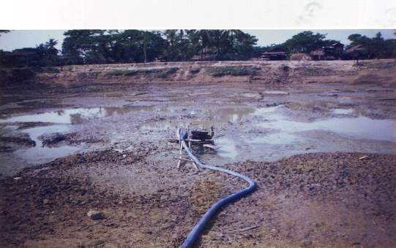

Figure - 17: Pumping out for pond rehabilitation

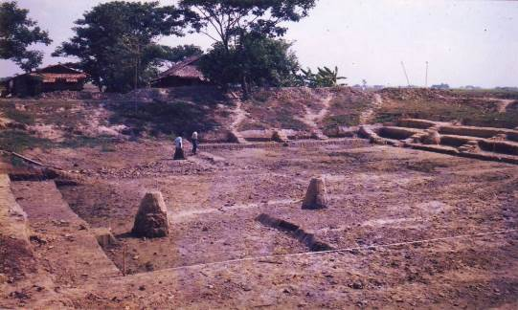

Figure - 18: Rehabilitation of pond
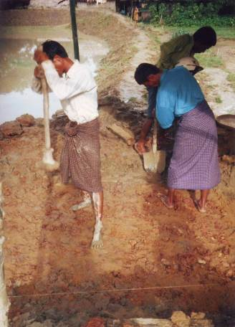

Figure - 19: Compaction of embankment

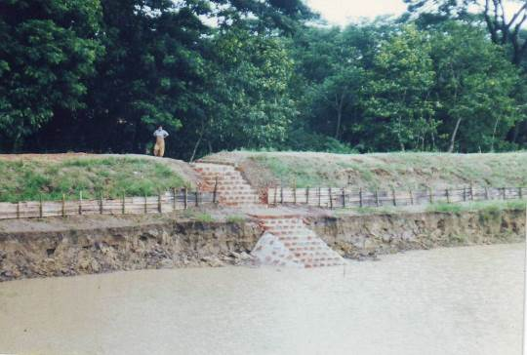

Figure - 20: Completed embankment and steps

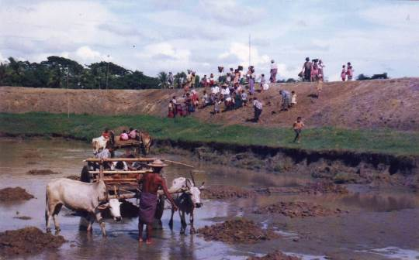

Figure - 21: Clay filling for impervious blanket

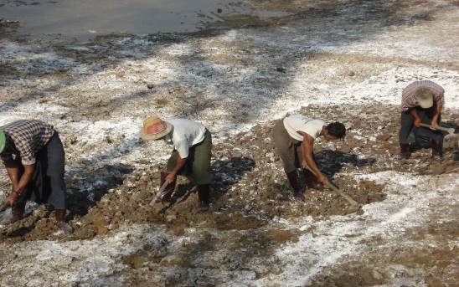

Figure - 22: Scarification of soil for lime stabilization
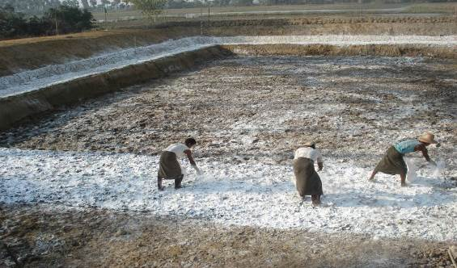

Figure - 23: Quick lime application

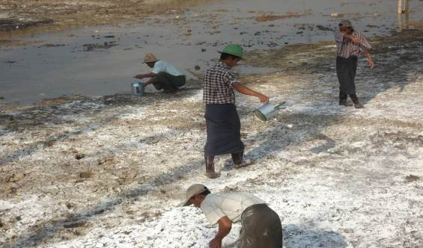

Figure - 24: Hydrating lime with water

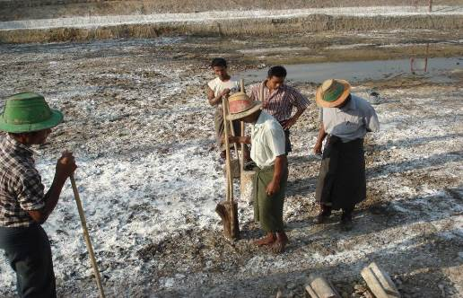

Figure - 25: Compaction by ramming

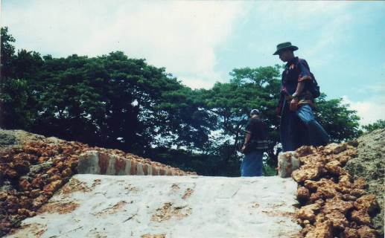

Figure - 26: Channel overflow construction

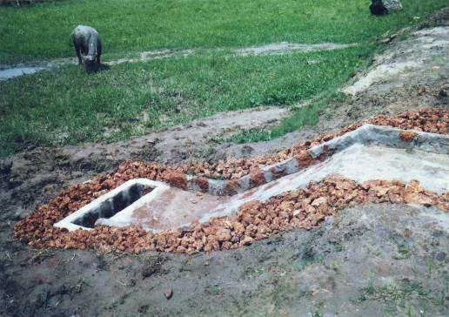

Figure - 27: Completed overflow construction

