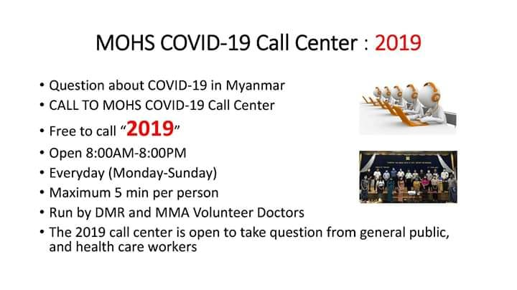

**MOHS- Ministry of Health and Sports**

**DMR- Department of Medical Research**

**MMA- Myanmar Medical Association**