Collaborative management of watershed area by providing water supply system

Case Study: Lessons learned from a top-down vs. bottom up approach to implement a gravity-flow water system in Kamoethway

Conception

In a community meeting in November 2014, TRIP NET proposed improving clean water access in Kamoethway by implementing a gravity-flow system to transport water from a nearby mountain spring to Wa Shu Kho (Seik Pyone) Village and Ler Wah Klo Village. The project was to be implemented in collaboration by the two local people’s organizations in the area – RKIPN (Rays of Kamoethway Indigneous People and Nature) and CSLD (Community Sustainable Livelihood and Development) – and facilitated by TRIP NET (Tenasserim River and Indigenous Peoples Network). TRIP NET proposed the project for funding by TBC (The Border Consortium) in January 2015 with the stated goal: “By providing efficient and clean water for household consumption, local villagers are mobilized to collaborate in watershed management.”
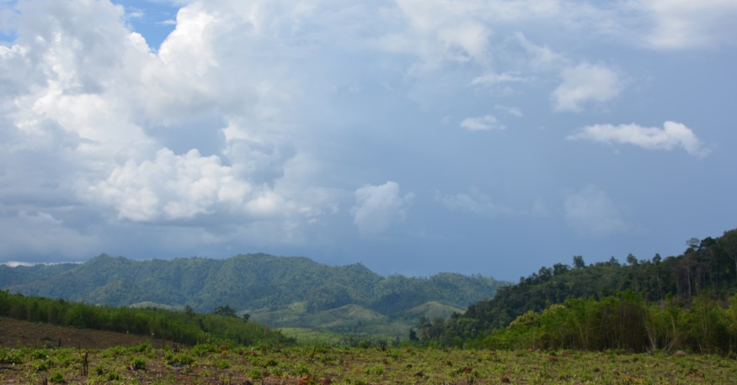
In this way, the project aims to not only provide clean water for villagers, but through a participatory process and locally-owned project, empower Kamoethway villagers themselves to more effectively manage their watershed, protect the natural environment, and take the lead of their own development.
Ko Kee watershed forest

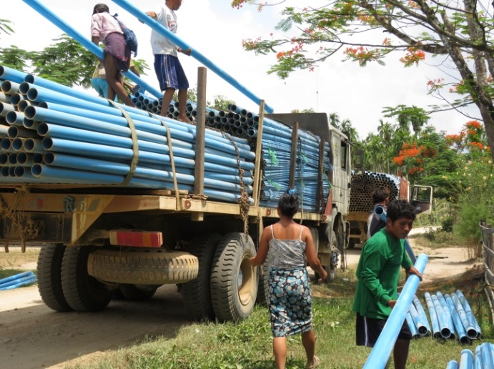
Participatory Process

Villagers were involved in every step of the project’s design and implementation, building up their capacity and confidence throughout the process. In December 2014, an independent water engineer from the Netherlands visited Kamoethway, and together with TRIP NET and villagers conducted a survey in order to design the technical aspects of the water system. This provided villagers a valuable opportunity to learn the importance of calculating water volume, flow, and pressure when designing a gravity-flow system. In February 2015, TRIP NET conducted water quality tests, and found that the water contained no evidence of contamination and would be safe for drinking. These findings were confirmed by lab tests in the Netherlands.
PVC pipe from Thailand arrived to Washuko village
In March, more than 60 RKIPN members began work on the project, clearing the ground where the pipe would be installed. At the end of April, RKIPN held a meeting to set up water management system, and clarify roles and responsibilities. They formed a committee tasked with managing the project, which included RKIPN members, CSLD members, and some villagers who were members of neither group. From May through September villagers constructed the system, laying the pipe underground and building the break-tanks. Construction was completed in September, when villagers began to test the system and make adjustments so it would be ready for the official opening on 8 October 2015.
Villagers work on 3,800 meters length of laying PVC pipe
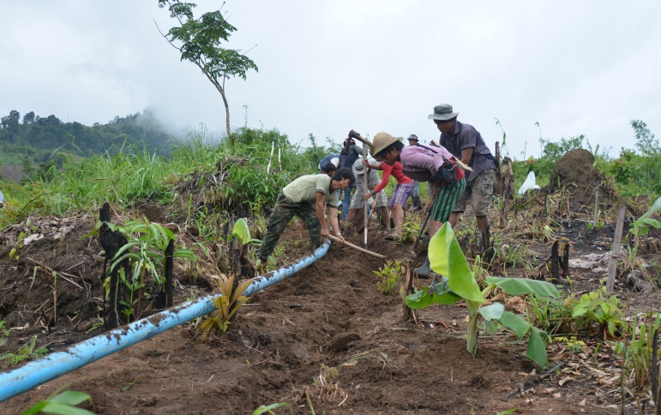

Villagers reject TNRP’s top-down project

This bottom-up, participatory process is much slower than a top-down approach, and in the time it took villagers to discuss and agree and the project’s design, secure funding and materials, and begin implementation, their efforts were undercut by TNRP (Tanintharyi Nature Reserve Project), who had attended the community meeting last November and attempted to steal the idea and implement a gravity-flow water system as their own project. Three out of the 12 villages in Kameothway have land located inside the proposed TNRP area, and would likely lose access to their forest and agricultural lands despite having lived there for at least 200 years. It is possible that TNRP is attempting to win the approval of these distrusting communities by providing the water project. So, without consulting local villagers, RKIPN, CSLD, or TRIP-NET about the ongoing project process, TNRP dropped off a water pipe at Wa Shu Kho Village in April 2015. Angered that TNRP did not respect their plans to design and manage their own gravity-flow system, villagers in Wa Shu Kho and Ler Wah Klo villages rejected the TNRP project.

Rising Tensions

Unable to implement their project in Wa Shu Kho and Ler Wah Klo, TNRP decided to move their water system to nearby Kalet Pa Doh village. However, TNRP’s project continued to cause a conflict between Kamoethway villagers. After Kalet Pa Doh villagers placed TNRP’s pipe on the ground, on the site that RKIPN members had already prepared for their own pipe, they found parts of it were cut with a knife. Kalet Pa Doh villagers then accused villagers from Wa Shu Kho or Ler Wah Klo of intentionally damaging the water system. Villagers denied they would take this kind of action, even though they were upset about the project. They agreed the damage was more likely done by farmers who were angry about the pipe going across their land without being informed. To avoid this problem, RKIPN always asked farmers permission before building on their land. TNRP also located their water intake at the same site where RKIPN and CSLD had already planned to locate theirs, not leaving enough water flow for both systems. This created some conflict, but after meetings in May, TNRP agreed to move their intake site further upstream, and to specially construct it to allow enough water flow so that both systems could co-exist. In the last week of September 2015, villagers from Kalet Pa Doh met with those from Wa Shu Kho and Ler Wah Klo to better understand the project and settle their tensions.

Design Differences

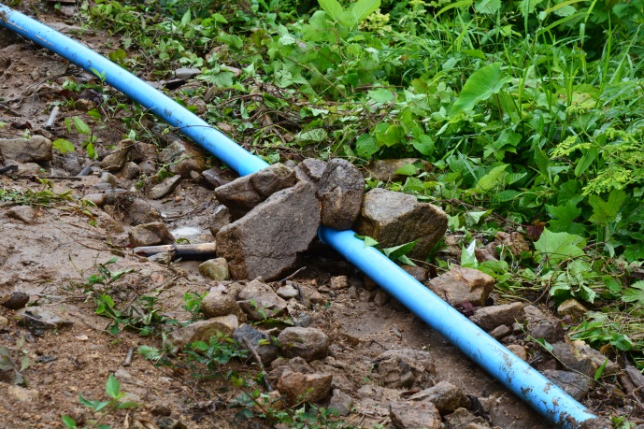
TNRP’s design proved to be inferior to the RKIPN/CSLD design in several key aspects. First of all, their intake mechanism can be easily blocked, and it is not easy to access to remove the blockage. RKIPN/CSLD designed a special intake mechanism to avoid this problem. Secondly, TNRP laid their water pipe above ground, leaving it vulnerable to damage by sunlight or animals. Indeed, rats have already damaged the pipe in Kalet Pa Doh village. On the other hand, RKIPN/CSLD used the participatory process to discuss the need for long-term sustainability of the project, and in this way decided to bury the pipe 1-foot underground. This required substantial cooperation and labor among the villagers, but was completed enthusiastically.

Pipe of TRRP’s project is kept above the ground

TNRP System Failure

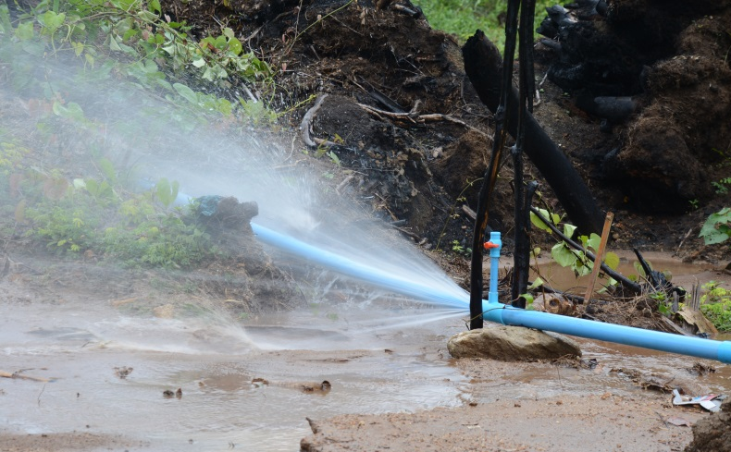
When Kalet Pa Doh villagers attempted to turn on TNRP’s water system in June, the pipes burst. It seems TNRP had failed to account for the build up of pressure caused by the altitude changes along the water system. Nobody has come to fix the system, and villagers still do not have access to water. On the other hand, RKIPN and CSLD specially designed their system to account for water pressure. With training by the independent water engineer, the villagers learned they would need to construct two break-tanks to relieve water pressure along the system. They did so accordingly, and the system is currently successful in bringing water to every household (more than 220) in Wa Shu Kho and Ler Wah Klo villages. After unsuccessful water transportation system, TNRP offered to hand it over its project to the local groups. Villagers still refused, instead preferring to continue with their own project.
Pipe bursting is commonly seen under the system of TNRP

Local Ownership and Ongoing Improvement

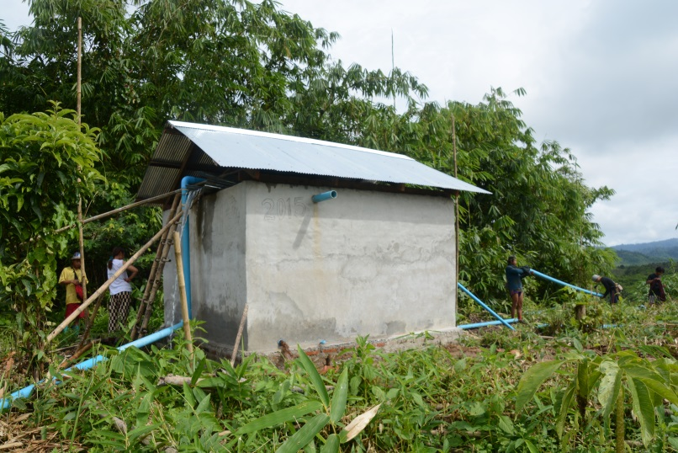
Perhaps the most important difference between TRIP-NET and TNRP’s approaches is that under TRIP-NET, local villagers are truly the owners and managers, and so they value the project more. For example, after the system was switched on, it was found that some of the farthest villages had a very low volume of water supplied. So the villagers took it upon themselves to fix this unfair outcome, by replacing the pipe with a larger one, and adjusting the break-tanks accordingly. They are using their own time and land to make this effort possible. So, not only has the water project empowered villagers to take charge of their own development, but also it will lay the foundation for more projects to come – including hygiene, fish-raising, and home gardening. The water system was officially opened on 8 October 2015 with a thanksgiving ceremony in Kamoethway.
The location of second break tank

Key Lessons Learned
- A step-by-step, bottom-up process can help avoid design flaws.
- A top-down approach to development can cause conflict in the community.
- Good communication and community involvement is necessary for a successful project.
- If villagers are the owners and managers of their own project they will value it more.
- A participatory approach does not simply bring water to the community, but through the process empowers villagers to protect the watershed, and manage their own development.

Timeline
November 2014 | TRIP NET first proposes project a community meeting.
17 December 2014 | Water engineer conducts survey to design project with TRIP NET and villagers.
6 February 2015 | TRIP NET tests the water source and confirms it is safe for drinking.
11 February 2015 | TRIP NET holds meeting and explains the project to Wa Shu Kho and Ler Wah Klo villagers.
7 March 2015 | More than 60 RKIPN members begin work clearing ground for the pipe and water intake site.
20 April 2015 | TNRP brings their own water pipe to Wa Shu Kho without informing the community, and villagers reject this top-down project, and TNRP moves it to Kalet Pa Doh village.
30 April 2015 | Villagers form a committee to manage the water system that includes members from RKIPN and CSLD, as well as other villagers.
2 May 2015 | Villagers meet with TNRP at Kaw Paw village to resolve issues relating to the location of the two water systems.
9 May 2015 | Villagers visit the water source with TNRP and agree that TNRP will locate their system further upstream and specially construct it to allow enough water flow so that both systems could co-exist.
14 May 2015 | TRIP NET’s PVC pipe for the project arrives in Kamoethway.
23 May 2015 | Villagers begin work on laying the pipe.
3 June 2015 | Villagers begin constructing the break-tanks.
22 June 2015 | TNRP pipe bursts when the Kalet Pa Doh system is turned on.
September 2015 | Construction of the water system is completed and testing and adjustments begin.
8 October 2015 | The TRIP NET water system is fully operational and officially opened at a public thanksgiving ceremony.

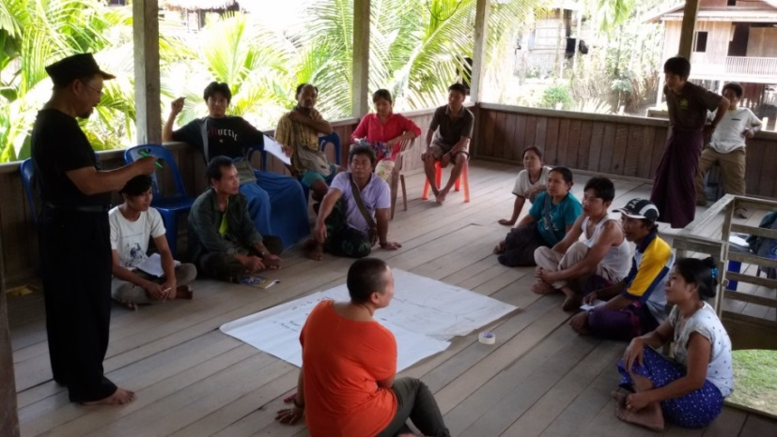

TRIP NET holds meeting and explains the project to Wa Shu Kho and Ler Wah Klo villagers
11 February 2015

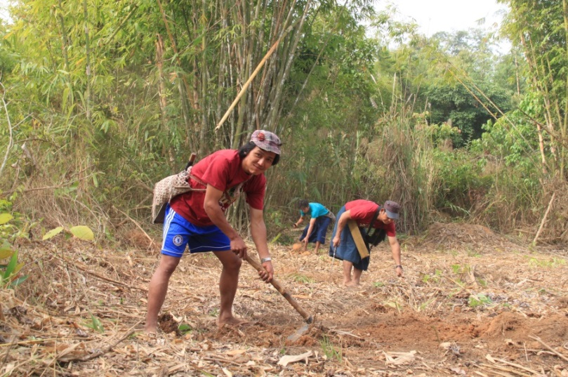

More than 60 RKIPN members begin work clearing ground for the pipe and water intake site.
7 March 2015

TNRP brings their own water pipe to Wa Shu Kho without informing the community, and villagers reject this top-down project, and TNRP moves it to Kalet Pa Doh village.
20 April 2015

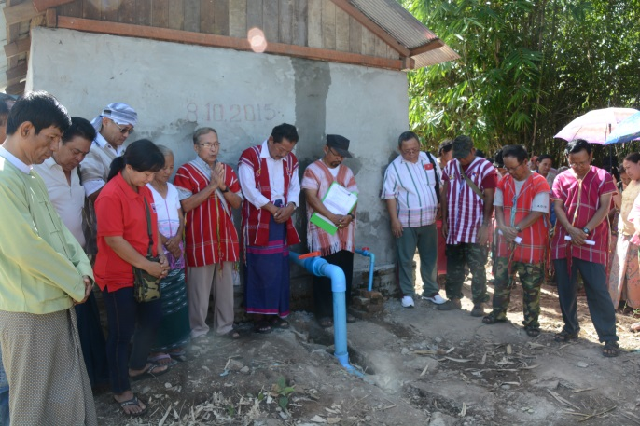
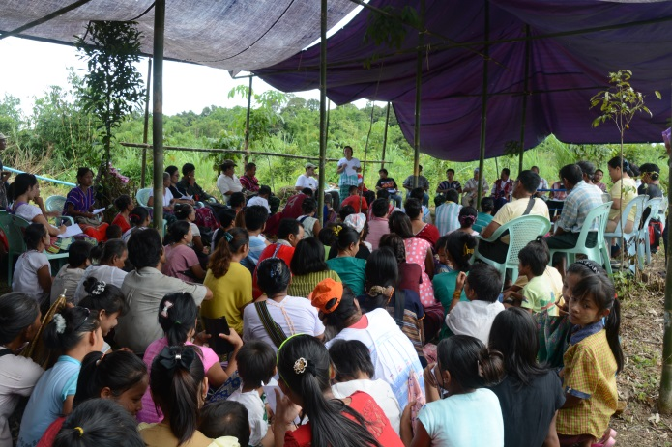
Official opening ceremony of the water project
8 October 2015

