RAKHINE STATE

Cluster Monthly review - March 2015

|  |
| --- |
| Produced by: Rakhine Wash Sub Cluster team  Organization: UNICEF  Location: Sittwe  Month: March  Resources: <http://www.themimu.info/emergencies/wash-cluster> |

# Context, main events of the months

**New accommodation for conflict-affected communities**

Across the state, Rakhine State Government (RSG) has initiated the upgrade of accommodation for conflict-affected populations. Based on recent exchanges with authorities, feedback from partners on the field and observations gathered by the WASH Cluster monitoring team, the government plans is deploying as follows:

1. Individual houses within the current camp site (~3200HH):

Some camps have been identified by the authorities for new accommodation in the same site.

* Kyien Ni Pyien (Pauk Taw 1086 HH): Construction of individual houses has begun through a contractor. Some 110 houses are under construction, likely for the households who were victims of the fire in February. The individual houses have been, in some cases, built after destruction of latrine blocs, drainages and wells.
* Nget Chaung 1 (Pauk Taw 905HH): Material is currently being delivered, contractor and sub-contractor have been identified. One long house (hosting today 8HH) would be replaced by 3 individual houses. The camps site will be expanded to accommodate additional houses.
* Nget Chaung 2 (Pauk Taw 713HH): IDP have until now refused the plan offered by the authorities similar to NC1. Discussions will continue after Water Festival
* Bassara (Sittwe 387HH): Individual houses are planned, consultation of IDP by authorities is ongoing, construction has not started
* Ni Din (Kyaw Taw 85HH) and Kaung Htoke (Kyaw Taw 97HH): the authorities and community are discussing and searching for suitable places to locate the IDPs.

The foreseen impacts on the WASH situation are very high, as the camps will expand to accommodate individual houses in place of the current shelters, leaving new areas without access to services. In addition, the damage of existing facilities and infrastructures during the construction of the individual houses is a risk. The imminent rainy season will add another layer of risk for public health with reduced services.

Current plans of rehabilitation and repair of WASH facilities may need to be postponed until the situation is cleared. The WASH partners will face challenges in terms of fund availability and project delay, as the construction of new infrastructure had not been planned. In some cases such as in Ni Din and Kaung Htoke, the Wash facilities are currently under construction.

1. New accommodation for IDPs in or near point of origin (~2700HH):

The Muslim IDP that have not yet been verified in or near their point of origin will receive support from the government to return to their original land plot or at least to their original village. Kyaw Taw, Minbya, Mrauk-O towanships and Ah Nauk Pyin and Nyaung yin Gyi (Rathedaung) are in this process. The support from GAD is under the form to cash provided to households – around 1’000.000MMK/HH. The detail mode of deployment varies from one township to another:

* In Mrauk Oo and Rathedaung, all HH received 800.000MMK and will receive additional 200.000MMK when the construction has progressed
* In Minbya, only some household have received 1’000.000MMK, the rest will receive after the first have completed the construction.
* In Kyaw Taw, not all households will benefit from the support, as some original land plots are in Rakhine areas. These families will stay in the longhouses for the time being.

All the concerned sites are villages (not camps). The WASH situation of beneficiaries is slightly affected, in particular related to sanitation and availability of latrines. Indeed, the current facilities may not be in the same area than the new accommodation. In relation to water, all these sites have various communal water points (wells, ponds) therefore the new accommodation has no impact.

The WASH partners, currently working is some of these sites, will require to adapt theirs implementation to allow some flexibility in the location of latrines construction. In some cases, the change from 8-units longhouses to individual houses may bring challenges related to latrines sharing. There is no WASH partner in Minbya and Mrauk-Oo.

1. New accommodation for citizens (~180HH):

The Rakhine and Maramagyi IDP may be relocated to a new sites: Ka Nyin Taw (Kyauk Phyu), Kan Thar Htwat Wa (Myebon), Set Yone Maw & Chait Taung (Minbya), Raw Ma Ni Sin Oe & Yai-Thei-Thi Kyar (Mrauk-U). This part of the plan is under GAD responsibility. The discussions between the authorities and the communities is still ongoing to find an agreeable location. It is unclear today the mode of implementation planned – cash support, materials support or construction of individual houses.

The impacts on the WASH situation of beneficiaries is very high, as the new site is likely to be an empty land without any infrastructure or facilities.

There is no WASH partner in Minbya and Mrauk-Oo. The WASH partners in Kyaw Phyu, Rameree and Myebon will face huge challenges if meant to support as there funding for new sites had not been foreseen and HR/logistical capacity may ne overstretched.

1. Repair and Maintenance (R&M):

Related to the Shelter and WASH infrastructure in existing camps that will remain for at least another rainy season. Government has requested the humanitarian community for support to cover as much as possible the R&M needs, the remaining gaps will be covered by the Government. In recent exchanges, only Sittwe rural area is been discussed, other townships such as Rathedaung are not mentioned.

The WASH Cluster has a commitment through the HRP 2015 to maintain the WASH facilities in camps. To fulfill this commitment however, a number of challenges need to be addressed by the authorities such as frequent landowner issues related to WASH infrastructures, and frequent challenges with attribution of construction contracts. In addition, the funding available for the cycle is not yet clear as discussions with donors are still ongoing.

## Improvement of hygiene practices and behavior change – creative tools, methods and training

With the objective to initiate the improvement of the WASH Cluster member’s capacity to develop appropriate hygiene promotion campaigns and achieve behavior change, the WASH partners have sought support from the Communication with Communities specialist from OCHA and from external consultants. During this month, the following topics have progressed:

* Quick audits on specific topics and agency followed by very specific recommendations: high levels of open defecation among children, inappropriate design of child-friendly latrines, specific hygiene education activities – by CwC specialist
* Accountability to affected populations : an context adapted AAP self-assessment tool (based on the IASC Principals’ Commitments on Accountability to Affected Populations) has been developed to allow partners to build on the results and the recommendations issued from the AAP survey from the Global WASH Cluster completed in August 2014
* Focus group discussion guidelines – CwC has proposed an interesting FGD guidance for WASH staff.
* Social Marketing - identified as an interesting alternative approach to promote behavior change and currently piloted by Oxfam. The preparation of a series of trainings and orientation sessions addressed to the wash managers, staff an government staff has been completed, as a joint collaboration between CwC, ACF and the WASH Cluster

## Assessment of coordination needs for WASH Cluster in Maungdaw district

Since beginning of 2014 Maungdaw district – Maungdaw and Buthidaung townships -is included in the Humanitarian Response Plan (HRP) target. Unfortunately, the WASH Cluster faced specific difficulties in 2014 to properly integrate this area in the usual coordination tools deployed in Rakhine state. A first visit then took place during March 2015, with the objective to start to build up overall WASH Cluster understanding of the situation, identify potential needs of coordination mechanism to support WASH action. It appears that an external support for coordination could bring an added value to the response - a support in terms of more visible inter-sectorial strategic definition, technical support, situation analysis and orientation of future support.

## Emergency water supply

Upon request from the Inter Cluster group, a fact sheet analyzing the different options for more sustainable water supply in Ah Nauk Ye camp has been produced and shared widely. The alternatives identified imply extensive funding and high level engagement from authorities required.

# 4W and M&E system analysis

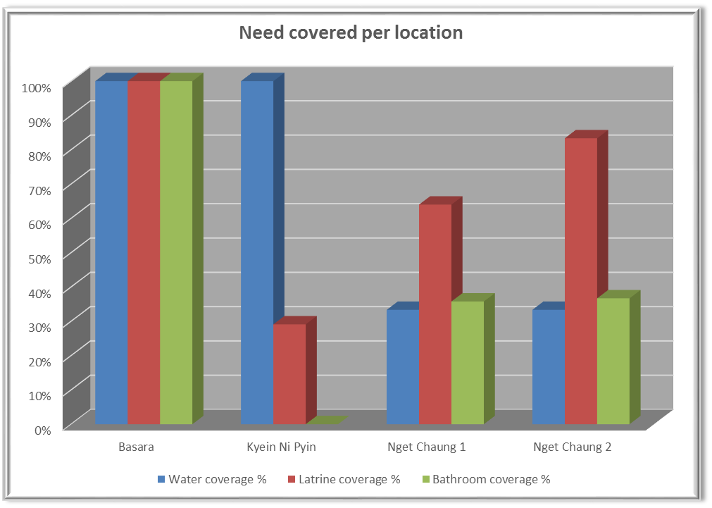

Figure – summary of coverages in camps expanding due to individual houses construction

The figure shows the estimated coverages of WASH services in camps where the construction of individual houses are either planned or started, and where the impacts for the beneficiaries in terms of WASH services are foreseen important. It is to be noted that the current situation is far from being ideal, and efforts are required today to achieve minimum standards – emergency water supply, latrines requiring disludging and heavy repair…. A new setting of the camps, with damaging of existing services will further create risks in public health.

In order to achieve the minimum standards for WASH services, the intervention required is different from what was initially planned by the WASH partners within the committed projects, in particular, construction of new WASH facilities and secure decommissioning of old ones, instead of repair and upgrade. Additional challenges include also the imminent rainy season and the difficulty to deploy quality constructions during this time.

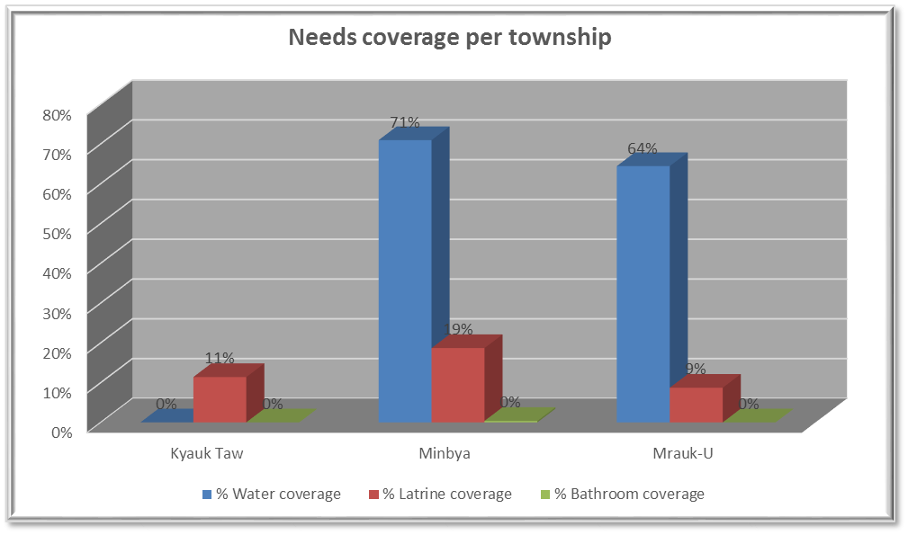

Figure – Estimation of needs coverage in townships where the return to point of origin is currently taking place

The figure above shows the estimated coverage of WASH needs in the townships where return to the point of origin is taking place. The very low current coverage in this area highlights the fragility of these communities and the fact that they remain vulnerable.

# Produced by the WASH members

* 4W WASH matrix for March
* Updated contact list of WASH sub cluster members
* Ah Nauk Ye camp - emergency water sources and alternatives fact sheet
* Wash Cluster field trip report to Maungdaw district
* Briefing note on relocation progress and impacts on WASH

# Main Priorities for next month

## Continuous monitoring of the WASH situation of beneficiaries, in particular in locations with new setting

## Revised M&E strategy

## Emergency water supply follow-up

## Protection mainstreaming training for WASH agencies staff

# Wash cluster indicator update







