RAKHINE STATE

Cluster Monthly review

February 2015

|  |
| --- |
| Produced by: Rakhine Wash Sub Cluster team  Organization: UNICEF  Location: Sittwe  Month: February  Resources: <http://www.themimu.info/emergencies/wash-cluster> |

# Context, main events of the months

## Dry season and water scarcity (see analysis section below)

The rainy season was shorter and lighter that previous years. The water scarcity is currently a concern in several zones of the state, as rain water collected in ponds is reaching critical levels. Where there is a WASH agency present, emergency water supply is progressively being deployed across the state and include pumping from distant sources or transporting water by boat from other townships and treating prior to distribution. In the specific case of the urban camps in Sittwe – currently supplied through obsolete leaking networks managed by DRD. Oxfam has already donated the necessary material for the upgrade to DRD, the repairs have not started yet. As implemented by MRCS on previous years, water trucking may be an option to complete the needed supply.

## Overall inter-sectorial frame for Relocation of affected populations

Although the Rakhine State Government has not shared yet the official plan, some pieces of information have been shared and evidence of actions being implemented in the field are available. While Shelter cluster, with RSG, is consolidating a package with technical solutions to maybe address potential relocation, a WASH technical definition complementing “habitat” (accommodation + sanitation) will be jointly developed with the government technical departments. Nevertheless, political concerns and contextual risks in this sensitive environment must not be supported alone by technical sectors, a more global framework (inter-sectorial and inter-agency), including protection, humanitarian and coordination pre-conditions, would prevent from putting beneficiaries at risk through blind decisions.

The relocation of some populations as currently being mentioned at several fora. In particular, different alternatives, with different levels of maturity and funding, seem to be considered by RSG:

## Set Yon Su 1 camp (Sittwe urban)*: The construction of individual long term accommodation for the IDP of Set Yon Su 1 is ongoing by UNHCR. In coordination with Oxfam, the construction contract includes household latrines and individual bathing spaces as part of the habitat. The on-site disludging site used for Set Yon Su 1 and Set Roe Kya 2 had to be dismantled as colliding with the new site planning. The WASH Cluster submitted a proposal of “relocation package” to the Inter-Cluster Coordination group as a contribution to an intersectorial proposal to the HCT (not completed yet).*

## Populations in point of origin (Minbya, Mrauk-O and Kyaw Taw): *Following information shared by the Minister of Transport and Communication, the affected households would receive a package that includes the materials and labor charges for the construction of individual accommodation. The funding of such an alternative by the RSG does not include WASH infrastructures and seems to be ready for deployment.*

## Population near the point of origin: *the affected households from Nget Chaung, Kyien Ni Pyien (Pauk Taw Township) and Ah Nauk Pyin and Naung Pyin Gyi (Rathedaung Township) are considered by RSG for a similar package as above, on a later step.*

## Sittwe “economic” IDPs: *this category of displaced people are considered for return to their point of origin, although there are not details shared at this moment by the RSG.*

## Myebon*: relocation to a proposed site is under discussion by RSG with the IDPs although no agreement has been found yet.*

## Kyaw Phyu, Ah Thet Nar Yar (Rathedaung): *have been mentioned, although details have not been shared.*

## Minbya and Mrauk-O townships – opportunities for possible transition from emergency to development

Due to lack of funding, CDN, historical actor in the affected sites in Minbya and Mrauk-O, is not covering anymore these townships since January 2015. In terms of WASH, conditions in theses villages after two years of humanitarian intervention seem to have reached the situation prior to the conflict. The WASH needs do not appear to be higher than the ones in the neighboring non-conflict affected villages that show similar environmental conditions. Indeed, the water sources are unprotected and scarcity is a risk every year for all, but communities have learnt since long to cope with it and have developed community mechanisms to prepare difficult times. There are also examples of involvement of the local authorities ready to provide the necessary items to contribute to the latrines repairs. A quick evaluation by the WASH Cluster brings some elements for discussion a possible switch from wash humanitarian assistance to development needs, as the rest of the state.

## Gender mainstreaming in WASH

With the support of the Senior Gender Capacity Advisor, an audit of the WASH intervention is currently taking place in some representative sites in order to issues to be addressed. The outcomes of this exercise will be capitalized in the Gender mainstreaming training planned for WASH actors in March and related WASH Cluster guidelines.

The Gender Based Violence subgroup are currently supporting the WASH agencies in the definition of operational alternatives taking into consideration the specific needs of women and girls, in particular related to lighting of WASH infrastructures.

## Epizooties in Pauk Taw township

Abnormal number of animal deaths in Nget Chaung and Sin Tet Maw camps (goats, dogs, chickens) have been reported. The WASH Cluster partners have coordinated with CCCM and Health sector to report the issue to the Veterinary services of the government, evaluate the risk for human health and promote specific messaging insisting on the absolute need for humans to drink only treated water seems advisable.

## 2015 WASH Cluster strategy for Rakhine State

The WASH Cluster collective has defined the WASH cluster strategy for 2015 based on a collective analysis of data provided by the partners. The consultative process led to a comprehensive and complete document that has been shared widely. The strategy does not consider however the relocation plans from the Rakhine state government, should this plan be implemented, the strategy must be deeply revised.

# 4W and M&E system analysis

The rainy season was shorter and lighter that previous years. The water scarcity is currently a concern in several zones of the state and different strategies are being put in place, either by the communities themselves or by the WASH Cluster partners.

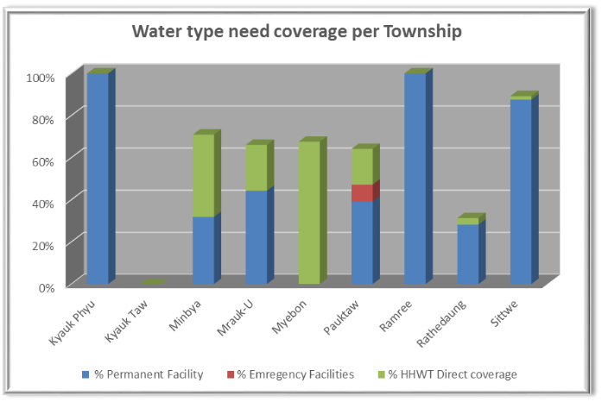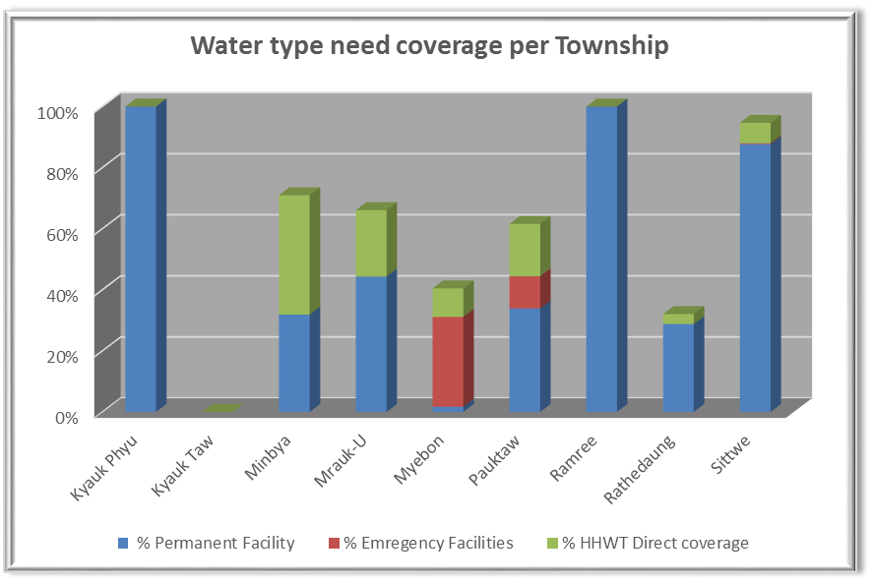

Figure – Access to water in conflict affected townships comparison between December 2014 (left) and February 2015 (right)

* Minbya and Mrauk-O townships – rain water collected in ponds is almost over, communities are in some locations using river water to fill the ponds. In some communities where affected population are in their point of origin, wealthier families contribute to the fuel charges to pump river water to refill the ponds. This coping mechanism was already in place in the area before the conflict
* Ah Nauk Ye camp - Pauk Taw township – the levels in ponds are low, emergency water boating jointly between SI and DRD is ready to be deployed, most probably by mid-march.
* Nget Caung 1&2 camps – closer ponds are empty, water is being pumped to the camp from remote ponds
* Taung Paw camp - Myebon township – the levels in ponds are low to supply the water networks. RI is currently supplying emergency water through pumping. The water quality being very low, treatment is being implemented
* Urban camps in Sittwe – currently supplied by networks managed by DRD. The source pond shows quickly decreasing levels and the network requires repair to reduce the quantity of water leaking. Oxfam has already donated the necessary material for the upgrade to DRD, the repairs are ongoing. As implemented by MRCS on previous years, water trucking may be an option to complete the needed supply.

# Produced by the WASH members

* 4W WASH matrix for February
* Updated contact list of WASH sub cluster members
* WASH cluster quick evaluation in Minbya and Mrauk-u townships
* Camp based staff incentives for WASH personnel mapping
* Relocation package proposed by the WASH Cluster for Set Yon Sue 1
* Terms of references for Social Marketing training

# Main Priorities for next month

* Emergency water supply follow-up
* Relocation of affected populations follow up
* Improvement of hygiene practices and behavior change – creative tools, methods and training
* Assessment of coordination needs for WASH Cluster in Maungdaw district
* Revised M&E strategy

# Wash cluster indicator update







