**KACHIN and NORTHERN SHAN**

**Monthly report**

**March 2015**

|  |
| --- |
| Produced by: Kachin & North Shan Wash Sub Cluster team  Organization: UNICEF  Location: Myitkyina  Month: March 2015  Resources: [*http://www.themimu.info/emergencies/wash-cluster*](http://www.themimu.info/emergencies/wash-cluster) |

**Overall Humanitarian WASH situation and WASH actor’s mobilization**

The deteriorating humanitarian situation in Kachin and NSS following fighting between Myanmar army and armed groups over the last months led to a multiplication of small scale and short term displacements of people to be followed by the WASH focal agencies. It is estimated that from the beginning of the year a total of 10,000 people have been displaced in Kachin and NSS with only approximately 10% remaining as IDP’s

This follow up requires to continuously assess the eventual WASH needs and to respond appropriately within a changing and instable environment. Five main scenarios have been identified over the last months:

**Scenario 1**

Temporary displacements of people (villagers and/or migrants workers) escaping conflict areas and transiting temporarily few days in some stopover locations before leaving again to another destination. For these people in temporary transit, basic access to WASH facilities is obviously needed and humanitarian agencies are mobilized to assess first the needs according to the population caseload and available existing WASH facilities and second, to eventually provide support through WASH interventions

**Scenario 2**

Arrival of IDPs in existing IDPs camps. This additional IDP caseload induces pressure on existing WASH facilities and requires from the WASH focal agencies the need to upgrade / extend these WASH facilities to be in compliance with minimum humanitarian standards

**Scenario 3**

Creation of new IDP camps that require the construction / extension of WASH facilities

**Scenario 4**

Conflict area with no presence or limited WASH actors. No access to the area and limited or absence of information. WASH needs are not known.

**Scenario 5**

Sporadic armed conflict that doesn’t entail significant displacement of people but that alert humanitarian agencies and mobilize their human resources to follow up the situation

The table below is an attempt to summarize the main geographical areas that required a specific attention from WASH actors over the last month

|  |  |  |  |  |  |  |  |  |
| --- | --- | --- | --- | --- | --- | --- | --- | --- |
| *Area* | Township number on the map | Township | **Scenario** *1*  *IDP in temporary stopover locations* | **Scenario** *2*  *IDPs arriving in existing IDPs locations* | **Scenario** *3*  *Creation of new IDPs camps* | | **Scenario** *4*  *Conflict area with no access for humanitarian actors* | **Scenario** *5*  *Armed conflict without significant displacement* |
| ***North Kachin*** | 76 | Putao |  |  | ***X*** |  | |  |
| 66 | Hpakant |  | ***X*** | ***X*** |  | |  |
| 71 | Mogaung |  |  |  |  | | ***X*** |
| ***South Kachin*** | 70 | Mansi | ***X*** |  |  |  | |  |
| ***North Shan*** | 245  245 | Namkhan  Muse: | ***X*** | ***X*** |  |  | |  |
| 232 | Kutkai |  |  | ***X*** |  | |  |
| 228 | Hseni |  |  | ***X*** |  | |  |
| 234 | Lashio | ***X*** |  |  |  | |  |
| 230  235  231 | KonKyan  Laukkaing  Kunlong |  |  |  | ***X*** | |  |

**Putao:**

Fighting in the area of N-Ga Hka village on 15 January has displaced over 300 people to Putao town. One new camp has been created over the last months following fighting between Tatmadaw and armed groups. Given the mountainous area of Putao and unlike plain area of Myitkyina the use of groundwater resource through shallow hand dug wells hardly enables to provide enough water in IDPs camps. Seasonal water shortage has been mentioned by the wash focal agency in this area and temporary water trucking has been set up to address this water shortage issue. WASH NFI needs have been identified and a response through ERF has been looked at between the WASH cluster members.

**Hpakant**

Fighting that broke up in January led to the arrival of about 660 individuals in four existing IDPs camps and to the creation of one new camp. The limited operational capacity of WASH focal agency in this area prevented from carry out robust WASH assessment following these fights. Chronic water shortage are encountered in Hpakant area and the intensive use of groundwater resource for mining activities is also putting pressure on the groundwater resource. The WASH actors including WASH cluster team and WASH focal agency prepare an assessment to be conducted in April.

**Mogaung**

Very recent armed conflict (March- April) that would have led to military casualties. The tension in the area needs to be followed up by the Humanitarian and WASH agencies.

**Mansi**

New arrivals (about 200 people) from outskirts of Mansi to Mansi town were reported in March. Given the limited caseload of IDP’s, no specific WASH intervention has been needed and local organizations could host temporarily these IDPs. WASH actors based in BHAMO followed up closely the situation to trigger response if needed. Some Humanitarian agencies remove temporarily their staff from Mansi area

**Namkhan / Muse / Hseni / Kutkai / Lashio**

A former camp that was closed has been reactivated in Namkhan area in order to host new IDPs following fight in the area. The arrival of about 2000 people in Namkhan area from the conflict zone required a strong vigilance from the humanitarian agencies but didn’t lead to specific WASH interventions given the temporary nature of the displacement. Significant caseload of displaced people also transited in Lashio but their presence didn’t require major hardware interventions. Two new camps have been created in Hseni and Kutkai townships

**KonKyan / Laukkaing / Kunlong**

The humanitarian situation has been deteriorating over the last month in this area that is not accessible by the humanitarian agencies. WASH needs could not been assessed. The National WASH cluster coordinator participated to a coordination meeting in Lashio requested by the governmental authorities The map below gives an overview of the main townships affected by the conflict in Kachin and NSS over the last month and that required a special vigilance and mobilization from WASH actors.



The North Shan area has been especially concerned by the conflict in March. This situation raises some coordination challenges given the limited communication and road infrastructures in Kachin and NSS combined with the overall security situation and the limited or impossible access to some concerned areas. Access to humanitarian & international staff to affected area remains an issue and prevents from undertaking proper assessment and situation monitoring.

The WASH sub-cluster Kachin/NSS has not been coordinating assessment or response for the consequences of the conflict in Konkyan. Following crisis in Konkyan, the WASH cluster coordination has been managed mainly from Yangon actors directly with Lashio actors

**Dry season and water shortage**

The water shortage prone areas identified in March are:

* Hpare IDP location where a temporarily solution through the transportation of drinking water with three wheels vehicle has been implemented,
* Waingmaw area where joint efforts of two humanitarian agencies are currently undertaken to address permanently water shortage issues in 3 IDPs locations through deepening of wells and rehabilitation of water facilities
* Hpakant area where a WASH assessment is planned for April
* One IDP location in Putao area where the WASH focal agency, in coordination with the WASH cluster is looking for solutions to address water shortage

**WASH projects funding update**

The table below provides the updated timeframe for the current WASH projects led by the WASH focal agencies in Kachin and NSS



The main updates regarding the last month are:

-The inclusion of HPA (Help Poverty Action) as a WASH actor in Laiza area,

-The extension of two WASH project SI / UNICEF and KBC / UNICEF

The graph below extracted from the 4W of March 2015 gives an insight of the funding situation for Kachin.

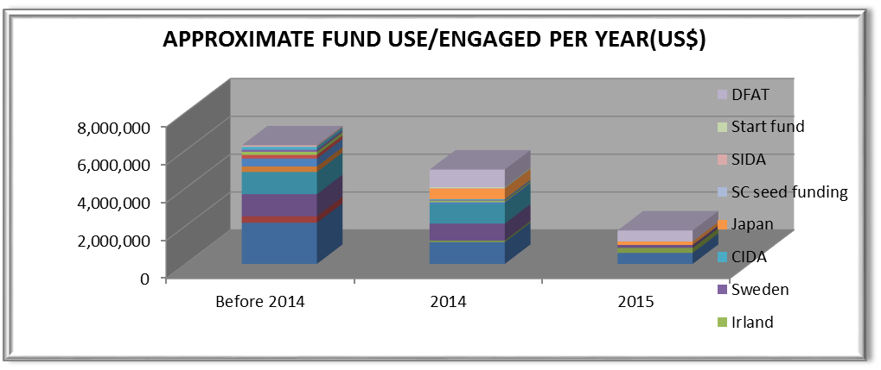

Almost four years following the conflict resume in Kachin, fund raising within the protracted crisis becomes more challenging. Although efforts should be continued in terms of WASH facilities coverage, priority should be given today to the upgrading /rehabilitation of facilities and to their appropriate operation and maintenance through community mobilization and hygiene promotion interventions. These software activities are less costly than hardware components but given the decreasing of fund availability, it is crucial for the WASH cluster to:

* Reinforce the monitoring efforts in order to better identify the most critical situations and the most deprived people regarding access to basic WASH facilities and services,
* To prioritize the most urgent WASH needs as identified in the WASH cluster strategy,
* To rationalize and optimize the operation and maintenance costs through notably the capacity development of communities and upgrading of water facilities.

**Other events**

***Technical Working Groups***

Two Technical Working Groups (HWTS and Technical standards) have been organized by the WASH focal agencies in March in Bhamo

***Wash cluster meetings***

In Bhamo, 15 participants from 7 agencies attended the cluster meeting co-chaired by DRD district office

In Myitkyina, 14 participants from 10 agencies attended the WASH cluster meeting focusing on desludging issues with the presence of WASH related authorities (SHD, DRD and RRD) . This meeting led to the organization of a joint field visit with Humanitarian partners and local authorities in order to assess the relevance and feasibility of a location for excreta disposal purpose in the North of Myitkyina.

***Reinforcement of WASH cluster team’ structure***

The WASH cluster team has been reinforced with three WASH specialists, consultants, in order to monitor the WASH situation in North and South Kachin and North Shan.

**Main Priorities for next month**

* WASH assessment in Hpakant area,
* Follow up the overall humanitarian situation in Kachin and North Shan,
* Participation to cross line missions according to the agenda,
* Finalize monitoring framework for WASH cluster in Kachin and NSS,
* Produce a positioning paper on WASH running cost,
* Keep following the desludging issues with local authorities and WASH led agencies

**Produced by the WASH members**

* Desludging assessment report in Bhamo area
* WASH cluster meeting minutes
* Regular updates on Emergency WASH situation
* 4W matrix
* Minutes of TWGs