**KACHIN and NORTHERN SHAN**

**Monthly report**

**January - February 2015**

|  |
| --- |
| Produced by: Kachin & North Shan Wash Sub Cluster team  Organization: UNICEF  Location: Myitkyina  Month: January – February 2015  Resources: [*http://www.themimu.info/emergencies/wash-cluster*](http://www.themimu.info/emergencies/wash-cluster) |

**Humanitarian WASH over January and February months**

***Hpakan***

On 14 January, fighting broke out in the Hpakan area of Kachin State between the Government of Myanmar Army and the Kachin Independence Army (KIA). This fighting led to the arrival of about 660 individuals in four existing IDPs camps and one new camp.

An inter UN agency scoping mission including WASH staff has been deployed from 22 – 24 January to conduct a quick overview of needs and the humanitarian situation.

On 30 January, local NGOs could distribute - through ERF mechanism support (consortium of three INGOs) - 200 HKs to IDPs affected by the conflict.

Training of WASH NGOs staff on emergency WASH assessment has also been carried on through this ERF mechanisms.

Although no significant WASH needs have been highlighted by the WASH cluster members following the arrival of new IDPs, the recurrent water shortage issue in Hpakant area requires to follow up closely the situation.

***Putao***

Fighting in the area of N-Ga Hka village on 15 January has displaced over 300 people to Putao town. Local organizations have accommodated them and provided initial food, WASH, NFI and shelter assistance. WASH activities included notably the construction of 6 emergency latrines and 1 well in a new IDP location at Puta O town. Within the context of challenging remote area of Putao, HKs needs to be distributed to the new IDPs.

Possibility to distribute these HKs through ERF mechanism is being explored.

***Humanitarian situation in North Shan***

On 5 February, approximately 300 IDPs arrived in Kutkai town from remote areas of Kutkai Township and have been accommodated by local NGOs. One monastery hosting 72 new displaced HHs has been supported by WASH actors, through notably ERF mechanisms. This supports consisted of distribution of water treatment for drinking and domestic water, construction of two temporary bathing space, 6 emergency latrine and one water storage.

Besides, the recent fighting led to the “reopening” of a former IDPs camp in Namkhan area  with the presence of 226 individuals (68 HH). WASH response in this IDP location consisted of 5 emergency latrines and water storage tank construction and eventual WASH NFI distribution will be considered on a need basis.

The overall security situation in NSS is making WASH interventions more challenging and field travel for humanitarian staff based in Muse is limited to essential travel only. The need to respond to additional displacements has an impact on regular project activities as project staff need to cope with an additional project area.

On 9th February 2015, fighting started between the Myanmar Tatmadaw and Myanmar National Democratic Alliance Army (MNDAA) and other armed groups in the Kokang self-administered zone of northeast Shan State. There are no current emergency WASH projects carried out by The WASH clusters members the Kokang area. The conflicting areas is not accessible by the humanitarian agencies due to unpredictable security situation.

**Main events of the last two months**

***WASH cluster strategy review***

The WASH cluster strategy review workshop has been organized on 27th and 28th January with a total number of 43 participants representing 6 local NGOs, 7 INGOs, 4 UN Organization, and 4 Governmental Departments. This two day workshop enable to review the main objectives and challenges of WASH humanitarian response in Kachin and NSS and to reinforce the inter sectors / clusters coordination on WASH issues.

***Water safety Plans training***

A three days training on Water Safety Plan (WSP) supported by UNICEF and facilitated by the Department of Health (Nay PyiDaw team) and UNICEF Yangon WASH specialist took place in Myitkyina from 10th-12th Feb 2015. This training aimed at increasing the knowledge and skills of WASH actors in Kachin and Northern Shan states to develop Water safety plans approach as well as conduct testing of water quality. 59 participants from 14 NGOs and two governmental departments (DoH and DRD) have attended to this meeting.

This training has been the opportunity for the MoH to provide 6 water testing kit (Wagtech) to Kachin and Northern Shan State WASH actors in support of water safety plan. DoH and DRD (Kachin) received 2 and 1 respectively, and 3 kits were set aside for the local NGOs. About 10 NGOs in Kachin and NSS are today equipped with bacteriological water quality testing equipment that would allow to better follow up water quality issue.

***Joint WASH cluster meeting***

A quarterly Joint WASH / Shelter meeting has been held in Bhamo on 25th & 26th February. 29 participants attended from 8 NGOs, 2 UN agencies and DRD.

***Technical Working Groups***

ToRs have been developed for a TWG on Household Water Treatment System that will be held on a regular basis at Bhamo. This TWG is the only current active TWG in Kachin and NSS

**4W matrix: Highlight of the month: The presence of WASH actors**

The table below provides the timeframe for the current WASH projects led by the WASH focal agencies in Kachin and NSS



At the end of February 2015, there are 51 IDPs camps out of 151 that are not currently targeted by any WASH projects. 13,760 people are living in these IDPs camps

The graphs below provide the geographical distribution of IDPs camps hat are not currently targeted by any WASH projects

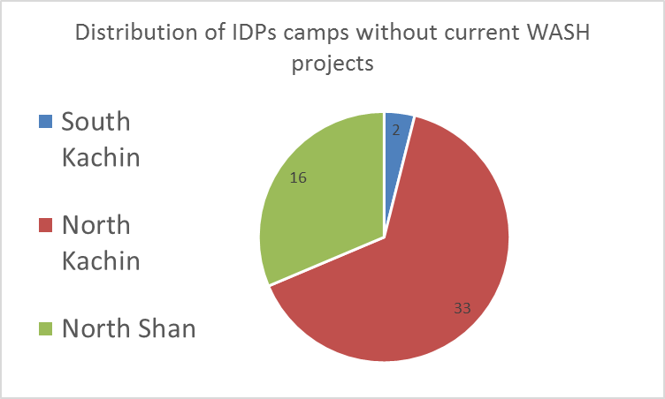

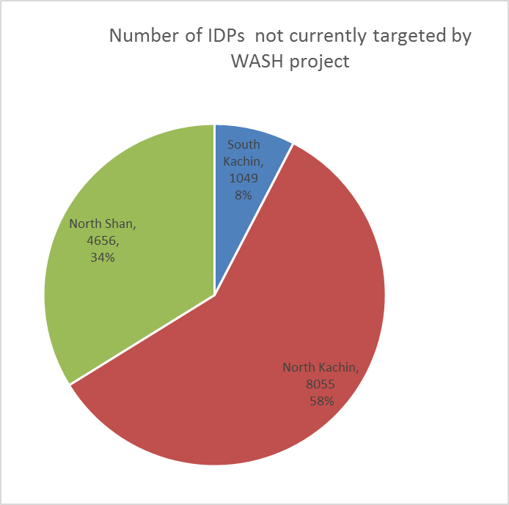

Most of the IDPs camps without any current WASH projects are located in North Kachin and notably in Hpakant and in NSS area.

The main WASH needs identified in the 4W matrix for these locations are the Household Water Treatment Systems and semi permanents facilities. The water coverage within these IDPs camps is high but this coverage doesn’t take into account the water shortage and water quality issues.

Beyond the quantitative needs issue, this discontinuity of WASH activities led to a weak monitoring of the WASH situation. Given this situation, it is crucial to empower camps and sub WASH committees with operation and maintenance issues in order to prevent any deterioration of the WASH facilities and situation.

**Main Priorities for next month**

* WASH assessment in Hpakant area,
* Follow up the humanitarian situation in Kokang,
* Participation to cross line missions according to the agenda
* Finalize monitoring framework for WASH cluster in Kachin and NSS
* Produce a positioning paper on WASH running cost
* Meeting on desludging issues with local authorities and NGOs
* Follow up water shortage issue

**Produced by the WASH members**

* WASH cluster strategy 2015
* Presentations of WASH cluster members for the WASH cluster strategy review
* Note on desludging activities
* Draft desludging assessment report
* Regular updates on Emergency WASH situation