RAKHINE STATE

Mid Term Strategy review

July 2015

|  |
| --- |
| Produced by: Rakhine Wash Sub Cluster  Organization: UNICEF  Location: Sittwe  Month: July  Resources: <http://www.themimu.info/emergencies/wash-cluster> |

# Context, main events of the semester

## Relocation/Return process

The main significant changes during the first semester of 2015 was the return/relocation process initiated by the authorities, related to the Governmental Rakhine action plan.

The first target was to support the return of 2000 household, in Mynbia and Mrauk-u Township. The process stated in April, and progressively has been extended to 5000 household for which the target was extended to Kyaw Taw, Pauktaw and Meybon. Ratheudong, Kyauk Phyu and Ramree may be also integrated.

So far around 1,779 Household have benefit form that plan, mainly in Mynbia and Mrauk-U. There is still a confusion in Pauktaw, between return and shelter upgrading, while individual temporary shelter has been provided by the authorities. Indeed, some camp sites are also the point of origin of a fraction of the camp population. However due to that mixing the setting remains camp like. Negotiation are still on-going in Pawk Taw to stimulate return to the place of origin, with some resistance of beneficiaries.

In Meybon negotiation with IDP (Rakhine and Muslim) are still on going to validate the new settlement, while the return is to be considered near the point of origin.

Situation is not yet clear about Kyauk Phyu and Ramree, while in Ratheudong it is likely to be solved.

The impact on the WASH response depend of the location:

* Mynbia & Mrauk-U: There was no more Wash agency working since January and then during the time the return process took place. It those locations IDP was still in their villages of origin, having lost their habitat and living in long shelter. The Wash cluster evaluate at the beginning of the year that the past 2 years Wash project by the Wash focal agency (CDN) improved sufficiently the overall wash situation in the concern “affected” villages, in comparison with surrounding villages situation. Then, rather than deploying a specific project to accompany the return process, which can be a heavy process to re-build acceptance and access as well as fueling tension between communities, the Wash cluster is looking at alternative option to consolidate the Wash situation in those location: Integrated approach with the authorities process, habitat approach integrated latrine in new shelters provided, coordinating with Early recovery network to envisage integrated livelihood approach in future project…
* In Pauktaw the process strongly impact the Wash activities in camps (Kyein Ni Pyin and Net Chang), while the construction individual temporary shelter in the camps has affected the site planning, sometime destroying existing wash facilities, and requiring to spatially re-organize wash infrastructure. But most of all, the lack of coordination between Township Administration and camps actors, did not allow the necessary join site planning to ensure reactive measures, leading to the standby of Wash project to “wait and see” for the best option a posteriori. The sanitation situation in both location has then degraded quickly under acceptable level of services for IDP

In the meantime, **the Wash cluster produce a positioning note toward re-settlement of IDP**, re-affirming the centrality of protection and no harm principle, and prosing different case scenario to be addressed with different package.

In parallel Wash cluster and Shelter cluster developed **an integrated approach toward habitat**, rather than strictly Shelter, proposing to integrate a low cost latrine (Bamboo pit type) in each new shelter developed for the purpose of return.

## The dry season

The reporting period covered the dry season, during which usual location suffered from Water scarcity and require emergency measure: Pawktaw Township:

* ANY camps: Water boating
* Net Chang 1 & 2: remote water pumping and distribution

It should become a priority to find more sustainable solution to stop the water boating activity necessary every year. **The Wash cluster produce in February a Technical note on ANY water supply situation**, proposing different option to end emergency water supply.

The raining season came a bit lately than usual, leading to a Water shortage in village location in the northern Township, where UNICEF supported a quick support with a one shot water trucking.

## Main constrains

* Temporary individual shelter extended camps size and re-positioned Wash infrastructure
* Ending displacement to be supported
* Contracting work in camps
* Landowner issue
* Water scarcity in dry season

## Main achievement

* Preparedness to raining and cyclone season:
  + Contingency plan developed under OCHA/HCT umbrella for Cyclone
  + Upgrading of latrine was speed up before the raining season (but delayed in some location – Pawktaw)
  + Drainage was validated to be systematically in concrete in 2015: Moderately applied
* On-site deslugging structure has increased and more systematize
* Maungdaw district information sharing through 4W in place, following a WASH cluster visit beginning of the year, identifying the necessary support to be developed, followed by a cluster Information management training. Linkage with authorities and sharing information is to be developed as a next step, associated with Capacity development
* Upgrading latrines design to limits dismantling (Cement floor, zinc sheet wall…)
* WASH cluster monitoring system: Wash cluster team (3 consultant) regularly visit all location equipped with monitoring tools harmonized allowing to have a good situation follow up. However the system of data interpretation need to be urgently consolidated to allow formalized sharing results.
* Review of the coordination between Wash and education sector to improve Wash in School/TLS response in emergency setting => **Positioning note developed** formalizing the coordination principle
* The development of a water point data base, including possibility of and extensive characteristic definition, and development of delineating hydrogeological map under development (in collaboration with Hydrologist Without Border, based in London)
* Several survey and study produced by wash partners, supporting the development of adapted Hygiene education approach: KAP survey (DIFID Consortium) , Social marketing survey, Distribution modalities studies related to market conductivity…

## Specifics

This phase led to an appropriate and good geographic coverage of most locations, based on a cluster mapping exercise, shared with donors, based on the “focal wash agency per location” approach.

Most of the location are covered continuously with a high stability of wash focal agency per location expect Kyauk Taw, covered by Oxfam (ERF funding) have suffered to a services interruption of 2 months but affecting villages only, without creating specific risky situation, and Mynbia/Mrauk-U where CDN have ended their project beginning of the year. The Wash cluster will ensure regular monitoring visit, associated to the relocation process, in the coming month.

During the wash cluster review strategy workshop, all Wash partners presented the situation per township (join presentation while several actors). Following that review, and the present report, **a 2 pager per township to describe the Wash situation is planned to be consolidate for end of August**.

The wash cluster maintained its strong relationship and exchange level with the DRD and ministry of transportation and communication (as chair of the Relocation and resettlement sub-committee), who participated actively to the WASH cluster review.

# Strategy objective overview[1]

## Target population

The population targeted by the current WASH intervention is summarized in the table below.

|  |  |  |  |  |  |
| --- | --- | --- | --- | --- | --- |
| **Strategy target:** | **HRP 2015** | **WASH Target HRP 2015** | **Updated Wash target** | **Wash Presently covered** | **% Targeted** |
| IDP in camps | 116,183 | 114,392 | 119,158 | 118,286 | 99% |
| IDP in villages | 8,158 | 11,194 | 14,246 | 14,246 | 100% |
| Affected families in villages | 14,969 | 13,724 | 19,833 | 10,823 | 55% |
| Hosting villagers | 100,000 | 100,000 | 45,394 | 37,792 | 83% |
| Surrounding villagers | 50,000 | 50,566 | 101% |
| Maungdaw district | 177,290 | 70,000 | 70,000 | 116,152 | 166% |
| **Total** | **416,600** | **309,310** | **318,631** | **347,865** | **109%** |

Figure 1 – Target population July 2015

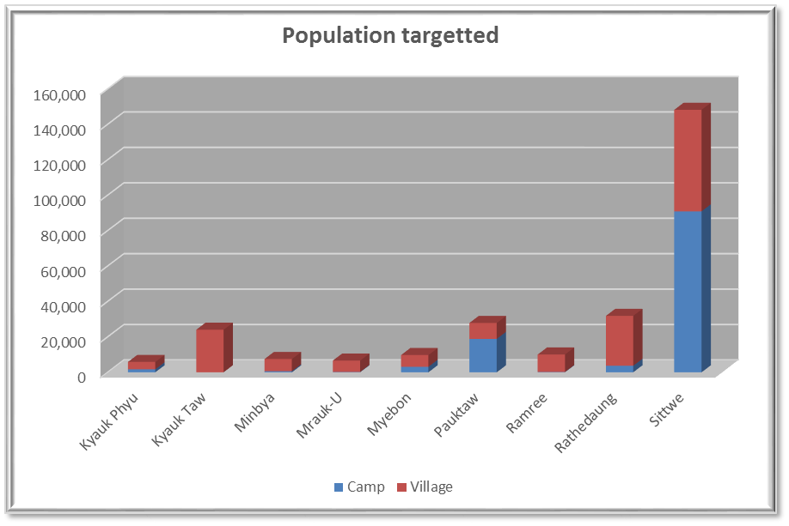 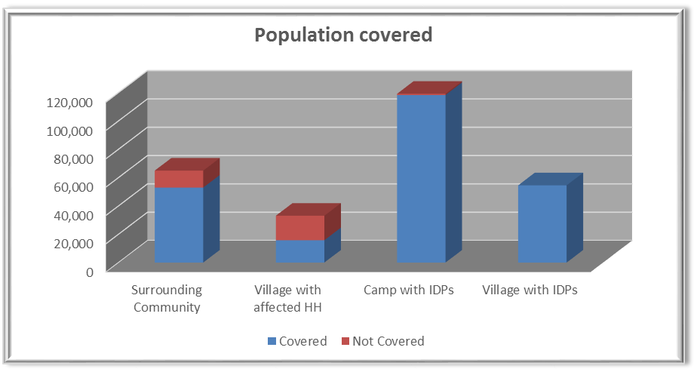

The updated Wash HRP target is based on the update declare for IDP population in 4W form CCCCM and Wash partners. It appear a need to better consolidate population between the 2 sectors, to limit the variation observed.

To notice that 2 camps in Mynbia Township have never been reached.

The total population in villages are given by the Wash partners, while the Wash defined in 2014 a holistic village approach looking at the Wash coverage of the whole population rather than specific for IDPs in villages.

The surrounding population is defined based on self-declaration of Wash partners. The Wash cluster didn’t solve yet the weakness of not having a baseline for surrounding target. Then despite a 100% reach objective could be questioned, does all villages declare as such really respond to “surrounding” criteria, while maybe other not declared while not targeted, should be. To notice that in the financial analysis below, 2015 show a lower financial investment of WASH project toward surrounding communities, while the target remain stable compare to last year.

The **HRP target for Maungdaw** District is mainly related to nutrition, food insecurity and heath needs, based on statistical approach defining 170,000 people in needs. However, this population is not geographically located and global analysis suggests that vulnerable population is scattered among the overall 800,000 district population and that no specific pockets of malnutrition are to target. The **WASH approach cannot target specifically the population defined in the HRP**, as this would mean to work throughout all villages/locations of the district. Especially when it is demonstrated more and more in the whole state that “village approach” should be promoted addressing the needs for the whole community rather than for specific families. Then it is complex in a WASH perspective, to define a specific priority or emergency target, especially looking at the very high WASH demand in all locations. In such situation whereas humanitarian situation of the population can’t be denied in perspective of health, nutrition and protection, the WASH needs fall in an overall humanitarian situation but require development response. Then the results presented are the beneficiary reach with actual project in Maungdaw district, whatever Development or emergency.

The lower results of coverage for “affected villages” is related to the ending of CDN project in Mynbia & Mrauk-U, population benefiting now form the return plan for the government. This last element should at some point lead to a decrease of that population to be considered having ending there displacement, while no more WASH critical needs are identified in the humanitarian scope.

**Then, globally more than 100% of the target population is reached/benefit of a WASH project, which does mean that 100% of the need are covered, as demonstrated in the following chapter per objectives.**

**Around 50% of the population targeted in the WASH cluster strategy are in villages**.

## Overall results

The overall results per objective are summarized as below, taking in consideration the need coverage reach by the project in place:

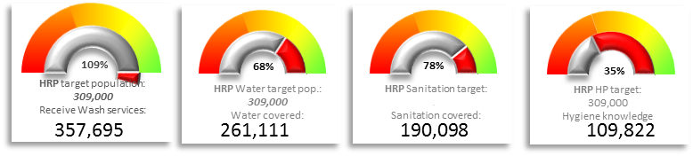

The comparative coverage of needs shows an improvement, although small, for water and latrines. Bathing spaces has decreased, indeed, the communal bathing spaces design was never adopted by the communities. Agencies stopped building those and are looking for new alternatives, in the meantime, infrastructures is slowly been dismantled for firewood.

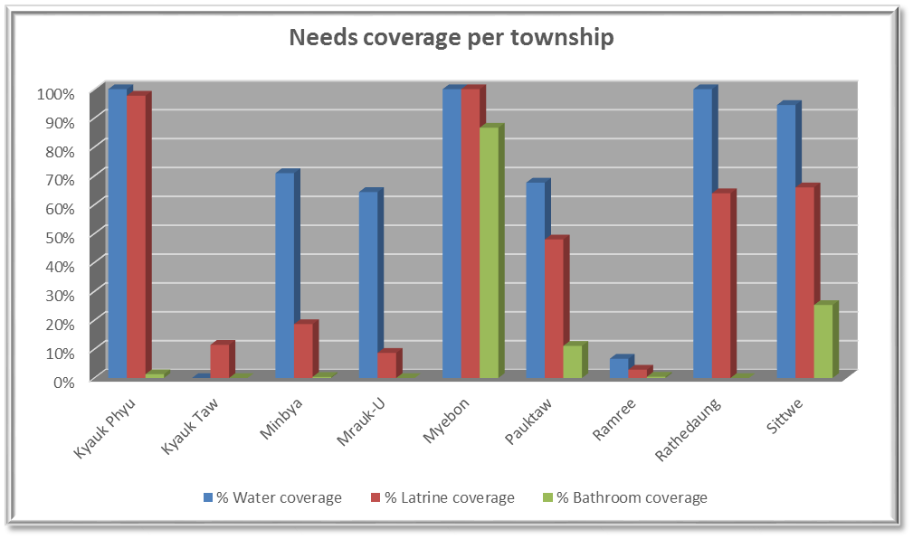 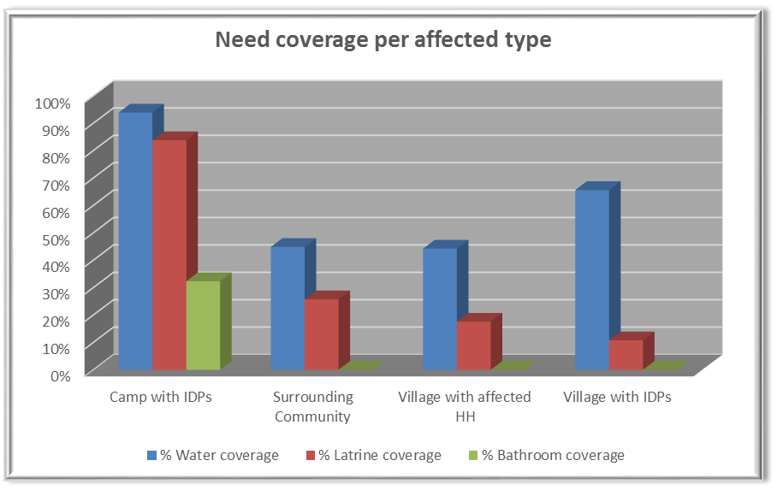

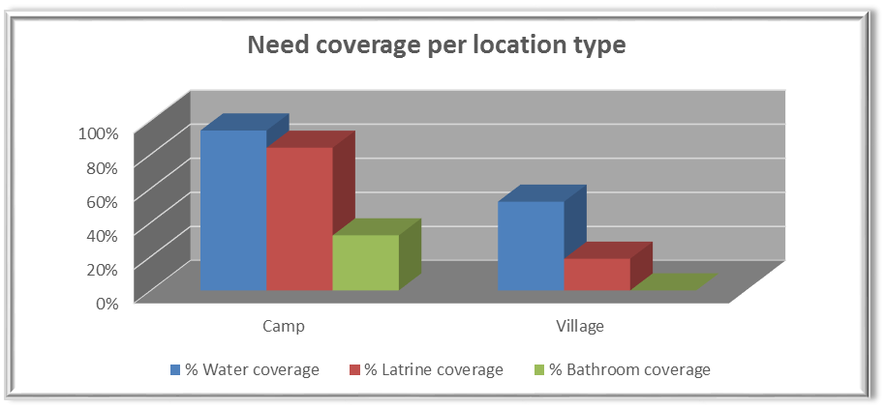

It is important to remind that the objective and indicators apply are not the same for Villages and Camps setting and comparative interpretation has to be handle carefully. In term of water access, the analysis do not take in consideration the “Pond” water (but can be track in 4W for references), while many villages are relying mainly on that sources of water. The Cluster promote the development of “safe Water point”, but often not possible due to hydrogeological situation. For sanitation the village approach defined target 60% of the need in 2015, with Household latrine or share latrine between household, rather than 1 for 20 persons in camps.

Finally the camp setting is to be considered as a risky environment in term of health, protection and environment more globally, leading to the responsibility to developed more assistance with striker standard to mitigate those risk and create a more dignified environment.

# Equitable and sustainable access to sufficient quantity of safe drinking and domestic water

**HRP indictor results:**

The achievement in the table is relative to the real coverage of the needs based on pre-defined target (e.g. Sphere in camps). For example in a camp of 10,000 persons, if 75% of the water needs is reach, the result is 7,500 persons, despite the fact that the 10,000 are anyway benefiting of the wash project in place.

The target used for the coverage of the needs are:

* In camps: 1 open hand dug well for 400 persons, 1 protected open dug well for 500 persons
* In villages: 1 Hand dug well for 250 persons



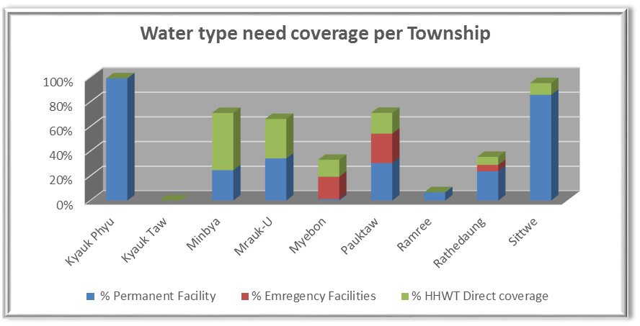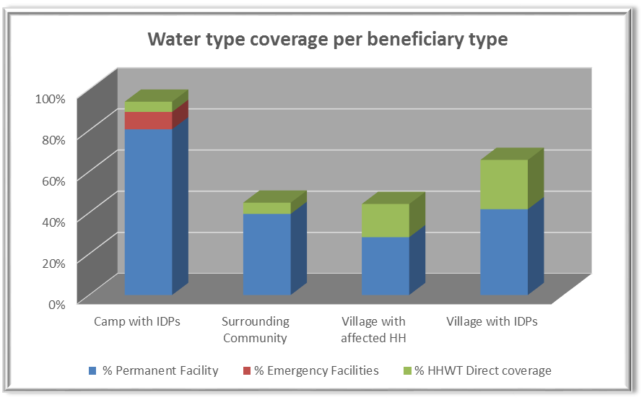

The target in Kyauk Taw and Ramree is mainly villages whose rely on pond.

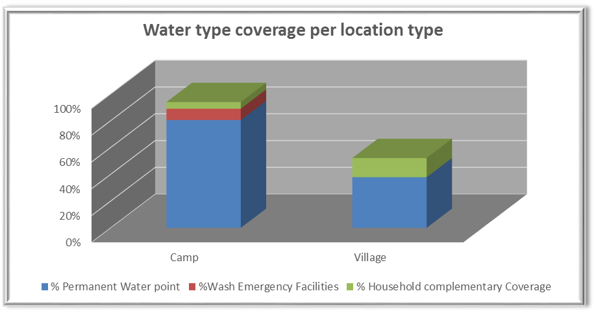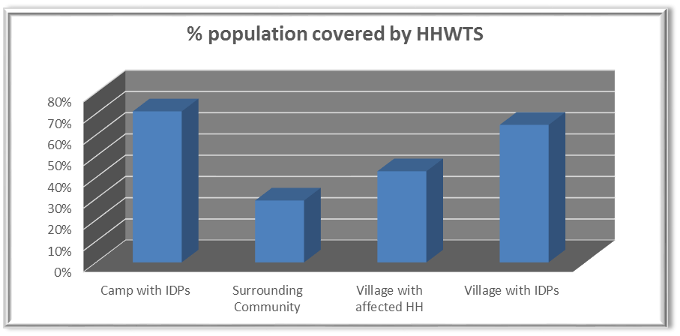

The Household Water treatment system (HHWTS) measured is about the distribution of Ceramic Water filter.

This approach is planned to be evaluated in the second 2015 semester. So far it is agreed as a good “emergency” complementary response, impacting quickly on the water quality, especially in area relying mainly on pond water or where the high number of shallow water point (Sittwe township) do not allow cost-efficient systematic chlorination system in the protractile situation. However, the sustainability is weak, the ceramic filter not existing on the market, and considering that around 20% of them (PdM results) are not functional a year later.

# Equitable access to safe and sustainable sanitation and to a non-contaminated environment

HRP indictor results:



The achievement in the table is relative to the real coverage of the needs based on pre-defined target (e.g. Sphere in camps). For example in a camp of 10,000 persons, if 75% of the sanitation needs is reach, the result is 7,500 persons, despite the fact that the 10,000 are anyway benefiting of the wash project in place.

The target used for the coverage of the needs are:

* In camps: 1 latrine for 20 persons
* In villages: it is defined depending of the Wash agency approach 1 per HH or 1 for X HH)

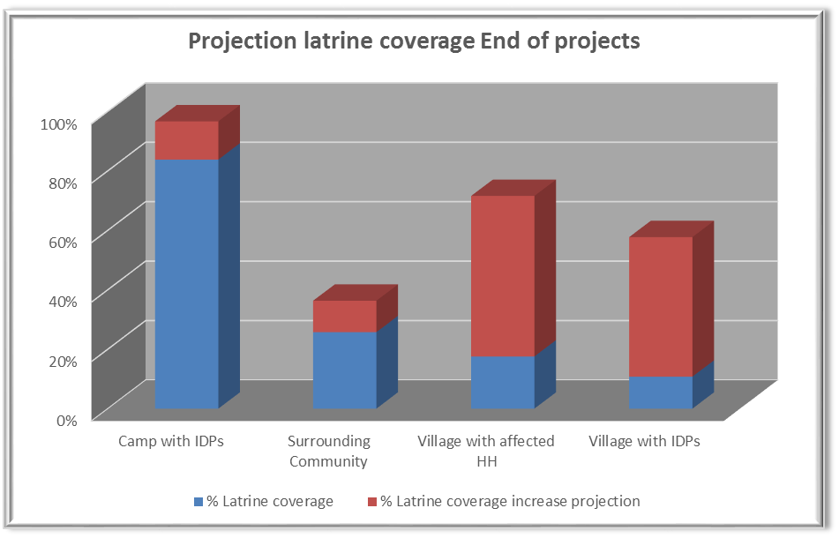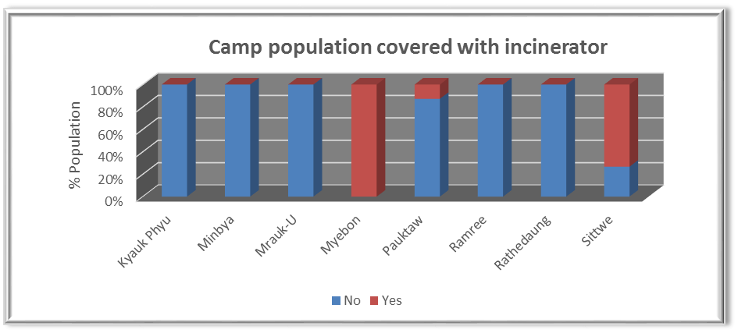

The latrine coverage in camp is stabilized in most places, bur require constant maintenance due their semi-permanent nature and the dismantlement their suffer of. However Pawtaw shown a drop down of coverage, due to operational constrain and re-settlement process.

Progressively, year after year, the sanitation is improving in village setting, supported by the “village approach”. However more mobility should be expected a to change target on surrounding community, while care should be given not creating too much coverage differences between communities, in a do harm perspective.

# Improvement of hygiene practices and behaviors change

HRP indictor results:



The achievement analysis below is based on KAP survey results, generalized and then giving very approximate overall vision.

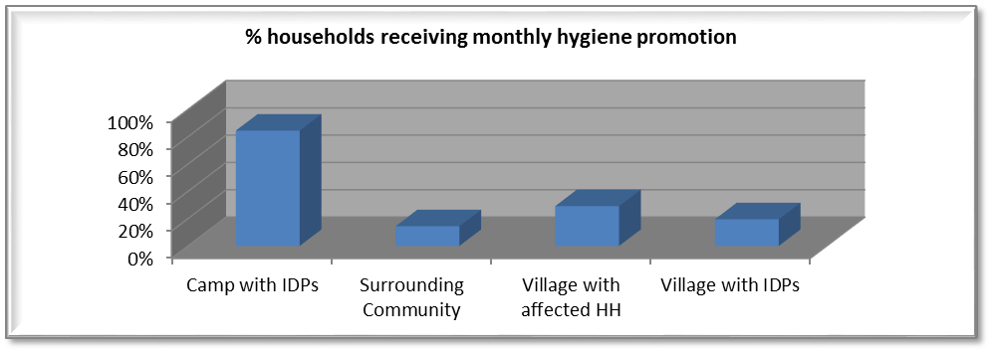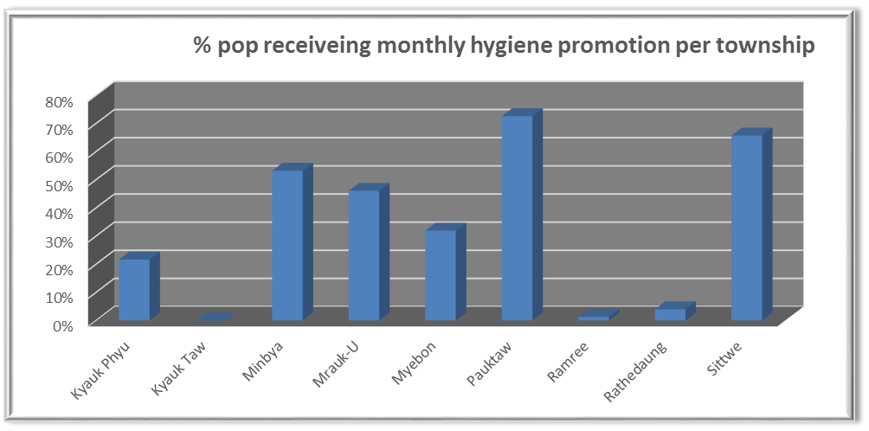

It demonstrate that hygiene promotion should be re-enforced in villages, while in the camp Wash partner are working on more creative approach to initiate change in behavior rather than knowledge (already reached by now). Social marketing are under pilot, PHAST approach, and globally more participative approach.

# Transversal approach

Gender:

An evaluation has been conducted about the proper integration of gender consideration in the Wash approach, results expected to be shared in July. The 4W provide the following global vision:

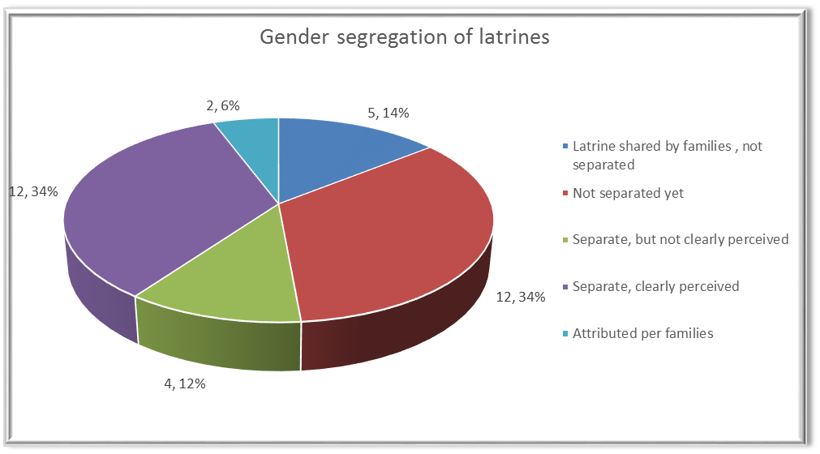

Globally is is empirically known that the gender consideration are not strong enough in the wash response, especially in camps where the risk protection risk associated with WASH services are significant. The cultural habit are a strong constrain to mitigate those risks, but the following has been initiated:

* Protection Training of all WASH intervening in camps plan in July
* Gencap Assessment requested (results under finalization)
* Re-enforcement of coordination with protection sector leading to technical positioning: KLightening of the latrines
* Initiate a more systematic attribution of latrines per families
* Abandon of the bathing space approach (2014) to favorite private limited space for bathing in shelter
* Accountability assessment done in 2014, demonstrating the need to include more the women in decision making
* Representation of women increase in WASH project

The menstruation management remains a challenge in terms of WASH intervention and it will be dealt with in the coming months by the two sectors. The issued guidance paper on “Menstruation management” has been used as a basis but need to be consolidated

Self-reliance and community empowerment

Defined as a main objective in 2015 the barrier remain numerous. The first attempts from Wash agency are:

* Attribute the latrine per family rather than gender to increase ownership and self-basic hygienic maintenance
* Remove the subsidies for cleaning latrines
* Creating/re-enforcing Water committee for basic maintenance, committee supported with tools and training

The results in camps remain limited while the absence of livelihood limits the possibilities. The lack of livelihoods opportunities for the IPD population leads to a dependency on WASH interventions as part of incoming generating activities. This dependency will not change unless other actors bring targeted livelihoods opportunities.

The absence of livelihood lead to high stress on infrastructure, dismantle for cooking purpose, jeopardizing energy invest, lowering considerably the wash impact, and forcing re-investment. While it remain a main objective and approach to developed community based management of infrastructure, despite Wash actor effort, it won’t be reasonable to expect high level of success without appropriate livelihood parallel activity to support resilience development of the IDP in camp.

Looking more globally at the resilience re-enforcement of the communities, it appear that the DRR approach are very weak as for example to protect the Wash infrastructure. That weakness could be perceived as an opportunity to have integrated approach with livelihood through CFW approach: E.G. Building drainage with CFW to decrease the risk of flooding.

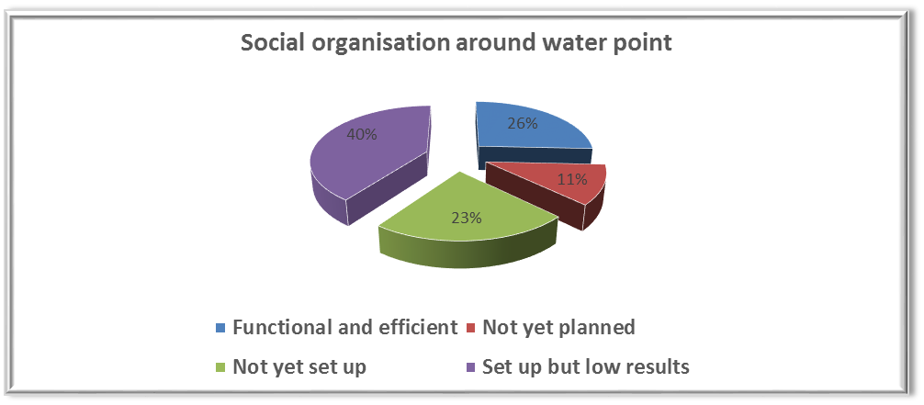

# Main priorities for the next semester

* Water quality improvement still an issue, and to be better integrated in a cluster water quality monitoring system
* Improve Hygiene education toward change behavior
* Social mobilization to still be re-enforced toward self-reliance
* Exiting of blanket Hygiene kit distribution
* Fund raising to support “ending displacement”
* Ending Water emergency supply during dry season
* Consolidation of surrounding villages base line
* Keep specific monitoring of situation in Pawk taw
* Ensure the continuity of project coverage with focal point agency per sites, to ensure maintenance and operation

# Funding analysis

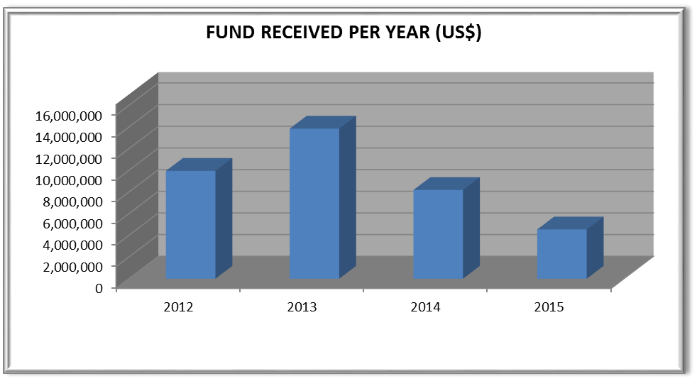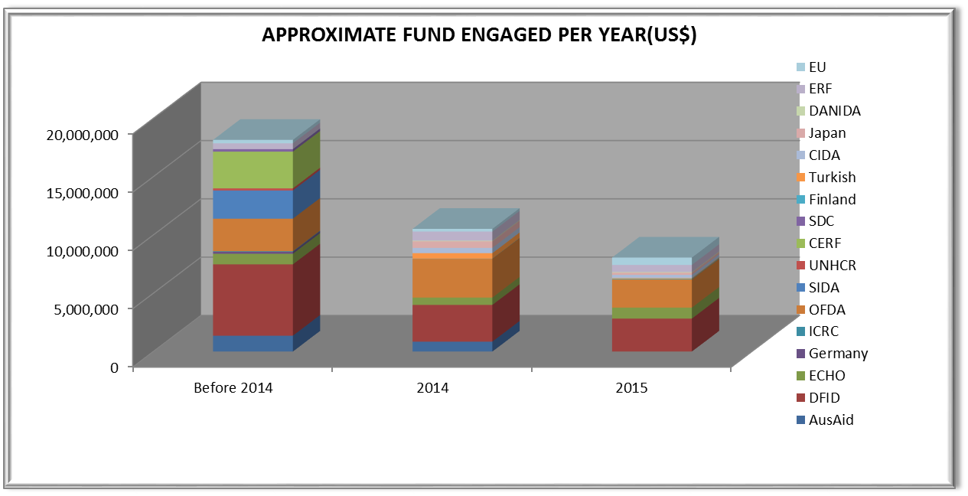

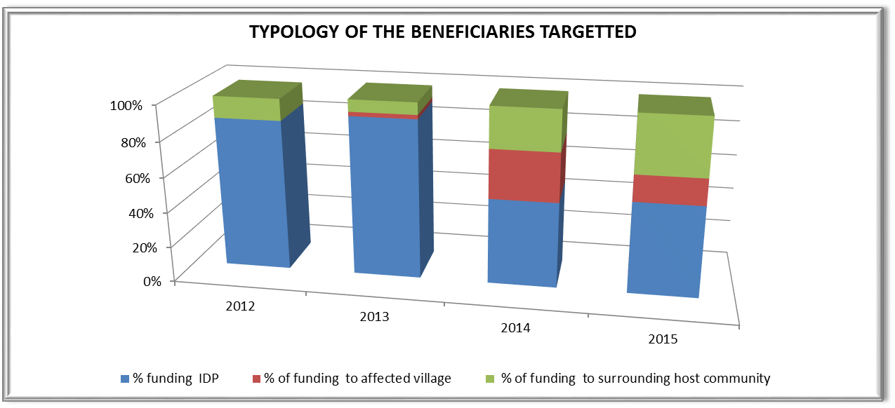

The approximate fund engaged per year is a repartition of funds received with consideration about the project starting and ending dates.

**The funding target for the Rakhine wash cluster response in 2015 is 16,6 MUSD, around 5 MUSD received, so 30% received.**

Despite the underfunded situation, while Wash project is about continuous services in affected location (camp and villages), most critical location are covered with a Wash project, ensuring maintenance and operation in each camps, and development of the need coverage in village settings. This can be explain due to:

* Reduction of the need in 2 township (Mrauk-U, Mymbia)
* Revision of the HK target, where blanket distribution is not any more requested
* Compression of services
* …

1. The data for this analysis are from June 2015.