STANDARD IEC MATERIALS

Produced by: WASH Cluster
Specific Support: ACF, Malterser Int’l, Oxfam, Save the Children and Solidarites Int’l
Type organization: UNICEF and NGO
Subject: Hygiene Promotion- IEC Materials for protractile emergency context
Created: 2013
Updated: June2014
Resource: http://www.themimu.info/emergencies/wash-cluster

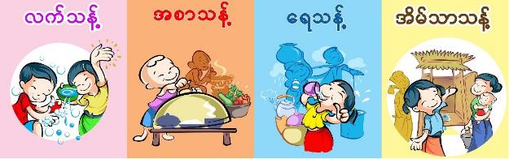
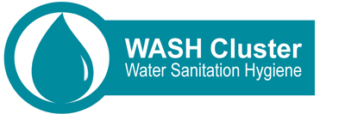

Background
This document aims to capitalize the selected most relevant IEC materials produced so far for the Kachin and Rakhine emergency responses, in order to constitute a simplified and standardized package recognized by the cluster.
The approaches related to hygiene promotion are beyond the scope of this document and will not be addressed in this document. As it is a major concern for all WASH agencies to meet the local context, majority of the IEC materials produced by WASH agencies are replicated or modified from the previous resources of emergency cyclone responses to improve the pertinence of the IEC materials in the targeted population.
Among the various types of IEC materials, this document will only emphasize on the IEC materials used at the household and community level rather than other purposes such as training and campaign. After several exchanges between the WASH agencies based on their experiences and findings, the IEC materials shared below have been accepted and already implemented since mid-2013 as a harmonized approach. The approach is not to limit the production of new IEC materials but to keep the minimum standard by WASH agencies.
This document is subjected to change based on the regular review and inputs from the field situation based on lessons learned. (Preferably every 12 months)

Key Themes on IEC Materials
The cultural, socio-economical and educational backgrounds greatly differ among the targeted populations. In both Kachin and Rakhine, the findings from hygiene promotion activities highlighted the need of the key themes and messages on hygiene promotion to be consistent and reflecting the field situation. WASH Cluster recommended the key hygiene promotion themes (4 clean) that have been approved at the national level with the Ministry of Health. However, the key messages should be developed based on the hygiene practices of the targeted population.
Key Themes | Messages by each Theme at household and IDPs/Community level
Clean Food | - Clean food with water before cooking  - Cook well  - Store food (with cover or in cupboard)  - Warm food before eating (if the food is kept for long)  - Avoid eating contaminated food (fly-blown food)  - Hand washing before handling food
Safe water | - Colourless  - Odourless  - Tasteless  - Treated by boiling, chlorination /or using ceramic filter  - Stored water safely in a jerry can with a tap; to prevent contamination, do not introduce hands or objects into the stored water  - Collected from a protected water point
Clean Hand | Wash your hands with soap and water at the critical times:  - After going to the toilet  - After wiping a child’s bottom  - Before eating  - Before feeding a child  - Before preparing food  - Before handling water  - After looking after a sick person or a dead body
Clean Latrine | Always use a latrine or toilet.  If you don’t have a latrine, bury all faeces including babies’ and children’s.  Provide hand washing facilities next to the latrine and always use them after using the latrine
AWD specific | - It is critical to stay hydrated. The lost body fluids must be recovered  - ORS can help to prevent dehydration and death  - AWD is nothing to be ashamed of  - Disinfect areas and materials soiled with vomit and faeces  - Keep people safe at funerals  - Use the NFIs/supplies as intended  - Seek for medical assistance
The IEC materials developed by UNICEF and other NGOs are available at the MiMu website. However, due to the size of these IEC materials, it will be made available through the CDs or USB sticks at the WASH sub-cluster so that WASH agencies can use the good quality image for printing.

IEC Materials in Rakhine
Hygiene Promotion working group was formed in Rakhine and Solidarites International took lead in the development of IEC Materials and many WASH agencies contributed their experience in the development of the following IEC Materials. The following IEC Materials got the approval from the State Health Director from the Rakhine State Health Department.
Table 1 Description of IEC Materials
No. | Year of Issue | Name of IEC Materials | Language | Key Messages | Pictures used | Intended location | Intended users
1 | 2013 | F-Diagram (Prevention & Transmission) poster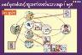 | Myanmar | 4 clean, diarrhea transmission and prevention | Pictures showing good and bad practices (Layout and format were changed)  Several versions available | Camp, Temporary learning space, child friendly space, camp office and other communal places such as market. | - WASH field Staff  - Camp based Volunteer  - Women and Men  - Children
2 | 2013 | Hand Washing poster  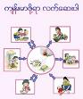 | Myanmar | Wash your hands to be healthy | Pictures showing the critical time of hand washing | Camp, Temporary learning space, child friendly space, camp office and other communal places such as market. | 1. WASH field Staff  2. Camp based Volunteer  3. Women and Men  4. Children
3. | 2013 | 3 pile sorting cards  To be used for interactive discussion with groups “good practices, bad practices, neither good nor bad practices” | Pictures only | No messages | 30 pictures showing the good and bad practices | Group discussions and game-type sessions | 1.WASH field Staff  2.Camp based Volunteer  3.Women and Men  4.Children
4. | 2013 | Comic Book ( A clean hand is a good medicine) | Myanmar, Kachin | Good hygiene practices vs bad hygiene practices.  Washing hands to prevent diarrhea. | Stories  Color and Black & White (for painting) | Child friendly spaces, Temporary learning spaces, Household, Library and clinic | 1.WASH field Staff  2.Camp based Volunteer  3.Children over 5 years
5. | 2013 | Hopscotch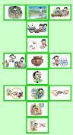 | Pictures only | No messages, game | Pictures showing good and bad practices | Child friendly spaces, Temporary learning spaces, Household,  Children groups | 1.WASH field Staff  2.Camp based Volunteer  3.Children over 5 years
6. | 2013 | Snake & Ladder  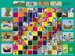 | Myanmar | Who is healthier? | Pictures showing good and bad practices  Game | Child friendly spaces, Temporary learning spaces, Household  Children groups | 1.WASH field Staff  2.Camp based Volunteer  3.Children over 3 years
7 |  | Ceramic water filter  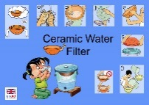 | Pictures only | How to use and maintain CWF | Poster and  Pamphlets | Householdvisits | 1.WASH field Staff  2.Camp based Volunteer
8. | 2013 | Disease route football |  | Disease route | Game, explanation provided | Child friendly spaces, Temporary learning spaces, Household  Children groups | 1.WASH field Staff  2.Camp based Volunteer  3.Children over 3 years
9. | 2013 | Story of cholera | English, rohingya | Video | Explanation of cholera, transmission and prevention | Groups | 1.WASH field Staff  2.Camp based Volunteer  3.Women and Men  4.Children
10. | 2000 | Meena's three wishes | English | Video | Hygienic practices |  | 1.WASH field Staff  2.Camp based Volunteer  3.Women and Men  4.Children
11. | 1990 | Source of life | No dialogues | Video | Water contamination |  | 1.WASH field Staff  2.Camp based Volunteer  3.Women and Men  4.Children
12. | 2012 | Tippy tap | No dialogues | Video | How to build a tippy tap |  | 1.WASH field Staff  2.Camp based Volunteer  3.Women and Men  4.Children
13. |  | Hand washing gangnam style | No dialogues | Video | Hand washing steps |  | field Staff  2.Camp based Volunteer  3.Women and Men  4.Children
14. |  | Songs | Myanmar | audio | Hygiene topics |  | field Staff  2.Camp based Volunteer  3.Women and Men  4.Children

IEC Materials in Kachin
A Workshop to unify and standardize all the hygiene key messages was conducted in early 2013. The workshop decided to produce the IEC materials in Kachin language for better communication and effective hygiene promotion. Preliminary test for the IEC materials in Kachin was conducted in the KBC camp in Bhamo area to realize the level of understanding among the Kachin IDPs and it was found that the IEC materials are well illustrated and understood among the IDPs. Therefore, the bilingual (Kachin and Myanmar) IEC booklets were developed and shared among the WASH partners.
In mid 2013, IEC messages in Kachin were reviewed by WASH Cluster and it was found that the IEC messages are well tuned and still relevant apart from few spelling errors. In addition, all agencies discussed about the translation to Shan Language should be done or not. Although some agencies commented that Myanmar language was enough as most of the Shan ethnic group understand Myanmar language and no final decision was made at that time. As a first step, all WASH agencies agreed to use the IEC materials developed in Kachin version.
Inconsideration of the investment realized, the precision and translation of this Kachin IEC materials, based on collective work including most NGO working in Kachin, but also direct input from beneficiaries themselves, this “tools box” is strongly recommended to be used, in an harmonized and resources rationalization spirit.
Table 2 Description of IEC Materials
No. | Year of Issue | Name of IEC Materials | Language | Theme Covered | Pictures used | Intended users
1 | 2013 | 4 clean, diarrhoea transmission & prevention | Kachin and Myanmar | 4 clean (Water, Food, Latrine, Hand) and about the prevention and transmission of water-borne diseases and helminth(worm) infestation | Pictures/Drawing from UNICEF and Ministry of Health that were used in the previous projects. (Layout and format were changed by workshop) | 1. field staff  2. Hygiene promoters  3. Other relevant persons (teachers, volunteers, WASH committee members etc.)  4. Community
2 | 2013 | Personal Hygiene | Kachin and Myanmar | Daily Hygiene Practices, Hygiene Poem and Songs (in child focus format) | Pictures/Drawing from UNICEF and Ministry of Health that were used in the previous projects. (Layout and format were changed by workshop) | 1. field staff  2. Hygiene promoters  3. Other relevant persons (teachers, volunteers, WASH committee members etc.)  4. Community
3. | 2009/10 | F-diagram posters/ four clean IEC booklets | Myanmar | 4 clean (Water, Food, Latrine, Hand) and about the prevention and transmission of water-borne diseases | Pictures/Drawing from UNICEF and Ministry of Health that were used in the previous projects. (Layout and format were the same) | 1. WASH agencies  2.WASH officers  3.WASH field staff  4.Hygiene promoters  5.Other relevant persons (teachers, volunteers, WASH committee members etc.)

IEC Materials for AWD response
Key Messages for AWD prevention | Key Messages for AWD response
- Only drink safe water  - Prepare food safely  - Protect your children by feeding them safely  - Dispose of all feaces safely in a latrine or burying it  - Wash hands with soap and water | - It is critical to stay hydrated. The lost body fluid must be recovered.  - ORS can help to prevent dehydration & death.  - Cholera is nothing to be ashamed of.  - Disinfect areas and materials soiled with vomit and feaces.  - Keep people safe at funerals.  - Use the NFI/supplies as intended.
IEC materials for AWD response were also developed in Rakhine. The key messages for the AWD response are developed by the Hygiene Promotion Working Group and can be divided into two parts (prevention and response).
The following posters were also developed and used for AWD response in Rakhine. 4 main posters with critical and key messages for the prevention and initial measures for AWD responses were used in Rakhine. All the posters were approved by the State Health Department to be used in the targeted population in Rakhine.

Table 3 Description of IEC Materials for AWD response
No. | Year of Issue | Name of IEC Materials | Language | Key message | Pictures/Layout | Location to use | Intended users
1. | 2013 | Poster for AWD response | Myanmar | Preventing AWD Towards healthy life | New pictures showing key hygiene practices to prevent AWD | Household, Child friendly space, temporary learning space, camp, schools, clinic | 1.WASH field Staff  2.Camp based Volunteer  3.Children over 3 years  4. Community
2. | 2013 | Poster for AWD response | Myanmar | Signs of severe dehydration | New pictures showing the signs and symptoms of severe dehydration
3. | 2013 | Poster for AWD response | Myanmar | 4 Key Actions when one gets AWD | New pictures showing what to do when one gets AWD
4. | 2013 | Poster for AWD response | Myanmar | “To be healthy for All of us” | New pictures showing 3 critical actions for AWD prevention

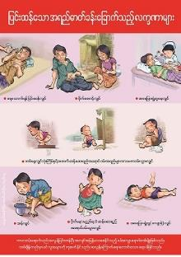
Figure 1 Poster for AWD responses (signs of dehydration)
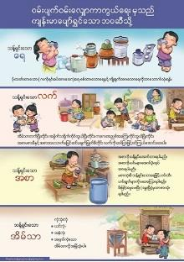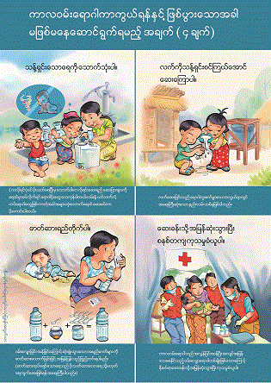
Figure 2 Posters for AWD response
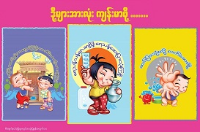
Figure 3 Poster for AWD response

Guidance notes
There is no specific guidance available for the use of the IEC Materials but the following recommendation is proposed for WASH agencies and should be modified further.
IEC Materials developed
- should follow the 4 clean themes that have been approved at the National level. Necessary approval from the State and Division should be obtained for better communication, the WASh Cluster can support with this.
- should reflect the local culture, customs and practices.
- (mainly posters and banners) should be displayed at the strategic location at the camps (such as clinic, schools, market, child friendly spaces, temporary learning spaces around camp office and around latrines)
- should be comprehensible by vulnerable groups such as illiterate people and if possible, specific IEC materials should be made available for disable persons with totally impaired hearing and vision.
- should be developed in local language, if necessary and where possible
- Specific IEC Materials should be used in specific hygiene promotion activities such as IEC for AWD should be used in AWD responses etc.
- The level of understanding and key take-home messages should be assessed in every use of the IEC materials.
- The type of materials used should withstand the wear and tear effects of weather in the targeted areas.
- The relevancy of the IEC Materials developed should be checked regularly and modified where necessary.
- Provision of bias or unclear messages should be avoided by all means. Always keep the “Do No Harm approach.”
- The use of songs, poems, games and other audio-visual aids should be applied depending on the acceptance of the target population.

Main Findings & Lesson Learned
All WASH agencies expressed the need of the IEC materials and emphasized on developing the IEC materials to use in the hygiene promotion. In almost all the camps, it is found that IEC materials are displayed, distributed and used for the community mobilization. However, few actions are taken by WASH agencies to evaluate the IEC materials that have been disseminated and used. Moreover, there is few IEC materials available for waste management and no IEC materials available for women in menstrual hygiene management. All IEC Materials developed can be downloaded at the MiMu Website at the following link http://www.themimu.info/emergencies/wash-cluster or are available through USB at the WASh sub-cluster office, and the annex files.

Recommendations
- Discussions with the community or IDPs to identify and understand the cultural, social and geographical background and barriers should be done prior to the development of the IEC materials. These findings from the hygiene promotion activities should be incorporated in the development of the IEC materials.
- Approval from the respective person from the health department (eg. State Health Director) should be obtained before producing in large quantity.
- The IEC materials should be durable and can withstand the weather in where these materials are intended to use. For example, vinyl or laminated poster.
- The content IEC materials should be comprehensible by all the targeted population or age group. For example, illiterate people and children.
- The IEC materials should be translated into local language, where possible and relevant, taking into account that the approval from the respective health department is required for language translation.
- The evaluation of the IEC materials used should be conducted in small scale and improved, updated or modified where possible. The relevancy of the IEC Materials should be checked regularly.
- Specific IEC materials should be developed in certain situation such as hand washing campaign, world water day and acute watery diarrhea outbreak.
- IEC materials related to the waste management and menstrual hygiene should be developed.
- Exchange of the IEC materials between Kachin and Rakhine should be also done where relevant.

Annexes
The IEC Materials with good quality for printing and offset are made available through the attached annex files.
Annex includes some of the available posters and images.

Due to the size of the materials produce, it has been share by CD, and printing is planned, but no sharing possible on cluster Web site

