**STANCE PAPER ON CERAMIC WATER FILTER**

|  |
| --- |
| Produced by: WASH Cluster  Specific Support: ACF, CDN, IRC, Oxfam, SCI and SI  Subject: Household Water treatment with Ceramic filter in emergency context  Created: March2014  Updated: May 2014  Resources: [*http://www.themimu.info/emergencies/wash-cluster*](http://www.themimu.info/emergencies/wash-cluster) |

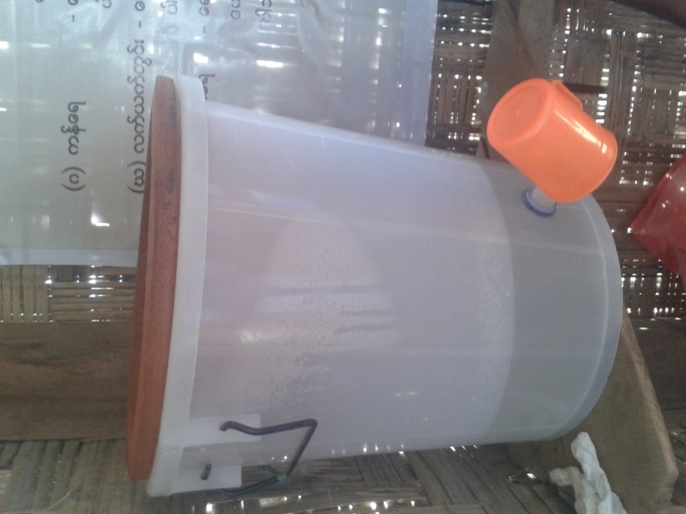



Table of Content

1 Background 2

2 Ceramic Filter in Myanmar 3

3 What is the current ceramic filter? 4

4 What is the current trend in Rakhine Emergency Response? 5

5 What is the current trend in Kachin Emergency Response? 7

6 Guidance Notes and protocol 8

1 Supply 8

2 Implementation 8

**6.2.1** Guidance points to strictly consider 9

3 Monitoring 10

6.3.1 Monitoring of supply quality –See 6.1 Supply 10

6.3.2 Regular monitoring 11

6.3.3 Sampling 12

4 Evaluation 13

7 What are the main findings after a brief study in IDP camps to date? 14

8 Bibliography 14

Appendix 1 Ceramic Water Filter Inspection Protocol 16

Appendix 2 Tool for household visit 17

Appendix 3 Flow rate testing 18

Appendix 4 Tool for water quality testing 21

# Background

Water quality management remain challenging in both Kachin and Rakhine emergency response due to contextual situation as access, environment, actor capacity, means, geographical repartition of the camps, population habits and acceptance, market availability, …

In addition the nature of both crisis being now protractile, concerns about more durable solutions are raised, with cost efficiency concern, and building more self-management capacity of the displaced community.

In this context, household water treatment interest is raised, and spontaneously, based on past Myanmar experience and population knowledge, wash actors have shown particular interest in ceramic filter approach. The 2014 Wash Cluster strategy mention already that approach as promising, and suggests pilot development.

However, such approach should be clearly defined, in order to ensure its added value to the emergency standard to be reached, avoiding short cutting overall water quality management objective, developed on evidence base, and included in a global safe water access strategy.

Then this document aims to unify the common approach on the use of ceramic filters with strong consideration on the followings:

* Evidence based on previous lesson learn in Myanmar
* In perspective of overall responsibility towards beneficiary in term of safe water access, and overall objective in “decreasing water born disease”, and so, related to other option depending on the context and situation
* Highlighting the risk related to such approach and limitation
* Supply protocol ensuring quality filter deliver to beneficiaries meeting minimum standard
* Distribution and post distribution protocol, to ensure optimization of good usage and measuring objectively the outcomes of the approach
* Proper inclusion in hygiene promotion activities and tools

**As such, this document aims finally to formalize as positive the Wash cluster stance toward such approach in both Kachin in Rakhine, conditioned by a proper and responsible approach.**

Globally the Wash cluster, in consideration of the emergency context, considers the ceramic filter approach as follows:

* An appropriate alternative and immediate solution while the area targeted does not allow rapid safe water point development due to hydro-geological constrains
* As a positive complementary solution in camp and village environment to the existing safe protected water point
* **In any case, the technical wash objective remains to develop protected water point producing un-contaminated water to the population**, in respect of international minimum standards
* In such emergency IDP living condition, related to conductive environment for water born disease or even AWD in specific situation/period (raining season, flooding, …), the approach should not limit capacity, preparedness of emergency response with necessary use of chemicals as chlorine-source product (HTH, …)

# Ceramic Filter in Myanmar

The first ceramic filter factory in Myanmar was set up in early 2007 in Shwe Pyi thar Township, Yangon Division. The factory is run by a local NGO, Community Development Association (CDA) and ThirstAid is a key partner in the factory development and the quality control process.

In 2007, CDA is the only factory supplying nearly 7,000 filters. During 2008, there were 3 main factories set up to meet the demand of the ceramic filters and supplied more than 34,000 units. The greatest production was documented in 2009 reaching a total of 100,000 ceramic filters and delivered to 17 different agencies across Myanmar. This massive demand was met by a total of 8 factories across Myanmar. In 2010, it is documented that more than 20,000 ceramic filters were produced and supplied to 11 different agencies. To date, more than 160,000 ceramic filters have been supplied to various humanitarian and development actors across Myanmar. Ceramic Water Filter Interventions during the Nargis Cyclone are a well-known example in Myanmar. Moreover, Myanmar now has the largest production capacity for this form of household water treatment in the world.

A number of technical studies for the use of the ceramic filters have been conducted by UNICEF, ACF, Myanmar Red Cross Society (with French Red Cross and American Red Cross) and International Rescue Committee during Nargis and Giri Cyclones (See in references). The key findings are the critical role of the quality control on the ceramic filter production especially for the high demand in a short timeframe and the need of the replacement mechanism if the filters got broken. The lessons learnt during the Cyclone Nargis and Cyclone Giri are compiled in the guidance notes for the use of ceramic filters for better planning, implementation and monitoring in the emergency context.

# What is the current ceramic filter?

The ceramic filter factory in Myanmar was initially established by a local NGO, Community Development Association, and the design modification was supported by ThirstAid. The current design is the semi-spherical shape ceramic filter impregnated with colloidal silver (now suppliers are using silver nitrates) to remove the bacteria and the plastic bucket with lid and tap. In 2009, UNICEF and ACF conducted studies on the quality of the ceramic filters produced by the suppliers in Myanmar. Key data references are taken from the technical document of World Health Organization. The detail specification of a ceramic filter is as follow;

Table 1 Ceramic Filter Operation Cost3

|  |  |  |
| --- | --- | --- |
| Capital Cost | Operation Cost | Maintenance/Replacement Cost |
| 12-25 USD | 0 USD | 4 USD/1-2year |

Table 2 Treatment efficiency[1]

|  |  |  |  |  |  |  |
| --- | --- | --- | --- | --- | --- | --- |
|  | Turbidity | Iron | Bacteria | Viruses | Protozoa | Helminths |
| Laboratory | 83%-99% | Not available | 98% -100% | 19%-99% | 100% | 100% |
| Field | <5NTU | >90% | 88% - 95.1% | Not available | 100% | 100% |

Table 3 Operating Criteria3

|  |  |  |  |
| --- | --- | --- | --- |
| Inlet Water Quality | Flow rate | Batch Volume | Daily Water Supply |
| <50 NTU | 2-3.8 litres/hour | 8-10 litres | 20-40 litres/day |

Table 4 Ceramic filter and its accessories

|  |  |  |
| --- | --- | --- |
| No. | Particulars | Quantity/Remark |
| 1 | Date of production | Should be pressed on the ceramic filter |
| 2 | Name of Factory | Should be pressed on the ceramic filter |
| 3 | Batch Number | Should be pressed on the ceramic filter |
| 4 | 40 liters plastic bucket with tap and lid | 1 piece |
| 5 | Soft cleaning brush | 1 piece |
| 6 | User manual in picture or text | 1 copy |
| 7 | Semi-spherical shape ceramic filter | 1 piece (2 to 3.8 liters/ hour) |
| 8 | 15 liters plastic bucket (fetching and storage) | 1 piece |
| 9 | tap with washer (spare) | 1 piece |

# What is the current trend in Rakhine Emergency Response?

In Rakhine Emergency Response, the use of ceramic filters is now regarded as an appropriate complementary solution for the household level water treatment.

Since the beginning of the emergency, many agencies have mainly oriented their approach toward water chlorination (bucket chlorination, household level chlorination etc.). However in some locations, as Sittwe township, in regards of the very high number of shallow water point (hand dug well or tube well), it has been quickly challenging to set up rational system and to monitor it.

In addition, high level of resistance has been faced, and despite high means invested in Hygiene promotion and sensitization about the importance of free residual chlorine, chlorine acceptance remain very low. Indeed, due to the huge amount of water point in the area, in camps or surrounding, population can find easily un-chlorinated water point without walking too long distances.

Key findings after 18 months of implementation and the risk assessment done by Oxfam and ACF in 2013[2], also highlighted the need to reconsider the chlorine approach in the long-term perspective in relation to its cost effectiveness, sustainability, lack of the availability of chlorine stock locally and the community acceptance remaining a major issue.

**However, it is commonly agreed that specific care should be given during the rainy season, where based on specific alerts, chlorination has to be re-systematized. The WASH Cluster has an AWD (Acute Watery Diarrhea) contingency plan since 2013 which should drive the water treatment protocol in such specific situation.**

The overall goal of the WASH cluster remains to provide (when possible) durable solutions through protected water points such as protected hand dug wells or tube wells (boreholes) to supply safe drinking water.

But with the above consideration and the protractile crisis nature, systematic chlorination of such protected water points seems unrealistic and not sustainable, also considered the high cost of such activities related to the number of shallow boreholes in Sittwe Township (13USD/filter versus approx. 4USD/borehole/day x 365 days/year x # of boreholes in the camps).

The current trend of the use of ceramic filter is expected to expand. The development of such an approach is mainly based on the empiric knowledge that the population is used to such household water treatment. The acceptance is very high and the initial evaluation has been positive based on the data of post distribution monitoring undertaken by CDN[3].

But clearly at this stage, the current monitoring system, including water testing, proper sampling, integrated in a broader perspective of knowledge and aptitude of the beneficiary is too weak to offer key evidences on the approaches direct impact. The current trend needs improvements with the common approach ranging from the quality control of the supplier to the development of the proper monitoring and evaluating system proposed below.

# What is the current trend in Kachin Emergency Response?

Sporadic distributions of ceramic filters have been done in IDPs locations of Kachin and Shan state and were not part of an overall strategy at states level. 10 IDPs camps out of the 144 have a full coverage in CWF (source: 4W may 2014)

These distributions have been undertaken within an emergency context without focusing on sustainability concerns and were not accompanied with post distribution monitoring. No lessons learned and post distribution monitoring reports are available with the WASH cluster of Kachin and North Shan.

These distributions were not systematically accompanied with HP sessions. Both local and international agencies as well as donation from private sector have been the main providers of the ceramic filters. Most of the CWF distributions have been motivated by the high turbidity issues that IDPs face during rainy season, and that is the result of inappropriate technical design of water intakes and inadequate operation and maintenance of water infrastructures.

The main household filtration devices encountered in Kachin and North Shan are:

* Korean CWF usually distributed in limited quantity and usually seen in the community meeting room in IDPs camps. Although their efficiency needs to be proved, their design seems to be a very attractive reason to acquire them,
* CWF with clay pot coming either from China or from Myanmar,
* Other filtration systems that have been distributed at the onset of the conflict such as life-straw brand have been also observed in few locations,
* Others traditional systems such as cloth or screen are also used to cope with turbidity issues either at household level or at the outlet of hand pump

The April 2014 4W matrix provides the following information:

* 99 IDPs camps out of the 144 without any CWF (51% of total camp population)
* 10 IDPs camps with full coverage of CWF (16% of total camp population)
* 11 IDPs camps with a coverage from 50 to 80 % (22% of total camp population)
* 24 IDPs camps with a coverage from 4 to 20 % (11% of total camp population)

With the protractile nature of Kachin and North Shan crisis, it is crucial to go beyond the mere distribution and to look for sustainable solutions that should enable to secure the water quality at household level. The decision to introduce CWF should be based on socio- cultural, economic and technical considerations in each location.

Besides the purification efficiency of CWF - that is closely linked with handling and maintenance conditions-, the main benefit of the CWF is the reduction of turbidity. Priority should therefore be given to areas where water turbidity has been identified as a major concern. Technical improvement of water intakes and strengthening of community water infrastructures are two clear needs to be addressed in Kachin and North Shan in order decreasing turbidity from the source and raising the lifespan and purification efficiency of CWFs. The question of free or subsidized distribution should be also raised by the WASH members in order to look for more sustainable and replicable solutions. In areas where turbidity is not a major concern, the introduction of chlorination appear very relevant in Kachin where GFS enable a water treatment at distribution point. The chlorination is surely the best way to insure the bacteriological quality of supplied water but socio-cultural consideration need to be overcame in Kachin and North Shan where the chlorine taste appears to be a barrier to the development of such treatment.

The next distribution of CWG should systemically include appropriate HP sessions and post distribution monitoring.

# Guidance Notes and protocol

The implementation of ceramic filter should be achieved with high concern about:

* Quality and efficiency of filter provided
* Acceptance and proper use of those filters by the beneficiaries
* Monitoring and evaluation of the outcomes of the approach

To reach those objectives, the following protocols are developed, for each stage of the implementation process, to ensure minimum guaranty for successful results, and then considered by the Wash cluster as compulsory to be followed.

## Supply

All suppliers are not providing the same quality of ceramic filter and can cannot be considered as suitable for the need to be address here. In addition, even despite some pre-assessment completed (ref: UNICEF/ThirstAid June 2009), allowing to define acceptable suppliers, regular inspections and investigations on quality control process should be undertaken. It is then the responsibility of each Wash actor to ensure that a proper quality control is put in place in the supply process.

The protocol of quality control to be systematically applied in the supply process is in Appendix 4 Ceramic Water Filter Inspection.

***The NGO ThirstAid can be contacted bilaterally by each actor, in order to develop specific agreement, while ThirstAid has a strong expertise in Myanmar and can to some extend ensure support with supplier identification.***

## Implementation

The following steps have to be considered in any ceramic filter implementation.

Table 5 A checklist for WASH Agency using ceramic filter as Household level water treatment method

|  |  |  |
| --- | --- | --- |
| No. | Checklist |  |
| 1 | **Conduct feasibility study at the targeted area**   * *Ceramic filters should not be proposed in case where outbreaks are frequent, presence of virus threat, systematic chlorination must be preferred* * *The acceptance of the community, the average consumption rate of drinking water, the time of the peak demand in a day, should be explored through Key informant interview or Focus Group discussion* |  |
| 2 | **Pre-organized the supply chain**   * *Ensure quality control of supplier to ensure minimum quality standard* * *Globally each wash implementing actor should consider 10 to15 % of additional ceramic filters for damage when placing the order.* |  |
| 3 | **Incorporate in the Hygiene Promotion Program**   * *Training should be provided to the staff, volunteers, committee members and community* * *IEC for ceramic filters should be included in the hygiene promotion activities* * *Refresher training for staff, volunteers and community should be implemented* |  |
| 4 | **Set up proper monitoring and evaluating system (ref: next section)**   * *The indicators, monitoring plan should be defined before the implementation* * *Post-distribution monitoring system must be established* * *Regular household visit along the hygiene promotion activities should be undertaken* * *Link with the water quality testing activities* * *Measuring the impact such as the trend of diarrheal incidence rate etc.* |  |
| 5 | **Ensure interventions for sustainability (continuing usage and maintenance)**   * *Set up mechanism for replacement and maintenance (with low-cost vs free)* * *Link with other sectors (Education, Livelihood, private sector etc.)* |  |

The following guidance is mainly developed from the field inputs, sharing of the previous experience and the 2 studies done by UNICEF and ACF in 2009[4]. It is important that the beneficiaries are fully aware of the pros and cons of the use of the ceramic filters.

### Guidance points to strictly consider

* An average family size of 5 persons should receive 1 ceramic filter. Larger families (>6 members) should receive 2 ceramic filters.
* For turbidity greater than 50 NTU (Nephelometric Turbidity Unit), water should be strained through a cloth or sediment before using the ceramic filter.
* All families who received ceramic filters should have adequate storage capacity (a minimum of 40 liters per filter).
* The ceramic filters should be distributed together with the soft cleaning brush and extra 15litres- bucket.
* All ceramic filters should be cleaned by lightly scrubbing the surface when the flow rate reduces. Soap or Chlorine should **not** be used when cleaning the ceramic filters. The container, tap and lid should be cleaned on regular basis.6
* All ceramic filters should be ideally filled at least 3 times per day (eg. 7.00am, 12.00pm and 6.00pm) by the users. The flow rate is higher when the pot is full. To increase the yield of the filter, individual family can fill more often (eg. 6.00 pm, 6.00 am, 8.00 am and noon )
* Care should be taken while transporting and handling ceramic filter to avoid damage and recontamination of filtered water.
* Normal life span of the ceramic filter is about 2[5] years. Filters should be replaced when there is visible crack or every 2 years.
* There should be a replacement mechanism for ceramic filters, taps or plastic buckets. (Eg. buying at extremely low price vs free).
* All the ceramic filters should be distributed **after** proper demonstration on how to use and how to maintain.
* All families who received ceramic filters should have access to IEC materials or user manual in picture or text.
* At least 1 site-based demonstrator/100 HH (on how to use the ceramic filters) should be available.
* All families should be well-informed about using the additional treatment methods (such as chlorination) at times of outbreak.

## Monitoring

The ceramic water filter as household water treatment solution should be monitored. Among others, the following indicators that are used:

* All households have access to enough safe drinking water
* all head of households (or all adults) understand the importance of treating water to reduce contamination
* all head of households (or all adults) understand the importance of protecting treated water to prevent contamination
* all men, women and children understand the importance of handling water correctly to prevent re-contamination
* drinking water quality of household shows < 0 fecal coliform presence
* users are satisfied with the current household water treatment

Monitoring should take place at all stages of the process:

1. Monitoring of the quality of the filters supplied – at suppliers or upon reception
2. Monitoring of the CWF at household level all along the intervention

The monitoring should be done on a sample of the filters per site. The sampling is described in Section 6.3.3 Sampling.

### Monitoring of supply quality –See 6.1 Supply

### Regular monitoring

The minimum indicators to monitor, the minimum frequency and the tools to use are summarized in the table below:

|  |  |  |  |
| --- | --- | --- | --- |
| Indicators | Minimum frequency | Sample size | Methodology and Tool |
| * Filter usage, maintenance and acceptance | 1 to 2 weeks after distribution  6 weeks after distribution  3 monthly | See section 6.3.3 | Appendix 2 Tool for household visit |
| * Flow rate of water through the filter | 3 monthly | Appendix 3 Flow rate testing |
| * Water quality entering filter at HH level * Water quality leaving filter's tap * Water quality contained in a storage filtering | 3 monthly | Appendix 4 Tool for water quality testing |

The WASH Cluster will also integrate some basic markers into the global monitoring cluster tools, as 4W to look at coverage, and other qualitative tools under definition.

#### Filter usage, maintenance and acceptance

Household visits made by all WASH partners in the framework of hygiene activities are opportunity to monitor closely water ceramic filters distributed. Observation, questioning and discussion would allow to obtain information.

The analysis of this information and the results should highlight the need of specific messages or additional hygiene education. This can be carried out at the next visit or integrated to the regular hygiene promotion.

Minimum information to be collected:

* + ceramic filter condition (presence of cracks)
  + cleanliness and maintenance
  + monitor replacement or exchange filters
  + satisfaction of users concerning filters and flow rate

Additional useful information to be collected:

* + identify bad practices and additional training needs
  + spread messages on good practices

The recommended frequency of data collection is 2 weeks after distribution, 6 weeks after distribution and then 3 monthly. A recommended tool is provided in Appendix 1 Tool for household visit.

#### Flow rate

The flow rate is the average volume of safe water produced by the filter over the time, measured in liter per hour.

The flow rate will decrease with time as the filter is clogged and communities may stop using it. The evolution of the water flow rate will be affected by the frequency of the maintenance and the turbidity of the water used. The regular monitoring to the flow rate of the filters in a site where the source water is the same for all can therefore allow to anticipate the need of replacement of the filters in a site where water particularly turbid.

However, it has to be taken into account that a crack or damage in the filter will produce a faster flow, as the water goes through the crack without properly filtering. This should be detected through visual inspection.

The flow rate test is not mandatory as it will not bring additional information than a regular external evaluation.

The recommended frequency of testing is 3 monthly. A recommended methodology is provided in Appendix 2 Tool for flow rate testing.

#### Water quality

The efficiency of the ceramic filter technology will be measured by the bacteriological (thermo-tolerant fecal coliform) tests at 3 different moment of the treatment:

* Water entering filter at HH level
* Water leaving filter's tap
* Water contained in a storage filtering

The two first items will determine if the ceramic filter is efficient for the treatment of the water. The third parameter will show the final quality of the water for drinking. The target is to obtain drinking water (storage) showing 0 UCF/100ml.

The recommended frequency of testing is every 3 months. A recommended tool is provided in Appendix 3 Tool for water quality testing.

### Sampling

The recommended method is simple random sampling of the total number of filters distributed in one site targeting a precision of 10%.

The sample size is defined by the formula most commonly used as follows:

$$n=\frac{z^{2}p(1-q)}{c^{2}}$$

Where:

* n: sample size,
* Z: value corresponding to a given confidence level (1.96 for a confidence level of 95%-value commonly used),
* p: percentage of the primary indicator, expressed as a decimal (use of 0.5 for a complete questionnaire and providing conservatively the highest sampling size),
* c: selected precision, expressed as a decimal (in this case 0.1),

A correction factor can be applied when the sample size reaches one tenth that of the target population (large sample in relation to the population). In this case:

$$Nr=\frac{n}{1+n/N}$$

Where Nr is the size of the corrected sample, n the size of the sample calculated using the general formula, and N the size of the target population (number of families in the target population).

The table below summarizes the sample size in function of the total number of households. For example, for a site having 358 households (and therefore 358 filters) 81 filters need to be monitored to obtain a 10% precision.



## Evaluation

The wash cluster will ensure end of 2014 an independent review study in order to better evaluate:

* The relevancy of the approach in term of:
* Acceptance
* Well usage of beneficiaries
* Water quality control at household level
* Estimate Impact on global heath situation
* The extend of respect by wash actors of the wash cluster protocol here defined
* The relevancy of the Wash cluster protocol here defined

This evaluation would be carried out with RECA and global wash cluster support in order to use Myanmar as a case study.

# What are the main findings after a brief study in IDP camps to date?

A brief investigation taken by WASH Cluster Consultant in the beginning of May in Rakhine in 2 IDP camps (1 Muslim- Kaung Doke Khar and 1 Rakhine- Set Yoe Kya communities) in Sittwe area to understand the use of ceramic filters among the beneficiaries.

In the 2 IDP camps, about 5% of the total households are randomly visited and 3 interviews with users were done in each camp. According to the field observation and interviews with the users, more than half (60%) of the ceramic filters distributed are still in use. The distributions were done in early 2013 and early 2014. The remaining ceramic filters are not in use at the time of observation for various reasons. The main reason is the damage to the ceramic filter, plastic bucket and tap. Some households mentioned that they cannot get adequate amount of water from the ceramic filter. Despite they handle with care to avoid the damage during water filling and cleaning, the ceramic filters are easy to damage.

All households interviewed received at least one time of demonstration on how to use. The key responsible persons to take care of the ceramic filter are the housewives. The frequency of cleaning of ceramic filters ranges from twice per week to once a month. However, more than 80% of ceramic filters did not have the IEC stickers during the observation. Some households in Muslim communities mentioned that they reported to the camp based volunteers if the ceramic filter got broken. However, there is no proper mechanism for the replacement and maintenance set up yet during the visit.

As an initial step, this brief study was taken to understand the current situation of the use of the ceramic filter and to help develop this document. This type of study including the methodology and quality of the data need to be systematize in the coming months to have a more concrete conclusion related to the use of the ceramic filters in the field.

# Bibliography

Toolkit for monitoring and evaluating household water treatment and safe storage program – WHO & UNICEF 2012

Scaling Up Household Water Treatment Among Low-Income Populations – WHO - 2009

Report on Quality Control of 4 CWF factories

Investigations on flow rate of ceramic filter

Yemen WASH cluster ceramic water filter production protocols_draft_23 Feb_ 2014 review

Quality control protocols for CWF inspection

Report on Pre-Delivery inspections of 2500 CWF (CWG)Technical brief n 59 : Household water treatment 2 – Water lines – 1999

Safe Water Systems - Report on Arsenic Leaching from CWF (Dec 09)

Brown and Sobsey 2006 - UNICEF ceramic filter final report

Joe Brown-ceramic filter report

Barrier Analysis on Ceramic filter report

Red Cross Red Crescent Experiences and Lessons

1. Ceramic Water Filter Inspection Protocol

**Day 1: Physical Inspection**

***Filter Selection***

5% of the lot is randomly selected - As filters are stored in piles, the selection ensures that the 5% sample includes filters from different parts of the pile.

***Physical Inspection***

The sample is physically inspected, from both sides:

* Cracks on the surface :
  + There should be no cracks along the rim more than 1cm.
  + Filters with visible cracks in the filtering area will be rejected.
  + Auditory inspection (ringing the filters) : Filters with through cracks have a dull/flat sound whereas filters with no cracks have a crisp ring to them
* Holes in the filter
* Incrustations (stones, …)
* Cosmetic modifications to the filter (covering of cracks, paint, grinding, …)
* Distortion – circularity of the filter and flatness of the flange
* Additional abnormalities

**Soaking**

* Immersion of filters in water upside down, trapping air in the filter chamber, and checking to be sure there are no air bubbles coming from the cracks
* Observation of bubbles that may not have been identified during the visual physical inspection
* Filters are soaked for a minimum of 16 hours prior to the flow rate testing

**Day 2 – Flow Rate Testing**

* Filters are removed from the soaking tank, brushed lightly to remove dirt, rinsed
* Filters are filled with water and allowed to run for 5 minutes prior to testing
* The filters are filled with water to maximum capacity a plastic bucket placed beneath then to collect filtered water and the time recorded
* Filters are allowed to operate for **exactly one hour** and the collection bucket removed
* The volume of filtered water is determined by weight using electronic scales accurate to 1mg (1 ml)

1. Tool for household visit



1. Flow rate testing

The flow rate is the average volume of safe water produced by the filter over the time, measured in liter per hour. If the filter is not regularly cleaned, the flow rate will decrease as material in suspension in the water will be gathered by the ceramic. A crack or damage in the filter will produce a faster flow, as the water goes through the crack without properly filtering.

Due to the hydraulic pressure on the filter, the flow rate decreases as the water is filtered. To fulfill the safe drinking water needs at household level, the first hour are the most important. Therefore, the monitoring of the flow rate will be measured 1 hour after filling the CWF.

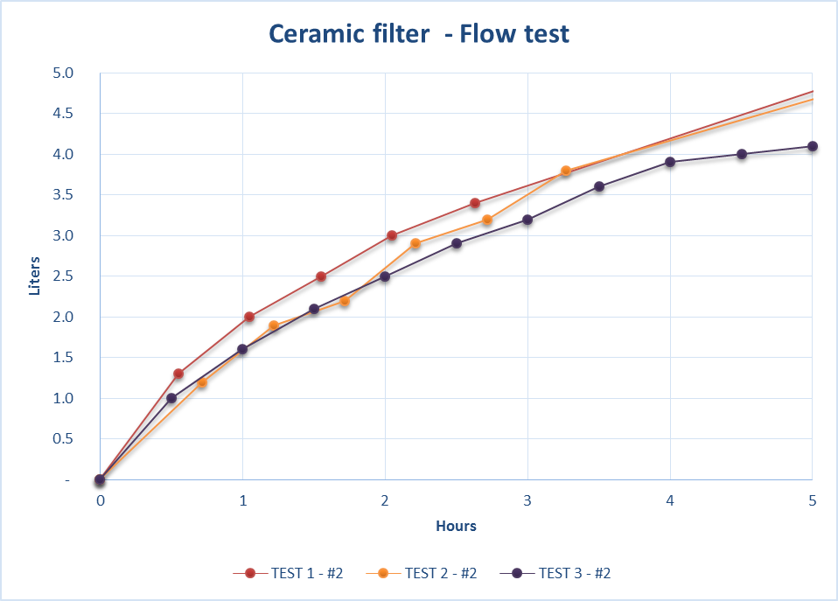

Figure – Example of flow rate test : 3 refills of the same filter – Average after 1h is 1.6l/h, after 2h 2.7l/h

The test of flow rate needs to take place when the filter has been filled at least during the last 24h so that the ceramic is already wet, otherwise, the measurement will be disturbed by the absorption of water by the filter itself. The filters must be filled with the same water used by the household, without previous cleaning.

The measurement of the flow rate is done using either a previously calibrated bucket where the CWF is positioned for the test or a ruler that is placed inside the CWF.

To measure the flow rate, the volume of water passed through the filter will be taken after are taken after 1 hour. The flow rate will be then calculated as follows:

$$flow rate (l/{hour})=\frac{total water passed thought filter (in liters)}{total test time \left(in hours\right)}$$

|  |  |  |
| --- | --- | --- |
|  | Volume of filtered water (liters) | Flow rate (liters /hour) |
| After 1 hour | 2 | **2** |



1. Tool for water quality testing



1. Filtration: Ceramic pot filter, pg. 32 to 35- Household water treatment and safe storage factsheet by center for affordable water and sanitation technology
2. Only 6% of household had evidence of free residual chlorine at the time of sampling, Rapid Risk Assessment Sittwe/pilot August-September 2013
3. 56%, 71% and 38% of household sampled in Kaung Doke Khar, Ohn Taw Gyi 2 and Say Tha Ma Gyi IDP camps are still using ceramic filters, Report on monitoring survey for ceramic filters by CDN
4. A study of the filtration rates of Colloidal Silver, Ceramic Water Filters for UNICEF, Feburary 2009 and an Investigation into the Quality Control Mechanisms used by 4 Ceramic Water Filter Factories In Yangon and Ayeyarwaddy Divisions
5. The life span of a ceramic filter is approximate and average. The monitoring system in place and futur evaluations will allow a more accurate figure to be included in the new version of this document.